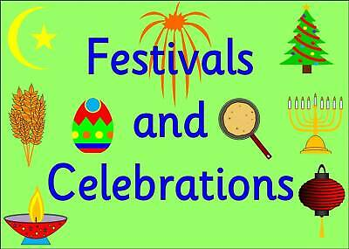
Religious/Cultural festivals and celebrations
Aims: These tasks are designed to be done with your child. Blue coloured tasks are aimed at Pathway 1 pupils as well as pupils who prefer more interactive activities and require a higher level of support. These are tasks we hope you will enjoy, please select the ones you feel are most appropriate for your child.
Thinking
Literacy Focus  Recommended Audible.com listening this week  Winnie the Pooh - Look out for the chapter In Which Eeyore Has A Birthday & Gets Two Presents.  https://stories.audible.com/pdp/B002V1BPOQ?ref=adbl_ent_anon_ds_pdp_pc_cntr-0-0  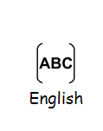 | Speaking & Listening: Tell someone about the best party you have been to OR a favourite present you have been given.  Resources: family photos, things in your bedroom.  Learning Focus: Identifying something you like. Explain why. Answer a question.  Communication: Play a game you would like to play at a party.  Resources: Any games you have at home or can find on the internet.  https://www.activityvillage.co.uk/indoor-party-games  https://www.youtube.com/watch?v=XEGQSjsNyW8  Learning Focus: Taking turns. Following the rules. Being a good sport!  Reading: Listen and talk about a story Winnie the Pooh’s birthday.  Resources: https://www.youtube.com/watch?v=DTQjdHhjZj8  Top Tip: Watch all the way through then rewatch stopping to answer questions..  Writing: Make a celebration card. Write your name clearly.  Resources: https://www.youtube.com/watch?v=G2dFlUpTVtg  https://www.youtube.com/watch?v=IvD6zvQCKOs 3D easy to follow, slow pace  https://www.youtube.com/watch?v=zsE81TzsQg8 5 easy to adapt cards  Learning Focus: Forming the letters of your name clearly. Fine motor work cutting or colouring in.
Maths Focus  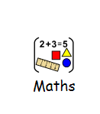 | - Hindu holi festival - can you create a collage of lots of different colours? Use paints, chalks, colouring pencils or felts. Can you use different tones of colours and sort them from dark to light?  - Easter egg decoration - paper mache a balloon, once it has dried can you decorate it using different shapes? Try and recall any 2d or 3D shapes you may have learnt at school. https://www.bbcgoodfood.com/howto/guide/how-make-paper-mache  - https://www.twinkl.co.uk/resource/eyfs-easter-themed-maths-home-learning-activity-booklet-t-tp-6542  - https://www.twinkl.co.uk/resource/easter-maths-addition-to-10-activity-booklet-t-n-7325 https://www.twinkl.co.uk/resource/t-t-27131-top-10-easter-maths-resources
Creativity
Cooking/Technology 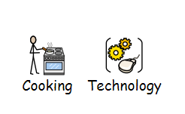 | Cooking tasks to choose from:  1.Rice Crispy Cakes for Easter  Link: https://www.bbc.co.uk/food/recipes/eastereggnests_93841  2.4th May is Star Wars Day! Cook up some Star Wars recipes:  Link:https://www.starwars.com/news/5-blue-milk-recipes-for-star-wars-day  https://www.starwars.com/news/jabbacado-toast  3.Here are some Easter recipes that you also may want to choose from which range from different abilities.  Link:https://www.goodtoknow.co.uk/food/recipe-collections/easter-recipes-for-kids-46497  Technology Task to choose from:  1.Design a device that will protect a hard boiled egg when it is dropped from a height.  2.Design some packaging for a new Easter egg.  Link:https://www.twinkl.co.uk/resource/au-t-3781-easter-egg-packaging-design-template  3.Build an Easter egg / bunny using Lego or other construction toys. Link:https://youtu.be/3PgOPg2OdM4 https://swooshable.com/sets/9000005-1
Drama/Arts  Other optional tasks for wider learning:  How to make Playdough eggs and a basket  https://www.youtube.com/watch?v=hCegW75_9q0 | Task Focus: Discuss parties and celebrations that you know, watch the Easter action song, have a go joining in with your family. Then make a card to celebrate your favourite festival  Key Information:  In RE lessons you all have so much to share about what you and your families celebrate, from birthdays, Christmas and Easter to Diwali, Eid and Chinese New Year, what do you remember?  Task helpful clip to watch:  Easter Action Song  https://www.youtube.com/watch?v=sOVFn2oZXWE  Fun Easter Cards https://www.youtube.com/watch?v=zsE81TzsQg8  Materials Needed:  Poster-Paper pencils, colour pencils or pens  Coloured paper or old wrapping paper, scissors and glue  Keywords: Celebration, Party, Food, Music, Dancing, Family, Friends, Easter Springtime Animals
Health and Wellbeing
Physical activity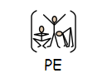 | Cosmic Kids Yoga ‘Easter’  https://www.youtube.com/watch?v=MEp9euhuu2E  Easy Zumba  https://www.youtube.com/watch?v=ymigWt5TOV8
Cross Curricular | In RE and PSHCE lessons you all have so much to share about what you and your families celebrate, from birthdays, Christmas and Easter to Diwali, Eid and Chinese New Year. Pick a celebration of your choice and create a collage (either drawings or computer based images) relating to that celebration. Label the pictures and discuss your collage with a sibling or adult

