RWI – Green Story and activities.
Stitch the Witch

- Watch the video and follow along, saying the speed sounds set 1: https://www.youtube.com/watch?v=TdpzE9wryzg

- Read the green words using finger spelling:
rub witch went cat have had fish ping dish milk soft bed

- Read the red words – Remember, these cannot be sounded out and must be learned on sight.

- Read the story:
Introduction:
If you had 3 wishes what would they be? Stitch the witch must be in a good mood because she has decided to give her cat 3 wishes. But Stitch can’t even get this right. What do you think could happen?

Story:
“Rub this lamp,” said Stitch the witch, then you can have 3 wishes.”
Rub-a-dub-dub, went the cat.
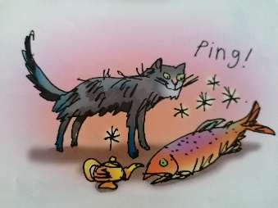
“I wish I had…. a fish.”

Ping!

Rub-a-dub-dub, went the cat.
“I wish I had a dish of milk.”
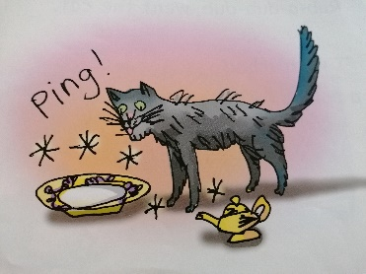
Ping!

Rub-a-dub-dub, went the cat.
“I wish I had a soft bed.”
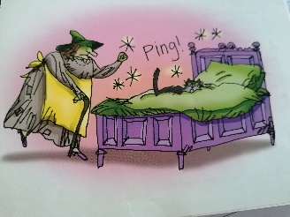
Ping!

- Questions to talk about.
Discuss these questions with a partner. You can write the answers down if you wish.

Why does the cat rub the lamp?
What does he say to make the magic work?
What is his first wish?
What is his second wish?
What is his final wish?
How do you think Stitch the witch is feeling about what happened?

Extension task:

Draw pictures of what your 3 wishes would be. Can you write a short sentence describing each wish?

