RWI – Yellow Story and activities.
In the Park.

- Watch the following videos and follow along, saying the speed sounds set 1 in video one and set 2 in video 2.
https://www.youtube.com/watch?v=TdpzE9wryzg
https://www.youtube.com/watch?v=p7hRbrpq5Bo

- Read the green words using finger spelling:
Park large far part bark sort with throw bench fetch round count play grass fish drink best pond
Read in Syllables:
gar ‘ den garden crick ‘ et cricket
loll ‘ y lolly sand ‘ pit sandpit
play ‘ ground playground round ‘a ‘ bout roundabout

- Read the red words – Remember, these cannot be sounded out and must be learned on sight.
The of you there are to do watch above they love

- Read the story:
Introduction:
Do you like going to the park? What is your favourite thing to do there? Who do you go to the park with? This book shows you lots of different people having fun at the park.

Story:
A park is a sort of large garden with lots of grass and trees.
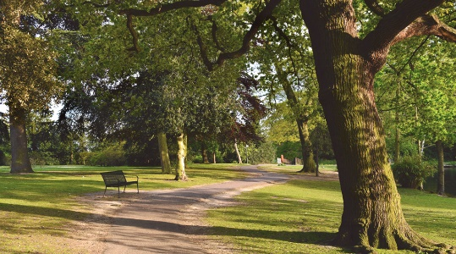
You can have fun at the park. There are lots of things to see and do.

You can play cricket or football or throw a ball. You can go round the park on a scooter.

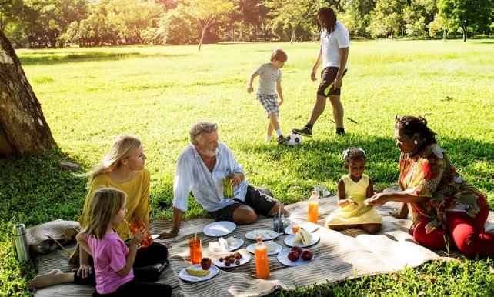
You can sit on a bench or have a picnic. You can go exploring in the trees and bushes.

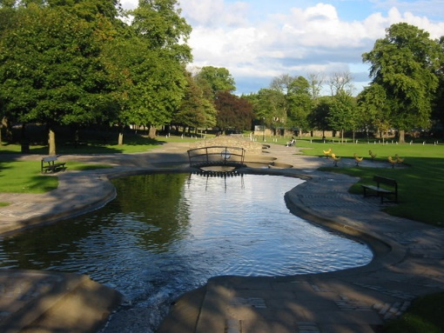
You can count the fish in the pond.

You can watch the birds flying high above you.

You can get a lolly or a drink.
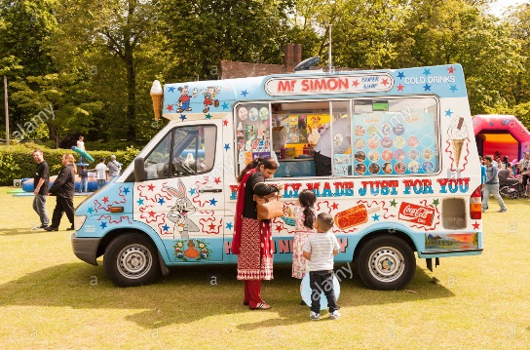
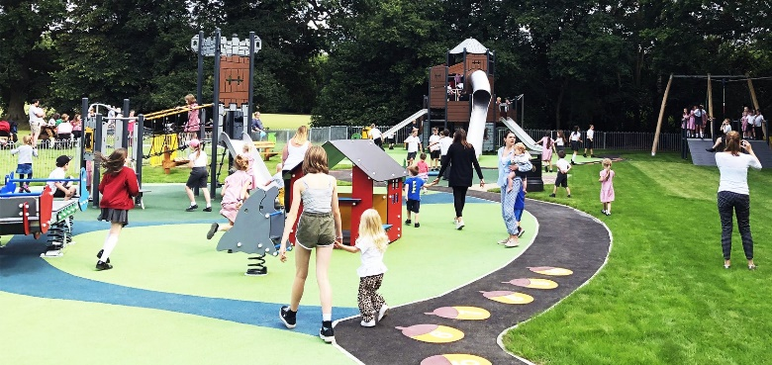
The best part of the park is the playground. You can go on the swings or roundabout. You can dig in the sandpit.

Dogs can have fun in the park. They love to fetch sticks and bark.
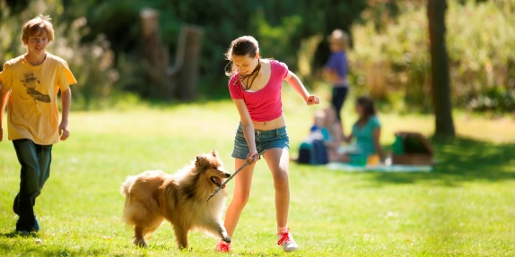
Do you have fun at the park too?

- Questions to talk about.
Complete these questions. Write the answers using full sentences.
- What can you play in the park?
- What can you count in the pond?
- Name 2 things you could buy from the ice cream truck.
- Why do you think the playground is the best part?
- What sort of animals have fun in the park? What do you think they like to do?

Extension task:
Create an advert or fact sheet encouraging people to come and visit your local park.
You could include:
Things to do in the park – make them sound exciting to encourage people to visit!
What makes the park special?
Pictures – either photos or drawings
Lots of colour!

