RWI – Blue Story and activities.
Save the whale.

- Watch the following videos and follow along, saying the speed sounds set 1 in video one, set 2 in video 2 and set 3 in video 3.
https://www.youtube.com/watch?v=TdpzE9wryzg
https://www.youtube.com/watch?v=p7hRbrpq5Bo
https://www.youtube.com/watch?v=n-Y4Ha4e7j4

- Read the green words using finger spelling:
Save whale pale age same shape stage male safe make day black back stuck born long swim krill milk twist sing feed

Read the syllables.
hump ‘ back humpback ad ‘ ult adult
a ‘ way away prob ‘ lems problems
At ‘ lan ‘ tic Atlantic Pac ‘ if ‘ ic Pacific

- Read the red words – Remember, these cannot be sounded out and must be learned on sight.
The there are waters mother some to they you want

- Read the story:
Introduction:
Humpback whales are very large sea creatures. Do you know any other kinds of whale? This book will help you learn all about these magnificent mammals and why they are in danger.

Story
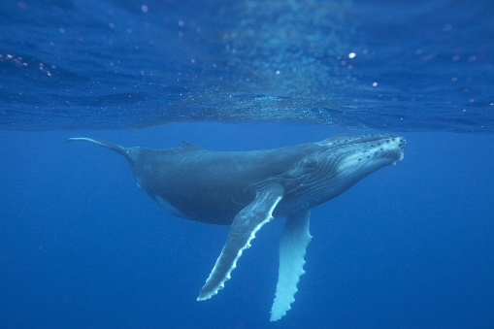
The humpback whale is a mammal.
It is black with pale markings.
It has long flippers and a fin on its back.

Whales live in groups called pods.
There are 2 – 5 whales in a whale pod.
A humpback whale can get to the age of 77.
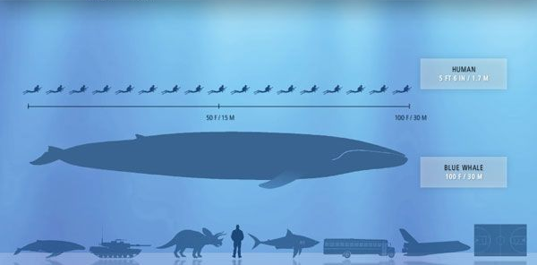

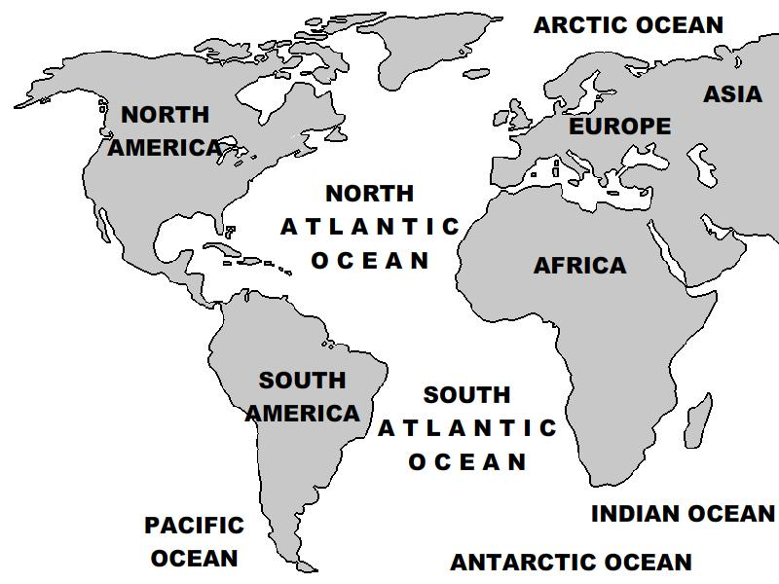
Humpback whales swim in the waters of the Atlantic and the Pacific.
They feed on fish and krill.

When it is born the humpback whale is 4 – 5 meters long and about 2 tonnes. It is the same shape as the adult whale. At this stage it drinks 400 litres of his mother’s milk a day.

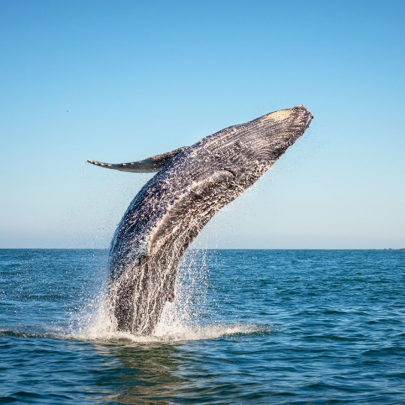
The humpback whale can jump out of the waves, twist around and then jump back in!
The male humpback whale can sing!

But the humpback whale has problems.
It is hunted and killed by man.
Fishing takes away it’s food.
It gets stuck in fishing nets.
It bumps into ships.
Some waters are too dirty to be safe for the whales.

If you want to help save the whale, contact the World Wildlife Fund.
Let’s make our waters safe for the humpback whale!
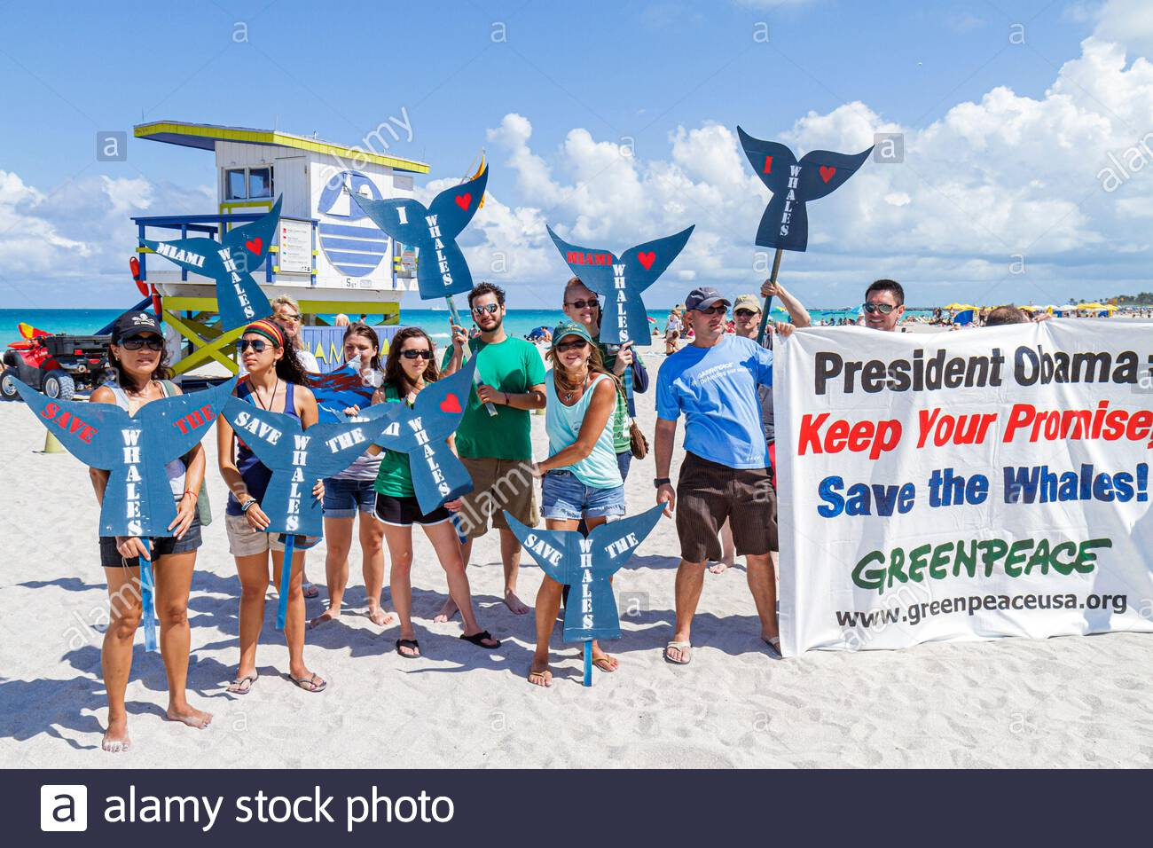

Questions to talk about.
Complete these questions. Write the answers using full sentences.

- Is this story fiction or non-fiction?
- Describe what the humpback whale looks like.
- What does a humpback whale have on its back?
- What do humpback whales feed on?
- How heavy is a baby humpback whale?
- Why do you think the male humpback whales sing?
- Why are fishing nets a problem for humpback whales?
- Name 2 things you could do to help save the whales?

Extension task:
A group of humpback whales is called a pod. Can you research other groups of animals and the names given to their group? For example, a group of lions is called a pride. Can you find any with funny or interesting group names?

1

2

3

4

