RWI – Grey Story and activities.
A job for Jordan.

- Watch the following videos and follow along, saying the speed sounds set 1 in video one, set 2 in video 2 and set 3 in video 3.
https://www.youtube.com/watch?v=TdpzE9wryzg
https://www.youtube.com/watch?v=p7hRbrpq5Bo
https://www.youtube.com/watch?v=n-Y4Ha4e7j4

- Read the green words using finger spelling:
sort for born worn more or poor floor Dawn sight right life lie white
Read in Syllables:
play ‘ ful playful be ‘ fore before
spon ‘ sor sponsor rep ‘ ort report
morn ‘ ing morning supp ‘ ort supp ort
im ‘ por ‘ tant important

- Read the red words – Remember, these cannot be sounded out and must be learned on sight.
all are come do some the they to want who you

- Read the story:
Introduction:
This book is about guide dogs. Have you even seen one? Did you know that guide dogs are specially trained to help blind people? They are very clever dogs and they do a very important job.

Story
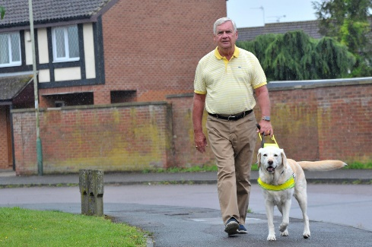
Mark needs his guide dog, Dawn, because he has poor sight. A Labrador is a good sort of dog for this.

Read this report about how Jordan, a Labrador pup, is trained to be a guide dog.
All pups can be playful, but a guide dog pup has to behave. His owner’s life will be in his hands – or his paws!

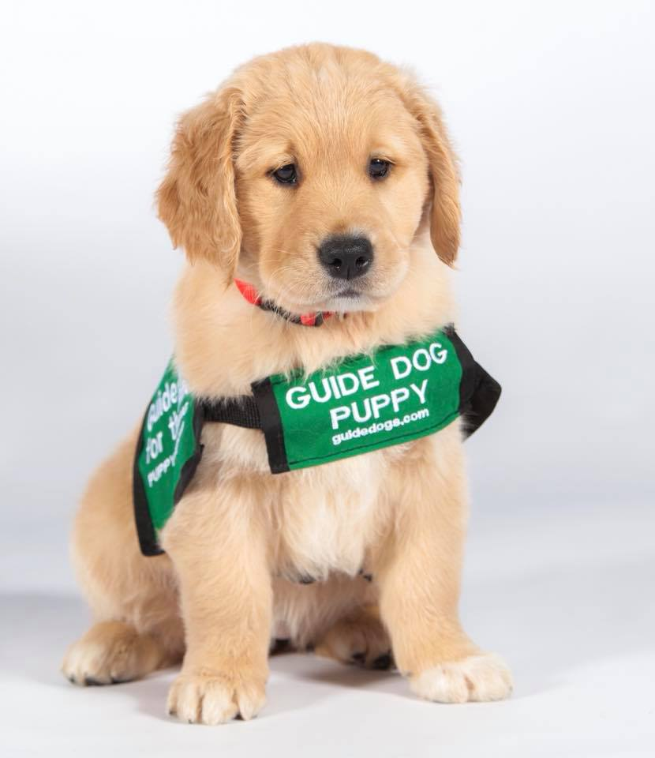
6 – 8 weeks after Jordan is born, he is taken out on a lead each morning to be trained.
A guide dog is trained to:
Sit
Lie down
Stay
Come
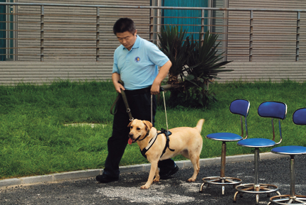
When he is 1, a harness is worn by the pup.
He is trained in some more important lessons:
- How to stop before crossing a street.
- How to go left or right on command.
- How to stop his owner bumping into things.
- How to deal with traffic.

Next, the guide dog meets his owner. They are shown how to act as a team.
A guide dog is a great help to a person with poor sight.
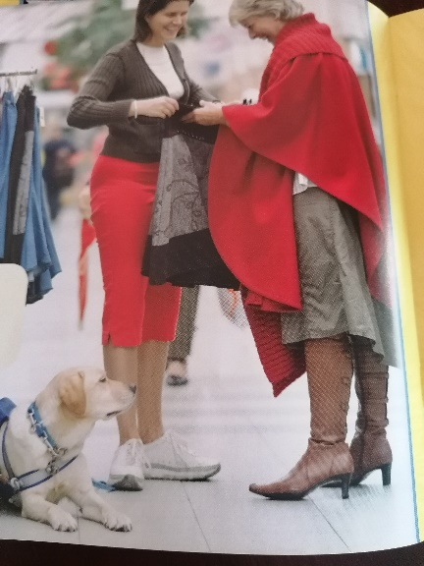
He lies on the floor until he is needed.

If you see a guide dog with his owner, do not speak to the dog or pat him. Let him do his job.

Would you sponsor a guide dog pup?
£1 a week will support a pup who is being trained to be a guide dog. With an adult, go to this website if you want to know more:
www.guidedogs.org.uk

Questions to talk about.
Complete these questions. Write the answers using full sentences.

- Who is Dawn?
- Why do you think guide dogs are trained to stop before crossing the street?
- What is worn by a guide dog when he is 1?
- Why do you think you shouldn’t talk to or stroke a guide dog when they are out with their owner?
- How much a week will support a pup who is being trained?
- Where can you find out more information about guide dogs?

Extension task:
Create a poster either by hand or on the computer persuading someone to sponsor a guide dog puppy. You could include:
Pictures
How guide dogs help people
Why they are important
Lots of colour to make it look interesting!

