RWI – Yellow Story and activities.
The Duckchick.

- Watch the following videos and follow along, saying the speed sounds set 1 in video one and set 2 in video 2.
https://www.youtube.com/watch?v=TdpzE9wryzg
https://www.youtube.com/watch?v=p7hRbrpq5Bo

- Read the green words using finger spelling:
egg well quick spring quack nest cluck long them hatch fell Mama wrong
Read in Syllables:
prob ‘ lem problem duck ‘ chick duck chick
a ‘ long along a ‘ cross across
ve ‘ ry very

- Read the red words – Remember, these cannot be sounded out and must be learned on sight.
One saw her to go the all was some she be he they watch

- Read the story:
Introduction:
Have you ever worried about something then it turned out alright in the end?
Hens lay eggs and then sit on them to keep them warm until they are ready to hatch. Mama hen has six eggs but one of them is bigger than the rest! Mama hen doesn’t realise that this is a duck egg. When this egg hatches, she and her other chicks are really shocked and surprised. But when a fox comes along, find out how duckchick saves the day.
What do you think will happen?

Story:
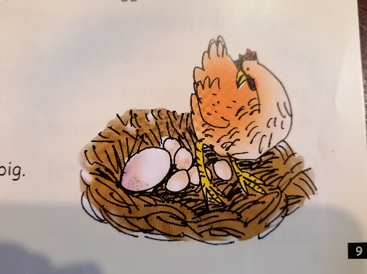
Mama hen had a problem. Things began to go wrong in the spring, when she was sitting in her nest on her six eggs.
Egg 6 was very big.
Mama hen sat on it a lot,
and went “cluck” at it, but she felt a bit upset that it was so big.

Eggs 1-5 began to hatch.
The soft, fluffy chicks (Sam and Chip and Dan and Ben and Mag) pecked and pecked at the shells until they went crack.
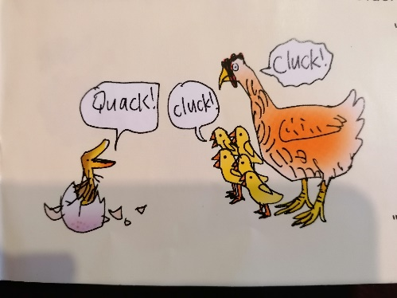
Then, with a very big cccc-r-a-ck, egg 6 hatched as well.
But this chick was a duckchick!

“Cluck!” went Mama hen, shocked.
“Cluck!” went Sam, and Chip, and Dan, and Ben, and Mag.

“Quack! Went the duckchick.

Mama hen and the chicks went to the pond.
Mama hen and Sam and Chip and Dan and Ben and Mag pecked up lots of grubs from the mud.
The duckchick flapped his long wings, stretched his long neck, and “Splash!” jumped into the pond.
He pecked up some crusts.

“Cluck!” went Mama hen, shocked.
“Cluck!” went Sam, and Chip, and Dan, and Ben, and Mag.
“Quack!” went the duckchick.
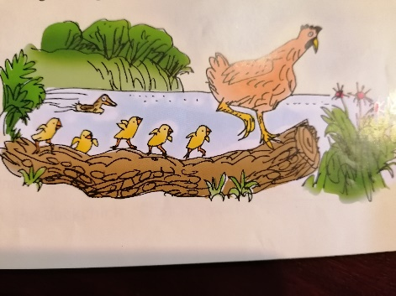
Mama hen jumped up on a log.
Sam, and Chip, and Dan, and Ben, and Mag jumped up as well.
They hopped along the log.

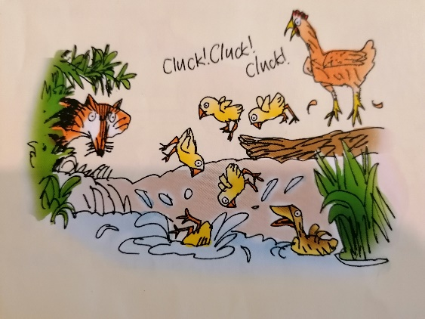
But fox was watching them. When Mama hen saw it, she went, “Cluck! Cluck! Cluck!” and all the chicks fell in the pond!
“Help” went Sam
“Help!” went Chip
“Help!” went Dan
“Help!” went Ben
“Help!” went Mag

Quick as a flash, the duckchick swam across to them. He grabbed Sam by his leg and swam with him to the bank. Then Chip, and Dan, and Ben, and Mag.

“Cluck!” went Mama hen.
“Thanks, duckchick!”

- Questions to talk about.
Complete these questions. Write the answers using full sentences.

- What did Mama hen sit on?
- How many eggs did Mama hen have?
- Why was mama hen shocked with egg 6 hatched?
- Who was watching the chicks?
- Why did the chicks fall into the pond?
- Do you think Mama hen has changed the way she feels about the duckchick? Why?

Extension task:
When Mama hen discovers that the 6th egg is a duckchick, she is shocked.
Can you use the word shocked to create 2 of your own sentences?

1

2

