
Aims: These tasks are designed to be done with your child. Green coloured tasks are aimed at pupils in the main body of the school. Tasks are a mixture of interactive tasks and tasks which build core skills. These are tasks we hope you will enjoy, please select the ones you feel are most appropriate.
Thinking
Literacy Focus: Maintaining and building key skills including communication skills and confidence ready for September.  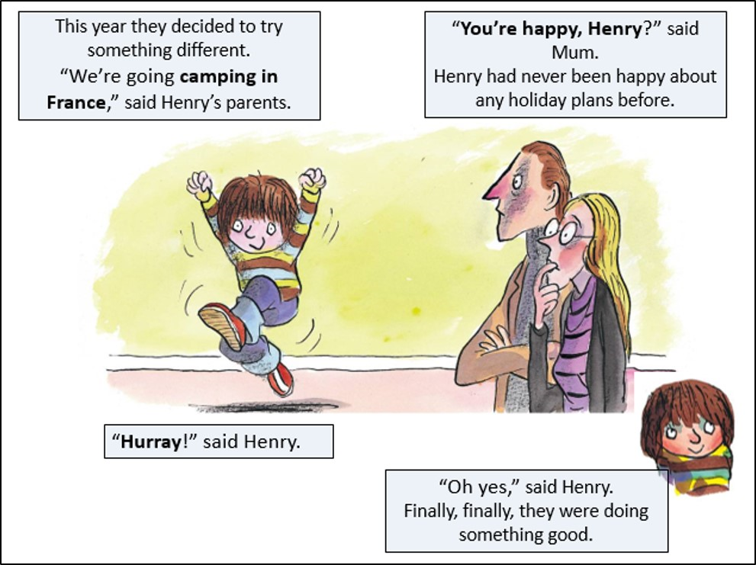  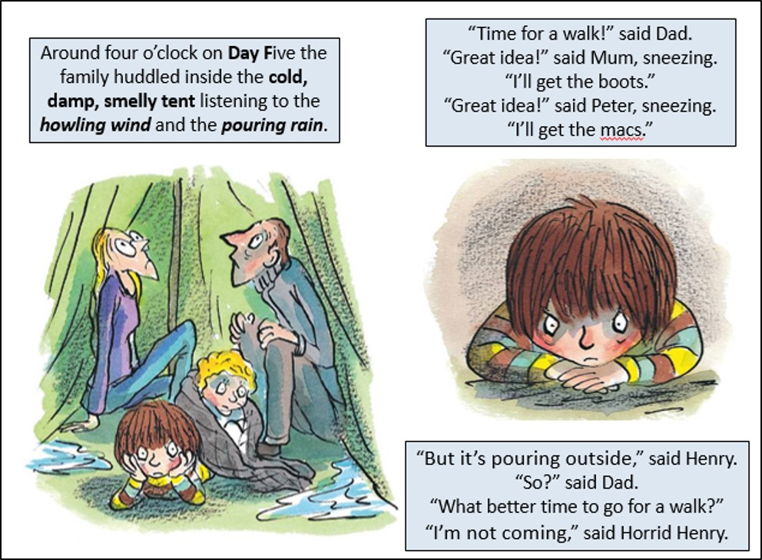  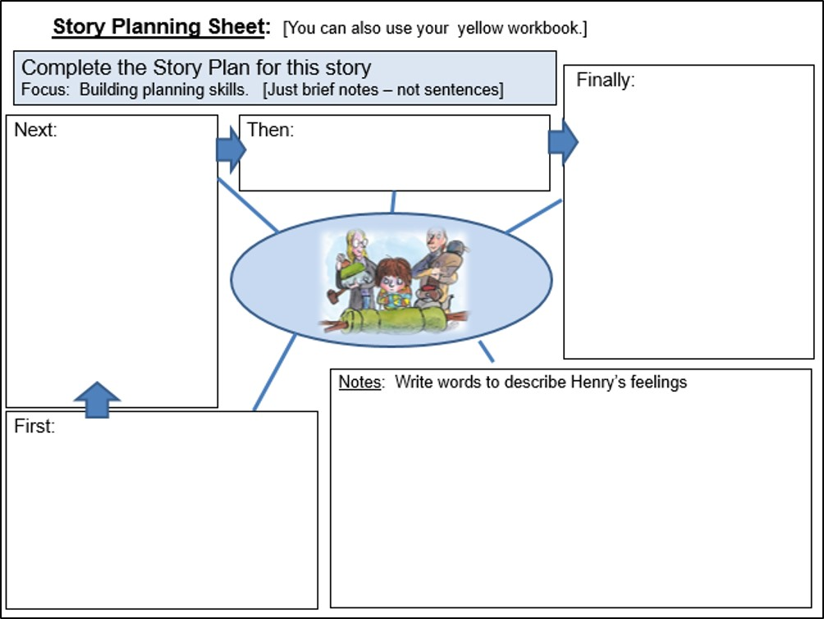  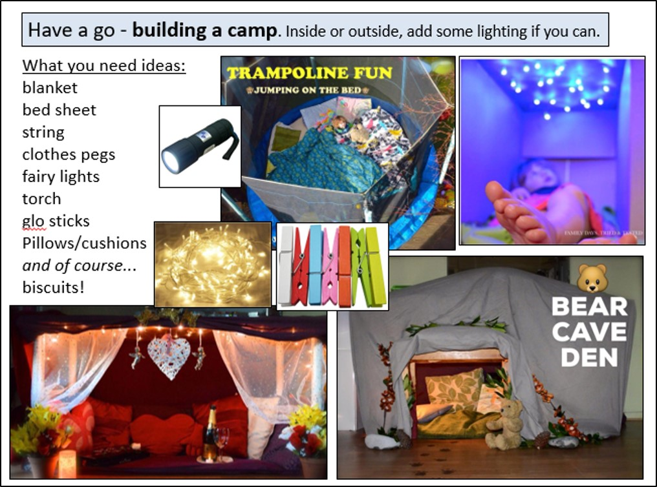 | Speaking, Listening & Communication, Reading and Fun Holiday Activities  Resources: Come and collect FREE bag of soil and seeds from school.  Powerpoints - W10 Leisure HH Holiday GREEN as  W10 Leisure Activities GREEN as  Videos -  1 x story - Horrid Henry’s Holiday [Full Text] read by Miss Barratt  Instructional - Miss Lennon teaches how to plant a seed  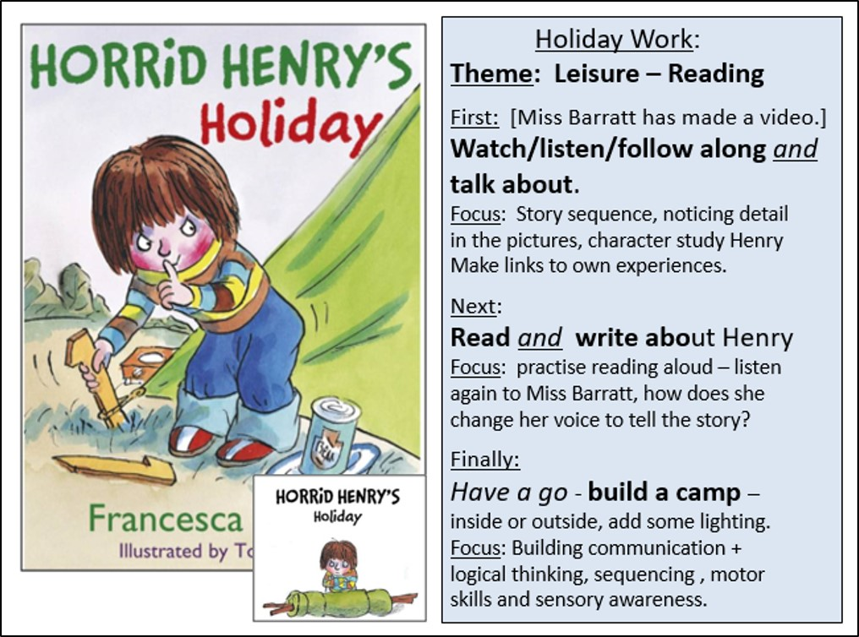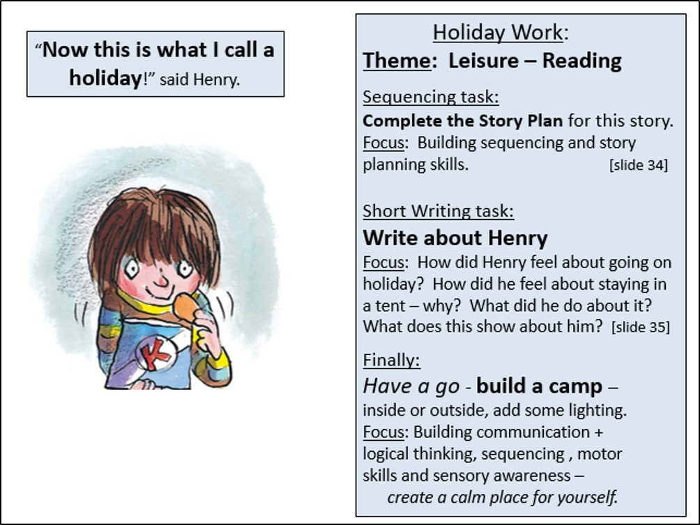  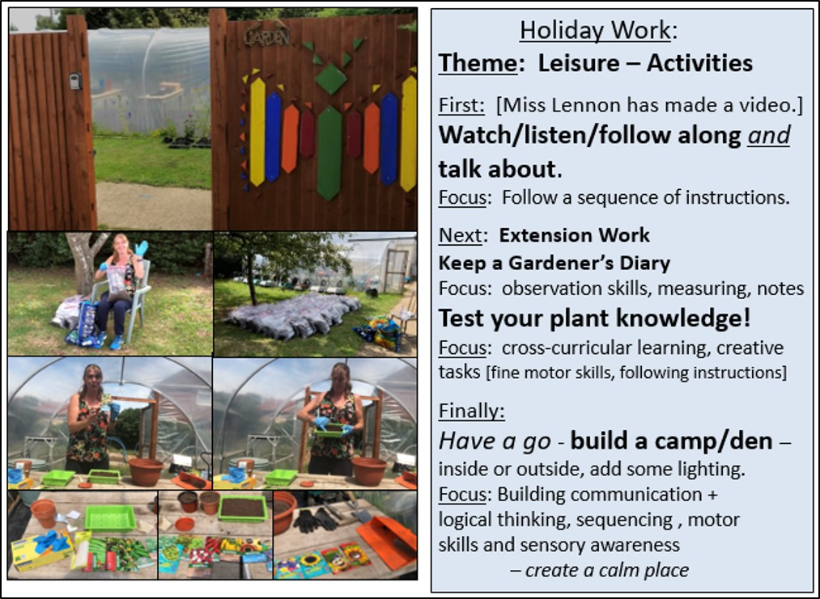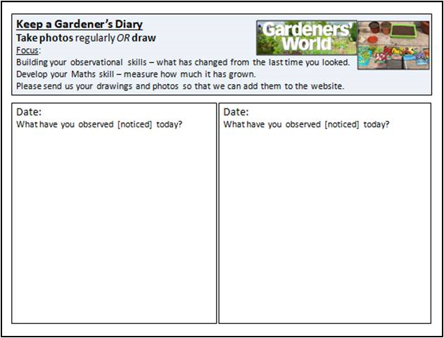  Remember: Take photos / draw the camp or den you made.  Take photos / draw your seeds as they grow.  Email meadow@meadowhighschool.org and we will put them on the website.
Maths Focus  EMOJI FUN! | - Break the emoji code… they get harder, attempt as many as you can!  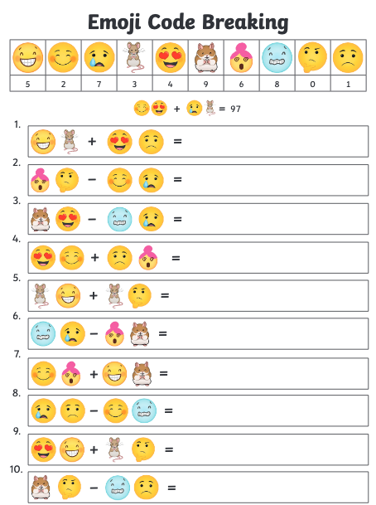  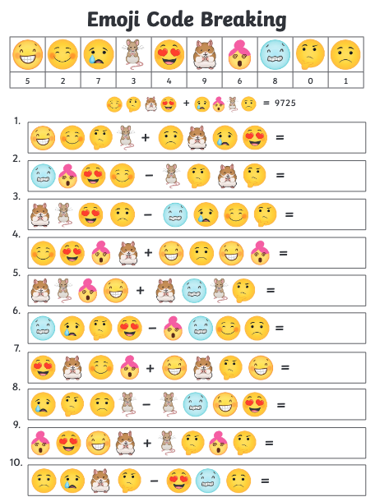  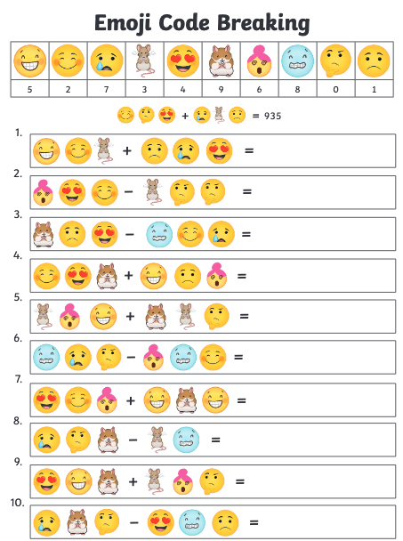  - Emoji craft  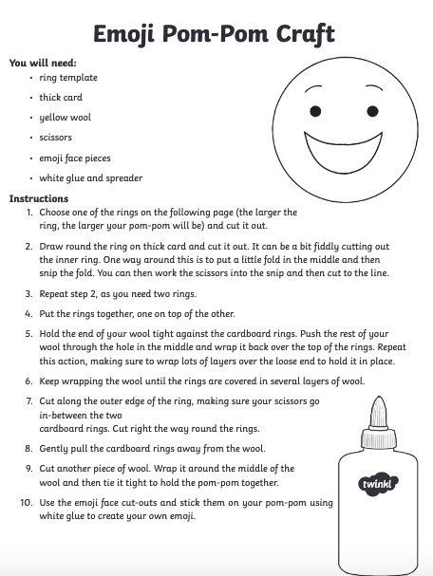  - Emoji co-ordinates  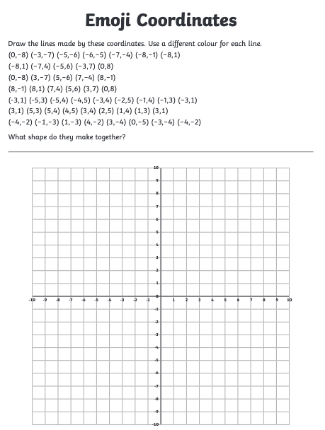  - Emoji multiplication mosaic - pick your level they get harder!  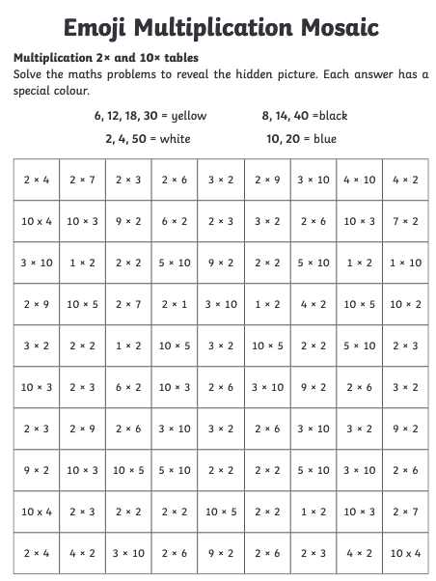  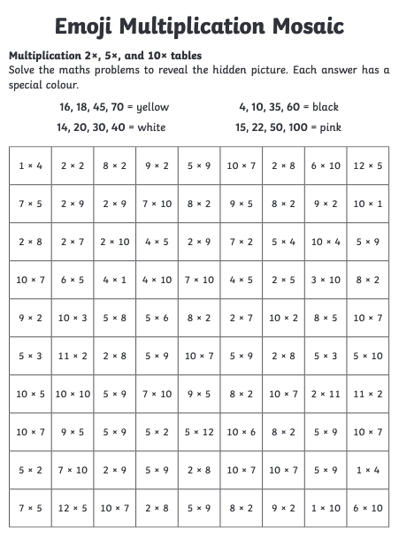  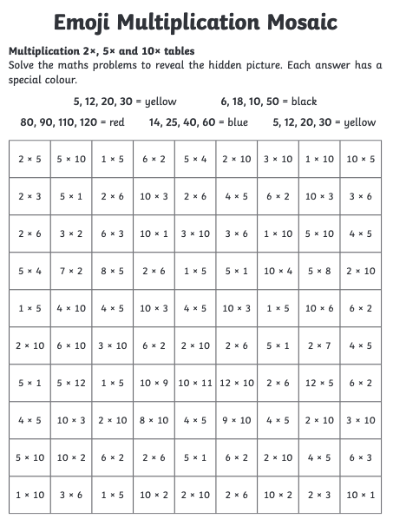
Science Focus | 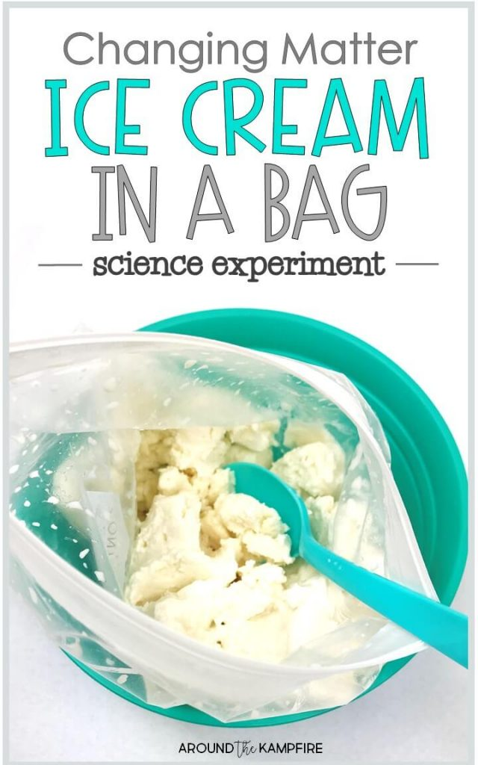  Task: Making ice cream in a bag!  There is actually a lot of interesting chemistry that goes on behind making ice cream. How do the ingredients change during this process? How important do you think it is that they are cooled to a certain temperature? How does the salt cause the ice to melt? Record your observations on the worksheet  What you will need:  - Sugar, milk /heavy whipping cream, vanilla extract, salt, ice cubes, sealable bags  Website:  https://www.sciencebuddies.org/stem-activities/ice-cream-bag#summary  https://aroundthekampfire.com/2020/01/ice-cream-bag-changing-matter-experiment-second-grade.html  Recording worksheet:  https://drive.google.com/file/d/0B-cVjZBMBNNXdTFWaC1XNTd6bE0/edit
Cooking/Technology | Pass Time  Think about your favourite pastime activity. Is it sports? Making art? Going to the park?  Brainstorm what you like about the activity and then write a blog styled piece on Word or by hand describing the activity and your favourite memory with it  Mobile Device - Wordsearch  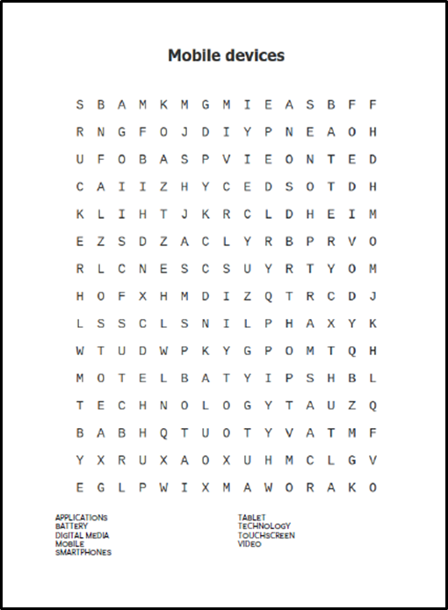  Attached: PDF - Mobile devices word search  Holiday Pizza - The latest in our cooking with kids series looks at kneading, rolling and sauce skills- then let your child build their own pizza from their favourite toppings  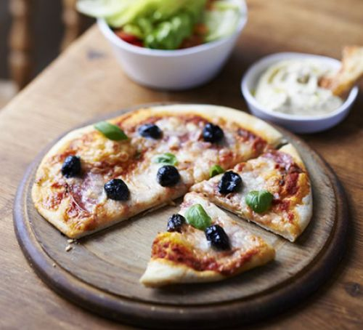  Link:https://www.bbcgoodfood.com/recipe/summer-holiday-pizzas  Here are some brilliant website for you to look at different recipes that you may choose to make:  https://www.bbcgoodfood.com/recipes/collection/school-holiday  https://www.bbcgoodfood.com/recipes/collection/summer-family  https://www.tasteofhome.com/collection/fun-recipes-for-summer-vacation/
Drama/Arts/Music | Task Focus: Learning to draw body poses  Information:  Art: Keith Haring was a famous American Graffiti Artist who liked to draw people who looked like they were moving.  Do you like to do lots of things and keep active when you are on holiday? What sort of leisure activities do you do?  Look at the image below:  What are the figures doing?  Task 1 Describe his style- Simple lines and pattern, bright colours, body poses  Task 2: Draw dancing figures and add colour.  Task 3:Put on some American music you think Keith Haring might like, pretend you are on holiday at the beach!  Task 4: Can you draw someone at home while they hold a pose? Then colour in the figure  Remember to thank them, how long could they hold a pose for, did you time them?  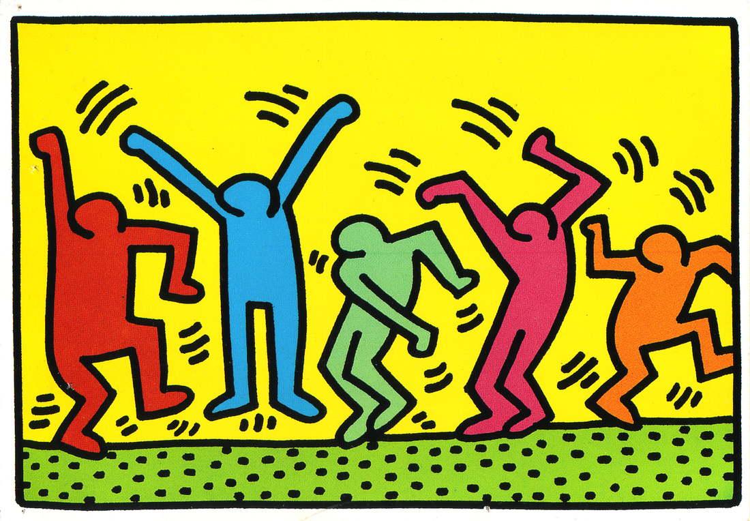  Materials you will need:  You will need:Pencils, colour pencils or felt pens  Task Helpful link to follow:  https://www.youtube.com/watch?v=Z7SnDuPX_JA  Keywords: Simple lines and pattern, bright colours, body poses  Other wider Learning  - https://www.youtube.com/watch?v=7i1XD2yN4Ug Watch the clip Yellow submarine, can you draw a submarine?  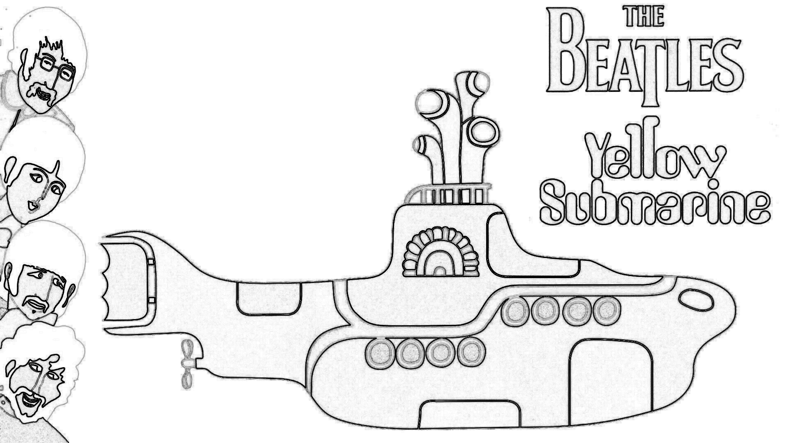  - How to make a Paper hot air balloon mobile  https://www.youtube.com/watch?v=-lOdTb5A6aw  You could bend a coat hanger or adapt plastic lid if you don’t have a fabric hoop  - Watch the link for some fun Summer craft ideas  https://www.youtube.com/watch?v=A7-okRDbdok  We hope you enjoyed the Arts Activities looking forward to seeing you in school again in September
Health and Wellbeing
Physical activity | The PE staff have uploaded lots of videos of circuits training or challenges to the youtube channel. Have a look and have a go. Keep active!  https://www.youtube.com/channel/UCQVlu1D0XnL-bwjaXIzbZxQ/videos  ThisIsPE: Updated 3 times a week. Fun and easy activities to be done at home. https://www.youtube.com/results?search_query=thisisPE  Using ideas from the “This is PE” link, try and create your own game using things you can find at home. Write down the rules and play with your family. If you can, upload to Twitter and tag “@MeadowPE” so we can see it.  Nike Move Crew: Fun games and dance activities led by Nike athletes. https://www.youtube.com/results?search_query=nike+move+crew  Go Noodle I Get Moving: Lots of videos to get children moving, dancing and exercising with lots of music and singing. https://www.youtube.com/user/GoNoodleGames  Fitness Blender: Build your own circuit training session  https://www.fitnessblender.com/videos  Lawn Bowling: Find 10 empty bottles and arrange them into a triangle. With a ball or rolled up socks roll/throw the object to knock down as many “skittles” you can in 2 rolls/throws. 1 game is made up of 10 turns (2 rolls/throws each turn). Count up your total score and see who wins.  Target Throw: Find 5 containers (they can be the same size or different sizes) and roll 5 pairs of socks up. Place the containers in different spaces and give them points based on how difficult they will be. Take a turn to throw the rolled up socks into the containers and count up your points.  Just Dance: If you like dancing or just want to keep moving. Use Just Dance’s youtube page and enjoy their videos.  https://www.youtube.com/channel/UC0Vlhde7N5uGDIFXXWWEbFQ  Using your leisure time to keep active is a way of creating and maintaining a healthy and active lifestyle. Find ways to enjoy keeping active!  Can you participate in some kind of activity that raises your heart rate for 30 minutes per day?
Wellbeing  Useful links offering support and discussion:  https://youngminds.org.uk/    https://www.time-to-change.org.uk/   | MAKE TIME TO STAND UP TO STIGMA  Objectives:  • To help students feel a part of wider movement tackling mental health stigma and discrimination  • To inspire students to take the campaign message out into their community  Resources:  ‘Week 4 make time to stand up to stigma’  ‘Week 4 Powerpoint Final’  Task:  Work your way through this very reflective activity and think about how you can change the stigma! These activities can be done individually or as a family.

