
World of Work
Aims: These tasks are designed to be done with your child. Green coloured tasks are aimed at pupils in the main body of the school. Tasks are a mixture of interactive tasks and tasks which build core skills. These are tasks we hope you will enjoy, please select the ones you feel are most appropriate.
Thinking
Literacy Focus: Developing skills identifying key information in fiction and non-fiction texts; making links to their own experiences and the world of work. Building auditory memory - identifying key information and making notes. Building research skills and developing imagination linked to an extended writing task.  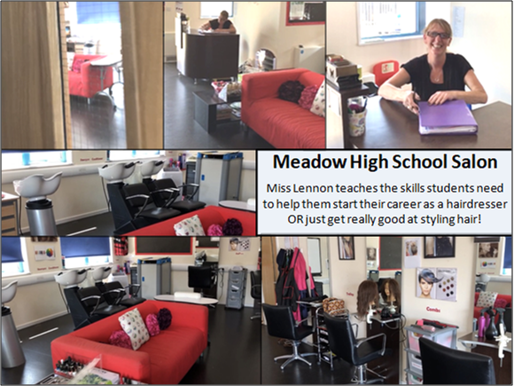  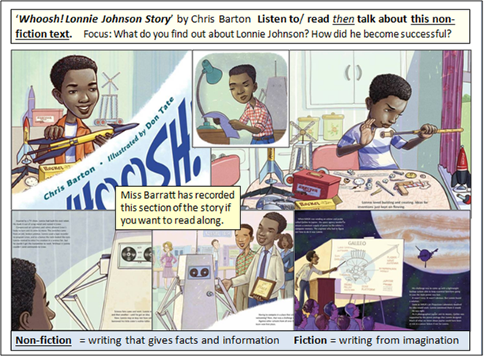 | Speaking, Listening, Reading & Writing:  Resources: videos links in powerpoints  Powerpoints: W9 WoW Hairdressers + Lockdown Hair GREEN as and W9 WoW Inventors GREEN as.  Videos: Mrs. Sugden reading Even Monsters Need Haircuts [sign supported]; Interview with a Hairdresser [Miss Lennon]; Miss Barratt reading an extract from Whoosh! [the story of the amazing inventor Lonnie Johnson].  Extension Work: Additional research work on world changing inventions.  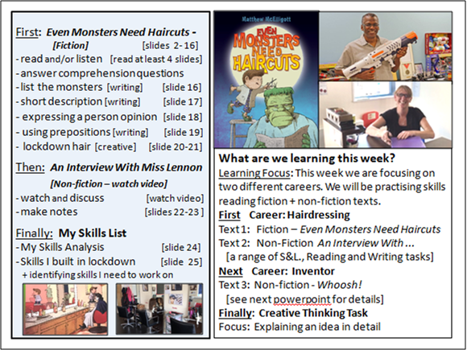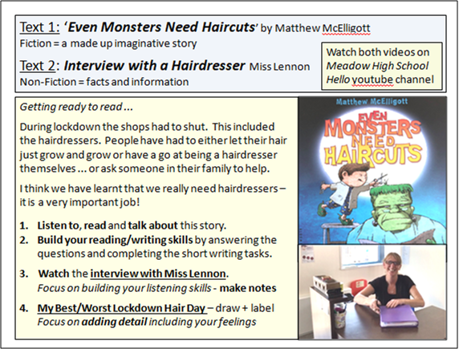  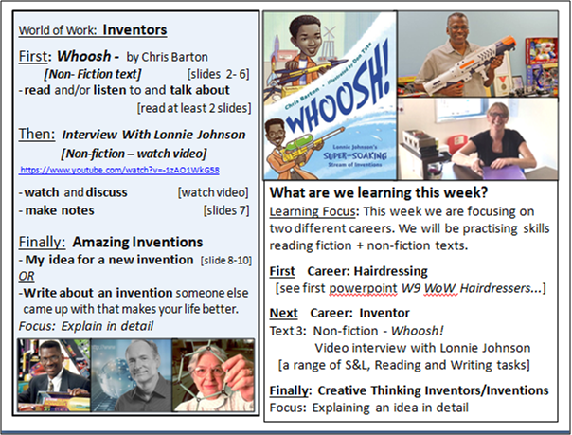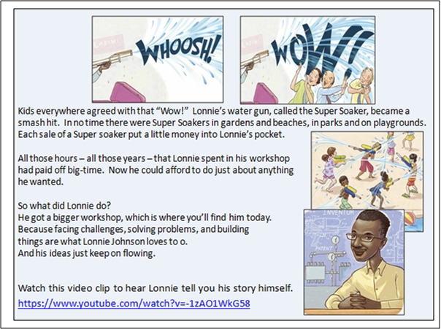  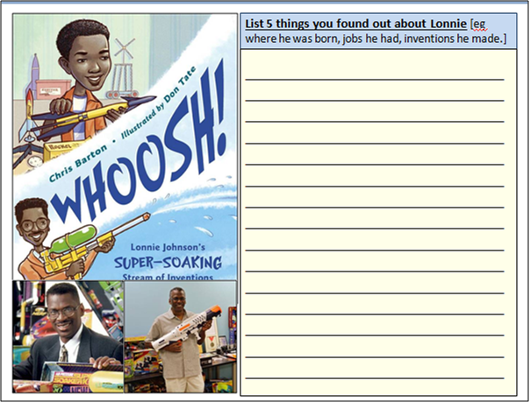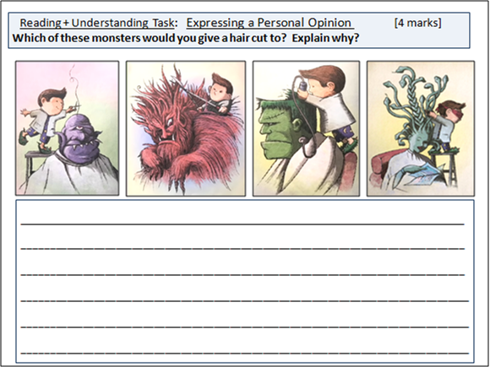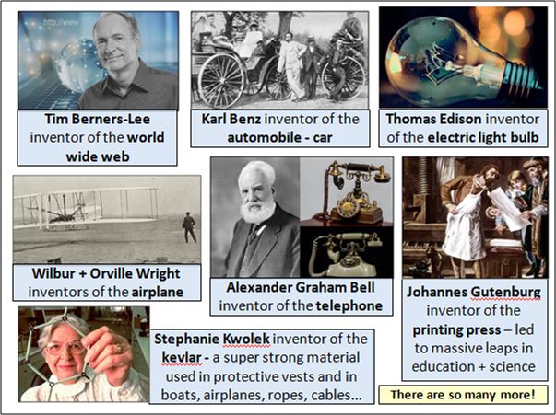
Maths Focus | - Different jobs wordsearch. Once you have completed the word search, research online the jobs and find out 3 key facts about each one  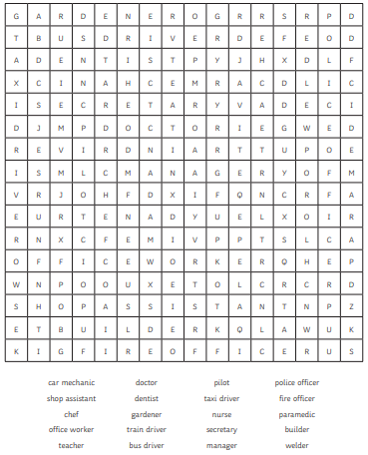  - You are an astronaut! Play this out of space game to practise your times tables  https://www.twinkl.co.uk/go/resource/T-GO-07-space-explorers-times-tables  - You are the headteacher of a school! You need to find out how people prefer to travel to school. Complete the tally chart/ pictogram and answer the questions  - Ask your siblings, cousins, friends, neighbours  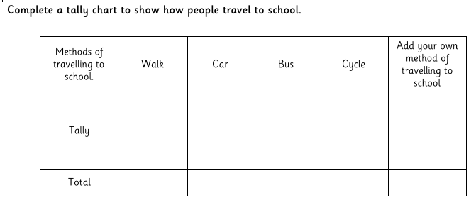  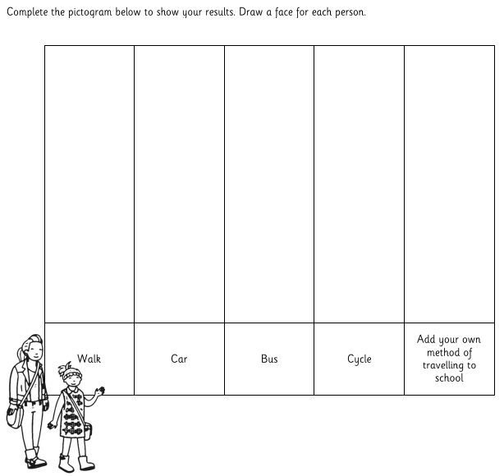  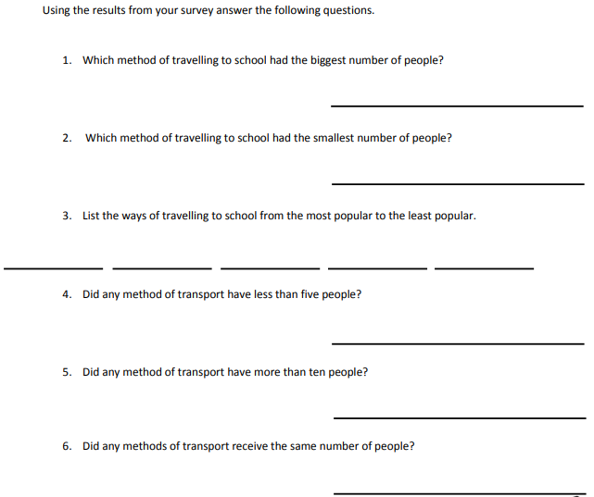  - You are collecting money for charity, count how much money in the jars at the end of the day  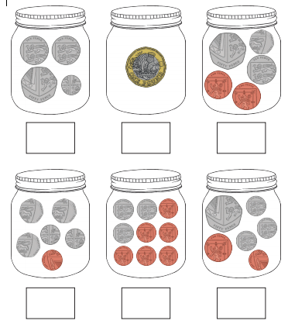  - You get really busy in the second week and people have donated more. How much money in this weeks jars?  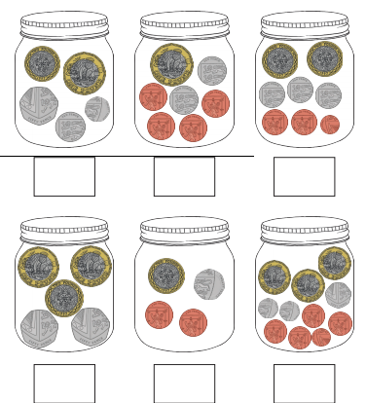  - In the third and final week, you have made the most money! How much money in each jar?  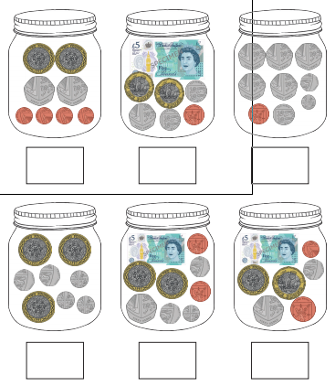
Science Focus |   Musician - Musicians write, record, and perform music. Sound is important in their jobs.  Task: Sound is produced by the vibration of air blowing across the open holes of the straws. Create your own pan pipe and explore frequency.  Aim: To investigate how the frequency of a sound can be varied.  Steps:  - Use several straws to make a set of pan pipes!  - Each straw should play a different pitch when you blow into it.  - Flatten the end 2cm of each straw, and cut a triangle in the end.  - Prepare several straws like this, then think about how to change the pitch of the sound each straw makes.  - Stick or tie the straws together to make your set of pan pipes.  - Blow hard through the triangle end of the straw to make a sound. You may have to try few times to make the sound  Key words: Sound, Frequency, Vibration, Pitch, High, Low  Equipment: Straw, Tape, Scissors  Worksheet: https://www.twinkl.co.uk/resource/t2-s-761-new-activity-sheet-straw-pan-pipes-differentiated  Background info:  https://www.theschoolrun.com/what-is-sound  Questions:  •Explain how you created your pan pipes so that they can play sounds of different pitches  •Did the shorter straw have a high or low pitch?  •Why do you think this is?  What’s happening?  Sound is produced by the vibration of air blowing across the open holes of the straws. Air blowing through a shorter straw moves quickly in one end and out the other. These vibrations move quickly and have a high frequency, which produces a high pitch. So the faster the vibrations, the higher the pitch / sound.
Cooking/Technology | Computing Challenge:  Your colleague at work receives a strange email with an attachment. They open the attachment and end up downloading a virus. This virus has now given a stranger access to your workplace’s database.  E-safety is always important whether it’s at home or in a place of work.  Task: Poster Challenge - Create a useful poster that can be distributed to help people identify the different ways of staying safe online while using the internet.  This can be created using a computer or drawn by hand.  (The link below shows useful information to remain safe online)  https://www.bbc.co.uk/bitesize/guides/zrtrd2p/revision/1  Task: Make you own Lunch - Whatever job you may work, from a builder to an office worker to a dentist or a waiter, it is important to take a break and have a balanced lunch. Can you think of good lunch ideas? Remember they must be healthy. You can write your ideas on the template attached.  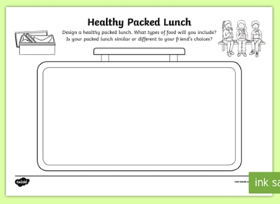  Attached: PDF - Packed Lunch Ideas - Green  Task: Healthy Lunch - In the world of work it is essential to keep your energy up through breaks and lunch. Therefore it is important that children know what a healthy lunch is and this resource is ideal for teaching them about making healthy choices. The children will cut out the foods and stick them in the lunch box to show what they think a healthy lunch is.  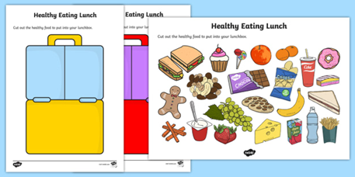  Attached: PDF - Healthy Eating Lunch Activity - Green  Task: Supper Salad Wraps Recipe - Make an exciting vegetarian salad wrap with crunchy veg for texture and a good hit of cheddar cheese. Perfect for packing into a lunchbox.  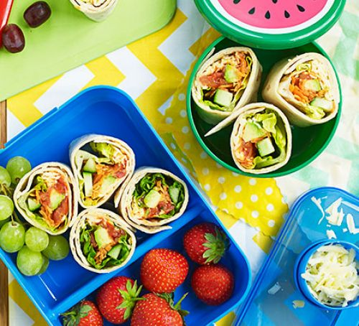  Link: https://www.bbcgoodfood.com/recipes/super-salad-wraps
Drama/Arts/Music | Task Focus: To pretend or mime you have a job in the circus  What job would you do?  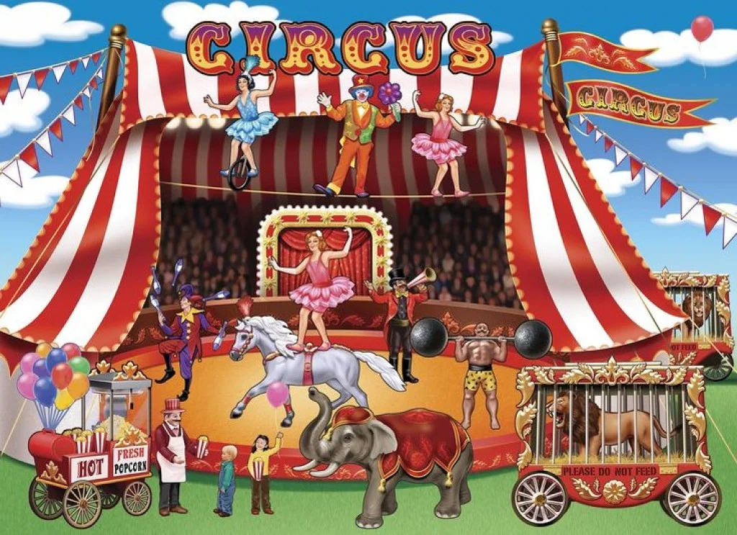  Information: There are lots of jobs people do in the circus. We call these performance jobs. Actors, Comedians, Singers, Stuntmen or Stuntwomen are also types of performers.  Can you think of any careers in the circus? Read the Key words to give you ideas.  Research the careers at BigtopMania (follow the link below)- they offer circus parties for companies who want a fun circus experience.  You will need:  -Paper plates  -Cardboard tube/s  -Paint or felt pens  -Paint brushes  -Scissors  -Tape  Instructions:  Step 1: Act out different jobs in the circus can you mime different careers and see if anyone can guess which one you are?  Step 2 Make the hoop challenge!  Have a go making the circus hoop challenge game  Once your hoops have dried you can play the game to see who can hoop the most hoops! One of you will need to be the Ringleader and make sure no one is cheating, count up the hoops and declare the winner!  1. Decorate one plate and cardboard tube to form the ring toss base. Set aside to dry.  2. Decorate your other paper plates to form the tossing rings.  3. Cut the circles out of the middle of these plates.  4. Cut 4-6 slits that are a half-inch long at the bottom of your tube.  5. Fold the tabs on the tube outwards and tape them down to the base plate.  6. Now stand back, and throw your rings towards the base. (Don't forget to aim!)  -If it's too easy, make sure you move back further.  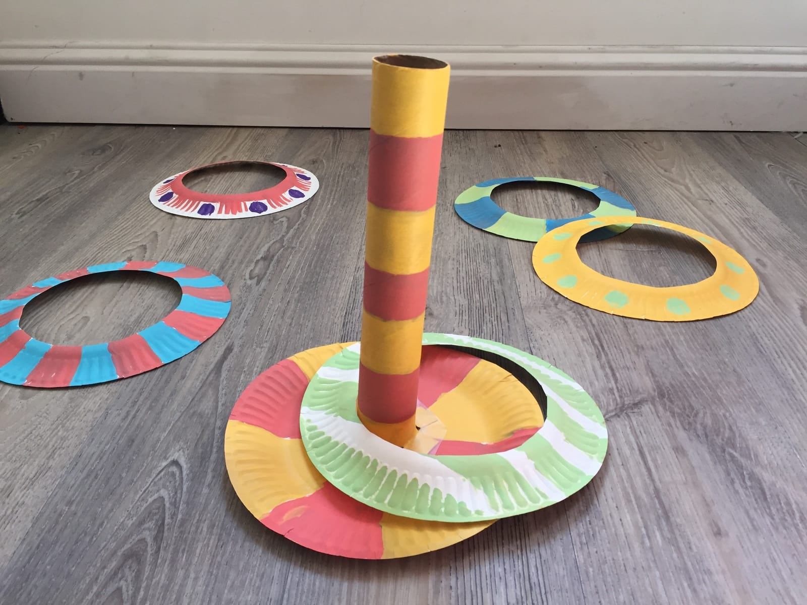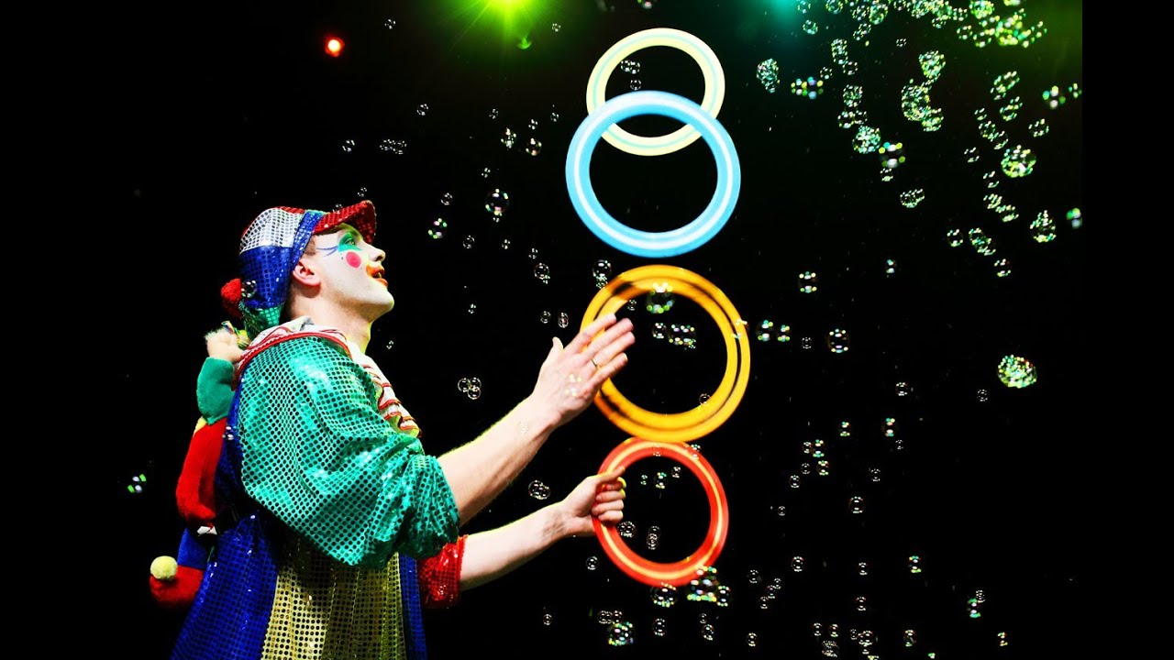  Task Helpful link to follow:  http://bigtopmania.co.uk/blog/circus-entertainment/  https://www.kiwico.com/diy/Arts-and-Crafts-Projects/1/project/Paper-Plate-Ring-Toss/2572  Keywords: Rings, Toss, Throw, Aim- Jobs Acrobat, Ringleader, Trapeze Artist, Clown, Juggler, Tightrope walker  Other optional ideas for wider learning:  Fairground games  You could make a coconut shy or Tin can Toss game-then use a ball or bean bag to knock them over  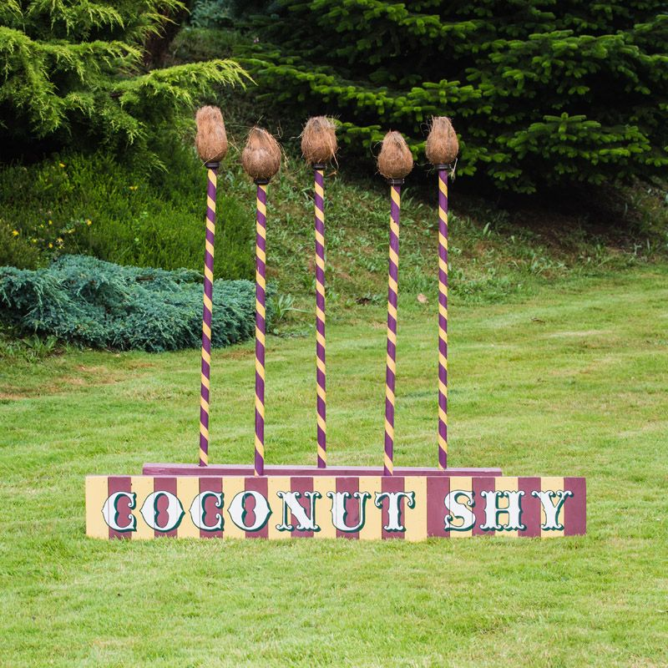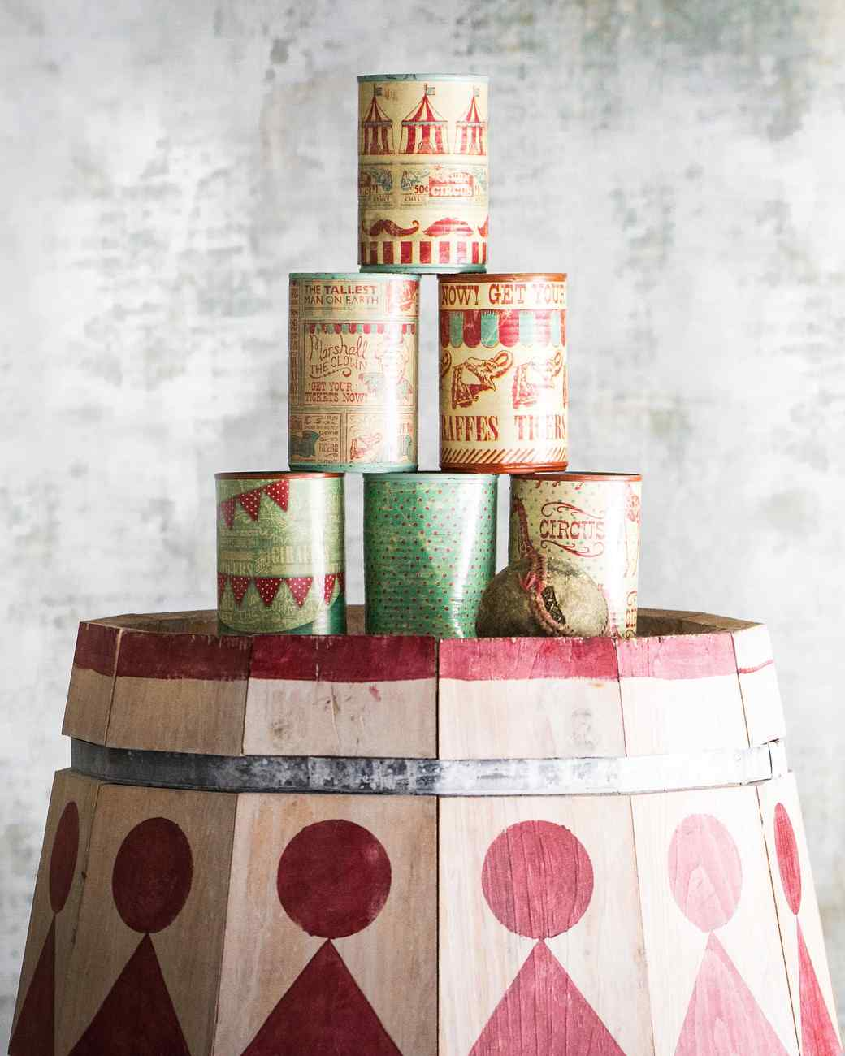  Colouring sheets-  Colour the Circus Career you would like to do  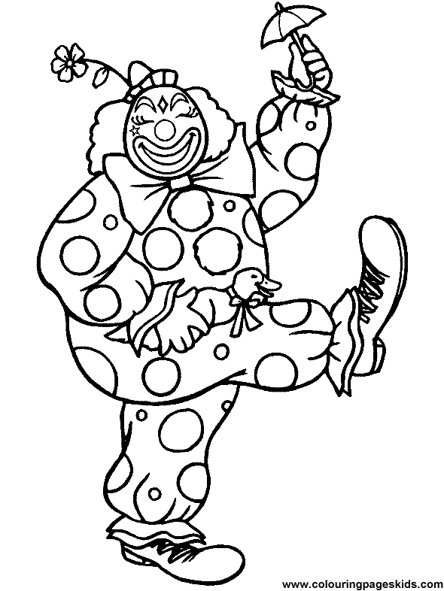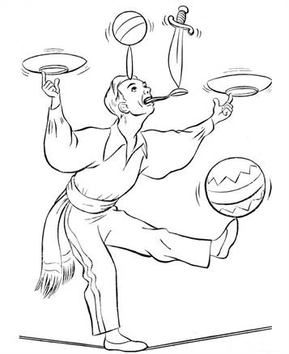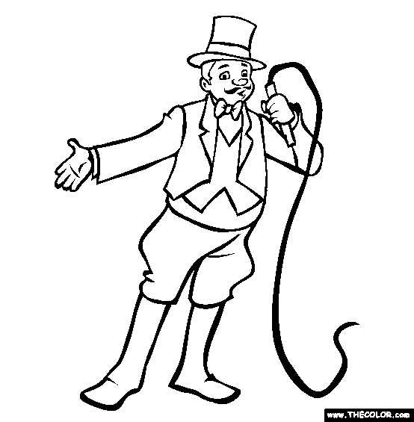  Act out being a hairdresser or another job  https://www.youtube.com/watch?v=xK_kHHYPLrI
Health and Wellbeing
Physical activity | The PE staff are uploading videos of circuits training or challenges every week. Have a look at this week’s videos and have a go.  https://www.youtube.com/channel/UCQVlu1D0XnL-bwjaXIzbZxQ/videos  ThisIsPE: Updated 3 times a week. Fun and easy activities to be done at home. https://www.youtube.com/results?search_query=thisisPE  Using ideas from the “This is PE” link, try and create your own game using things you can find at home. Write down the rules and play with your family. If you can, upload to Twitter and tag “@MeadowPE” so we can see it.  Nike Move Crew: Fun games and dance activities led by Nike athletes. https://www.youtube.com/results?search_query=nike+move+crew  Go Noodle I Get Moving: Lots of videos to get children moving, dancing and exercising with lots of music and singing. https://www.youtube.com/user/GoNoodleGames  Fitness Blender: Build your own circuit training session  https://www.fitnessblender.com/videos  Careers within the sports industry:  Photographer: Try and take a photo of someone performing a sporting activity. See if you can get the perfect “action shot”. If you can upload it to Twitter, tag @MeadowPE so we can see it.  If you can’t do this then take some photos of anything to do with sport. It can be equipment, clothes or places where you can play sports. Then maybe you can play around with some filters on your phone and make the photos even better!  Sports Journalist: Now that sport is back on the TV, watch some sport and write a review of what you have watched. Try to include players names and key moments within the games.  - Who was playing?  - What colour were the kits?  - What sport were they playing?  - What were their names?  - What was the score?  - What sport are they playing?  Personal Trainer: Start by watching the circuit training videos on the Meadow youtube then have a go at designing your own circuit. Challenge yourself more by trying to focus on specific areas of the body for different sport stars. You can use the Fitness Blender link above to help you.  Sports Nutritionist: Research and make a typical meal for sports people in these sports:  - Weight lifter  - Marathon Runner  - Swimmer  - Footballer  Which diet would you most like to have? What are the main differences between the diets? Why do you think that is?  Create a poster for the following components of food, giving their role and what sports they are useful for:  - Carbohydrate  - Protein  - Fat  - Fibre  - Vitamins & minerals  Dancer: After watching some “Nike Move Crew” or “Go Noodle” videos, can you plan your own set of moves into a dance sequence?  If you want to make it easier:  You could do a sequence of different animal positions. E.g. Tall giraffe, then small mouse etc.
Wellbeing  Useful links offering support and discussion:  https://youngminds.org.uk/    https://www.time-to-change.org.uk/   | This week's focus is: Make Time for Me  Resources:  ‘Wellbeing Make Time for Me activity’  ‘Wellbeing Resilience Exercise’  ‘Wellbeing Powerpoint’  Objectives:  • To encourage students to talk about mental health openly  • To make pupils aware there are ways we can look after our mental health  Work your way through this very reflective activity and think about taking some time out for you! These activities can be done individually or as a family.
Cross Curricular | PSHCE:  Task: Jobs for all learning pack  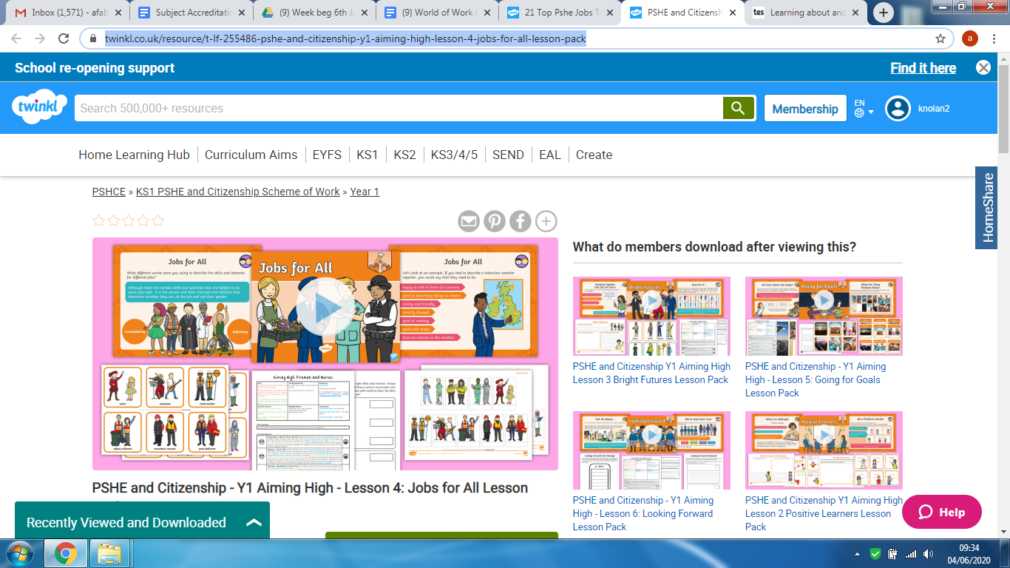  Link: https://www.twinkl.co.uk/resource/t-lf-255486-pshe-and-citizenship-y1-aiming-high-lesson-4-jobs-for-all-lesson-pack  Task: Bright Futures learning pack  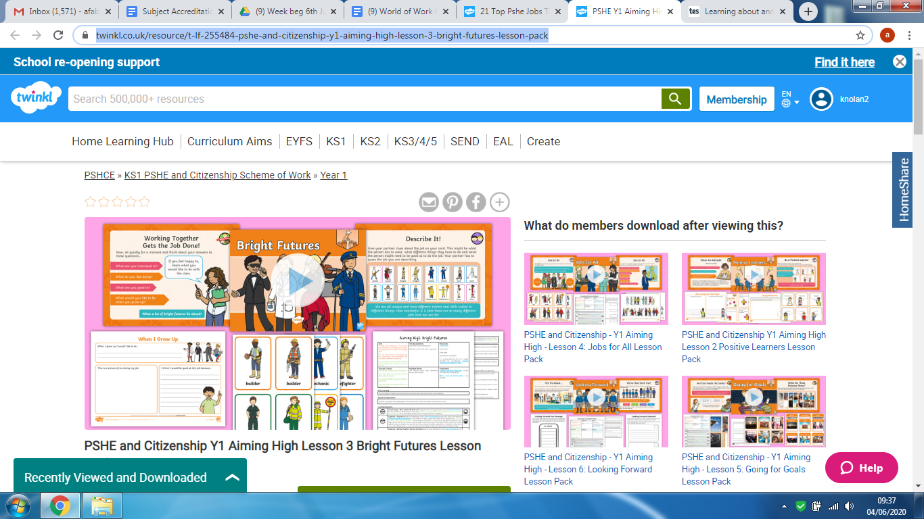  Link: https://www.twinkl.co.uk/resource/t-lf-255484-pshe-and-citizenship-y1-aiming-high-lesson-3-bright-futures-lesson-pack

