Aims: These tasks are designed to be done with your child. Green coloured tasks are aimed at pupils in the main body of the school. Tasks are a mixture of interactive tasks and tasks which build core skills. These are tasks we hope you will enjoy, please select the ones you feel are most appropriate.
Thinking
Literacy Focus: Build language and story sequencing skills making links between events and the character’s feelings. Develop close reading skills, using evidence from the text. Developing imagination and creativity through design challenge and extended writing task.  Signing & Communication Link: Zones of Regulation linked to feelings and language to talk about change and transition.  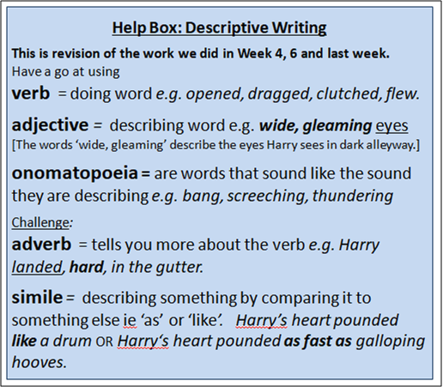  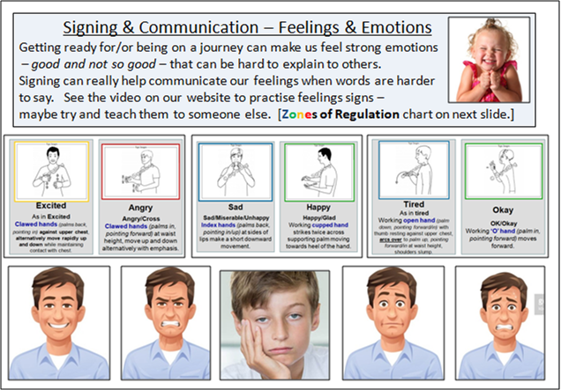 | Speaking & Listening, Reading + Writing:  Resources: range of video links in the powerpoint for  Horrid Henry, Go-Kart Challenge and Harry Potter the Knight Bus.  Powerpoints: W8 Transport Horrid Henry GREEN Text + Tasks as  W8 Transport Harry Potter the Knight Bus  Videos: Miss Barratt reading Horrid Henry’s Car Journey [3 x videos]  Mr. Brady reading Harry Potter the Knight Bus  Extension Work: Mrs. Sugden - Zones of Regulation + emotion signs  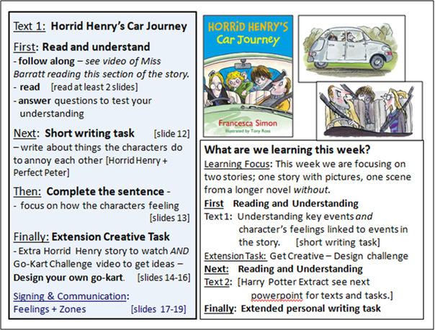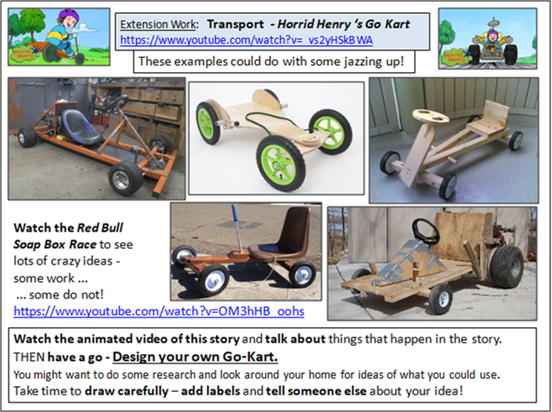  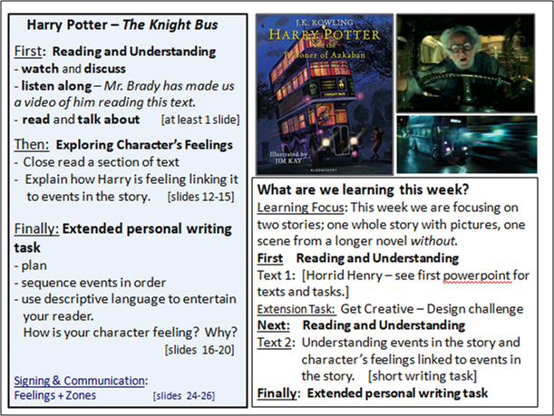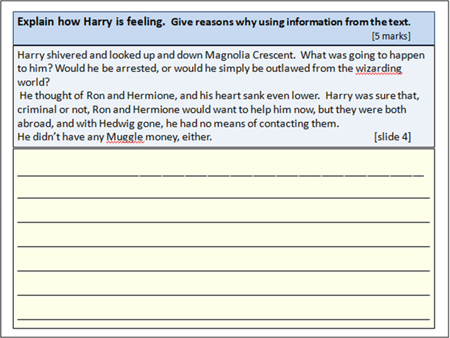  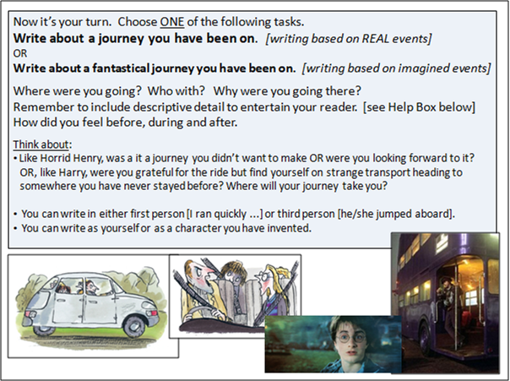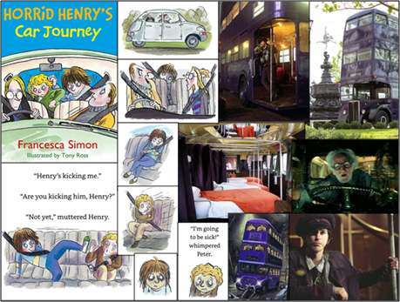
Maths Focus | - Transport survey  - When out on your daily exercise, take a look around and tally which different transport you see. Answer the questions below  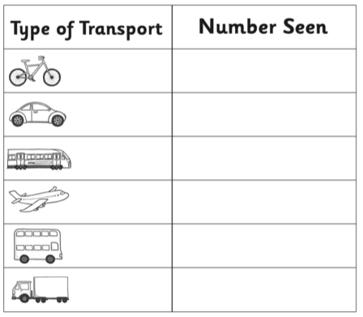  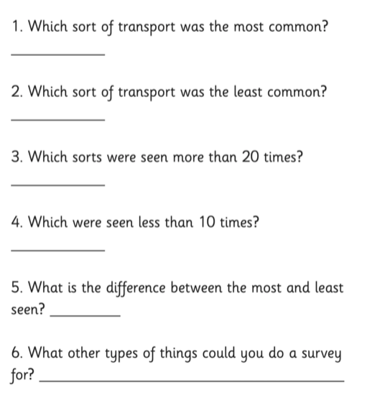  - Bus routes  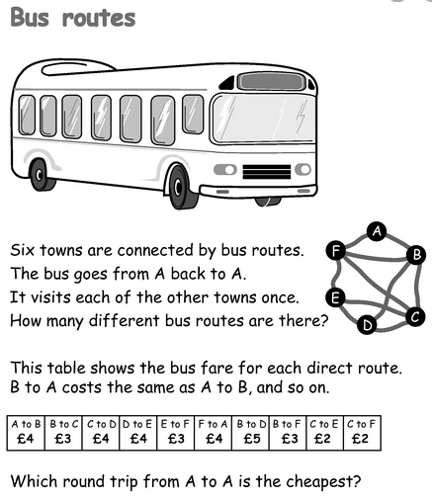  - Find the quickest walking route from:  - Edgware Road to Picadilly Circus  - Hyde Park Corner to Russell Square  - Temple to Chancery Lane  - Old Street to Euston  - Marble Arch to London Bridge  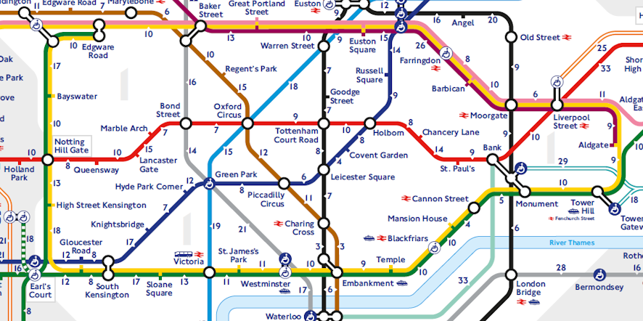  - Complete this transport puzzle  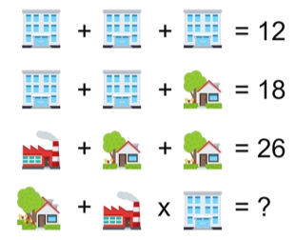  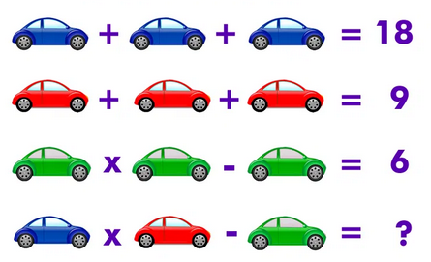
Science Focus | Task1: Design a zip line that can carry passengers  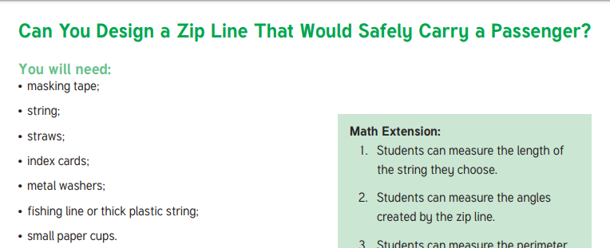  Link:ttps://www.twinkl.co.uk/resource/us2-s-45-zip-line-stem-teaching-ideas  Task 2: Bicycle riding aerodynamics - (please complete with adult’s agreement and supervision)  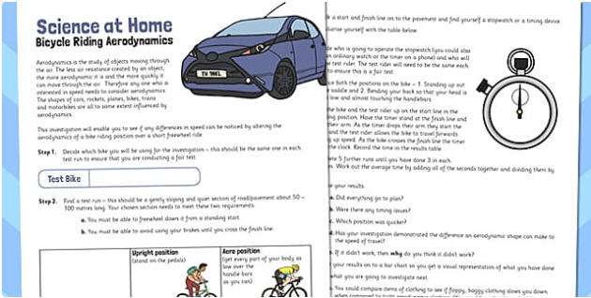  Link:https://www.twinkl.com/resource/t-he-050-bicycle-riding-aerodynamics-activity-sheet?sign_in=1  Task 3: Plasticine Boat Buoyancy - To build a plasticine boat and complete notes on upthrust.  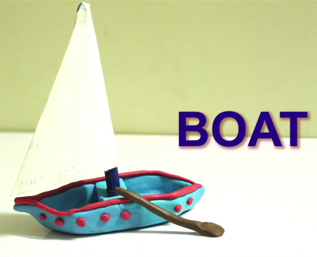  What to do: Build a boat out of plasticine that can support as many small objects as possible. Think about how you can make the plasticine float easily and how upthrust affects the boat.Experiment with different shape boats to find out which one works the best.  Key words: Boat, Float , Upthrust, Weight, Force, Sink  Equipment: Plasticine, Water, Little objects  Link:https://www.tes.com/teaching-resource/plasticine-boat-buoyancy-investigation-6162684  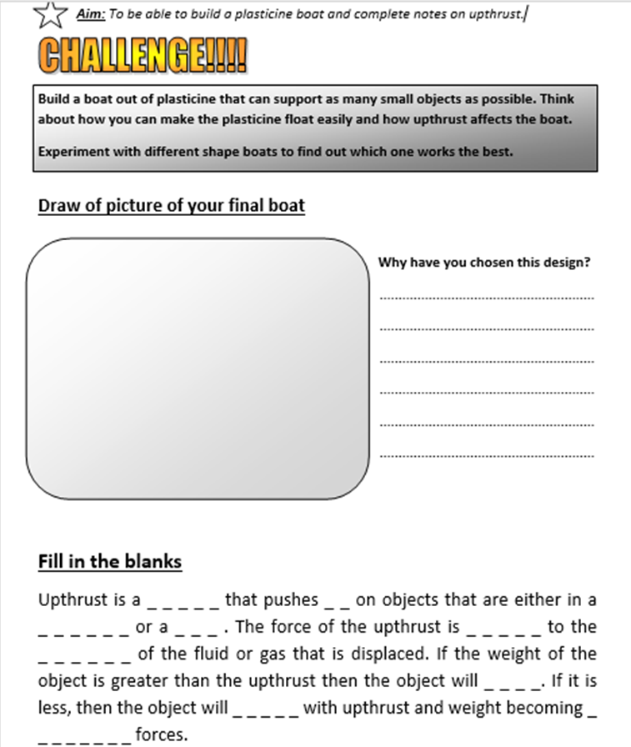
Cooking/Technology | Task: Make traffic lights “lollipops” snack! - This recipe is a fun chocolate treat that is simple to make.  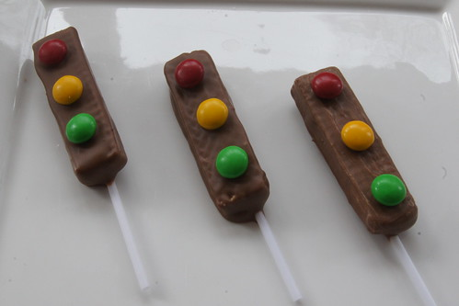  Link:https://planningwithkids.com/2012/09/30/traffic-light-party-treats/  Task: Computing - logo design - Social media is used to transport information all around the world, enabling people to keep up to date with the latest news and with each other.  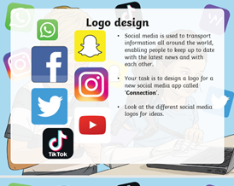  Your task is to design a logo for a new social media app called ‘Connection’. Look at the different social media logos for ideas.  Attached: PDF - Transport - Social media logo design  Task: Newspaper Article - Write a newspaper article about a modern form of transport powered by technology. Research and describe its features and how it transports people.  You can type this up using Word or design one by hand.  Remember to include a title, information and pictures.  Examples of modern transport: planes, trains and automobiles.
Drama/Arts/Music | Task Focus: Making transport from recycled materials  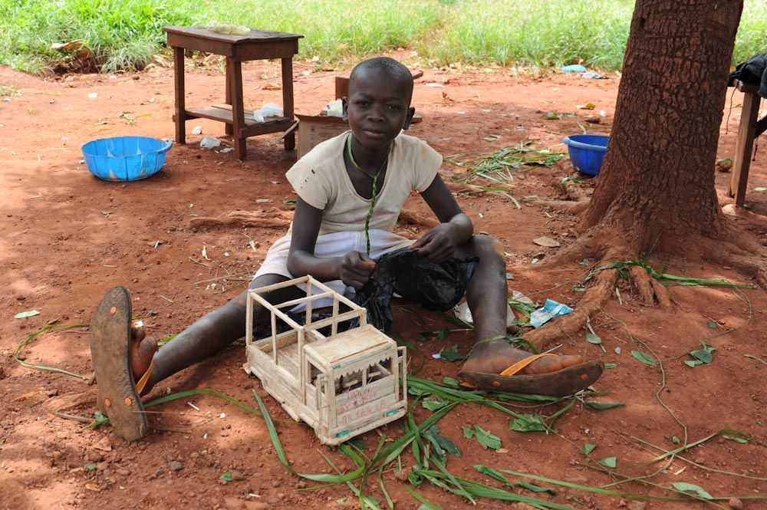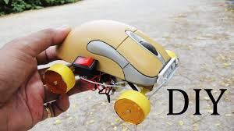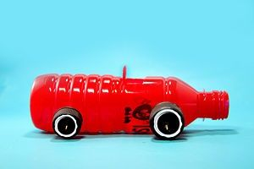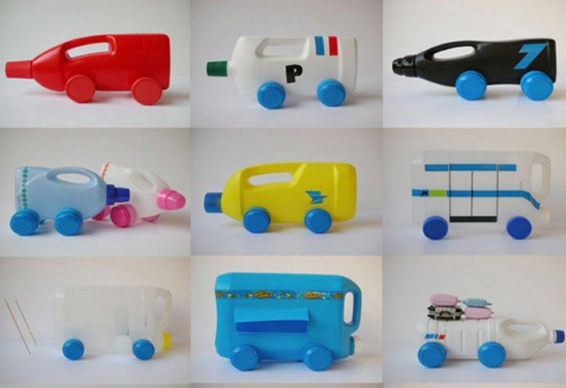  Task Helpful link to follow:  https://www.meadowhighschool.org/page/?title=Home+Engagement&pid=662  Key Information:  All over the world children make toy vehicles out of recycled packaging. Can you find items in your recycle bin and around the house that will help you make a vehicle. What can you use for the body? Do you need wheels or does it fly?  Use the link and pictures to help you decide what you want to make. You will need an adult to help you get started  You will need:  Packaging-bottles, lids, boxes, paper, card etc.. Cellotape, Scissors, Glue,  (you may wish to paint it at the end or add stickers)  Keywords: Recycled Materials, Vehicle, Wheels, Body, Plane Train Car Truck Lorry Bus  Instruction:  1. Pick what you will make  2.Find your materials and packaging.  3. Plan your design  4. Make the design  5. Play a guessing game, can you make the sounds of the transport? Then see if you can guess what the transport is?  6. Say what you did well.  Other Wider Learning  Task: Transportation crafts -  Making a paper/card Train Engine  https://www.youtube.com/watch?v=o87p1DLbAG8  https://www.youtube.com/watch?v=ek4xOGTnRRI  How to draw and paint a Lightning McQueen Car https://www.youtube.com/watch?v=S06iaW7Cq9wo  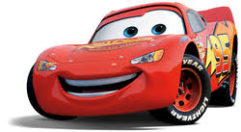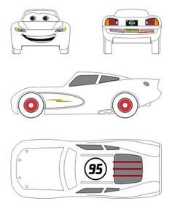  With Adult support!  How to make a toy plane from Lollipop sticks  https://www.youtube.com/watch?v=ur97l9Ci0mg  Make a Mobile car  https://www.youtube.com/watch?v=JwCzEcjqf1I
Health and Wellbeing
Physical activity | The PE staff are uploading videos of circuit training or challenges every week. Have a look at this week’s videos and have a go.  https://www.youtube.com/channel/UCQVlu1D0XnL-bwjaXIzbZxQ/videos  ThisIsPE: Updated 3 times a week. Fun and easy activities to be done at home. https://www.youtube.com/results?search_query=thisisPE  Using ideas from the “This is PE” link, try and create your own game using things you can find at home. Write down the rules and play with your family. If you can, upload to Twitter and tag “@MeadowPE” so we can see it.  Nike Move Crew: Fun games and dance activities led by Nike athletes. https://www.youtube.com/results?search_query=nike+move+crew  Go Noodle I Get Moving: Lots of videos to get children moving, dancing and exercising with lots of music and singing. https://www.youtube.com/user/GoNoodleGames  Measuring speed:  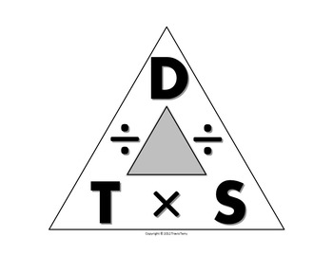  Distance, Speed, Time  - Measure a distance you want to run in metres. E.g. 10m, 5m or 200m. This could be in a room, garden or park.  - Get someone to time how long it takes you to run/walk that distance.  - Divide your distance by your time. E.g. 100m ➗ 9.58 seconds = 10.4m per second (Usain Bolt’s 100m world record!). This is your speed.  - Investigate what your speed is at different distances.
Wellbeing  Useful links offering support and discussion:  https://youngminds.org.uk/    https://www.time-to-change.org.uk/   | Make Time For Me  Task: To discuss the importance of speaking about mental health openly and think about how we can take care of our mental health and wellbeing.  Using the PDF and powerpoint discuss how we can make time for ourselves to do something that makes us feel good. Read through the Make Time for Me list. Explain that these are all ways that people can help themselves feel better when they’re feeling low or having a tough time. Some of them can help contribute to feeling more healthy physically and mentally (though, just as with physical health, sometimes people will get mental health problems even if they do all these things). Make a poster to include all the things you like to do that makes you feel good.  Links: https://www.time-to-change.org.uk/  How Many Positives  Individual/family task: In this task we want to think about all the positives we have to be grateful for. Use the PDF ‘How many positives’ to guide students and family through the activity.  Links: https://youngminds.org.uk/
Cross Curricular | PSHCE/ Geography: Travel and Tourism  Task: Travel and Tourism activity pack ( ppt, teaching ideas, worksheet)  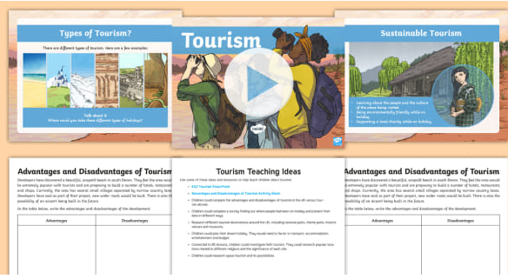  Link: https://www.twinkl.com/resource/ks2-tourism-resource-pack-t2-g-2567184

