Aims: These tasks are designed to be done with your child. Blue coloured tasks are aimed at Pathway 1 pupils as well as pupils who prefer more interactive activities and require a higher level of support. These are tasks we hope you will enjoy, please select the ones you feel are most appropriate for your child.
Thinking
Literacy Focus: Building language skills talking about and describing, reading practise [widget supported], sentence building, fine motor work, expressing a personal opinion. Letter sound skills [phonics]  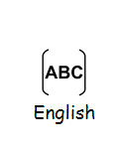  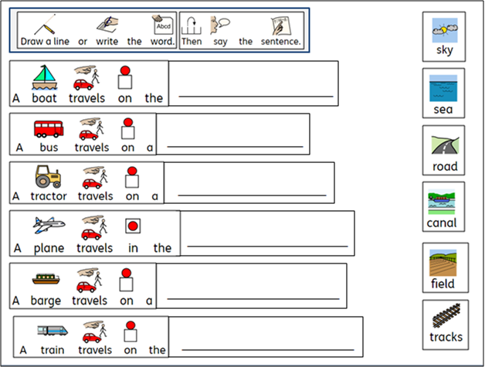  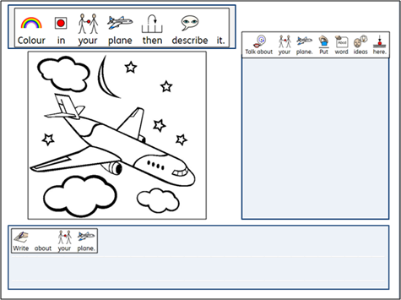  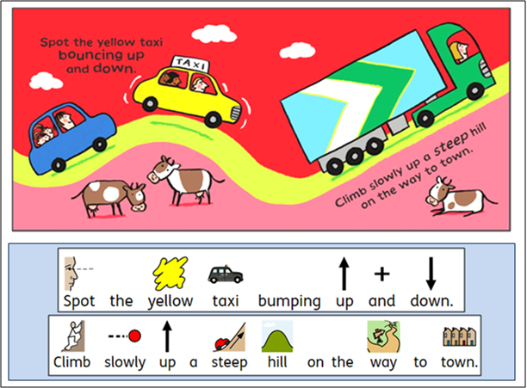 | Speaking, Listening & Communication, Reading and Writing:  Resources: links in the powerpoints to different types of transport to watch + talk about.  No internet, no problem - story and task sheets on the powerpoints below…  Powerpoints: W8 Transport Find and Sign BLUE fb [go for a walk and find]]  W8 Transport Story + Tasks BLUE as [signed story] W8 Big Digger ABC BLUE as [phonics]  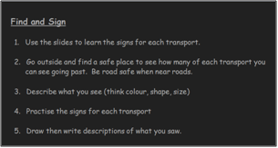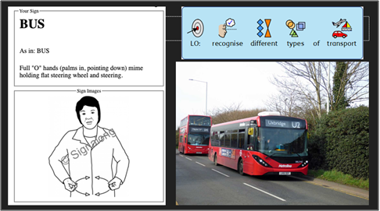  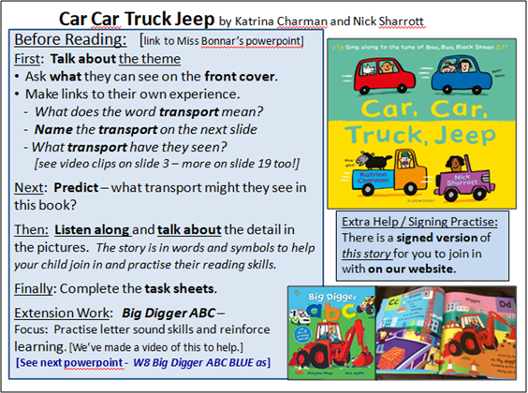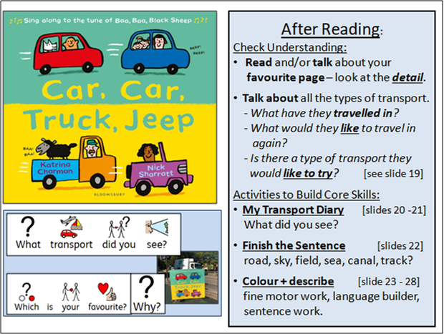  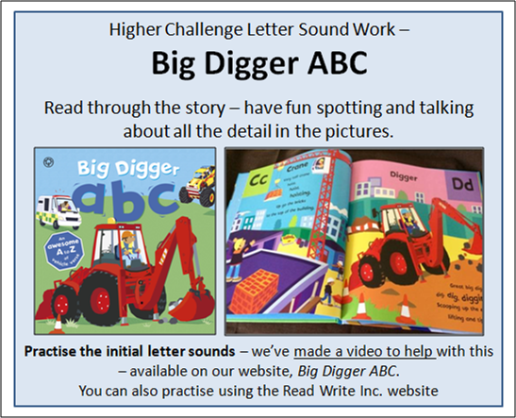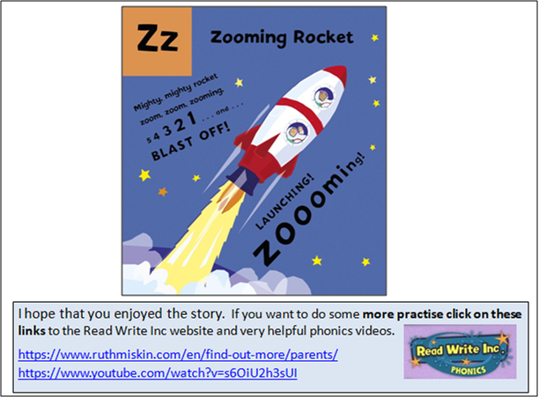
Maths Focus  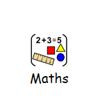 | - Watch the video about transport vehicles https://www.youtube.com/watch?v=B2S6g3OigmQ  - How many different vehicles have you seen?  - How many wheels does the bike have?  - How many wheels does the car have?  - How many passengers have you seen in the car?  - How many passengers have you seen on the bus?  - Which vehicle is the longest in length? Why?  - Watch the video (draw and paint a train): https://www.youtube.com/watch?v=-96ajr1P8BM  - What shapes can you see on the train?  - Draw your own train.  - Paint or colour your train.  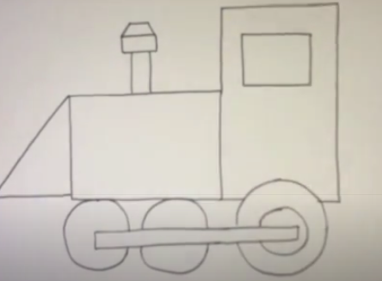  - Count the passengers  - How many passengers can you see on bus 1?  - At the next bus stop, 2 passengers got off. How many passengers left on the bus?  - At the next bus stop, 3 passengers got off, how many passengers left on the bus?  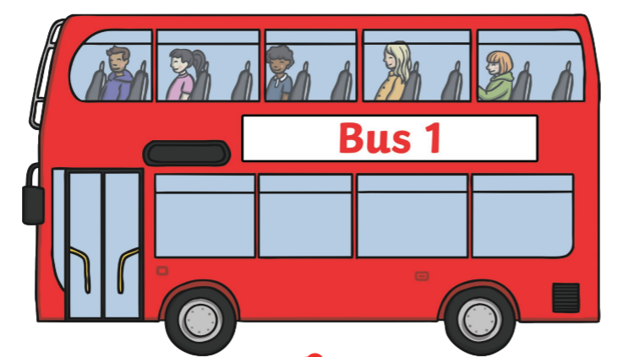  - Count the passengers  - How many passengers can you see on bus 2?  - At the next station, 2 more passengers got on the bus, how many passengers were on the bus altogether? At the next station, 3 passengers got off the bus, how many passengers left on the bus?  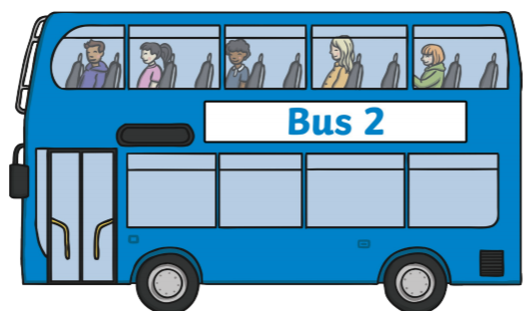  Which bus has the most passengers in the end? Which bus has the least passengers in the end?  - Transport addition  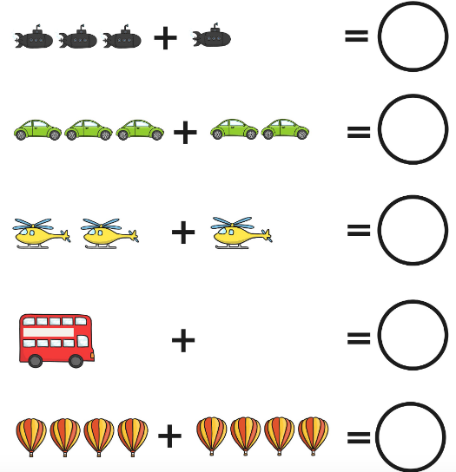
Science Focus  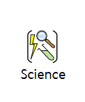 | Task 1: Balloon powered car experiment - A fun and hands-on science experiment. You could make 2 of these cars and race them! It contains details of what you will need, along with step-by-step instructions on how to carry it out. There is also a prompt card to promote discussion and exploration.  Key words: Balloon , Force , Air, Distance  Equipment: Toy Car, Straw, Balloon, Sticky Tape, Scissors  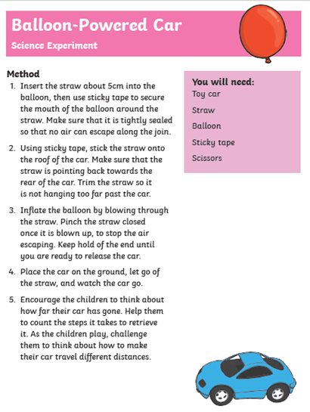Link:https://www.twinkl.co.uk/resource/t-t-2545520-eyfs-balloon-powered-car-science-experiment-and-prompt-card-pack-1  Task 2: How fast can a car go? - To find out how the height of a ramp affects the distance travelled by toy cars released from the top.  Starter:Watch the video clip below: https://www.youtube.com/watch?v=96fbm7XAFwg  What you will need:Toy cars,books or boxes, cardboard paper or a wooden plank  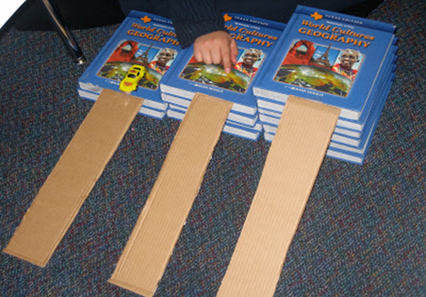  Plenary:  - Which car was the fastest? The one on 2 books or the on 5 books?--------------------------.  - Why did this happen?  - The car on two books was higher/lower so it went faster / slower. But the car on five books was higher/slower so it travelled faster/slower
Creativity
Cooking/Technology 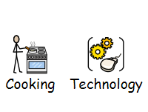 | Task: Make race car hot dogs! - Here is a fun, creative recipe that not only looks good but tastes yummy too. You can change the hot dog to a veggie alternative too.  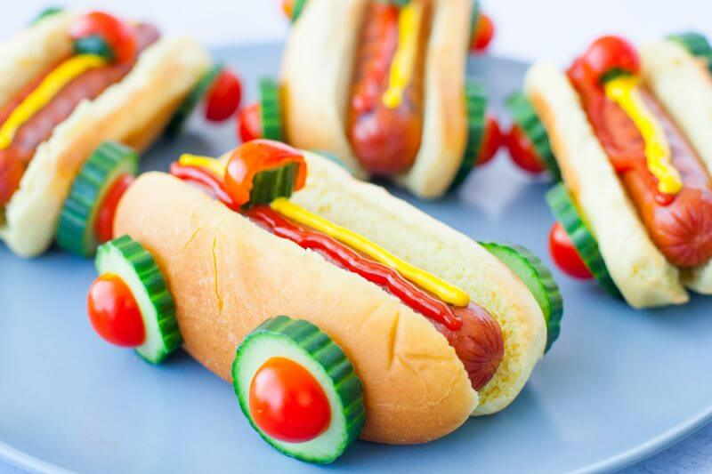  Link:https://eatingrichly.com/race-car-hot-dogs/  Task: Using PowerPoint and the Internet to copy and paste images  Aim: for pupils to search the internet for images of transport and create a Powerpoint presentation.  - Car  - Bike  - Bus  - Car  - Train  - Aeroplane  - Tram  Pupils to copy and paste images and create a page on PowerPoint for each mode of transport.  Pupils can also type the key features of each transport on each page.  Pupils can present their work to their family once complete.  Task: Using shapes on Word to make pictures - Pupils to use Word and insert shapes to create pictures of transport. Pupils to insert different shapes and then change the size of these and fit them together to make different modes of transport.  Task:Cooking Skills - Practise knife skills by copying some of these transport themed foods. Be careful. Always have an adult with you.  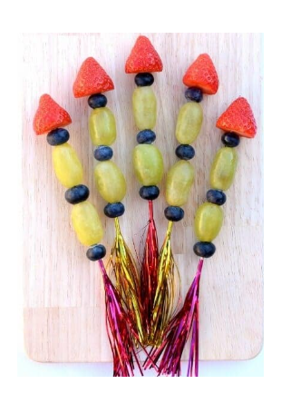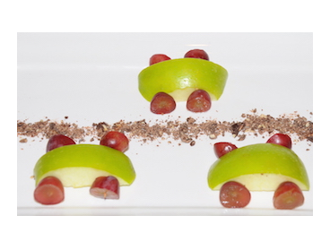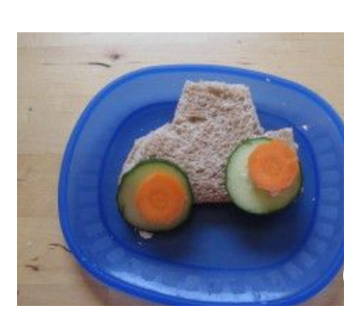
Drama/Arts/Music  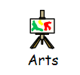 | Task Focus: Making a newspaper hot air balloon.  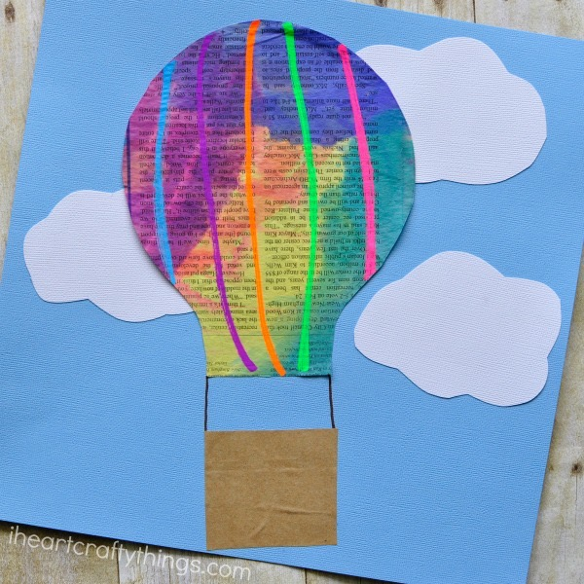  Task Helpful link to follow:  https://iheartcraftythings.com/newspaper-hot-air-balloon-craft-for-kids.html  Key Information:  Have you ever been up in a hot air balloon? Although I’m not sure I could handle the heights, I’ve always dreamed of how fascinating the experience would be. The watercolour painted newspaper hot air balloon craft for kids is so cute and perfect for summer. Kids will love getting creative by drawing unique and special designs on their hot air balloon craft.  You will need:  · Newspaper  · Liquid watercolours (but any paint will do)  · Paintbrush  · Blue and white card (if you have different colours make it a fantasy style)  · Brown paper lunch bag.  · Fun chalk markers or felt pens  · Scissors  · Glue  Keywords: hot air balloon, newspaper  Instruction:  1. Start by painting your newspaper with your liquid watercolours. Let the newspaper dry overnight. When it is dry, cut out a hot air balloon shape.  2. Cut clouds out from your white cardstock paper and glue them onto your blue cardstock paper. Then glue your hot air balloon top onto your paper on top of the clouds.  3. Cut a hot air balloon basket out of your brown paper lunch bag and glue it under your hot air balloon. Use your brown marker pen to connect the hot air balloon and basket.  4. Finish your craft by using your Fun Chalk Markers or felt pens to decorate your hot air balloon.  Other Wider Learning  Task: Transportation crafts -  Link: https://www.dltk-kids.com/crafts/transportation/crafts.html  https://youtu.be/Jv22CKVJSas Vehicles Transportation Song for blue  https://youtu.be/okq0ux8de70 Wheels on the Bus and Vehicles
Health and Wellbeing
Physical activity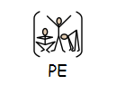 | The PE staff are uploading videos of circuit training or challenges every week. Have a look at this week’s videos and have a go.  https://www.youtube.com/channel/UCQVlu1D0XnL-bwjaXIzbZxQ/videos  Now that you have worked really hard to make your hot air balloon why not do this fantastic hot air balloon breathing exercise with lots of fun yoga moves. Follow the link below and turn your living room into a yoga disco!!!  https://youtu.be/dtQ72qRpVVE  ThisIsPE: Updated 3 times a week. Fun and easy activities to be done at home. https://www.youtube.com/results?search_query=thisisPE  Using ideas from the “This is PE” link, try and create your own game using things you can find at home. Write down the rules and play with your family. If you can, upload to Twitter and tag “@MeadowPE” so we can see it.  Nike Move Crew: Fun games and dance activities led by Nike athletes. https://www.youtube.com/results?search_query=nike+move+crew  Go Noodle I Get Moving: Lots of videos to get children moving, dancing and exercising with lots of music and singing. https://www.youtube.com/user/GoNoodleGames  Changing Gears:  1st gear: slow walk; 2nd gear: fast walk; 3rd gear: jog; 4th gear: run; 5th gear: sprinting; Handbrake: freeze.  In an open area you must move around at the speed of whichever gear is called out to you. You should see the different speeds you can move at. Make sure you avoid obstacles and other people.
Cross Curricular | PSHCE: Safety using transport  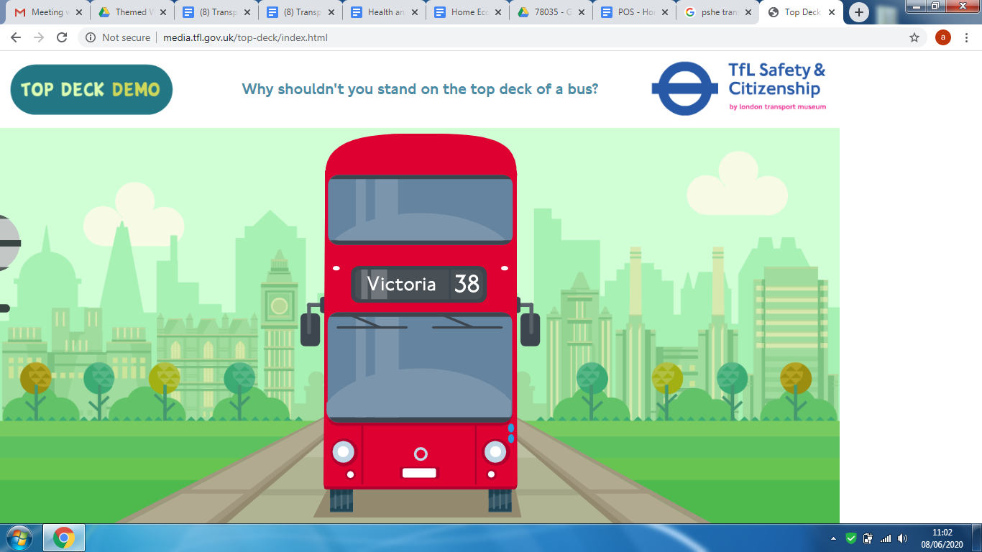  Task 1: Find out why we ask you not to stand upstairs on a bus  Link: http://media.tfl.gov.uk/top-deck/index.html  Task 2: Explore making safer choices about how far back to wait when using public transport  Link: http://media.tfl.gov.uk/waiting-distance/index.html

