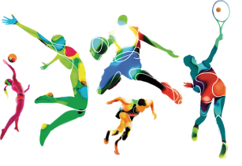

WORLD OF SPORT
Aims: These tasks are designed to be done with your child. Purple coloured tasks are aimed at pupils who would enjoy more of a challenge . These are tasks where pupils should be working with greater independence, however please take time to support pupils in starting the tasks and build communication skills.
Thinking
Literacy Focus: To build skills close reading, annotating and identifying the writer’s choice of language, linking this to the purpose of the text. [Fiction and Non-Fiction texts.]  To express an opinion using evidence from a text(s).  To build skills using language appropriately to write for different purposes.  To build understanding of how to debate a subject appropriately.  Debate= a formal discussion on a particular matter.  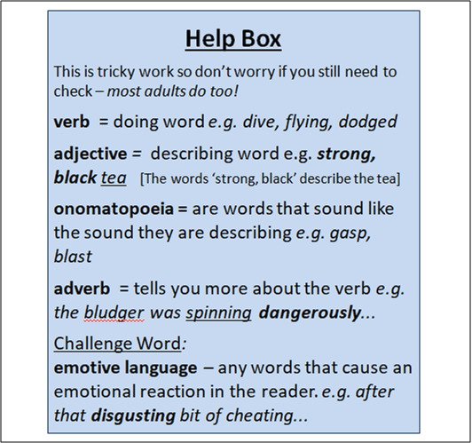  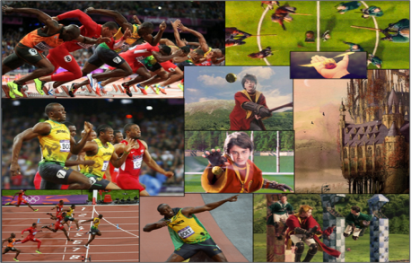 | Speaking & Listening and Reading Comprehension:  Resources: Powerpoints W7 WoS ReadDiscuss + Compare PURPLE as  W7 WoS Writing A Commentary PURPLE as  Harry Potter Quidditch Match https://www.youtube.com/watch?v=7mFyxsHIThM  https://www.youtube.com/watch?v=-uK5LDkET-Q  Sports Commentary https://www.youtube.com/watch?v=LWZQAVtkMBo  London 2012 Olympics Highlights https://www.youtube.com/watch?v=gKJDjg4ebNQ  Videos - Mr. Brady reading Harry Potter Quidditch match  Mrs. Sugden reading and signing a short picture story The Frog Olympics  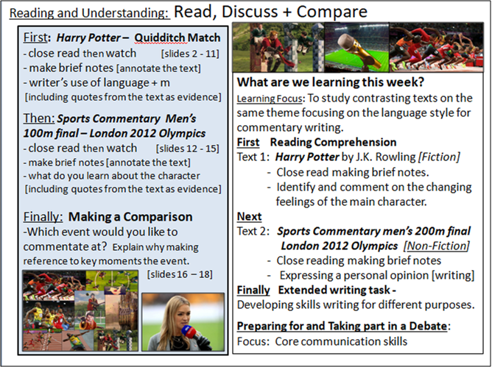  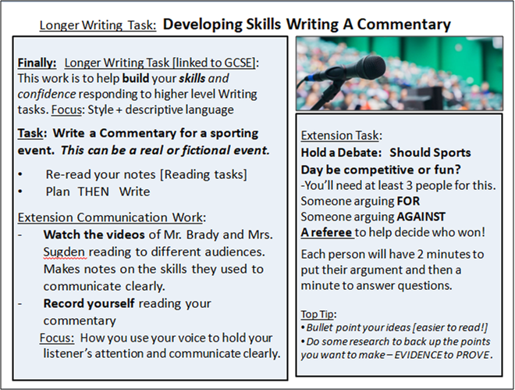
Maths Focus | - Complete this maths challenge booklet! Download the PDF document attached  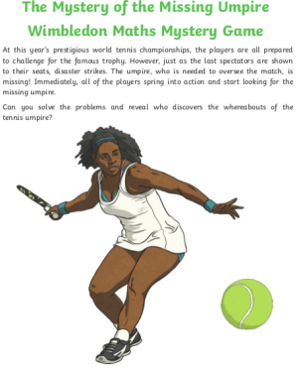  - Calculate the area and perimeter - worksheet  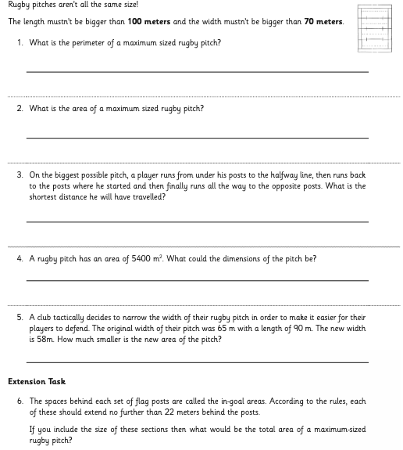  - Corbett Maths - writing numbers in words. Download PDF  - Corbett Maths - using calculations. Download PDF
Science Focus | Task: Test your dominant side - Check out this cool experiment that will teach you more about how your body and brain work together.  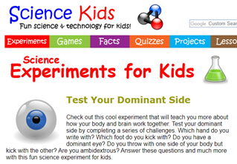  Link:https://www.sciencekids.co.nz/experiments/dominantside.html  Task: Sporty Science Ideas - Here is a link of some sporty science ideas for you to give a try.  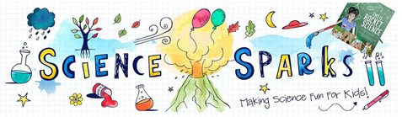  Link: https://www.science-sparks.com/sports-science/
Cooking/Technology | Task: Healthy Eating Recipes - This recipe pack has a number of healthy recipe ideas to support teaching on healthy eating and nutrition, whilst giving pupils an opportunity to have fun and be creative producing healthy meals. You can choose from recipes like Pumpkin Soup,Banana Boat, Owl on Toast and much more.  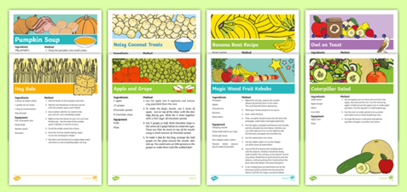  Link:https://www.twinkl.co.uk/resource/cfe-p-214-healthy-eating-recipe-ideas-resource-pack  Task: Redesign the Olympic Game Logo - Why not get creative and design your very own Olympic games logo and motto while reflecting on the origins and meanings of the official symbols of the event.  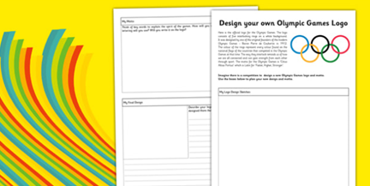  Attachment:PDF-Redesign the olympics game logo - Purple
Drama/Arts/Music -CK | 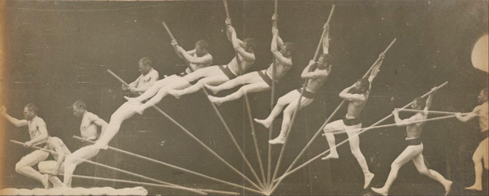  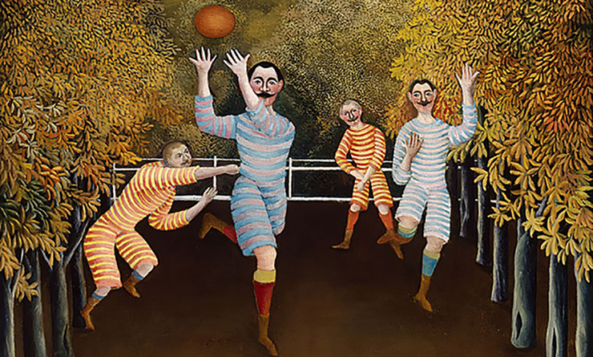  Task Focus: Investigating Movement in painting and Photography .  Task Helpful link to follow:  https://fineartamerica.com/art/paintings/sports  Key Information:  Over the last Century artists have tried to show movement in their paintings and photography. Sport is a popular topic for this.  - Look at the link and discuss your favourite pictures. What sports can you see in the artwork? How can movement be seen, is it in body movement, are there blurry lines, or repeated images?  - Have a go acting out different sports with some friends or family  - Pretend you are a sports photographer-Take a photo or pretend to take a photo of your friends/family acting a sport when they are in a great action position  - See if you can quickly sketch someone in different sports poses?  You will need:Paper, Pencils, colour pencils  Keywords: Movement Actions Pretend Sport Sketch Draw loose Line Blurry Images  Other optional ideas for wider learning:  Play sports charades- someone acts the sport and the others take turns to guess what sport it is.  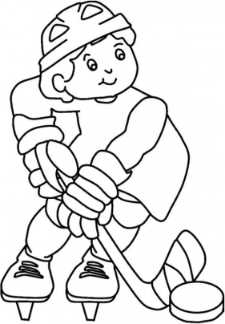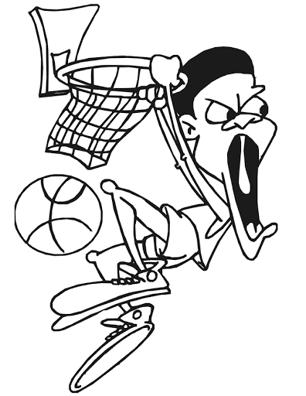  Or design your own sports character
Health and Wellbeing
Physical activity | ThisIsPE: Updated 3 times a week. Fun and easy activities to be done at home. https://www.youtube.com/results?search_query=thisisPE  Using ideas from the “This is PE” link, try and create your own game using things you can find at home. Write down the rules and play with your family. If you can, upload to Twitter and tag “@MeadowPE” so we can see it.  Nike Move Crew: Fun games and dance activities led by Nike athletes. https://www.youtube.com/results?search_query=nike+move+crew  Fitness Blender: Build your own circuit training session  https://www.fitnessblender.com/videos  Coordination Test  Stand three feet away from a smooth and solid wall. Throw the ball with one arm, in an underarm action at the wall. Catch it with the opposite hand as it bounces back at you. Throw it back at the wall with that hand and catch with the opposite. Repeat. Count how many successful catches you achieve in 60 seconds.  Check out the ‘Youtube channel - Meadow High School Hello’. See if you can beat the staff at the test.  Homeschool Olympics  There are 10 different events for you to have a go at. In each event you will have the opportunity to win Bronze, Silver or Gold depending on your score. Let’s see how many medals you can win.  You can even challenge someone else in your household.  If you do not have a measuring tape available, you can count up the distance using a shoe.  Let us know how you get on.  Event 1 – Plank.  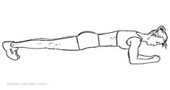  Using a floor space try and see how long you can hold the plank position for?  Bronze: 0 – 30 seconds.  Silver: 30 – 60 seconds.  Gold: 60 seconds plus.  Event 2 – Speed Bounce.  Using an item at home to make a line on the floor (roll up a t-shirt or a pair of trousers). Using both feet together try to jump over that line as many times as you can in 30 seconds.  Bronze: 0 – 15 seconds  Silver: 15 – 30 seconds  Gold: 30 plus seconds  Event 3 – Long Jump.  Stand behind a marked outline with feet slightly apart. A two-foot take-off and landing is used, with swinging of the arms and bending of the knees to provide forward drive. Jump as far as possible, landing on both feet without falling backwards. Three attempts are allowed  Bronze:0 – 0.5 meter.  Silver:0.5 – 1.5 meters.  Gold: 1.5 plus meters  Event 4 – Throw and catch.  Roll up a pair of socks into a ball-like shape. Throw the socks in the air and count how many times you are able to clap your hands and successfully catch the socks.  Bronze: 0 – 3 claps.  Silver: 3- 6 claps.  Gold: 6 plus claps.  Event 5 – Star Jumps.  See how many star jumps you can perform in 60 seconds.  Bronze: 0 – 20  Silver: 20 – 50  Gold: 50 plus.  Event 6 – Stork Stand.  Remove the shoes and place the hands on the hips, then position the non-supporting foot against the inside knee of the supporting leg. The stopwatch is started as the heel is raised from the floor.  Bronze: 0 – 10 seconds.  Silver: 10 – 30 seconds.  Gold: 30 seconds plus.  Event 7 – Compass.  Choose 4 items found in the house to mark out a 4 point compass (N,S,E,W). Once you have the 4 points, get someone to call out the names of those items and see how fast you can touch them and return back to the middle of the compass. Keep calling them and see how many touches you make in 30 seconds.  Bronze: 0 - 10  Silver: 10 – 20  Gold: 30 plus  Event 8 – Pillow throw.  Sit on the floor back straight. Hold the pillow against your chest. Then using a push motion see how far you can throw the pillow in a forward direction.  Bronze: 0 – 2 meters.  Silver: 2- 4 meters.  Gold: 4 meters plus.  Event 9 – Balance book on head.  You can either stand up or sit down. See how many books you are able to balance on your head for at least 5 seconds.  Bronze: 0 – 2 books.  Silver: 2 - 4 books.  Gold: 5 plus books.  Event 10 – Target throw.  Create a target using an item from your house (jumper, t-shirt). Roll up a pair of socks into a ball-like shape. See how far you can stand and throw the socks to land on the target.  Bronze: 0 – 2 meters.  Silver: 2-4 meters.  Gold: 4 plus meters.
Cross Curricular
PSHCE | https://www.twinkl.co.uk/resource/passport-template-ks1-t-t-1078  “All About Me” We would like to gather some information about you including your name, birthday, family information, favourite things and things you enjoy doing. This passport can be completed with other household members and try to think about your likes, favourite activities and things you are proud of… perhaps it is a sporting achievement?  If you have a passport from another country and wish to use a different template, please do! Twinkl has loads of templates, or you could even make your own.
Geography | Task 1:  https://www.twinkl.co.uk/resource/t-t-123-design-a-flag In Geography we do lots of work on where we come from and learn all about our countries and cultures. For your Geography task, we would like you to imagine you are off to the olympics. You can create your own country and flag to represent your team. Perhaps your country even has its own sport they play?  Task 2:  https://www.twinkl.co.uk/resource/nz-ss-49-about-my-special-country-activity  Now you have your own flag for your country, can you complete this ‘About My Country’ fact sheet and tell us a little bit about it?

