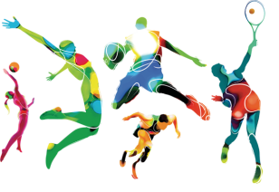
WORLD OF SPORT
Aims: These tasks are designed to be done with your child. Blue coloured tasks are aimed at Pathway 1 pupils as well as pupils who prefer more interactive activities and require a higher level of support. These are tasks we hope you will enjoy, please select the ones you feel are most appropriate for your child.
Thinking
Literacy Focus: Build story sequencing making links to personal experiences. Language building skills - preposition practise linking to social distancing rules.  Links to PE HomeSchool Olympics!  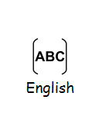  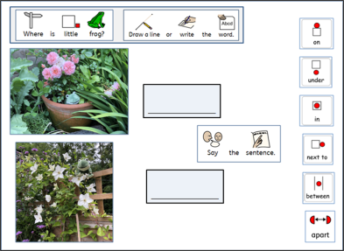  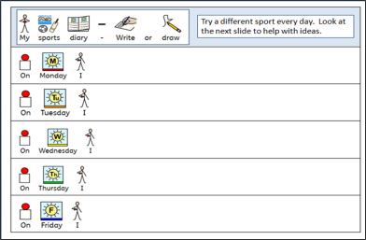  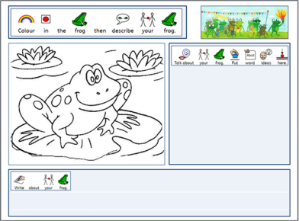 | Speaking, Listening & Communication, Reading and Writing:  Resources: Getting Ready https://www.youtube.com/watch?v=Im-hXlYTPSg  Story https://www.youtube.com/watch?v=gKJDjg4ebNQ  No internet, no problem - story and task sheets on powerpoint below…  Powerpoint W7 WoS The Frog Olympics BLUE as and a favourite toy  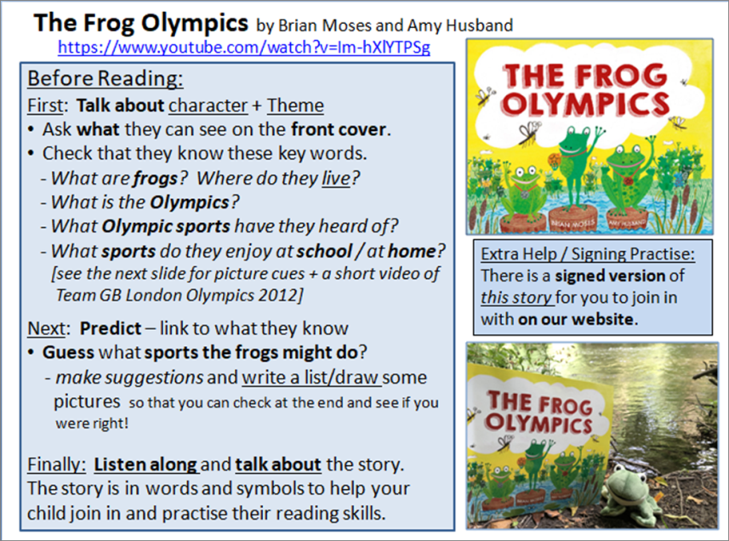  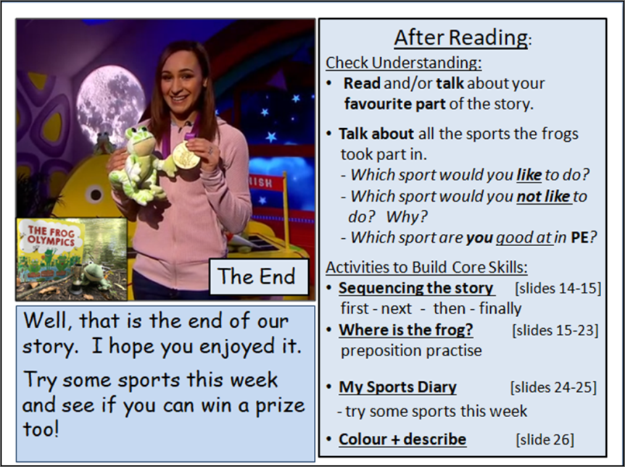
Maths Focus  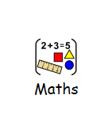 | - Answer these challenge questions!  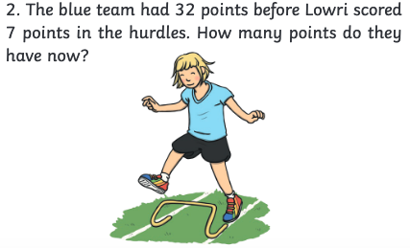  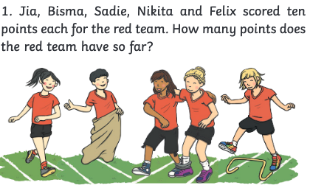  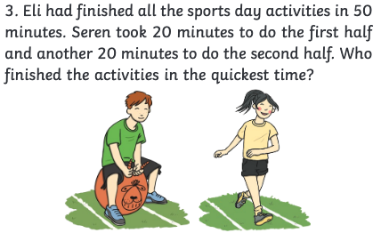  - Mark a straight line on the floor.  - Count how many times you can jump forwards and backwards without stopping.  - Can you keep jumping for 1 minute? (Remember: 1 minute = 60 seconds)  - Have you tried to jump higher?  - Have you tried to jump slower or faster?  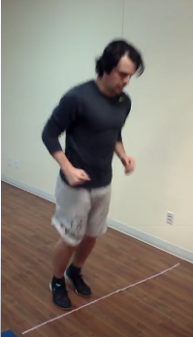  - Yoga poses - try the below yoga poses:  - Can you hold each pose for 10 seconds?  - Can you hold each pose for 20 seconds?  - Can you hold each pose for 1 minute?  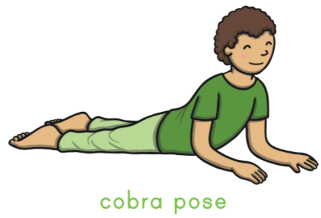  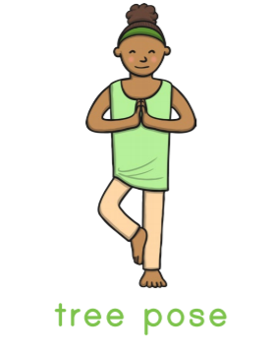  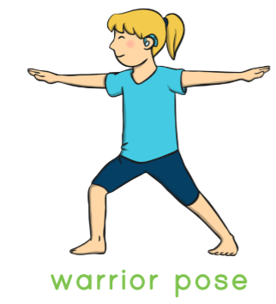  - Star jumps  - Count how many star jumps you can do in 30 seconds.  - Who did the most? Who did the less?  - Try again, can you jump faster? Compare your results. Have you done more jumps this time?  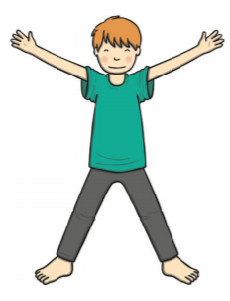  - High knees  - Start doing high knees with your buddy. Who can get his knees higher? Compare.  - Try again, count how many high knees you can do before you get tired. Record your results and compare the numbers with your buddy.  - This time, try to hold one of your knees. How long can you hold it?  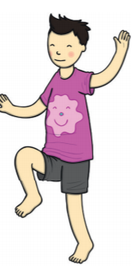
Science Focus  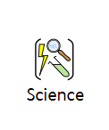 | Task: Design and Test a Parachute - Learn about air resistance while making an awesome parachute! Design one that can fall slowly to the ground before putting it to the test, making modifications as you go.  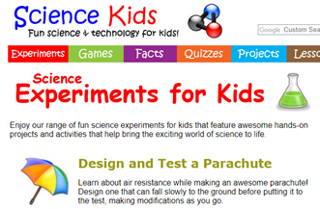  Link: https://www.sciencekids.co.nz/experiments/freefall.html  Task: Making your own sport equipment - Do you play or watch a sport where you use something (other than your hands or feet) to hit a ball? Golf, baseball, tennis, hockey—there are many different sports where players use something to hit a ball or a puck. In this activity you will design, build, and test your own sports equipment made from recycled materials.  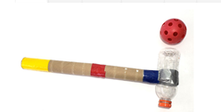  Link:https://www.sciencebuddies.org/stem-activities/make-sports-equipment#instructions
Creativity
Cooking/Technology 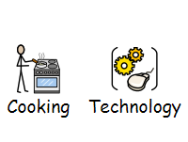 | Task: Healthy Strawberry Smoothies - These are simple and healthy smoothie recipes to make with a punnet of strawberries! Recipes require limited ingredients and equipment  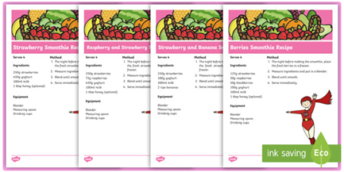  Attached: PDF - Strawberry Smoothies Recipe  Task: Foods from around the World - This fantastic matching activity gives your children the opportunity to match the different kinds of food with the country they think it's from!  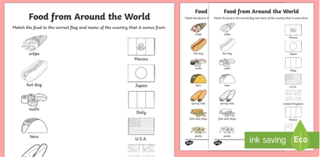  Attached: PDF - Foods from around the world matching activity - Blue  Task: Making OREO Basketball Pops - This is a fun, simple but effective recipe keeping in the theme of sports.  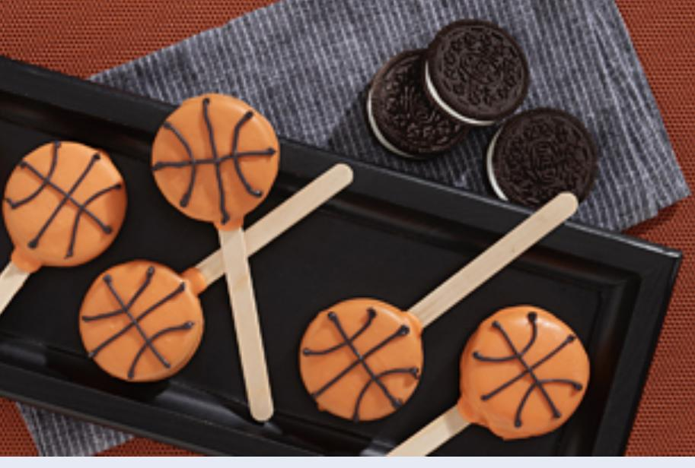  Link:https://www.snackworks.com/recipe/oreo-basketball-pops-194820.aspx  Keywords: Insert, Microwave, Dip, Cut
Drama/Arts/Music -CK  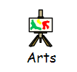 | Task Focus: Making a crafty trophy.  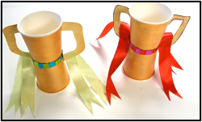  Task Helpful link to follow:  https://www.youtube.com/watch?v=Y0s5hXOYO6A  Key Information:  Trophies are a great way to make your event more memorable, especially if there is a competition and a prize to be won. Instead of buying a plain trophy from the store, however, you could make a personalized one using materials from around the house.  You will need:  · Paint  · Tape and/or glue  · Scissors  · Paper cups  · Card  · Ribbon  · Sequins  Keywords: trophy, competition, prize, sequin, ribbon.  Instruction:  1. Paint your paper cups.  2. From the card, cut out your handles.  3. Paint them and leave them to dry.  4. When dry stick both of your cups together.  5. Add your sequins.  6. Stick on your handles.  7. Stick on your ribbon.  Other optional ideas for wider learning:  Achievement is a big word! Trophy is one way to show our achievement. Follow the link below to find out about different ways of achieving things.  https://www.bbc.co.uk/bitesize/topics/zh3nmfr/articles/zvngf4j
Health and Wellbeing
Physical activity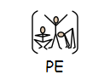 | ThisIsPE: Updated 3 times a week. Fun and easy activities to be done at home. https://www.youtube.com/results?search_query=thisisPE  Using ideas from the “This is PE” link, try and create your own game using things you can find at home. Write down the rules and play with your family. If you can, upload to Twitter and tag “@MeadowPE” so we can see it.  Nike Move Crew: Fun games and dance activities led by Nike athletes. https://www.youtube.com/results?search_query=nike+move+crew  Go Noodle I Get Moving: Lots of videos to get children moving, dancing and exercising with lots of music and singing. https://www.youtube.com/user/GoNoodleGames  Coordination Test  Stand three feet away from a smooth and solid wall. Throw the ball with one arm, in an underarm action at the wall. Catch it with the opposite hand as it bounces back at you. Throw it back at the wall with that hand and catch with the opposite. Repeat. Count how many successful catches you achieve.  Check out the ‘Youtube channel - Meadow High School Hello’. See if you can beat the staff.  Homeschool Olympics  There are 10 different events for you to have a go at. In each event you will have the opportunity to win Bronze, Silver or Gold depending on your score. Let’s see how many medals you can win.  You can even challenge someone else in your household.  If you do not have a measuring tape available, you can count up the distance using a shoe.  Let us know how you get on.  Event 1 – Plank.  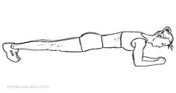  Using a floor space try and see how long you can hold the plank position for?  Bronze: 0 – 30 seconds.  Silver: 30 – 60 seconds.  Gold: 60 seconds plus.  Event 2 – Speed Bounce.  Using an item at home to make a line on the floor (roll up a t-shirt or a pair of trousers). Using both feet together try to jump over that line as many times as you can in 30 seconds.  Bronze: 0 – 15 seconds  Silver: 15 – 30 seconds  Gold: 30 plus seconds  Event 3 – Long Jump.  Stand behind a marked outline with feet slightly apart. A two-foot take-off and landing is used, with swinging of the arms and bending of the knees to provide forward drive. Jump as far as possible, landing on both feet without falling backwards. Three attempts are allowed  Bronze:0 – 0.5 meters.  Silver:0.5 – 1.5 meters.  Gold: 1.5 plus meters  Event 4 – Throw and catch.  Roll up a pair of socks into a ball-like shape. Throw the socks in the air and count how many times you are able to clap your hands and successfully catch the socks.  Bronze: 0 – 3 claps.  Silver: 3- 6 claps.  Gold: 6 plus claps.  Event 5 – Star Jumps.  See how many star jumps you can perform in 60 seconds.  Bronze: 0 – 20  Silver: 20 – 50  Gold: 50 plus.  Event 6 – Stork Stand.  Remove your shoes and place the hands on the hips, then position the non-supporting foot against the inside knee of the supporting leg. The stopwatch is started as the heel is raised from the floor.  Bronze: 0 – 10 seconds.  Silver: 10 – 30 seconds.  Gold: 30 seconds plus.  Event 7 – Compass.  Choose 4 items found in the house to mark out a 4 point compass (N,S,E,W). Once you have the 4 points, get someone to call out the names of those items and see how fast you can touch them and return back to the middle of the compass. Keep calling them and see how many touches you make in 30 seconds.  Bronze: 0 - 10  Silver: 10 – 20  Gold: 30 plus  Event 8 – Pillow throw.  Sit on the floor back straight. Hold the pillow against your chest. Then using a push motion see how far you can throw the pillow in a forward direction.  Bronze: 0 – 2 meters.  Silver: 2- 4 meters.  Gold: 4 meters plus.  Event 9 – Balance book on head.  You can either stand up or sit down. See how many books you are able to balance on your head for at least 5 seconds.  Bronze: 0 – 2 books.  Silver: 2 - 4 books.  Gold: 5 plus books.  Event 10 – Target throw.  Create a target using an item from your house (jumper, t-shirt). Roll up a pair of socks into a ball-like shape. See how far you can stand and throw the socks to land on the target.  Bronze: 0 – 2 meters.  Silver: 2-4 meters.  Gold: 4 plus meters.
Cross Curricular
PSHCE | https://www.twinkl.co.uk/resource/t-l-2262-eyfs-child-entry-passport  “All About Me” We would like to gather some information about you including your name, birthday, family information, favourite things and things you enjoy doing. This passport can be completed with other household members and try to think about your likes, favourite activities and things you are proud of… perhaps it is a sporting achievement?
Geography | Task 1:  https://www.twinkl.co.uk/resource/t-t-123-design-a-flag  In Geography we do lots of work on where we come from and learn all about our countries and cultures. For your Geography task, we would like you to imagine you are off to the olympics. You can create your own country and flag to represent your team.  Task 2:  https://www.twinkl.co.uk/resource/nz-ss-49-about-my-special-country-activity  Now you have your own flag for your country, can you complete this ‘About My Country’ fact sheet and tell us a little bit about it?

