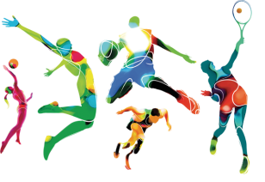
WORLD OF SPORT
Aims: These tasks are designed to be done with your child. Green coloured tasks are aimed at pupils in the main body of the school. Tasks are a mixture of interactive tasks and tasks which build core skills. These are tasks we hope you will enjoy, please select the ones you feel are most appropriate.
Thinking
Literacy Focus: Developing story sequencing and comprehension skills. Developing awareness of the writer’s use of language. Expressing a personal opinion.  Building skills planning and writing for different purposes.  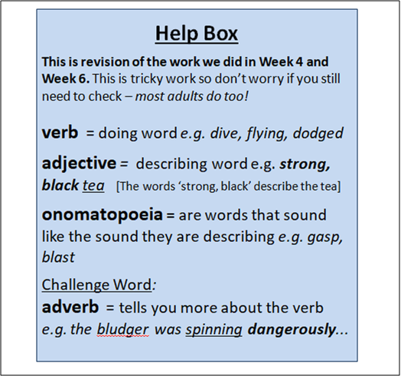  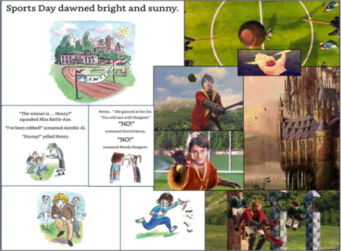 | Speaking & Listening + Reading:  Resources: Powerpoint W7 World of Sport Reading + Compare GREEN as  W7 WoS ReportWriting GREEN as  Horrid Henry Sports Day https://www.youtube.com/watch?v=rBgh6Imfkvs  Harry Potter Quidditch Match https://www.youtube.com/watch?v=7mFyxsHIThM  https://www.youtube.com/watch?v=-uK5LDkET-Q  London 2012 Olympics Highlights https://www.youtube.com/watch?v=gKJDjg4ebNQ  Videos - Miss Barratt reading Horrid Henry Sports Day and Mr. Brady reading Harry Potter Quidditch match.  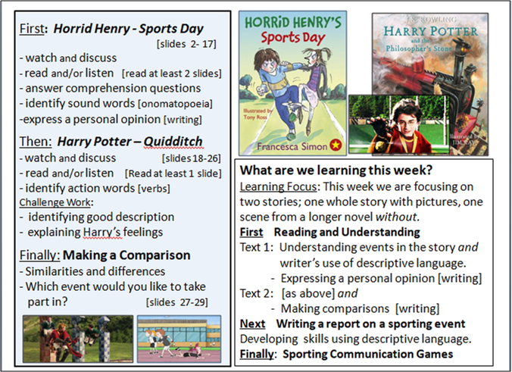  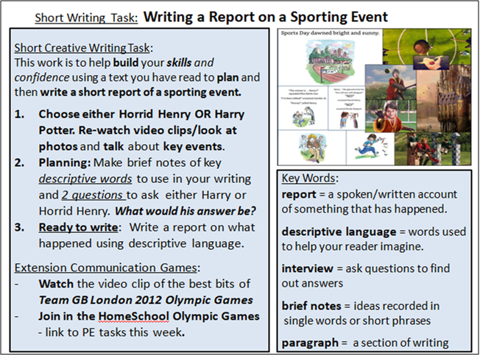
Maths Focus | - Answer these challenge questions  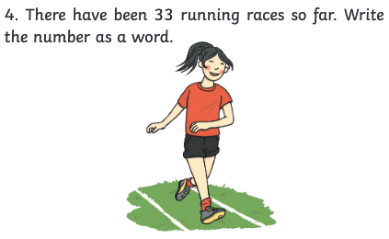  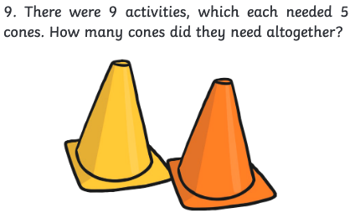  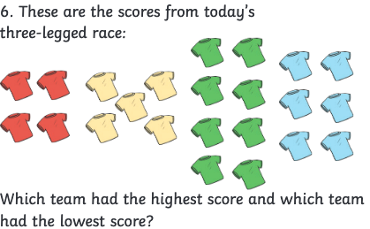  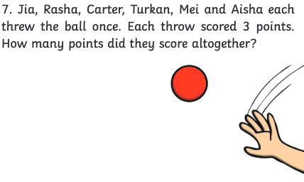  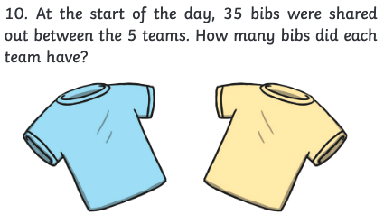  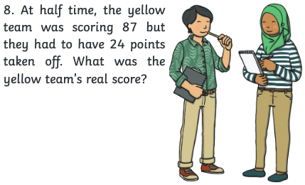  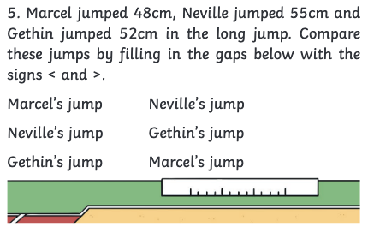  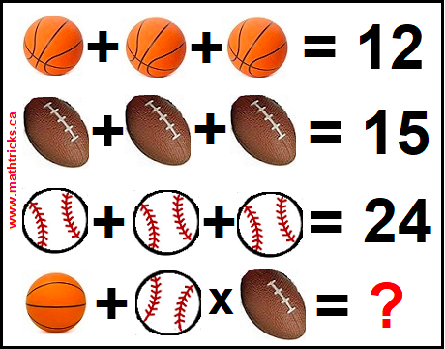  - Can you answer this puzzle?  - Data collection! Ask your family and friends what their favourite sport is, collect the data and put the information into a chart!  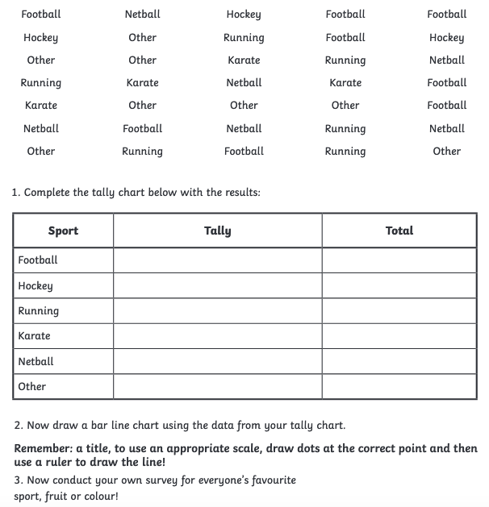  - Multiplication word problems  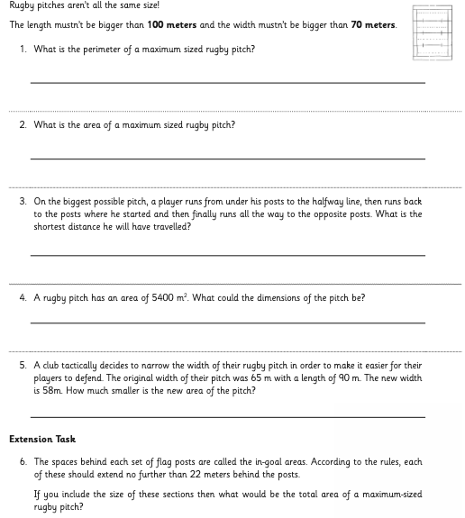
Science Focus | Task: Kinetic Energy - Use two balls to transfer kinetic energy from the big ball to the smaller one and see what happens.  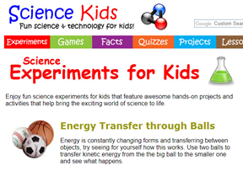  Link:https://www.sciencekids.co.nz/experiments/bouncingballs.html  Task: Measuring your heart rate after running - How do you feel after you have gone for a run or played your favourite sport? Tired right? This is because we need more energy, for example to run, the heart beats faster to pump more oxygen around the body. When your heart beats it sends a wave of pressure through all of your veins in your body. We call this your pulse. In this activity you will measure your own pulse and compare it to after running or playing your favourite sport.  - What did you find out?  - What happened to your pulse rate after activity?  - Why do you think this happens?  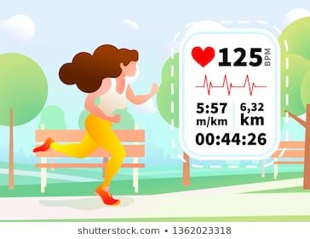  Link:https://www.science-sparks.com/heart-rate-investigation/  Optional worksheet: https://www.tes.com/teaching-resource/heart-rate-experiments-recording-sheets-and-presentation-11017248  Task: Sporty Science Ideas - Here is a link of some sporty science ideas for you to give a try.    Link: https://www.science-sparks.com/sports-science/
Cooking/Technology | Task: Healthy Eating and Living Game - This is a fun interactive game focused on healthy eating and living. You will also need a dice and a game piece to play.  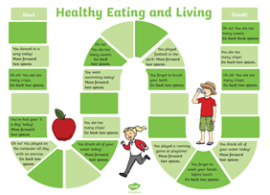  Attached: PDF - Healthy Eating and Living Board Game - Green  Task: Joe Wicks Healthy Bake Recipes - These healthy bake recipes by Joe Wicks are the perfect way to learn about healthy eating and healthy snacks. These two recipes, Banana and Peanut Butter Oaty Muffins and Energy Balls are packed full of healthy ingredients including oats, banana, cinnamon, oats and butter are easy to make and will keep children feeling fuller for longer. Please note these recipes include nut ingredients - However the recipes work well without the nut ingredients.  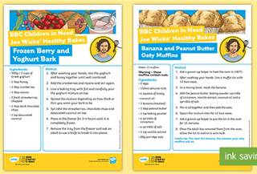  Attached: Joe Wicks healthy bake recipes - Green  Task: Designing a medal - Here is a useful template that allows your children to design their own medal - perfect for encouraging your children to be creative!  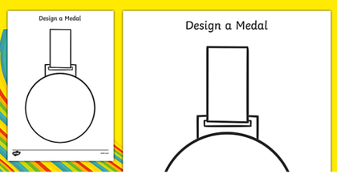  Attached: PDF - Design a medal - Green  If you would find this useful here is a powerpoint to give you a insight on the history of the Olympics  Link:https://www.twinkl.co.uk/resource/t-t-25545-olympics-information-powerpoint
Drama/Arts/Music- CK | 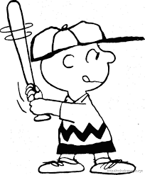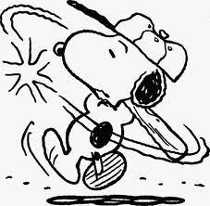  Task Focus: Investigating Cartoons and Movement in sport .  Task Helpful link to follow:  https://www.youtube.com/watch?v=xH3sq3tSKK8  Key Information:  Over the last century artist’s have tried to show movement in their paintings and drawing, especially in cartoons. Sport is a popular topic for this.  - Look at the link and discuss how the movement is shown in the cartoon. How can you tell the ball, Cap or bat is moving?  - Have a go acting out-playing Baseball or look for more cartoons with sport and describe the differences  - Play sports charades- someone acts the sport and the others take turns to guess what sport it is.  - See if you can sketch Snoopy or Charlie Brown playing Baseball, then draw them doing another sport you like  You will need:Paper, Pencils, colour pencils  Keywords: Movement Actions Pretend Act Baseball Sketch Draw Snoopy Woodstock Charlie Brown  .  Other optional ideas for wider learning:  Make Medals as prizes for the best acting and have your own prize giving ceremony :https://www.youtube.com/watch?v=0q5LmUvChdQ  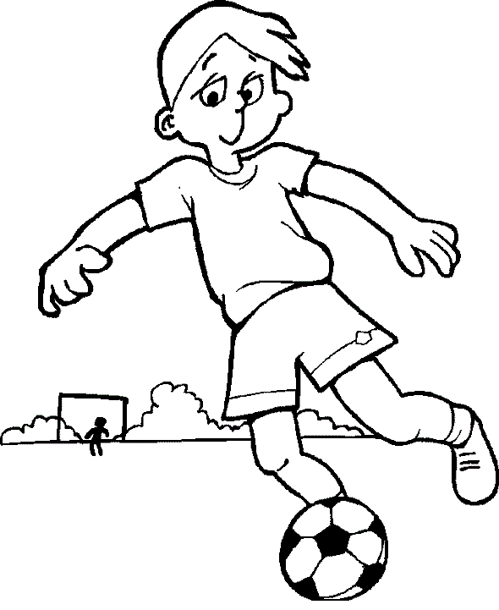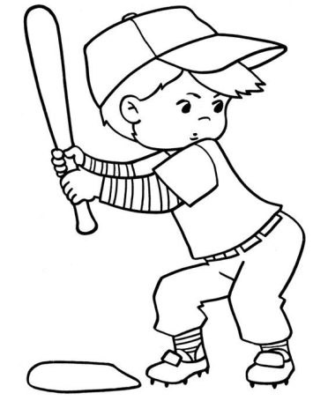  or design your own sports character
Health and Wellbeing
Physical activity | ThisIsPE: Updated 3 times a week. Fun and easy activities to be done at home. https://www.youtube.com/results?search_query=thisisPE  Using ideas from the “This is PE” link, try and create your own game using things you can find at home. Write down the rules and play with your family. If you can, upload to Twitter and tag “@MeadowPE” so we can see it.  Nike Move Crew: Fun games and dance activities led by Nike athletes. https://www.youtube.com/results?search_query=nike+move+crew  Go Noodle I Get Moving: Lots of videos to get children moving, dancing and exercising with lots of music and singing. https://www.youtube.com/user/GoNoodleGames  Coordination Test  - Stand three feet away from a smooth and solid wall. Throw the ball with one arm, in an underarm action at the wall. Catch it with the opposite hand as it bounces back at you. Throw it back at the wall with that hand and catch with the opposite. Repeat. Count how many successful catches you achieve.  Check out the ‘Youtube channel - Meadow High School Hello’. See if you can beat the staff.  Homeschool Olympics  There are 10 different events for you to have a go at. In each event you will have the opportunity to win Bronze, Silver or Gold depending on your score. Let’s see how many medals you can win.  You can even challenge someone else in your household.  If you do not have a measuring tape available, you can count up the distance using a shoe.  Let us know how you get on.  Event 1 – Plank.  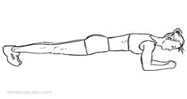  Using a floor space try and see how long you can hold the plank position for?  Bronze: 0 – 30 seconds.  Silver: 30 – 60 seconds.  Gold: 60 seconds plus.  Event 2 – Speed Bounce.  Using an item at home to make a line on the floor (roll up a t-shirt or a pair of trousers). Using both feet together try to jump over that line as many times as you can in 30 seconds.  Bronze: 0 – 15 seconds  Silver: 15 – 30 seconds  Gold: 30 plus seconds  Event 3 – Long Jump.  Stand behind a marked outline with feet slightly apart. A two-foot take-off and landing is used, with swinging of the arms and bending of the knees to provide forward drive. Jump as far as possible, landing on both feet without falling backwards. Three attempts are allowed  Bronze:0 – 0.5 meter.  Silver:0.5 – 1.5 meters.  Gold: 1.5 plus meters  Event 4 – Throw and catch.  Roll up a pair of socks into a ball-like shape. Throw the socks in the air and count how many times you are able to clap your hands and successfully catch the socks.  Bronze: 0 – 3 claps.  Silver: 3- 6 claps.  Gold: 6 plus claps.  Event 5 – Star Jumps.  See how many star jumps you can perform in 60 seconds.  Bronze: 0 – 20  Silver: 20 – 50  Gold: 50 plus.  Event 6 – Stork Stand.  Remove the shoes and place the hands on the hips, then position the non-supporting foot against the inside knee of the supporting leg. The stopwatch is started as the heel is raised from the floor.  Bronze: 0 – 10 seconds.  Silver: 10 – 30 seconds.  Gold: 30 seconds plus.  Event 7 – Compass.  Choose 4 items found in the house to mark out a 4 point compass (N,S,E,W). Once you have the 4 points, get someone to call out the names of those items and see how fast you can touch them and return back to the middle of the compass. Keep calling them and see how many touches you make in 30 seconds.  Bronze: 0 - 10  Silver: 10 – 20  Gold: 30 plus  Event 8 – Pillow throw.  Sit on the floor back straight. Hold the pillow against your chest. Then using a push motion see how far you can throw the pillow in a forward direction.  Bronze: 0 – 2 meters.  Silver: 2- 4 meters.  Gold: 4 meters plus.  Event 9 – Balance book on head.  You can either stand up or sit down. See how many books you are able to balance on your head for at least 5 seconds.  Bronze: 0 – 2 books.  Silver: 2 - 4 books.  Gold: 5 plus books.  Event 10 – Target throw.  Create a target using an item from your house (jumper, t-shirt). Roll up a pair of socks into a ball-like shape. See how far you can stand and throw the socks to land on the target.  Bronze: 0 – 2 meters.  Silver: 2-4 meters.  Gold: 4 plus meters.
Cross Curricular
PSHCE | https://www.twinkl.co.uk/resource/t-t-1078-british-passport-template  “All About Me” We would like to gather some information about you including your name, birthday, family information, favourite things and things you enjoy doing. This passport can be completed with other household members and try to think about your likes, favourite activities and things you are proud of… perhaps it is a sporting achievement?  If you have a passport from another country and wish to use a different template, please do! Twinkl has loads of templates, or you could even make your own.
Geography | Task 1:  https://www.twinkl.co.uk/resource/t-t-123-design-a-flag  In Geography we do lots of work on where we come from and learn all about our countries and cultures. For your Geography task, we would like you to imagine you are off to the olympics. You can create your own country and flag to represent your team. Perhaps your country even has its own sport they play?  Task 2:  https://www.twinkl.co.uk/resource/nz-ss-49-about-my-special-country-activity  Now you have your own flag for your country, can you complete this ‘About My Country’ fact sheet and tell us a little bit about it?

