Aims: These tasks are designed to be done with your child. Purple coloured tasks are aimed at pupils who would enjoy more of a challenge . These are tasks where pupils should be working with greater independence, however please take time to support pupils in starting the tasks and build communication skills.
Thinking
Literacy Focus: Building skills close reading, annotating identifying and recording key information. Expressing a personal opinion using evidence from the text.  Higher Challenge:  Planning, structuring and writing an argument.  Key Terms to try and learn:  protagonist = the leading character in a play, film or novel  close reading = a careful attention to individual words, phrases and sentences in a text.  annotate = add notes giving an explanation or comment  compare = make note of the similarities and differences  quote = words from the text  argument = exchange of different views  inference = a conclusion reached on the basis of evidence and reasoning  impression = an idea, feeling or opinion about something or someone - formed on the basis of evidence | Speaking & Listening and Reading Comprehension:  Resources: Powerpoint Food ReadDiscuss+Compare PURPLE as  These links are in the powerpoint…  Oliver Twist https://www.youtube.com/watch?v=hEQDllvuy1I  https://www.youtube.com/watch?v=7tOkpntQtBM  https://www.youtube.com/watch?v=NHRwmfSfl7A  Harry Potter https://www.youtube.com/watch?v=A0cla_h_f8M  https://www.youtube.com/watch?v=HjUq1HSbfRU  Matilda https://www.youtube.com/watch?v=EOQeU_6vbeg  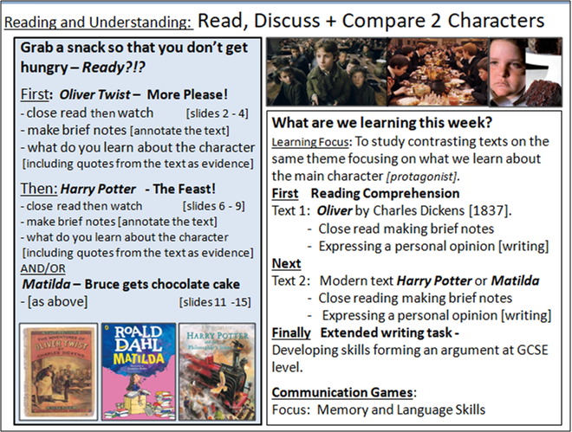  Planning and Writing - Forming and Argument :  Resources: Powerpoint Food ConstructingAnArgument Writing PURPLE as  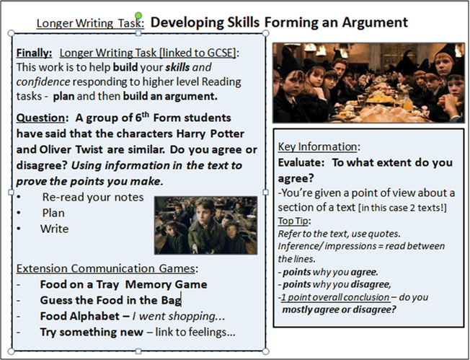
Maths Focus | - Mrs Mistry drinks too much coffee!  Mrs Mistry drinks 3 cups of instant coffee at home, and twice a week she buys a coffee from Starbucks. How much money could Mrs Mistry save if she gives up coffee for 40 days? (Round the amount to the nearest penny) How much money would Mrs Mistry save if she gave up only buying from Starbucks?  - Starbucks sells coffee for £2.75 a cup  - A jar of instant coffee costs £4.60 - 1.8g makes 1 cup of coffee  - Maths word search. As there is no list, it makes them harder to find! How many can you find?  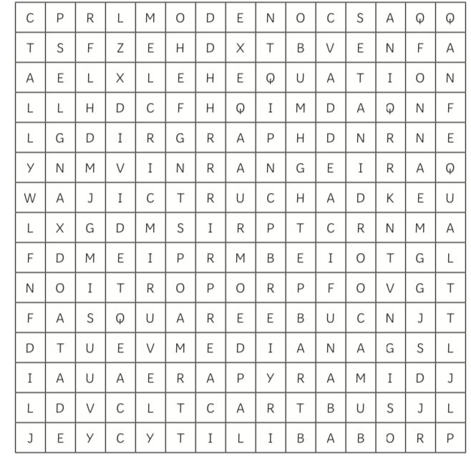  - Key terms - write a definition for each term. Try first without researching it online or in a dictionary if you can!  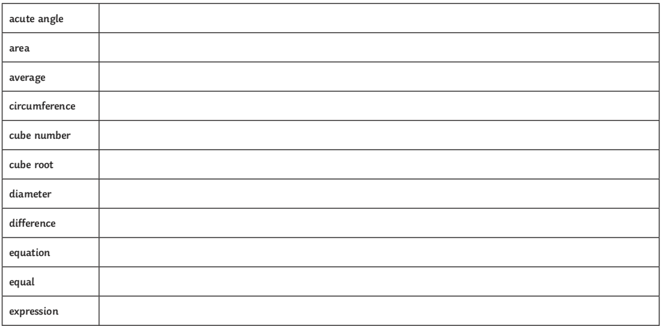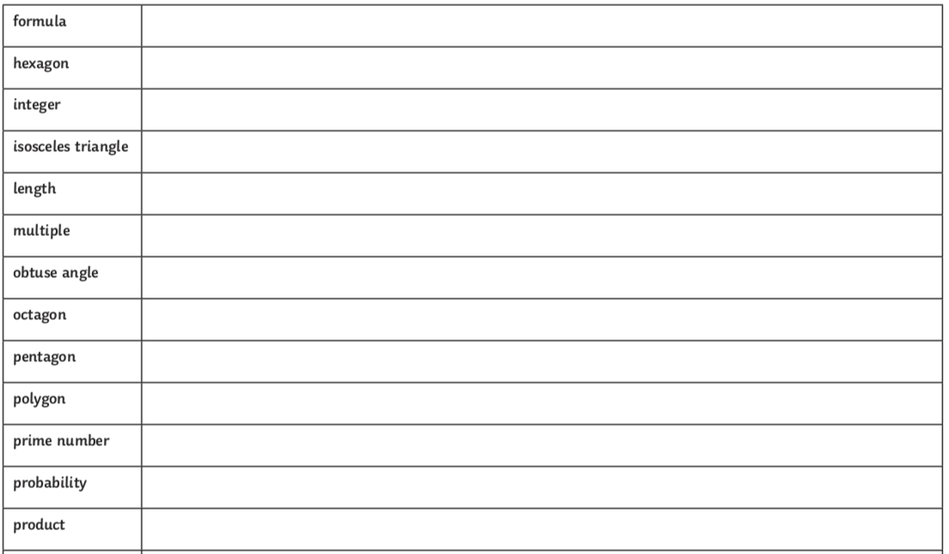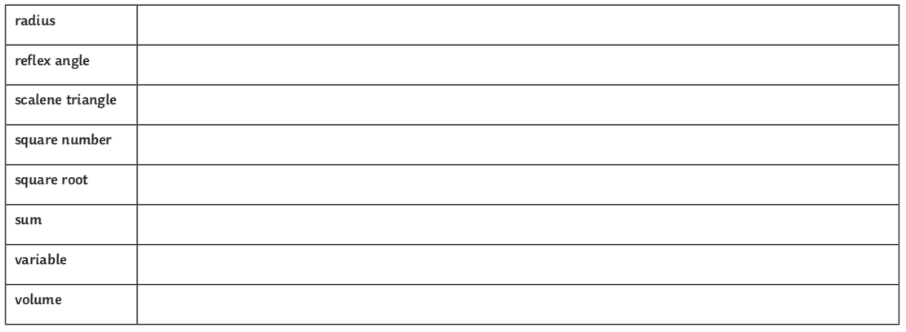  - Maths riddles  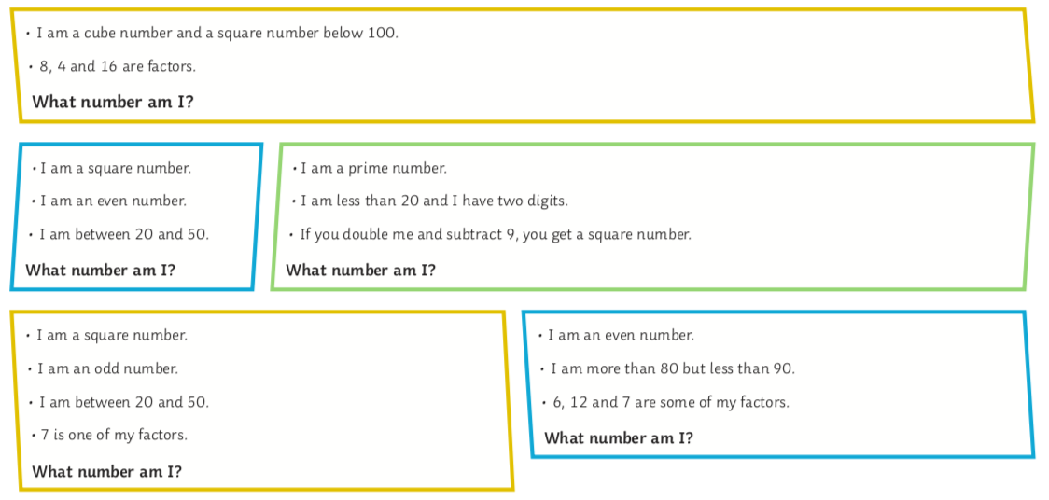
Science Focus  Additional Useful link:  https://www.gosh.nhs.uk/conditions-and-treatments/general-health-advice-children/eat-smart/food-science/food-group-fun  https://www.twinkl.co.uk/resource/ks2-food-science-experiment-activity-pack-t-sc-2549324 | Task 1: Poster on Eat Well Plate - Create a poster of a balanced meal on a plate (Eatwell plate) by selecting the required portions of healthy food needed from each food group.  - For each category write a short explanation of why each group is important to our wellbeing.  - Remember to include: Fruit and vegetables, Carbohydrates, Dairy and Alternatives, Protein, Fats and Sugars  For interactive version use: https://www.twinkl.co.uk/resource/t-t-5470-large-food-groups-poster  For ideas use:  https://www.twinkl.co.uk/resource/t-t-5470-large-food-groups-poster  Task 2: Chemistry Cake Experiment - see what happens when you leave out certain ingredients.  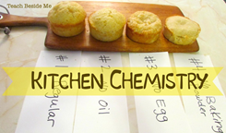  Link:https://teachbesideme.com/kitchen-chemistry-cake-experiment/  Task 3: How to make Edible Glass - Just like real glass, sugar glass is made from tiny grains which when allowed to cool, transform into an amorphous transparent sheet, which is solid yet brittle. What does amorphous mean? We’ll get on to that later!  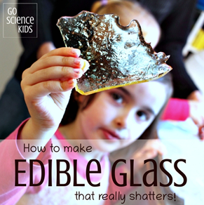  Link: https://gosciencekids.com/sugar-glass-edible-science-kids/  Task 4: DIY Solar Oven S’mores - Take advantage of the lovely weather and combine science with the pleasure of eating s’mores!  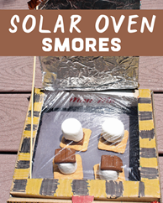  Link:https://desertchica.com/diy-solar-oven-smores-kids-science-experiment/
Creativity
Cooking/Technology | Cooking:  Task 1: Simple Recipes - Here are a few simple recipes that you can make together as a family. Why not choose one from these selections and try to use some of the skills you have learnt in your cooking lessons at school. Try to be as independent as you can when following these recipes.  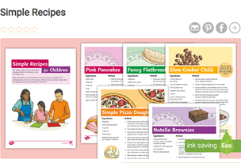  Attached: PDF - Simple Recipes - Green and Purple  Task 2: Awesome Pizza Recipe - Here is a recipe for pizza dough and also an additional space for you to design your own pizza topping using the worksheet to fill in.  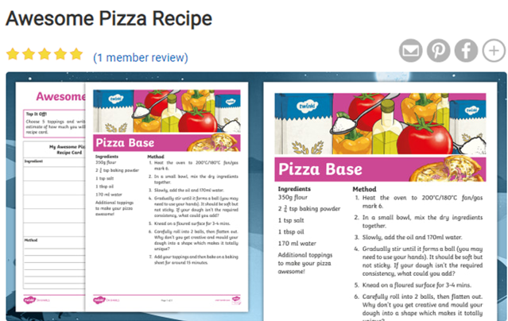  Attached: PDF - Awesome Pizza Recipe - Purple  Technology:  Task 1: Shopping Word Search - Create an online shopping wordsearch. Read Shopping Online - page 3 to help you to create a word search online or by hand. Use/highlight the keywords related to online shopping to use in your wordsearch..  Link to information on online shopping: https://www.bbc.co.uk/bitesize/guides/zbxbkqt/revision/1  Word search can be created online at the below website:  Link: http://thewordsearch.com/  ART/DRAMA/MUSIC  Task Focus: Making a face from food and taking a photo of your ‘Food Art’ for us!  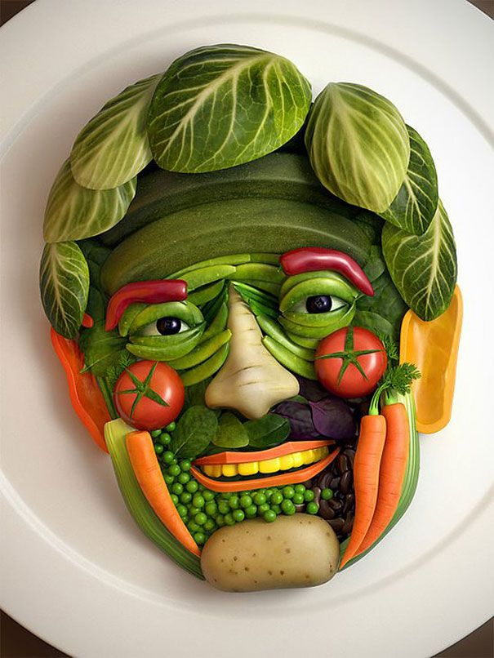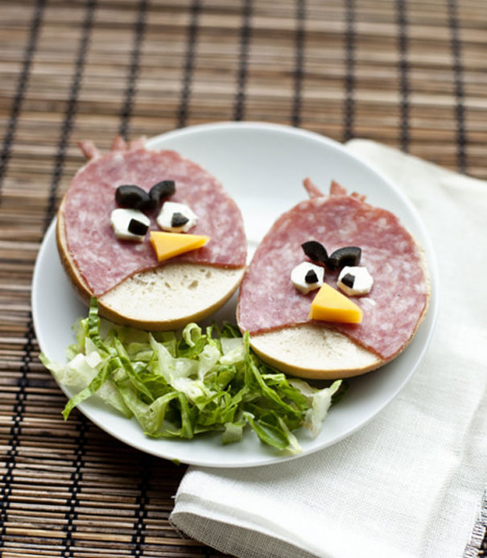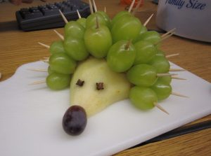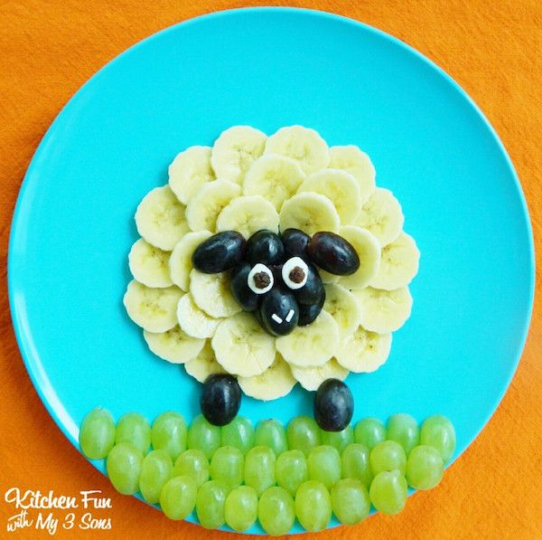  Task helpful clip to watch:  Arcimboldo’s imaginative portraits-https://www.youtube.com/watch?v=4-C_UQl3aVg  Key Information:  Guiseppe Arcimboldo is famous for making faces/portraits using food, he used fruits, vegetables and fish in his paintings. Can you make a face/portrait out of real food and then photograph it, you could send us the pictures to put on the website!  Discuss his portrait below what face features can you spot, what food are they made with?  Then use real food to make your own face out of food!  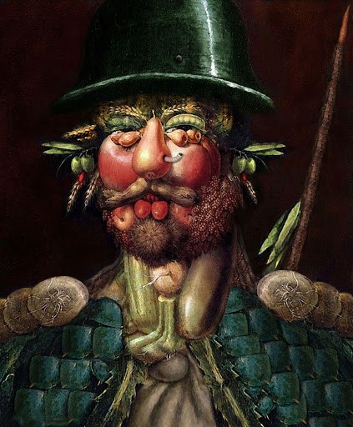  Materials Needed:  A range of types of food or a meal  A plate  Soap for cleaning hands  Keywords:Shape Face Eyes, Nose, Mouth Ears, Neck, plan idea.  Other optional tasks for wider learning:  Regular-challenging Tasks-4 Fun food for kids https://www.youtube.com/watch?v=ThY9ZcOFCmI  Mindful Monsters you can sign up and down load a great activity pack https://mindfulmonsters.co.uk/schools
Health and Wellbeing
Physical activity | The PE staff have uploaded another video onto the school’s Youtube channel. Check it out and have a go!  ThisIsPE: Updated 3 times a week. Fun and easy activities to be done at home. https://www.youtube.com/results?search_query=thisisPE  Fitness Blender: Build your own circuit training session  https://www.fitnessblender.com/videos  The Eatwell Guide video - https://www.youtube.com/watch?v=7MlE4G8ntss  Eat like an athlete - https://www.bbcgoodfood.com/howto/guide/eat-athlete-hub  My Healthy Eating Food Journal - Keep a diary of all the different foods you have eaten.  Dance fitness Challenge!: How many…  -Punch forwards 10x, Up 10x, Down 10x, To the side 10x  -Push up on knees 10x  -High Knee Jog 30secs  -Heel raises 10x  What can you do? Log it down and try to aim to beat the score at least twice this week!  Food stimulus Dance  To write a list of different types of foods and describe them using an adjective. Try to use a texture, length, temperature, appearance. Choose a movement to represent each of these foods, changing the DYNAMICs of the move to suit it. Link the movements together and try out the dance to 2 very different types of songs- a slow calm and then a fast bouncy song. Which did you prefer and why?  Watch the Strictly come dancing version of ‘Food glorious food’  https://www.youtube.com/watch?v=Daekcl6t3z0  How many travelling moves could you see? Can you try these in a safe space?
Cross Curricular

