Aims: These tasks are designed to be done with your child. Green coloured tasks are aimed at pupils in the main body of the school. Tasks are a mixture of interactive tasks and tasks which build core skills. These are tasks we hope you will enjoy, please select the ones you feel are most appropriate.
Thinking
Literacy Focus: Developing story sequencing and language skills. Expressing a personal opinion giving reasons from the text. Building skills planning and writing a descriptive paragraph.  Key Terms to try and learn: These are good revision for storytelling from our Week 4 pack of work.  noun = naming words eg pizza, burger, banana, cake  verb = doing word eg The Trunchbull marched onto the platform  adjective = describing word e.g. special, chocolate cake OR greedy little thieves  adverb = tells you more about the verb eg the Trunchbull barked suddenly.  simile = describing something by comparing it with something else eg sneaked like a serpent  punctuation = . , ? ! ‘ we need these to help the reader understand.  paragraph = section of writing about the same thing. | Speaking & Listening + Reading:  Resources: https://www.youtube.com/watch?v=EOQeU_6vbeg  https://www.youtube.com/watch?v=A0cla_h_f8M  https://www.youtube.com/watch?v=HjUq1HSbfRU  Powerpoint - W6 FoodReadDiscuss+Compare GREEN as  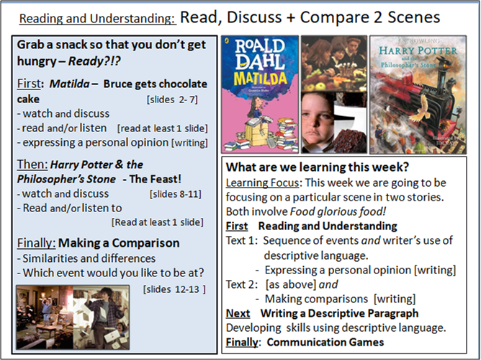  Speaking & Listening + Writing:  Resources: Powerpoint W6 Food DescriptiveWriting GREEN as  Food from your kitchen cupboards  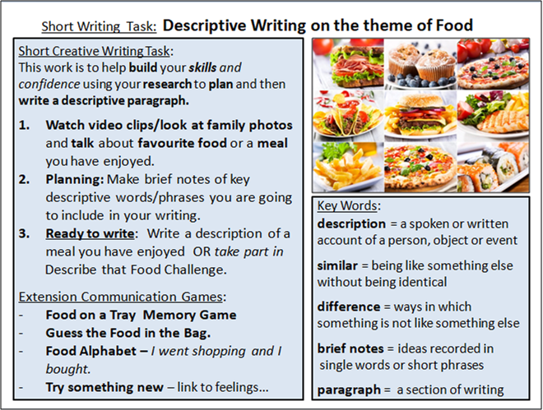
Maths Focus | - Create your own home tuck shop!  Set yourself a budget of £1 a day, collect all your snacks into a basket and create a price list. Play shop and practise your money skills at home.  - Can you recognise the smallest way to make an amount?  - Can you calculate change from an amount?  - What would you have to put back if you went over budget?  - If you saved up from the previous day's budget, what else could you buy?  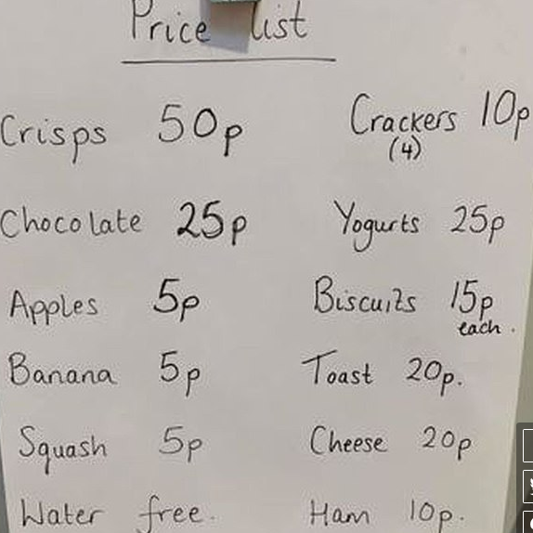  - How much is a portion?  https://www.stem.org.uk/resources/elibrary/resource/25337/going-bananas  - Guess what is in the bag  - Put a variety of food in a bag that you cannot see through e.g. whole fruits. Put your hand in the bag and think about guessing what item is. Can you describe the shape/size/weight.  - Make & play ‘Chocolate wrapper dominoes’  - You need 28 mini chocolate wrappers, cut each in half across the word e.g. BOU- - - NTY.  - Stick 2 different halves onto a piece of card [end to end] e.g. Snickers & Bounty KERS/BOU  - Cut out each card, keeping a different chocolate wrapper at each end joined up.  - Cut out 4 of each kind of chocolate wrapper e.g. 4 Bounty wrappers, 4 snickers wrappers etc. make them up as 2 halves stuck together.  - You need 7 different types of chocolate bar wrapper altogether e.g. 4 MARS 4 Malteeser 4 Bounty 4 Twix 4 Snickers, 4 Fudge, 4 Crunchie  - You need 28 cards altogether to play dominoes. 7 x 4 = 28. Celebrations or fun size bars work well.
Science Focus  Additional Useful link:  https://www.gosh.nhs.uk/conditions-and-treatments/general-health-advice-children/eat-smart/food-science/food-group-fun  https://www.twinkl.co.uk/resource/ks2-food-science-experiment-activity-pack-t-sc-2549324 | Task 1: Food that the body needs - This activity looks at the information on the food packages at home  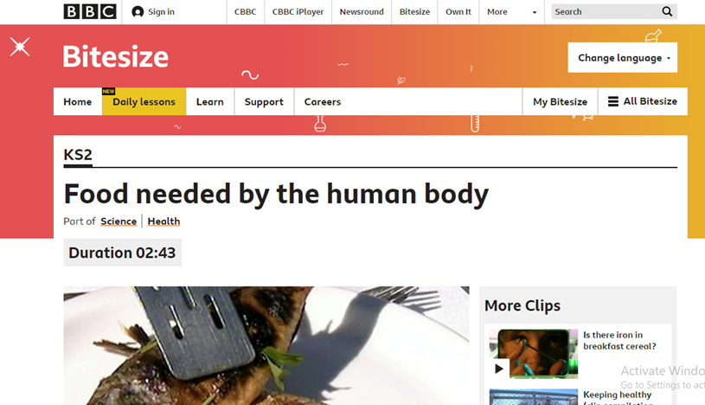  - Find out what foods you have in your cupboard and what provides you with the most energy.  - Find five foods that contain the three key nutrients carbohydrate, protein and fat.  - Create a list for each nutrient found that shows the largest amount and smallest amount found.  Link: https://www.bbc.co.uk/bitesize/clips/ztr3cdm  Task 2: Making Sourdough - Love cooking and experimenting?! Make your own sourdough (and maybe even make some bread?)  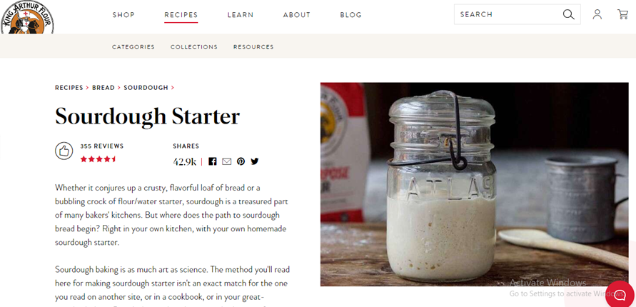  Link:https://www.kingarthurflour.com/recipes/sourdough-starter-recipe  Task 3: Bake a Potato Experiment - Find out What is the fastest way to bake a potato by completing this experiment.  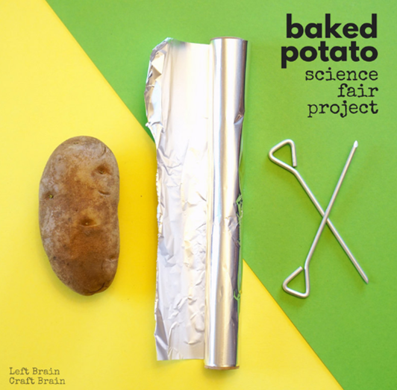  Link:https://leftbraincraftbrain.com/fastest-way-bake-potato-baked-potato-science-fair-project/
Creativity
Cooking/Technology  Art/Drama/Music | Cooking:  Task 1: Food sorting game - This is a fun interactive game which allows you to gain more knowledge on nutrition and basic food groups.  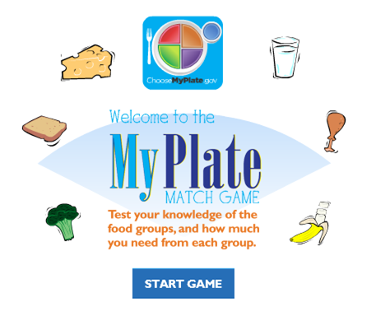  Link:https://www.healthyeating.org/Healthy-Kids/Kids-Games-Activities/My-Plate-Match-Game  Task 2: Grow your own - Why not try to grow your own fruit and vegetables at home. This website shows you what to grow this month as well as giving you a guide on how to do this.  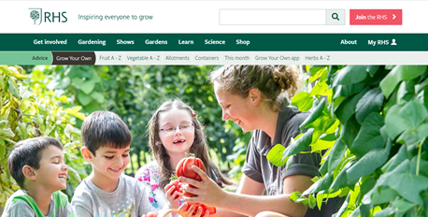  Link: https://www.rhs.org.uk/advice/grow-your-own  Task 3: Simple Recipes - Here are a few simple recipes that you can make together as a family. Why not choose one from these selections and try to use some of the skills you have learnt in your cooking lessons at school.  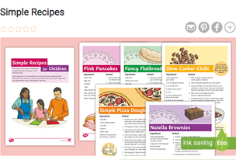  Attached: PDF - Simple Recipes - Green and Purple  Technology  Task 1: Shopping List - Create a food shopping list using Microsoft Notepad. The attached link shows you how to use Notepad on your computer.  - Open up Start, All Programs, Accessories, Notepad  - Use title ‘shopping list’  - List each food item required/desired underneath  Link: https://www.youtube.com/watch?v=htW1lOZIYfQ  ART:  Task Focus: Making a face from food and taking a photo of your ‘Food Art’ for us!  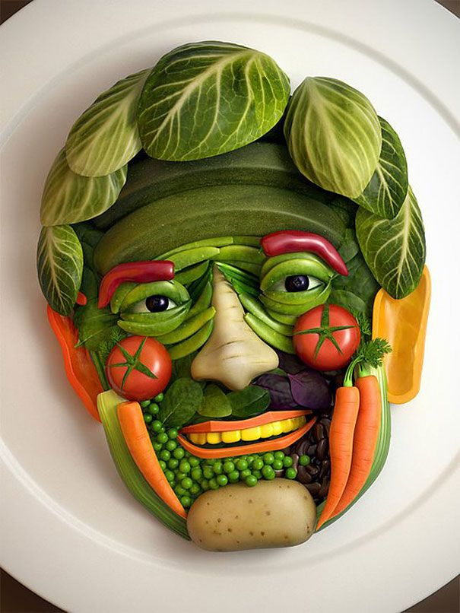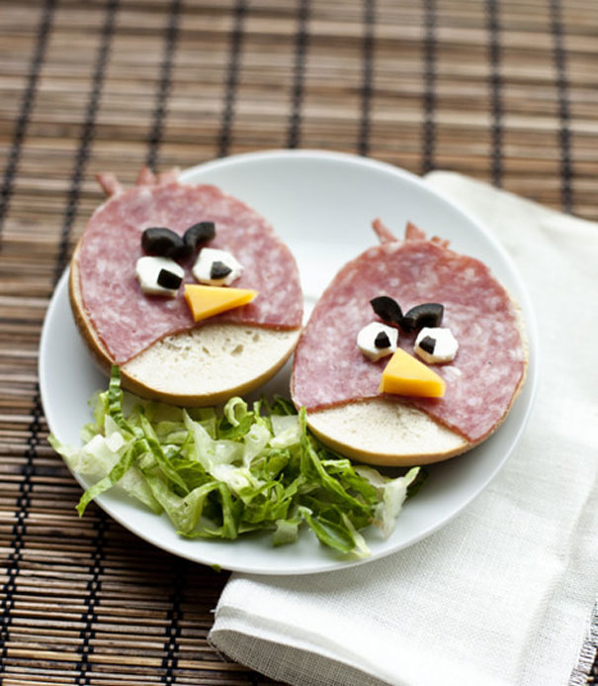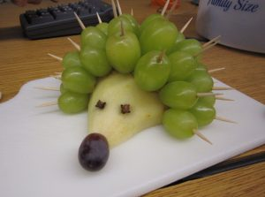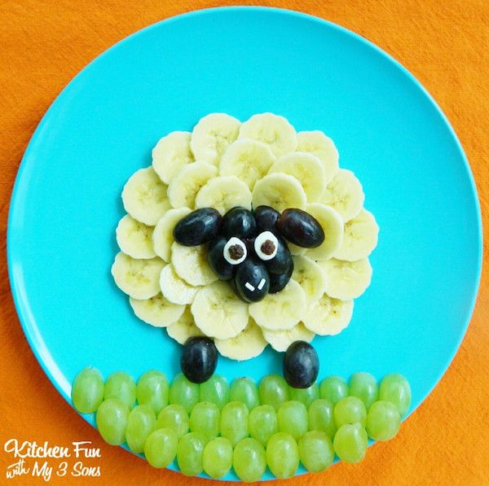  Task helpful clip to watch:  Arcimboldo’s imaginative portraits-https://www.youtube.com/watch?v=4-C_UQl3aVg  Key Information:  Guiseppe Arcimboldo is famous for making faces/portraits using food, he used fruits, vegetables and fish in his paintings. Can you make a face/portrait out of real food and then photograph it, you could send us the pictures to put on the website!  Discuss his portrait below what face features can you spot, what food are they made with?  Then use real food to make your own face out of food!  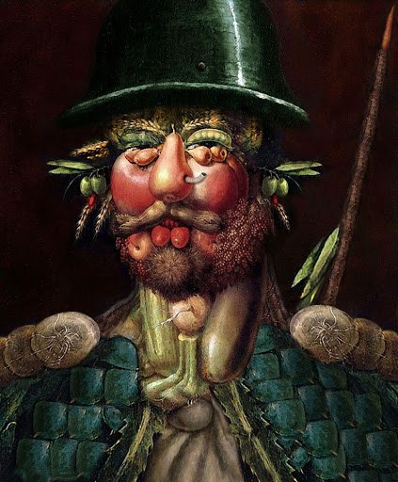  Materials Needed:  A range of types of food or a meal  A plate  Soap for cleaning hands  Keywords:Shape Face Eyes, Nose, Mouth Ears, Neck, plan idea.  Other optional tasks for wider learning:  Regular-challenging Tasks-4 Fun food for kids https://www.youtube.com/watch?v=ThY9ZcOFCmI  Mindful Monsters you can sign up and down load a great activity pack https://mindfulmonsters.co.uk/schools  Food line drawings: Watch the video to learn how to draw different foods:  https://www.youtube.com/watch?v=YQ2kikCY6eI
Physical activity | The PE staff have uploaded another video onto the school’s Youtube channel. Check it out and have a go!  Cosmic kids yoga ‘Betsy the banana’ https://www.youtube.com/watch?v=40SZl84Lr7A  ThisIsPE: Updated 3 times a week. Fun and easy activities to be done at home. https://www.youtube.com/results?search_query=thisisPE  Nike Move Crew: Fun games and dance activities led by Nike athletes. https://www.youtube.com/results?search_query=nike+move+crew  Go Noodle I Get Moving: Lots of videos to get children moving, dancing and exercising with lots of music and singing. https://www.youtube.com/user/GoNoodleGames  The Baked Bean game - Great for families or groups  Caller shouts out a type of BEAN and the participants move in ‘bean type’ of movement  Example:  Runner bean - runs  Jelly bean - wobbles  Baked bean - stands still [freeze]  Jumping bean - jumps  Kidney bean…walk on all fours [bottom up high]  Green bean...tiptoe through the grass  Black eyed bean…dances  Butter bean - skips  Or make up your own actions!!  The Eatwell Guide video - https://www.youtube.com/watch?v=7MlE4G8ntss  Eat like an athlete - https://www.bbcgoodfood.com/howto/guide/eat-athlete-hub  Healthy Meal Eating - Divided plate sorting activity.  Healthy Eating Meal activity: Design your own meal  Dance fitness Challenge!: How many…  -Punch forwards 10x, Up 10x, Down 10x, To the side 10x  -Push up on knees 10x  -High Knee Jog 30secs  -Heel raises 10x  What can you do? Log it down and try to aim to beat the score at least twice this week!  Watch the Strictly come dancing version of ‘Food glorious food’  https://www.youtube.com/watch?v=Daekcl6t3z0  How many travelling moves could you see? Can you try these in a safe space?
Cross Curricular

