Aims: These tasks are designed to be done with your child. Blue coloured tasks are aimed at Pathway 1 pupils as well as pupils who prefer more interactive activities and require a higher level of support. These are tasks we hope you will enjoy, please select the ones you feel are most appropriate for your child.
Thinking
Literacy Focus: Building story sequencing and language skills. Expressing a personal preference leading to sensory and core literacy sounds work.  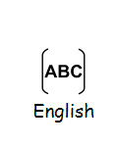  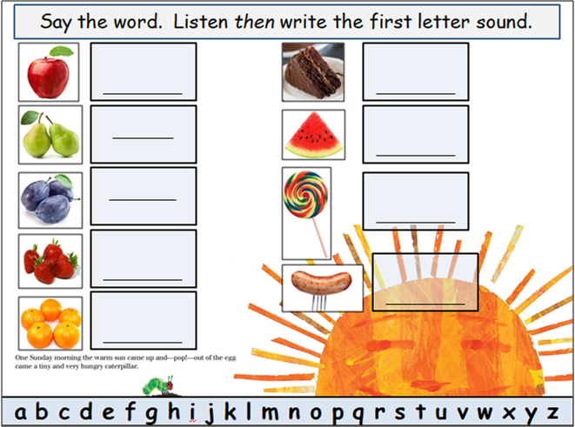  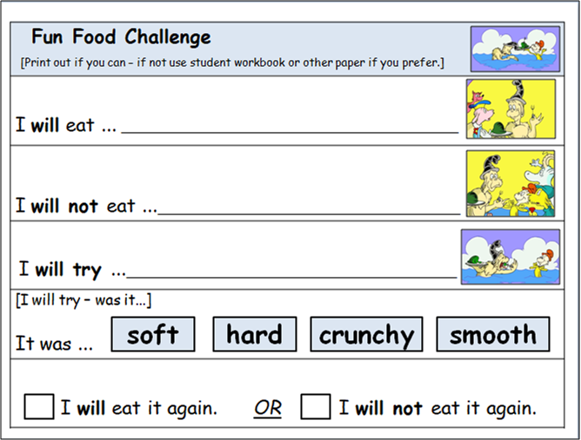  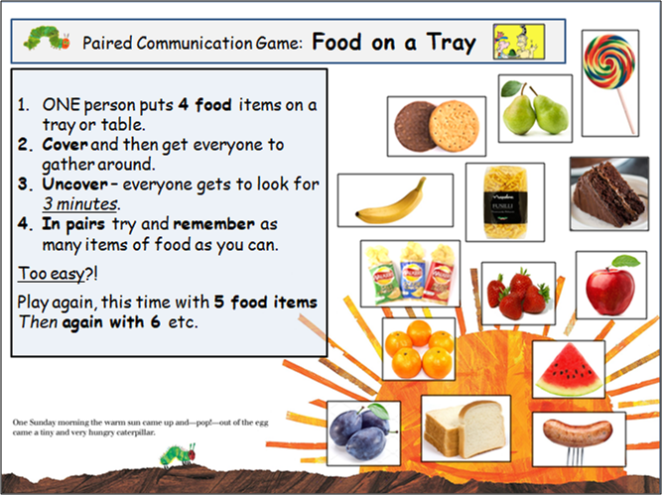 | Speaking, Listening & Communication, Reading and Writing:  Resources: https://www.youtube.com/watch?v=75NQK-Sm1YY  No internet, no problem - story and task sheets on the powerpoint below…  Powerpoint Week 6 The Very Hungry Caterpillar BLUE as  Food items from your cupboard for the Food Challenge task, pen/pencil.  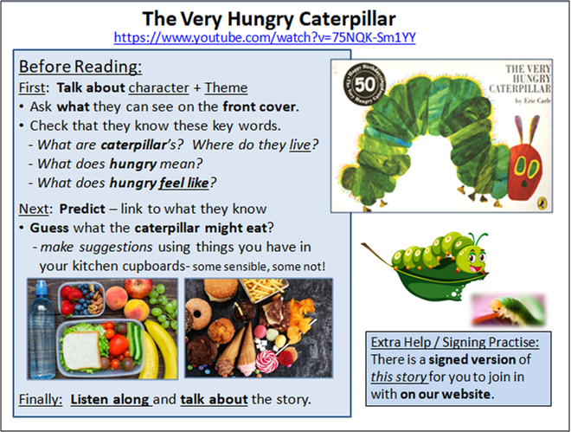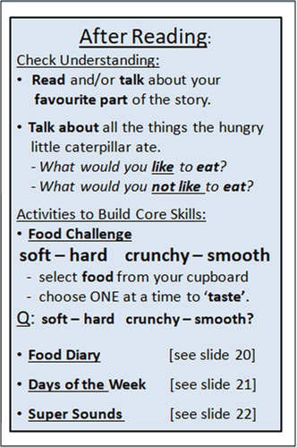  Speaking, Listening & Communication, Reading and Writing:  Resources: https://www.youtube.com/watch?v=ItPdeUnu5UI  No internet, no problem - story and task sheets on the powerpoint below…  Powerpoint Week 6 Green Eggs & Ham BLUE as  Food items from your cupboards for Fun Food Challenge, pen/pencil.  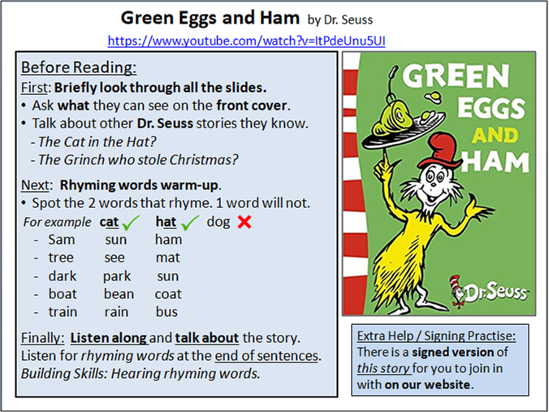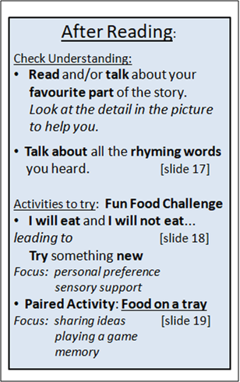
Maths Focus  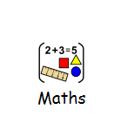 | - Listen to the story ‘give me half’  https://www.youtube.com/watch?v=hVaxiJB6Fls  - Discuss the meaning of a whole and a half? What does this look like? Can you find examples around your house?  - Draw and cut out shapes and attempt to fold/ cut these in half  - Do you know what a quarter is? What does this look like? Can you cut your shapes from halves into quarters?  *CLUE* all of the parts have to be of equal size!  If you need help, remind yourself of what a quarter is https://www.youtube.com/watch?v=ryGvCNDoAR0  - Create and decorate your own pizza! Either real or pretend!!  - Think about what you know about fractions, make a pizza and cut it into enough equal pieces to feed your family. How many slices did you cut? Do you know what this is as a fraction? Remember to make sure each slice is equal!  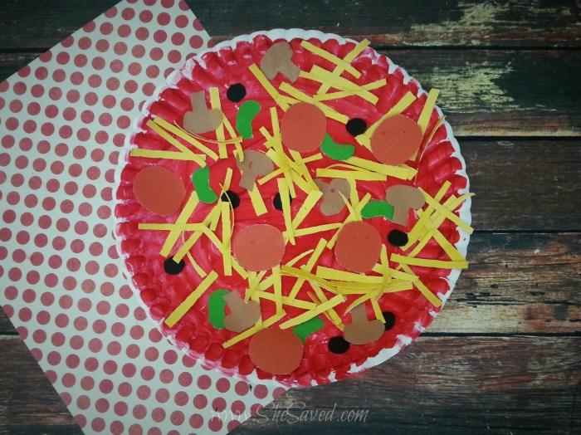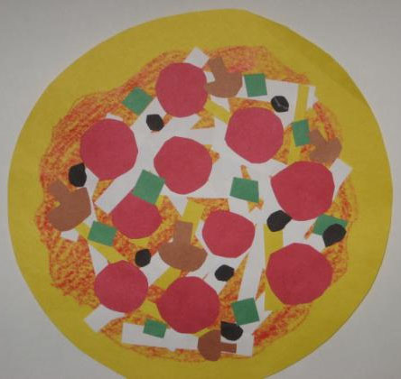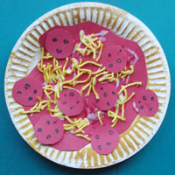  - Number rhymes - sing the songs and practise your counting!  - 5 currant buns - you could make some fresh buns to count along with and then eat! https://www.thespruceeats.com/peter-rabbit-english-currant-buns-4140348  - 20 fat sausages frying in the pan - cook some sausages and sing along to the song, remember to share them though!  - 10 green bottles hanging on the wall - decorate and line up some plastic bottles to play!  - 1,2,3,4,5, once I caught a fish alive - create some fish and float them in a small tub, practise catching them with a rod!  - Guess the shape and size  - Put a selection of goodies on a tray without anyone seeing what’s on the tray. Blindfold the person or hold the tray on their lap sitting at a table, if they don’t like the blindfold cover with paper tissue to smell & taste].  - Touch, smell, taste and guess what is on the tray, eat if you like it!  - [Stay safe! -separate tray for each person]  - Remember to use a variety of words to describe the shape and size. Challenge yourself and guess the weight too!
Science Focus  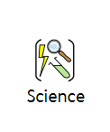 | Task 1: Healthy Packed Lunch - Draw or create a packed lunch of healthy foods. What kind of foods are good for the body?  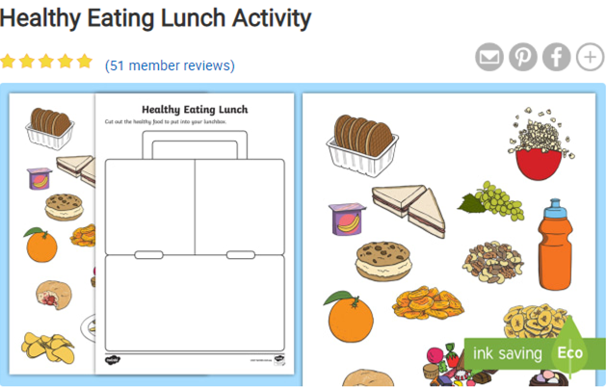  Link:https://www.twinkl.co.uk/resource/au-t-t-2399-australia---healthy-eating-lunch-activity  Task 2: Raisin Experiment: Make the most of the sun and make raisin. This is a fun visual experiment where you only need grapes and sunshine.  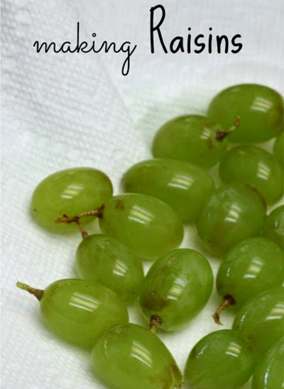  Link:http://www.learnplayimagine.com/2014/05/making-raisins.html  Task 3: How to make your own fizzy lemonade - In this simple science experiment, you mix a base with an acid to get a chemical reaction!  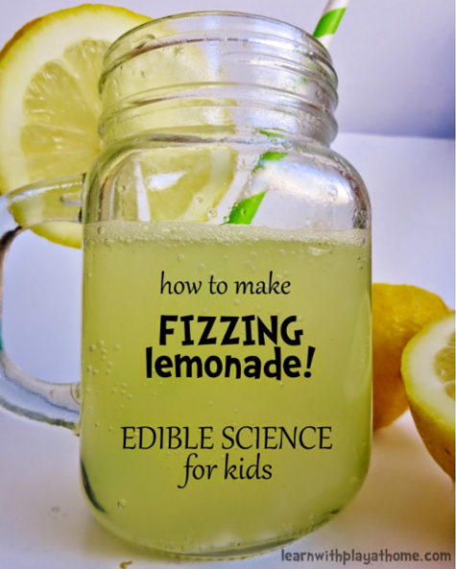  Link:https://www.learnwithplayathome.com/2014/09/how-to-make-fizzing-lemonade-edible.html  Task 4: Apple science experiment - Find out what keeps apples from browning!  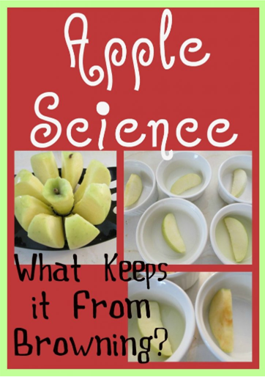  Link: https://teachbesideme.com/apple-science/
Creativity
Cooking/Technology 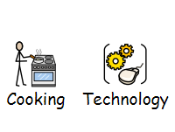 | Cooking:  Task 1: Rainbow fruit salad recipe - Why not make a rainbow fruit salad. Maybe try fruits that you have never eaten before.  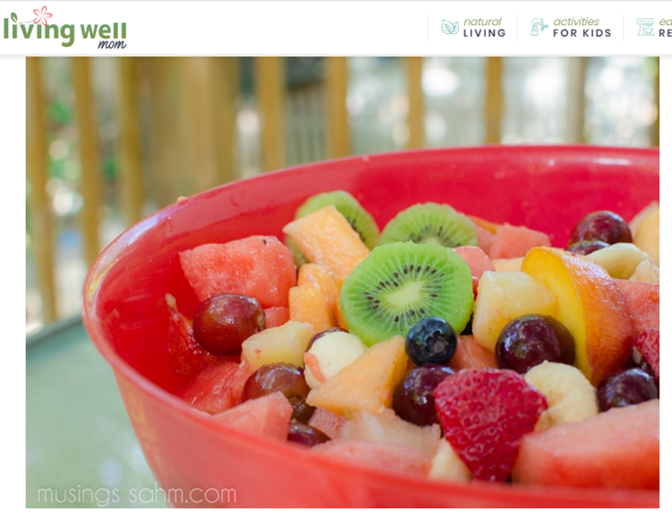  Link:https://livingwellmom.com/rainbow-fruit-salad-recipe-perfect-for-kids/#tasty-recipes-53274  Task 2: Guess the missing food game - Here are the instructions:  - Set up a tray of about 9 items.  - All look at the tray of food items for 1 minute and then cover.  - While everyone else closes their eyes, eat or remove one.  - Then uncover and take turns to look and say what's missing.  Use more or less items to suit who is playing.  Task 3: Caterpillar Salad - Following on from the book ‘The Very Hungry Caterpillar’ in the English activity section above, why not try and make your own salad using some of the ingredients in the story.  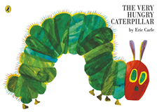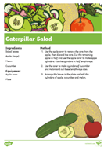  Attached: PDF - Caterpillar Salad Recipe - Blue  ART/DRAMA/MUSIC:  Task helpful clip to watch:  Arcimboldo’s imaginative portraits-https://www.youtube.com/watch?v=4-C_UQl3aVg  Key Information:  Guiseppe Arcimboldo is famous for making faces/portraits using food, he used fruits, vegetables and fish in his paintings. Can you make a face/portrait out of real food and then photograph it, you could send us the pictures to put on the website!  Discuss his portrait below what face features can you spot, what food are they made with?  Then use real food to make your own face out of food!  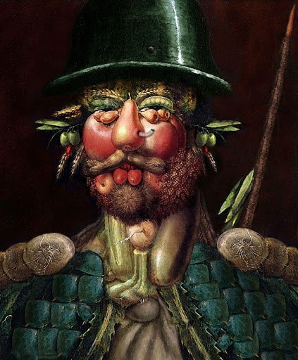  Materials Needed:  A range of types of food or a meal  A plate  Soap for cleaning hands  Keywords:Shape Face Eyes, Nose, Mouth Ears, Neck, plan idea.  Other optional tasks for wider learning:  Draw food: https://www.youtube.com/watch?v=YQ2kikCY6eI  Food Rhymes:  4 & 20 blackbirds baked in a pie;  Half a pound of tuppenny rice;  Bananas in pyjamas;  On top of spaghetti (the meatball song);
Health and Wellbeing
Physical activity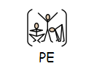 | The PE staff have uploaded another video onto the school’s Youtube channel. Check it out and have a go!  Cosmic kids yoga ‘Betsy the banana’ https://www.youtube.com/watch?v=40SZl84Lr7A  ThisIsPE: Updated 3 times a week. Fun and easy activities to be done at home. https://www.youtube.com/results?search_query=thisisPE  Nike Move Crew: Fun games and dance activities led by Nike athletes. https://www.youtube.com/results?search_query=nike+move+crew  Go Noodle I Get Moving: Lots of videos to get children moving, dancing and exercising with lots of music and singing. https://www.youtube.com/user/GoNoodleGames  The Baked Bean game - Great for families or groups  Caller shouts out a type of BEAN and the participants move in ‘bean type’ of movement  Example:  Runner bean - runs  Jelly bean - wobbles  Baked bean - stands still [freeze]  Jumping bean - jumps  Kidney bean…walk on all fours [bottom up high]  Green bean...tiptoe through the grass  Black eyed bean…dances  Butter bean - skips  Or make up your own actions!!  Healthy Eating Colouring activity - Colour in all the different foods.  Healthy Eating Meal activity: Design your own meal  The Eatwell Guide video -  https://www.youtube.com/watch?v=7MlE4G8ntss  Eat like an athlete - https://www.bbcgoodfood.com/howto/guide/eat-athlete-hub  Dance:  Starter- How many ‘food’ songs and dances can you think of?  Copy the Party in the kitchen Dance-  https://www.youtube.com/watch?v=xAMFq0THx-k  Copy the Hot Potato Dance-  https://www.youtube.com/watch?v=g8yzs4Li_1k
Cross Curricular

