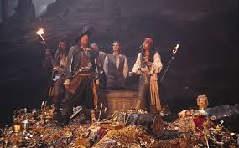
Pirates and Treasure
Aims: These tasks are designed to be done with your child. Green coloured tasks are aimed at pupils in the main body of the school. Tasks are a mixture of interactive tasks and tasks which build core skills. These are tasks we hope you will enjoy, please select the ones you feel are most appropriate.
Thinking
Literacy Focus: Identifying and talking about key information in short texts.  Developing research skills, using this information to add detail to a short piece of fictional writing task.  Key Terms to try and learn:  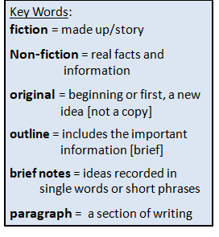  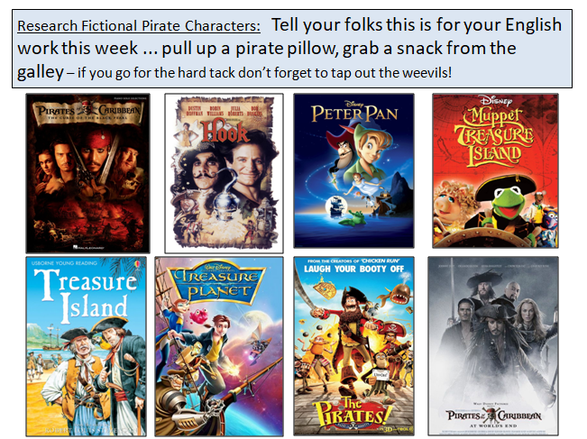 | Speaking & Listening + Reading:  Resources: Powerpoint Research Pirates GREEN as  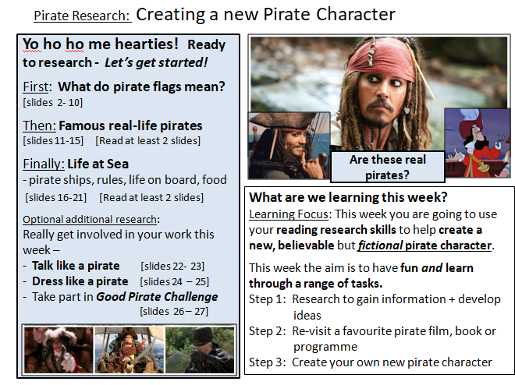  Speaking & Listening + Writing:  Resources: Powerpoint W5 New Pirate Character as  Films, T.V. programmes and books [you have at home]  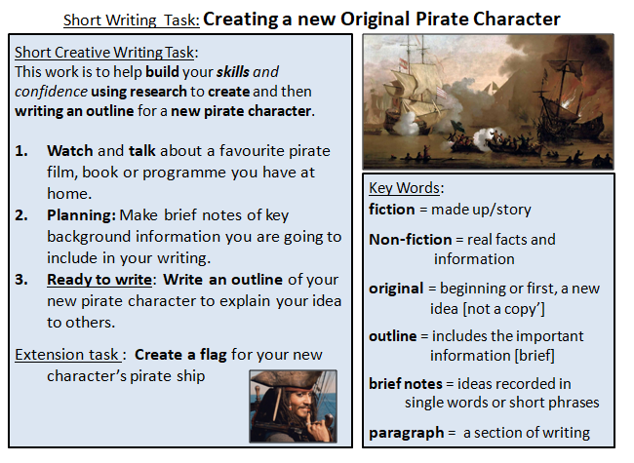
Maths Focus | - Pirate multiplication and division mosaic  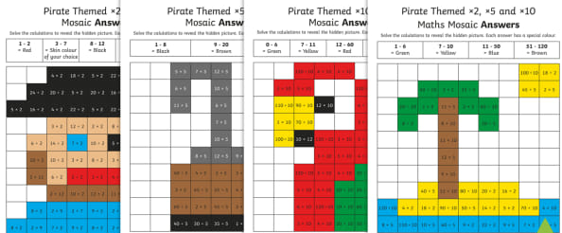  - Pirate multiplication dot to dot  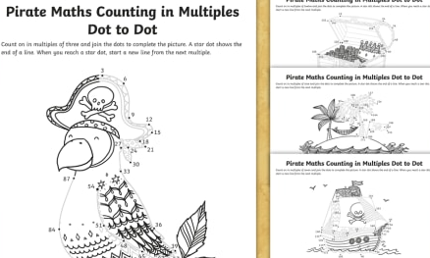  - Subitize with a pirate  https://www.youtube.com/watch?v=1L8bIDeW5co  - No counting allowed!  - Create your own pirate themed maze, make it as complex as you like! See example below:  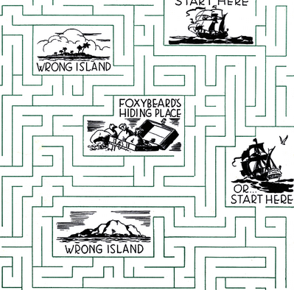
Science Focus | Tasks1: Pirate Science Experiments at Home 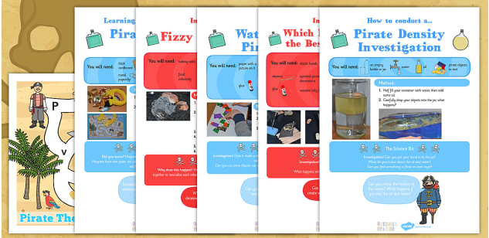  Here are a range of experiments that you can choose from to do at home.There is a list of things you will need and the instructions on how to do it.  The Experiments: Pirate density investigation, Which material makes the best pirate ship, How to waterproof a pirates ship, Fizzy pirate coins and Pirate magnet maze  Attached: PDF - Pirate Science Experiment at Home - Green  Task2: Density experiment - Density is quite a hard concept to grasp but this is a really nice introduction and full of little wow moments!  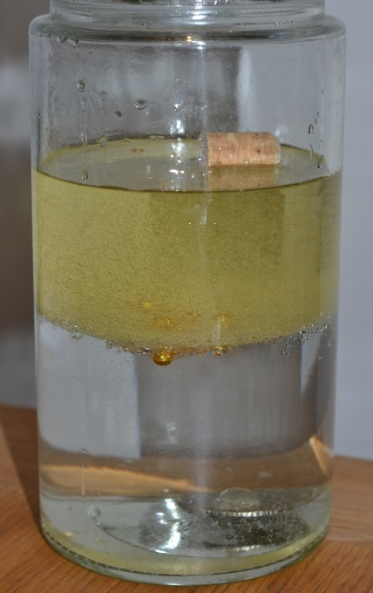  Link: https://www.science-sparks.com/density-experiment-pirate-themed/
Creativity
Cooking/Technology | Cooking:  Task1: Hardtack Biscuit Recipe - This recipe includes simple, easy-to-follow instructions on how to make your very own hardtack biscuits. Hardtack was originally eaten by sailors on long sea voyages and didn't contain anything but flour, water and sometimes salt - it could be so hard that it was occasionally called "molar breakers"! This recipe uses milk and butter instead to make them a little more yummy!  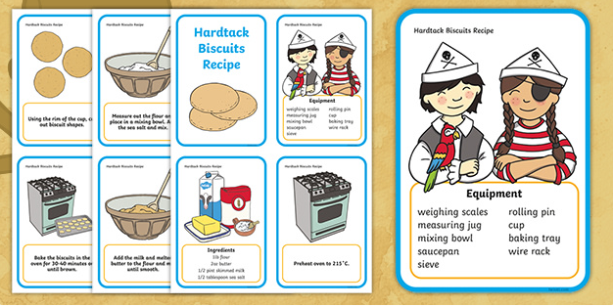  Key Skills: Weight, Mix, Shape and Bake  Attached: PDF - Pirate themed hardtack recipe - Green  Task2: Swashbuckle Smoothies - This recipe includes all the ingredients and instructions on how to create the Swashbuckle Smoothie and is perfect for developing independent learning, sequencing and life skills.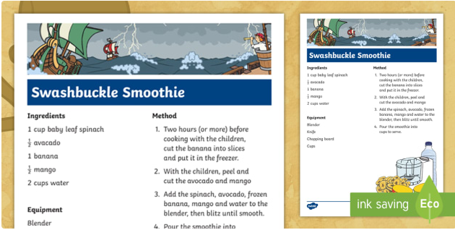  Key Skills: Chopping, Sequencing and Blending  Attached: Swashbuckle smoothie pirate recipe - Green  Technology:  Task: Egg box pirate ship - This is a fantastic activity where you can use an empty egg box and transform it into a pirate ship. The template of the sails are also included.  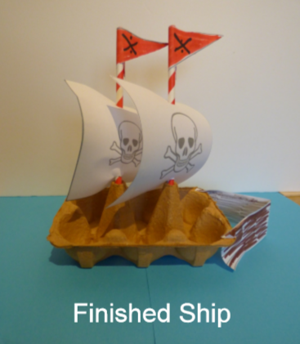  Attached: PDF - Egg box pirate ship instructions - Green  PDF - Egg box pirate ship resource - Green
Drama/Arts/Music | Task Focus: Develop imagination by pretending to be Sailors and Pirates  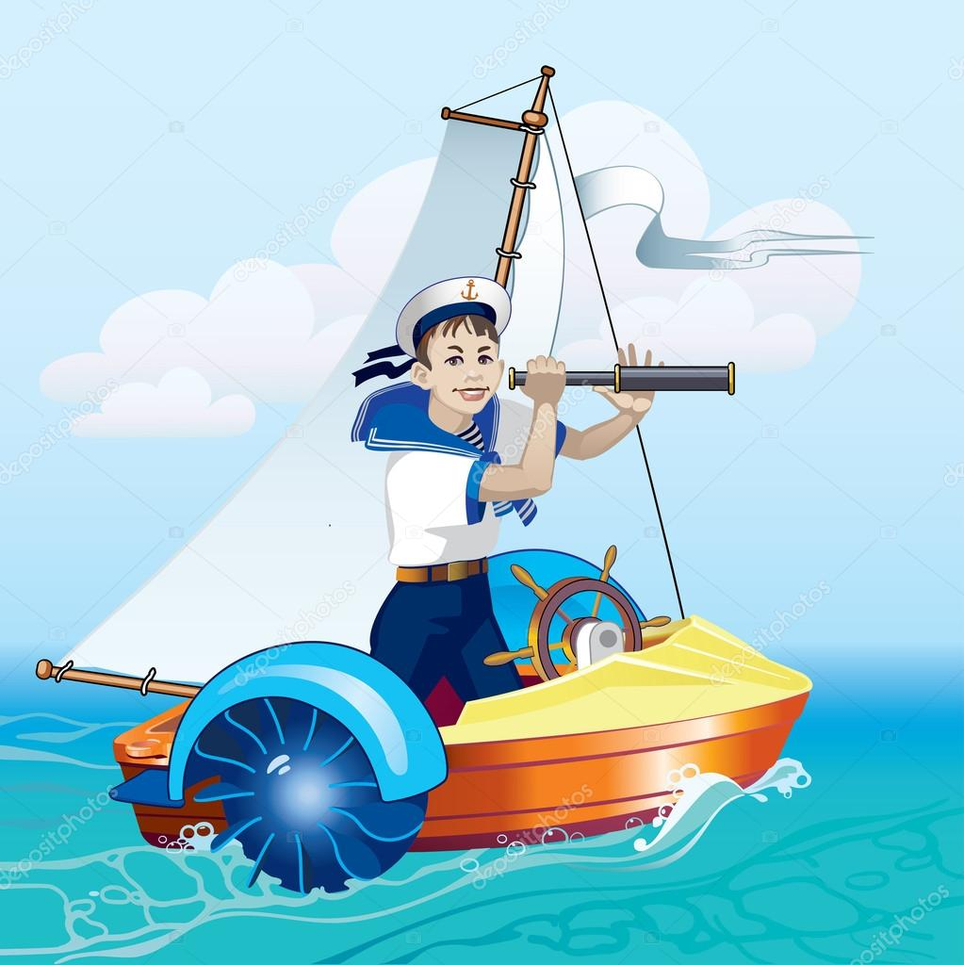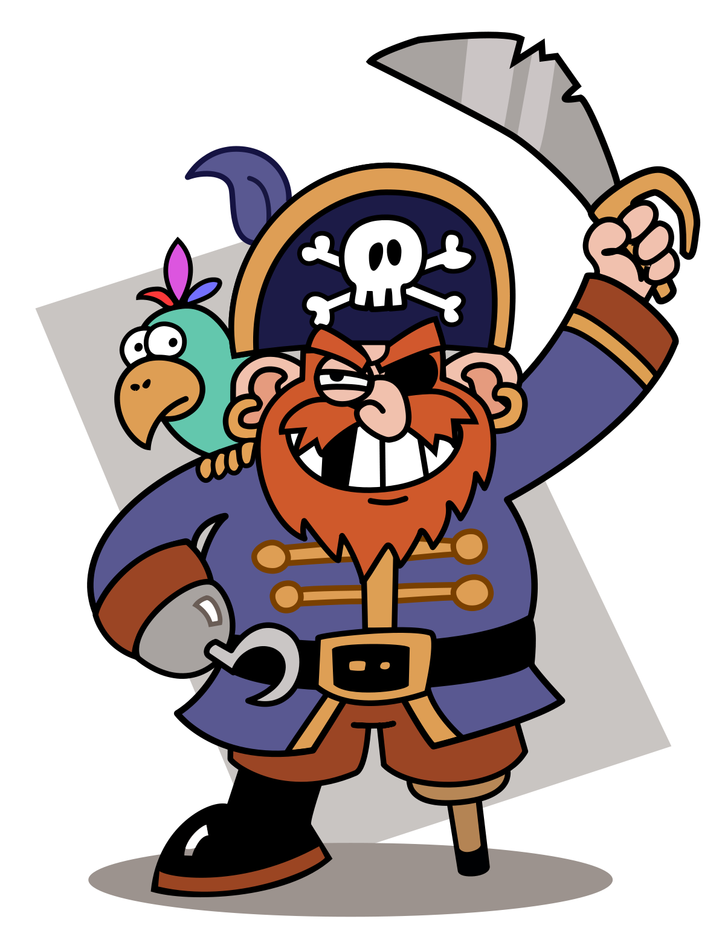  Key Information:  One of the jobs of a sailor is chasing pirates on the sea. Like the police chasing robbers in the city. What do you think a pirate is like?  What do you think a sailor is like? Start by making a sailor hat, you can turn it into a pirate hat by drawing a skull on it! (See Link)  Task helpful clip to watch:  How to make a sailor hat/boat  https://www.youtube.com/watch?v=T8hPKuqZsEc  Drawing a skull: How to draw a skull, step by step challenge:  https://www.youtube.com/watch?v=XBW1veqluvg  Materials Needed:  News paper or photocopy paper- 1 for each person playing.  Paper and scissors for sailor hats.  A scarf to use as a belt for the Pirate.  Keywords: Pirate Sailor Stop Start Hot Cold Treasure Listen Speak Decide Describe Clothes Hair Size.  Drama Games:For 2 or more people  Game 1: Hot and Cold -Hidden treasure  Everyone should find a piece of treasure, something they own which has meaning for them- this is an opportunity to learn something new about each other and what is important to each of you.  They should say why they chose their treasure and why it is important to them. Each person take-turns to be a pirate and hide the treasure in the room, while the others who are sailors try to find it. When someone is close to it, the hider says their name and you are hot but if everyone is far, they can say you are cold! Once the treasure is found make sure you congratulate the hider and the finder then let someone else take a turn in hiding their treasure.  Game 2: Spotting Pirates-You are all sailors on a ship, it’s quite wavy, so pretend to wobble around a bit. Take an empty kitchen roll to use as a telescope, use it to look through and spot the pirates. Everyone takes a turn to use the telescope. When you get it, pretend to spot a pirate and say what he or she looks like! In the second round try to make it harder by saying the other pirate descriptions as well as your own!  Other Activities  Making A Pirate Sword  https://www.youtube.com/watch?v=6hP79vMjinQ  Play Frog in the pond -do as I say not as I do!  https://www.youtube.com/watch?v=N34UNb6q9uA  Draw a map for hidden treasure on a tropical island  Draw a pirate ship  Make pirate treasure and use it to buy lunch or dinner?
Health and Wellbeing
Physical activity | Battle Pirate Ships: 2 people needed to play.  On three pieces of paper write (not thick marker that can be seen from the other side) “Pirate ship 1”, “Pirate ship 2”, “Pirate ship 3” and place face down with a number of other blank pieces of paper. The more blank pieces the harder it will be. Scatter them in a grid shape in front you. Players take it in turns to throw a softball or scrunched up piece of paper at the other players grid. Whichever piece of paper gets hit, gets turned over and if it is a Pirate ship then the ship is sunk. First player to sink all ships wins. You can change it around by adding more or less ships, increasing the distance between grids, or even if you have lots of plastic cups and having to land the ball in the cup to be able to see if it is a ship.  Cosmic Kids Yoga ‘Popcorn and the pirate’ https://www.youtube.com/watch?v=T_0P5grVoyg  Talk like a Pirate: Listening and Movement game - https://www.twinkl.co.uk/resource/t-tp-1303-talk-like-a-pirate-listening-and-movement-game  Pupils to draw a ‘treasure map’ of their garden/ home. Obj: Parents/ carers/ siblings to hide ‘treasure’ around the area for the students to find. Students are required to mark on the map the location of each treasure.  Treasure Island: At Home Addition - Pupils to create at least two ‘islands’ in the opposite direction, within the playing area. Objective: Pupils to stand in the middle of the playing area. When instructed, pupils need to run/ move to the correct ‘island’ within a certain time (decided by a family member). Progression: Communication skills - Pupils can instruct their family members to move to the designated ‘island’, making sure they use a clear and appropriate voice level.  Land or Sea: Play with members of your family.  One person in charge with those playing standing side by side on some form of “line”. Where they are standing is “land” and in front of the line is “sea”. The person in charge calls out “land” or “sea” and players must jump into the right section. Calls get faster and in different orders to try and trick the players. If you get it wrong you lose a life or are out.  Steal the Treasure: Play with at least 2 teams (you only need one per team if you like). Each team finds 10 (maybe more) items of “treasure”, these can be anything you like. Treasure is placed in a pile on your “island” and islands are as far apart as you like. There further apart the more fun it will be! The rules of the game are that 1 person from each team needs to run to another island and steal ONE piece of treasure and return it to their island before the next person on their team must go. The game continues for a period of time 2, 3, 5 minutes it is up to you. Whichever team can steal the most treasure the fastest is the winner. You can make it harder by trying to hide where your islands are in the house or garden or awarding different pieces of treasure more points if stolen.  ThisIsPE: Updated 3 times a week. Fun and easy activities to be done at home. https://www.youtube.com/results?search_query=thisisPE  Nike Move Crew: Fun games and dance activities led by Nike athletes. https://www.youtube.com/results?search_query=nike+move+crew  Go Noodle I Get Moving: Lots of videos to get children moving, dancing and exercising with lots of music and singing. https://www.youtube.com/user/GoNoodleGames
Cross Curricular | Task 1: Make your own Treasure Chest  Using a cardboard box (or any box you have lying around), make your very own treasure chest. Inside place objects that are special to you. Your own little treasures.  Examples:  - A shell or pebble from a beach you visited  - A picture of your family  - Trophies/ medals  - A sticker/ certificate you got in school  - Postcards/ birthday cards from friends and family  Decorate your treasure box with paint, paper, any materials you have.  Helpful videos: https://youtu.be/vL5EgeKtZ2I  Task 2 : Message in a bottle- ‘How do I feel today?’  Key information:  Make a message in a bottle and add rolled up pieces of paper of how you’re feeling everyday.  What you need:  - An empty bottle  - Paper  - Pen  - Emotion word map (as prompt) https://www.twinkl.co.uk/resource/t-s-1056-how-do-you-feel-today-emotions-chart  Instructions:  Everyday write down how you’re feeling on a piece of paper using the word map to help, if you want add why you feel like this eg. “I am happy because I made a pirate ship”.  Roll up your piece of paper and put it in the bottle.  You can decorate your bottle too!  

