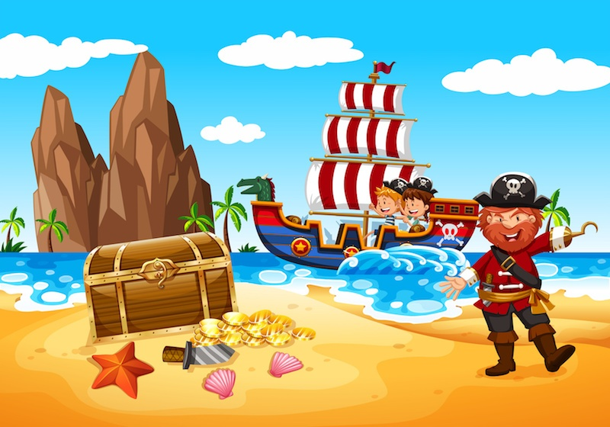
Pirates and Treasure
Aims: These tasks are designed to be done with your child. Blue coloured tasks are aimed at Pathway 1 pupils as well as pupils who prefer more interactive activities and require a higher level of support. These are tasks we hope you will enjoy, please select the ones you feel are most appropriate for your child.
Thinking
Literacy Focus: Building skills following a story sequence, making links between events in the story and the world around them. [See Note for Parents on powerpoint W5 Becoming a Pirate BLUE as]  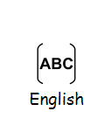  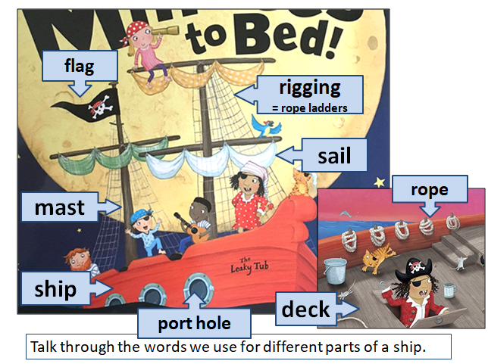  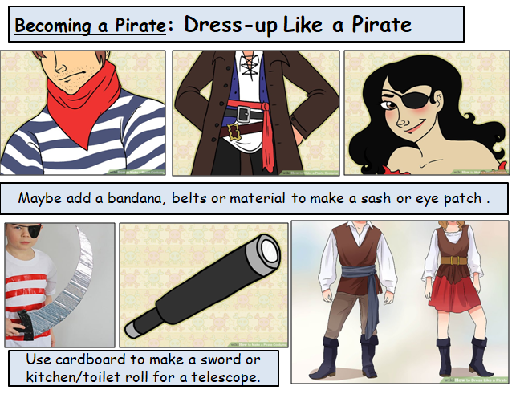  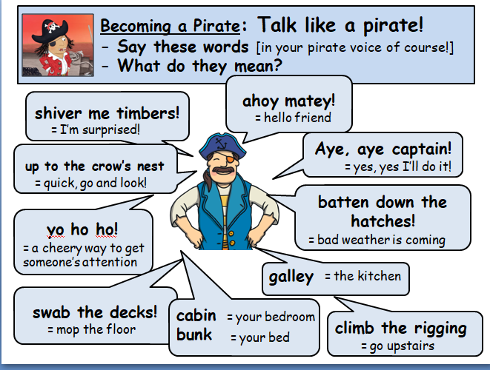 | Speaking & Listening and Reading:  Resources: https://www.youtube.com/watch?v=Bl5EKP1y4Ic  No internet, no problem - this story is on the powerpoint below...  Powerpoint W5 Skullabones Island PirateStory BLUE as  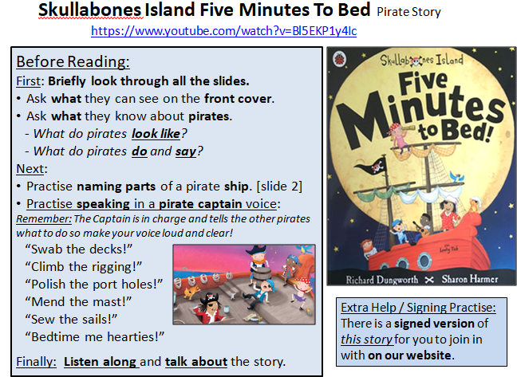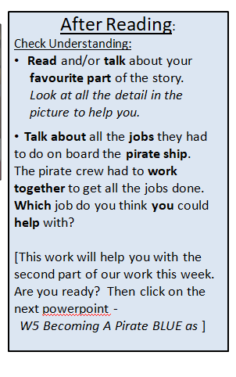  Speaking & Listening and Writing:  Resources: Powerpoint W5 Becoming a Pirate BLUE as  Optional: An old t-shirt or shirt, paint or felt tips, bandana, scarf or a strip of cloth. To make props cardboard, toilet/kitchen roll inner cardboard tube if you have them.  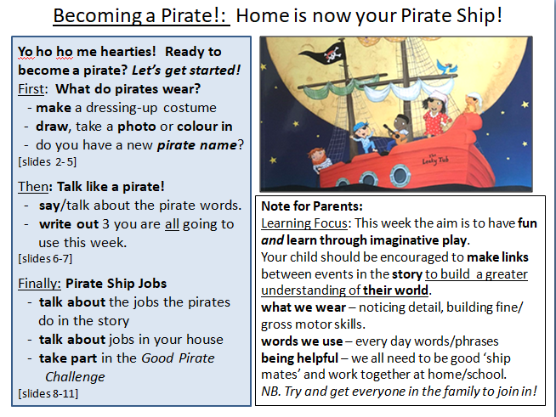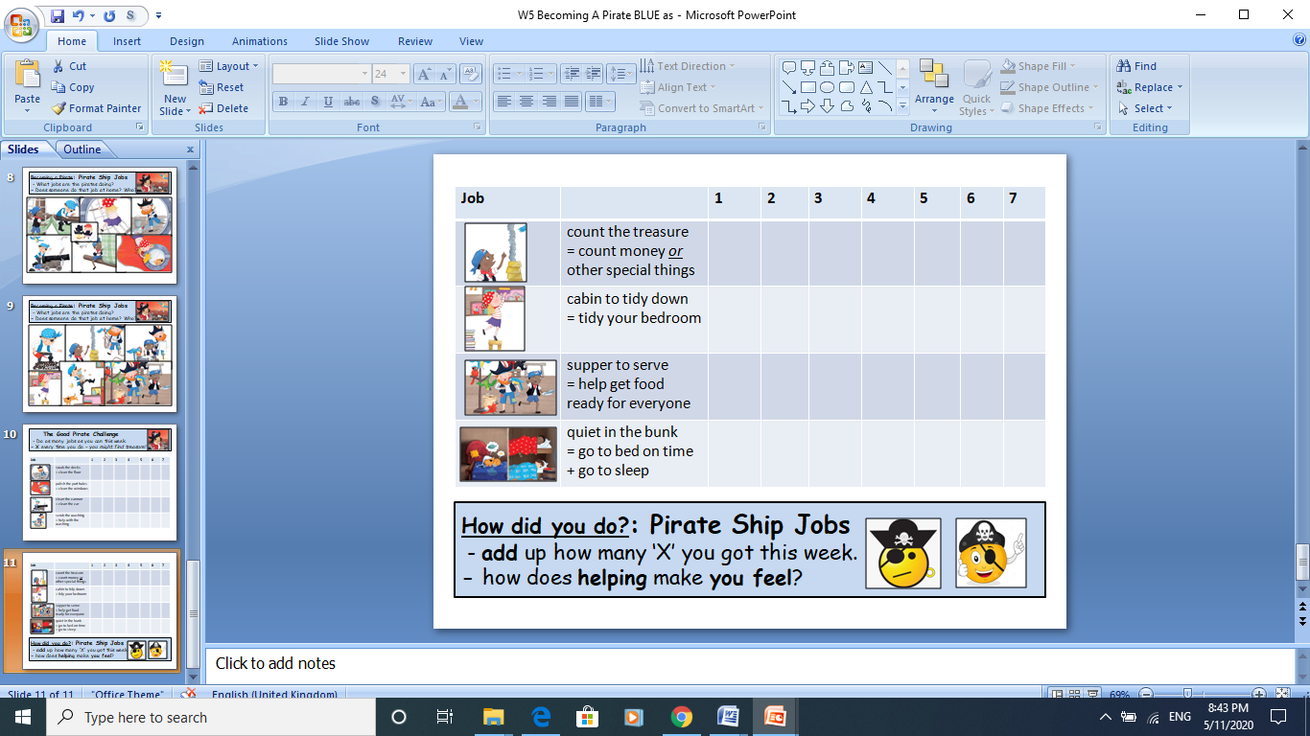
Maths Focus  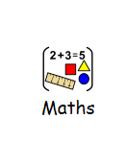 | Watch the video below:  https://www.youtube.com/watch?v=WT_wvvEvkw4  - Add with a pirate and find the sums.  Watch the video below:  https://www.youtube.com/watch?v=QkPa9V2wtZs  - Take away with a pirate and find how many left.  Discuss the meaning of addition and subtraction.  Can you remember the addition symbol?  Can you remember the subtraction symbol?  Can you remember the equals sign?  - Attempt to write your own number sentences with additions within 10 or 20 or even 50!  - Attempt to write your own number sentences with subtractions within 10 or 20 or even 50!  - Play treasure hunt with your family. Hide some coins in a little bag. Follow the directions to find the treasure in your house / garden. Count your treasure.  - Maths pirate activity booklet  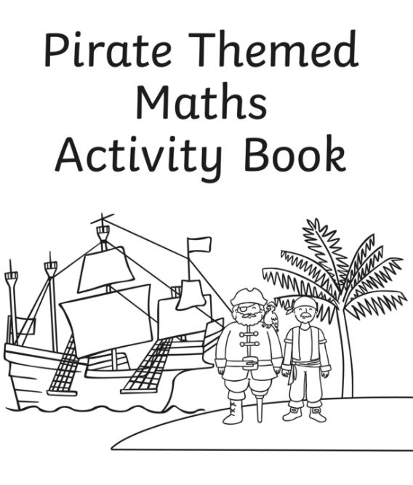  - Design your own pirate flag using shapes only!  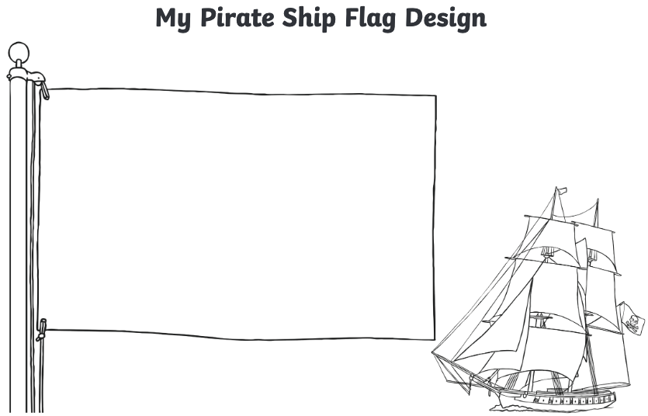  - I Spy Pirate counting to 20  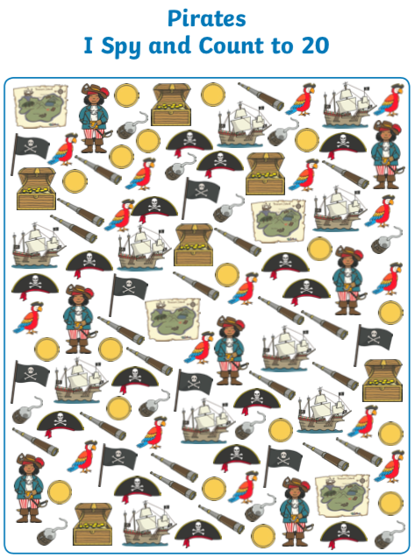
Science Focus   | Task 1: Create a waterproof pirate ship - Explore and discover different materials around your home that you can stick on your pirate ship.Using water, check to see which materials are waterproof and which materials absorb water.  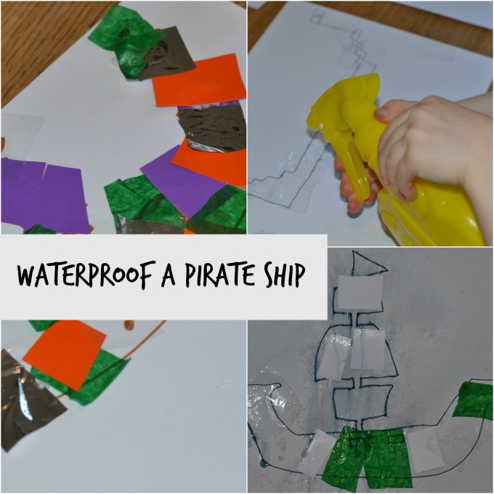  Link: https://www.science-sparks.com/waterproof-pirate-ship/  Task 2: Does it sink or float? - Do you know why things float in water?  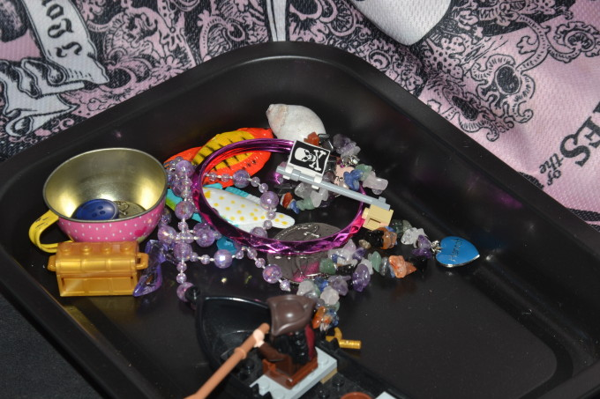
Creativity
Cooking/Technology 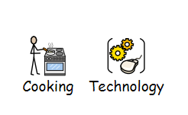 | Cooking:  Task: Cheese and Apple Pirate Ships - This is a fun step-by-step recipe where students can create lovely cheese and apple pirate ships. Once made, they can explore the different flavour combinations and the textures.  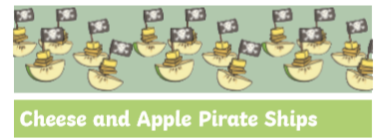  Key Skills: Cut with assistance and assemble  Attached: PDF - Cheese and apple pirate ships - Blue  Technology:  Task1: Pirate Treasure Hunt  - Open up Google Maps and click on directions  - Ask your child to input their address and support them where required  - Ask your child to input a second address of their choosing as the point of the treasure location  - Use the information on Maps to find out how far is the treasure location? How long will it take to get there?  Task2: Interactive phonics treasure game  This is a fun interactive game where students can apply phonic knowledge and skills as the route to decoding words when reading.  Link: https://www.ictgames.com/mobilePage/poopDeck/
Drama/Arts/Music   | Task1 Focus: Task focus: Making a pirate hat and eyepatch.  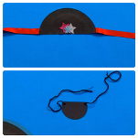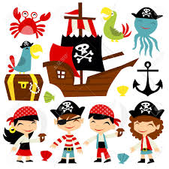  Key Information:  Not all little pirates are lucky enough to be fully outfitted when they hop aboard a ship. If your child has not got their own gear, why don’t you start making your own pirate hat and eyepatch in less than 15 minutes!  Task helpful clip to watch:  https://www.bbc.co.uk/cbeebies/makes/swashbuckle-make-your-own-pirate-hat-eyepatch  https://www.twinkl.co.uk/resource/t-t-16878-paper-pirate-hat Pirate hat  You can also used attached pages on the website.attachment pages  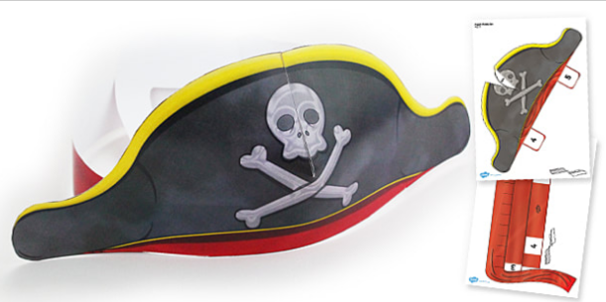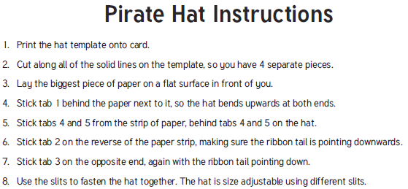  Materials Needed:  A paper plate  · Black paint  · A paintbrush  · Glue  · Ribbon  · Decorations  · Scissors (grown-up use only)  · A pencil and crayon  · A ruler  · Black card  · A cup  · Modelling clay  · Wool  Keywords: pirate hat, pirate eyepatch, pirate life, rowing.  Other Activities  Pirate Drama:  After making your cool pirate hat and eyepatch why don’t you watch the Drama Tots and become a pirate. Be prepared! because you will have to do a lot of rowing and pirate jobs. Follow the link below:  https://youtu.be/Y8dMNsd_m1k  Other optional ideas for wider learning:  Follow the link below and find out how Jeremy Jacobs became a pirate: https://youtu.be/y4m_BW5yddU
Health and Wellbeing
Physical activity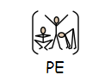 | Cosmic Kids Yoga ‘Popcorn and the pirate’ https://www.youtube.com/watch?v=T_0P5grVoyg  Talk like a Pirate: Listening and Movement game - https://www.twinkl.co.uk/resource/t-tp-1303-talk-like-a-pirate-listening-and-movement-game  Pupils to draw a ‘treasure map’ of their garden/ home. Obj: Parents/ carers/ siblings to hide ‘treasure’ around the area for the students to find. Students are required to mark on the map the location of each treasure.  Treasure Island: At Home Addition - Pupils to create at least two ‘islands’ in the opposite direction, within the playing area. Objective: Pupils to stand in the middle of the playing area. When instructed, pupils need to run/ move to the correct ‘island’ within a certain time (decided by a family member). Progression: Communication skills - Pupils can instruct their family members to move to the designated ‘island’, making sure they use a clear and appropriate voice level.  Land or Sea: Play with members of your family.  One person in charge with those playing standing side by side on some form of “line”. Where they are standing is “land” and in front of the line is “sea”. The person in charge calls out “land” or “sea” and players must jump into the right section. Calls get faster and in different orders to try and trick the players. If you get it wrong you lose a life or are out.  Steal the Treasure: Play with at least 2 teams (you only need one per team if you like). Each team finds 10 (maybe more) items of “treasure”, these can be anything you like. Treasure is placed in a pile on your “island” and islands are as far apart as you like. There further apart the more fun it will be! The rules of the game are that 1 person from each team needs to run to another island and steal ONE piece of treasure and return it to their island before the next person on their team must go. The game continues for a period of time 2, 3, 5 minutes it is up to you. Whichever team can steal the most treasure the fastest is the winner. You can make it harder by trying to hide where your islands are in the house or garden or awarding different pieces of treasure more points if stolen.  ThisIsPE: Updated 3 times a week. Fun and easy activities to be done at home. https://www.youtube.com/results?search_query=thisisPE  Nike Move Crew: Fun games and dance activities led by Nike athletes. https://www.youtube.com/results?search_query=nike+move+crew  Go Noodle I Get Moving: Lots of videos to get children moving, dancing and exercising with lots of music and singing. https://www.youtube.com/user/GoNoodleGames
Cross Curricular | Task 1: Make your own Treasure Chest  Using a cardboard box (or any box you have lying around), make your very own treasure chest. Inside place objects that are special to you. Your own little treasures.  Examples:  - A shell or pebble from a beach you visited  - A picture of your family  - Trophies/ medals  - A sticker/ certificate you got in school  - Postcards/ birthday cards from friends and family  Decorate your treasure box with paint, paper, any materials you have.  Helpful videos: https://youtu.be/vL5EgeKtZ2I  Task 2 : Message in a bottle- ‘How do I feel today?’  Key information:  Make a message in a bottle and add rolled up pieces of paper of how you’re feeling everyday.  What you need:  - An empty bottle  - Paper  - Pen  - Emotion word map (as prompt) https://www.twinkl.co.uk/resource/t-s-1056-how-do-you-feel-today-emotions-chart  Instructions:  Everyday write down how you’re feeling on a piece of paper using the word map to help, if you want add why you feel like this eg. “I am happy because I made a pirate ship”.  Roll up your piece of paper and put it in the bottle.  You can decorate your bottle too!  

