Animals and Nature
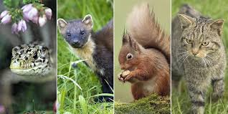
Aims: These tasks are designed to be done with your child. Purple coloured tasks are aimed at pupils who would enjoy more of a challenge . These are tasks where pupils should be working with greater independence, however please take time to support pupils in starting the tasks and build communication skills.
Thinking
Literacy Focus: Completing extended research over a range of texts.  Identifying and recording key information in texts.  Writing an information leaflet.  Key Terms to try and learn:  non-fiction = facts and information  fact = a true piece of information  fiction = made up/story  key information = the most important information  brief notes = are to help you remember key information. Notes should be just words/short phrases - not full sentences. NB. You should be able to quickly scan and re-read.  paragraph = a short section of writing.  heading = what the text is about.  sub-heading = what that section of text is about.  leaflet = a piece of paper giving information on a particular subject.  format = to organise or arrange a particular way for a particular type of text eg letter, newspaper article  structure = the way that the text is organised to help the reader.  style = the writer’s choice of words, sentence structure.  images =photos or illustrations  audience = is a person or group of people listening to or reading a text. | First: Speaking, Listening & Communication AND Writing:  Wildlife Extended Research [non-fiction texts]  Watch, discuss and make brief notes on TWO different animals.  Key skills to develop - listening carefully, identifying and recording key information in note form.  Resources: Yellow workbook. For this task you will need to watch a section of a nature documentary.  Here are some suggestions but use any animal programme you like  Deadly and Dangerous Steve Backshall  https://www.bbc.co.uk/programmes/p00kf6jh  Deadly 60 Steve Backshall Click here for a wide range of animal video clips.  https://www.bbc.co.uk/cbbc/shows/deadly-60  Planet Earth II David Attenborough This is a longer documentary but really good!  https://www.bbc.co.uk/iplayer/episode/p048sflc/planet-earth-ii-1-islands  Next: Read through the TWO example information leaflets  Gorilla Information Leaflet middle as  Gorilla Information Leaflet higher as  Focus: Think about who the audience for these leaflets is; how does the writer change the format, content, style and use of images? Who do you think the audience for each text is? Why?  Finally: Use your notes to create your own information leaflet about ONE of the animals you researched.  Focus: Who is your audience? How will you edit your notes - what information will you include? How will you structure the text and adjust the style to communicate the information you have learnt clearly?  Extra Study: Writing a letter [formal] to Paradise Wildlife Park to apply for a job as a keeper at their zoo.  1. Watch the videos below to learn more about the job of a zookeeper.  A Day in the Life of Zoo Keeper at Paradise Wildlife Park  https://www.youtube.com/watch?v=bIjQ4tAi49M  https://www.youtube.com/watch?v=KMmErFORdJ  2. Write a letter using the correct format,structure and style.  Include your address so that they can write back, today’s date, why you are writing, why you would be good at the job, sign your name clearly.
Maths Focus | - GCSE Maths revision topics  https://mathsmadeeasy.co.uk/gcse-maths-revision/  - Increasing and decreasing numbers by a percentage  https://www.youtube.com/watch?v=tjratsnlap8  - Calculating area  https://www.youtube.com/watch?v=PiwGstMGdPs  - Calculating perimeter  https://www.youtube.com/watch?v=o6Txi1zq8CM
Science Focus | Task: Make sun prints:  https://curiodyssey.org/activities/science-experiments-for-kids/how-to-make-sun-prints/  Task: Make an invertebrate hotel:  https://curiodyssey.org/activities/science-experiments-for-kids/how-to-make-an-invertebrate-hotel/  Predator and Prey:  Task: Research what a predator and what a prey is  Task: Create a list of animals and write down whether they are predators or preys  Task: Using your list of animals create a food chain  Task: Interactive food chains:  https://www.sheppardsoftware.com/content/animals/kidscorner/games/foodchaingame.htm
Creativity
Cooking/Technology | 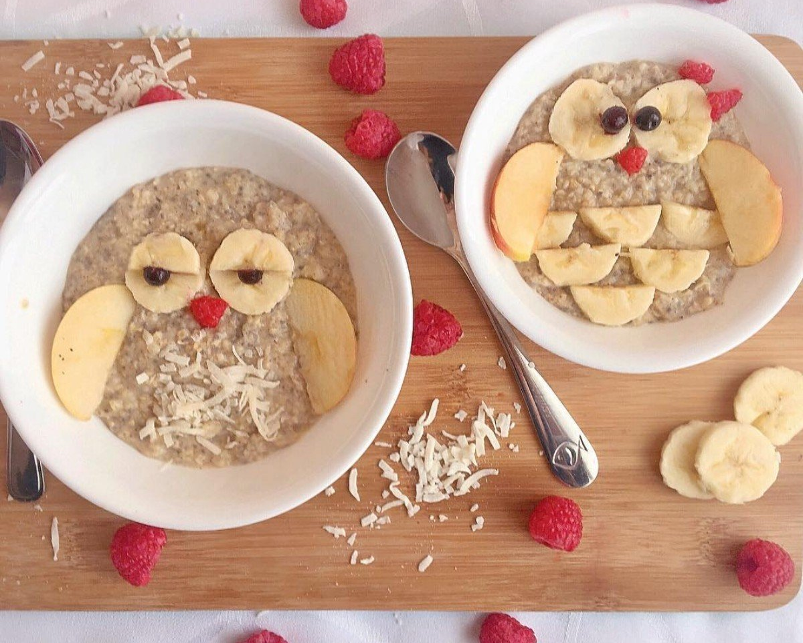  Recommended Recipe: Wholly Cute Wholesome Oats  Making breakfast fun! Why not get your child to make their own breakfast. It can be made with porridge or weetabix and add fruit to make an owl (Suggested fruit: bananas, blueberries, raspberries, apples)  Key Skills: Encourage independence, slicing the fruit, arranging fruit to look like an owl.  Cooking Task: Like a bit more challenge? Choose from these animal themed recipes!  https://www.tasteofhome.com/collection/animal-shaped-foods/  Cooking Task: Why not make an animal inspired snack. Try to get your child to do one of these recipes independently.  https://www.mommynearest.com/article/10-easy-animal-themed-snacks-for-your-preschooler  Technology Task: Zoo Themed STEM challenge! Design and make some of the buildings/ places you would have seen at the zoo. https://www.sarajcreations.com/2017/03/zoo-themed-stem-activity.html
Drama/Arts/Music  Other optional tasks for wider learning: | 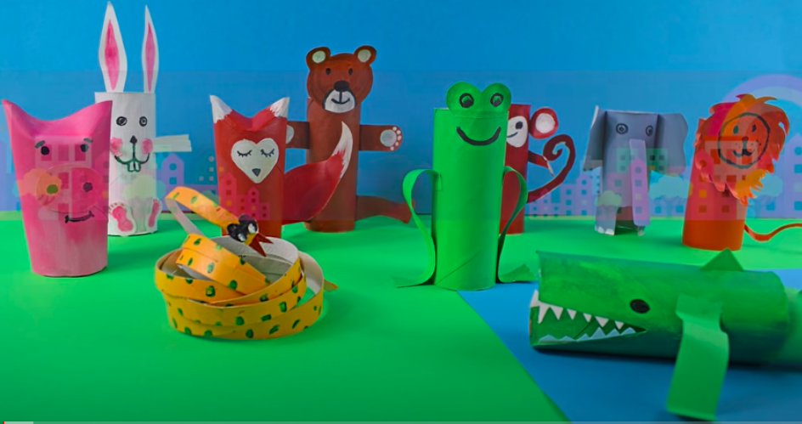  Task Focus: Making an animal kingdom  Key Information:  In art we like to make props to inspire imagination and interacting with each other. Have a go making an animal from recycled materials  Task helpful clip to watch:  Art: Toilet paper animals  https://www.youtube.com/watch?v=6NRBJR7-aGQ  Materials Needed:  Old kitchen rolls or Microwaved toilet roll centres.  Scissors, a range of the following (not all needed) :recycled packaging, glue, stapler or cellotape, string or wool, Cardboard, any old wrapping paper , tissue paper.  Ready Mix paint if possible but not necessary water pot, Paint brush apron etc..)  Keywords:  Sounds, Animals,sculpture  Other optional tasks for wider learning:  https://www.youtube.com/watch?v=Kb6rxy_Lpx0  (These may need adult support)  Work Sheet provided in art booklet-  Draw the Rabbit or lion using the step by step shape drawing guide provided or have a go tracing the finished animal.
Health and Wellbeing
Physical activity | Fitness Blender: Build your own circuit training session  https://www.fitnessblender.com/videos  Nike Move Crew: Fun games and dance activities led by Nike athletes. https://www.youtube.com/results?search_query=nike+move+crew  ThisIsPE: Updated 3 times a week. Fun and easy activities to be done at home. https://www.youtube.com/results?search_query=thisisPE  Pupils to draw ‘a map’ of their garden/ home. Obj: Parents/ carers/ siblings to hide objects around the set area for the students to find. Students are required to mark on the map the location of each item.  During your “once a day” walk, why not gather some leaves and make some patterns/collages  https://www.google.com/search?q=collage+making+with+dry+leaves&rlz=1C1GGRV_enGB751GB751&oq=making+dry+leav&aqs=chrome.5.69i57j0l7.13364j0j8&sourceid=chrome&ie=UTF-8
Cross Curricular  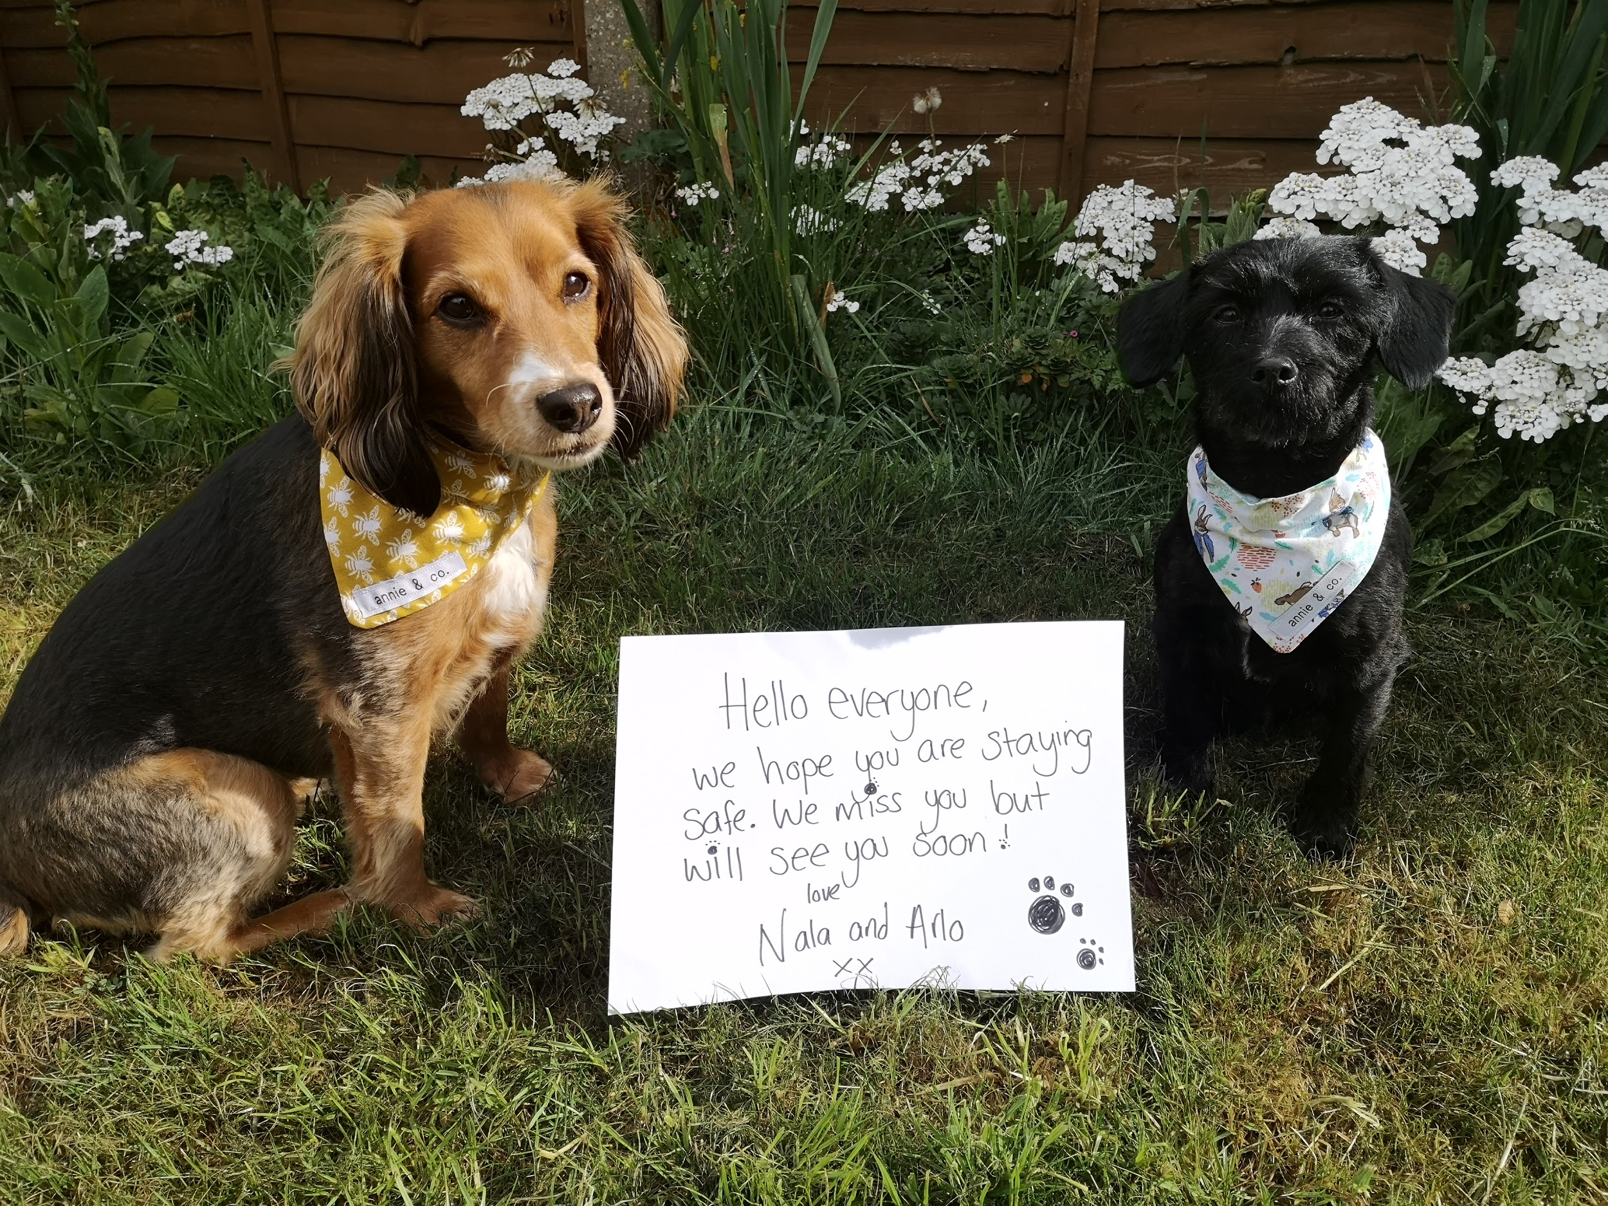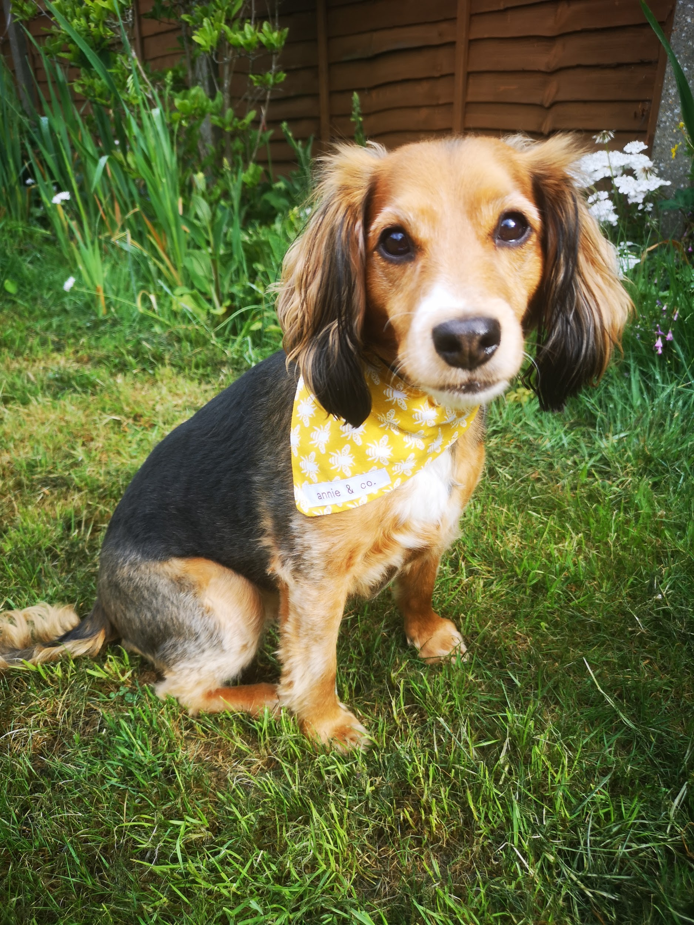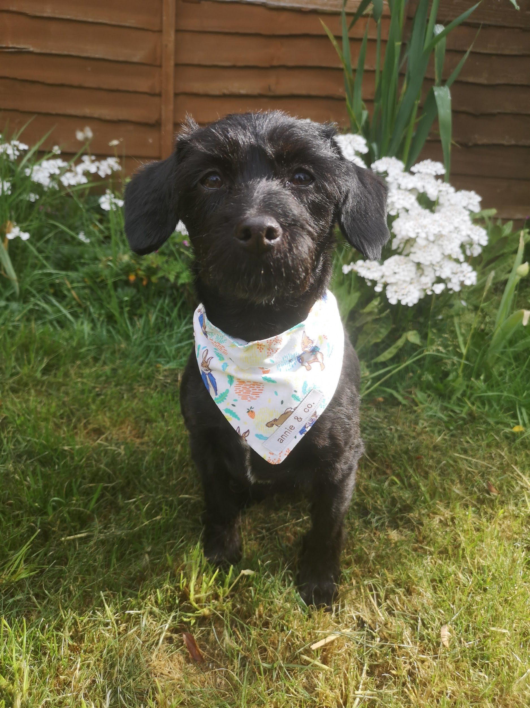 | PSHCE:  1)Create a how to care for ……. (pet/animal of your choice) profile. (All about a pet worksheet on Twinkl)  https://www.twinkl.co.uk/event/national-pet-month-202ve  If you don’t have a pet or are struggling to pick an animal, why not draw and create an animal profile of Nala or Arlo? They would love to see what you create!  2)Caring for animals is so important which we all know. Many of the students were able to spend time with school bunnies Gunner and Teddy and would be able to tell you lots about them. If you have seen the films Peter Rabbit, Chicken Run or Shaun the Sheep Movie there are wonderful powerpoints https://www.intofilm.org/resources/1468 with activities all film and animal care related!  Nala and Arlo would love to see any pet profiles and pictures you draw of animals so please email pictures over to petsastherapy@meadowhighschool.org for us to collate and create a collage.

