Animals and Nature
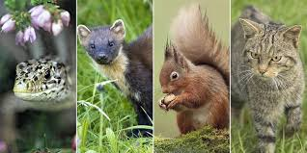

Aims: These tasks are designed to be done with your child. Blue coloured tasks are aimed at Pathway 1 pupils as well as pupils who prefer more interactive activities and require a higher level of support. These are tasks we hope you will enjoy, please select the ones you feel are most appropriate for your child.
Thinking
Literacy Focus: Link to building descriptive language vocabulary in the Elmer story set last week.  Expressing a personal preference  Focus: Like  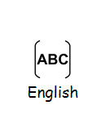  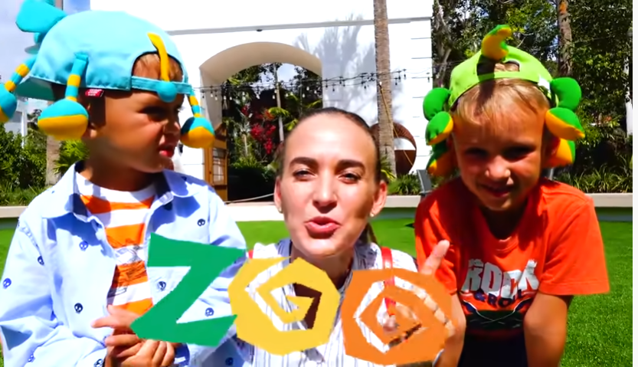  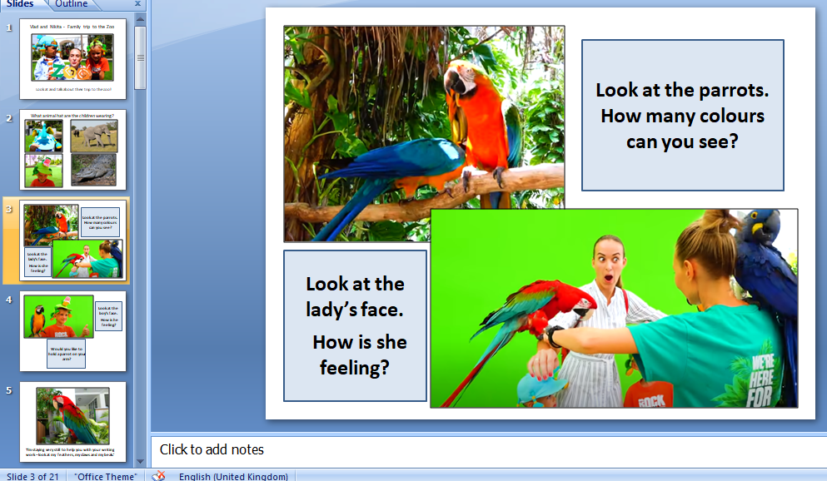  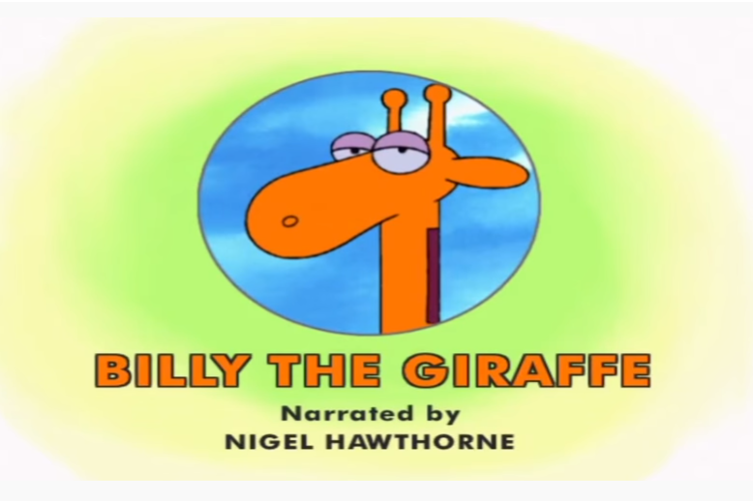 | Speaking, Listening & Communication:  Watch the trip to the zoo experience: [non-fiction = facts + information ]  https://www.youtube.com/watch?v=Smgjxn8hKfk  [Powerpoint version of this video is available to -  Look at and talk about ‘Trip to the Zoo BLUE as’ - it will help you to talk through some moments from the video and help with the tasks below.]  Reading & Understanding:  - What animals did you see?  - Complete CIP worksheet ‘What animals did you see at the zoo?’  Fine Motor/Creative work:  - Which animal is your favourite?  - Complete CIP worksheet ‘Your favourite animal at the zoo?’  Expressing a personal preference/Language development:  - Think about and talk about why you like this animal  Writing:  - Can you talk about and write what a parrot looks like?  - Complete CIP worksheet ‘Describe what a parrot looks like’.  [Note to parents: CIP = Communicate in Print. A programme designed to create symbol supported, accessible resources to aid communication and learning.]  Extension Work: Short Animal Stories [fiction = made up story]  Billy the Giraffe [link to last week’s theme of friendship]  https://www.youtube.com/watch?v=3Zt8K4tXeuc  The Very Hungry Caterpillar [favourite stories, creatures you might see in the garden or park and of course food!]  https://www.youtube.com/watch?v=0-NhjfJ_RZI  The Mixed-Up Cameleon [If you like the style of The Very Hungry Caterpillar - a bit harder but it’s good; it’s about learning to be happy being who you are.]  https://www.youtube.com/watch?v=FrmZeXf7ScU  Mr Tumble Something Special We’re All Friends Series 9: 1 Washing Pig  https://www.bbc.co.uk/iplayer/episode/b03qkw87/something-special-were-all-friends-series-9-1-pig-washing [non-fiction signed children’s programme]
Maths Focus  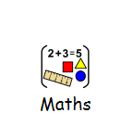 | - Click on the link below:  https://www.sheppardsoftware.com/preschool/animals/jungle/animaljunglefindcountgame.htm  Follow the instructions, find and count the animals in the jungle  Can you remember how many gorillas you have seen?  Can you remember how many lions you have counted all together?  How many gorillas and crocodiles are all together?  What animal was the largest in size?  What animal was the smallest in size?  What animal was the longest in length?  Complete basic additions and subtractions with jungle animals:  Jungle Animal Themed Subtraction Worksheet  Jungle Animal Themed Addition Sheet  Draw various jungle animals and compare their colours, sizes, lengths and heights.  - Counting in 10’s animal dot to to - free download  https://www.twinkl.co.uk/resource/t-t-12468-counting-in-10s-dot-to-dot-sheets-animals  - Sort the animals  https://mathsframe.co.uk/en/resources/resource/547/Animal-Sorting-Maths-Game
Science Focus   | Task: Taste Testing Without Smell: Some foods taste better than others but what gives us the ability to experience all these unique flavours? Carry out this simple experiment to see that there's a lot more to taste than you might have first thought: https://www.sciencekids.co.nz/experiments/smelltaste.html  Task: Make art with snails: Have you been wondering what to do with all of those snails in your garden? This project combines science and art!  https://curiodyssey.org/activities/science-experiments-for-kids/how-to-make-art-with-snails/  Task: Habitat online lesson https://en.e-learningforkids.org/science/lesson/mexico-animal-habitats/  Task:Matching animals to their habitats interactive game  https://matchthememory.com/animalhabitatsgame
Creativity
Cooking/Technology  | 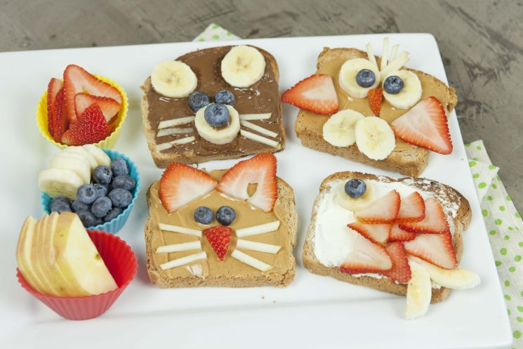  Recommended Recipe: Animal Toast  Why not use up any fruit you may have at home and create an animal inspired toast. You can use any bread, spread (peanut butter/nutella/cream cheese) and any fruit (suggestion: strawberries, banana, blueberries)  Key Skills: Spreading, supported cutting, copy the image above.  Cooking Tasks: Animal Themed Cooking ideas. Choose a recipe and enjoy!  https://www.kids-cooking-activities.com/animal-theme-food.html  https://www.allrecipes.com/recipes/1654/holidays-and-events/events-and-gatherings/special-themes/animals/  Technology Task: Animal craft ideas to choose from.  https://www.easypeasyandfun.com/animal-crafts-for-kids/
Drama/Arts/Music   | 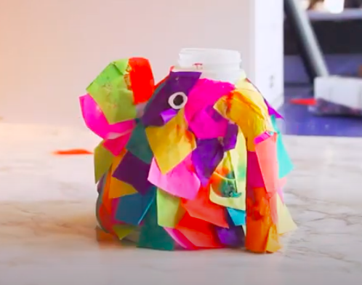  Task Focus: Making a 3D Elmer from recycled materials  Key Information:  In art and we like to make props to inspire imagination and interacting with each other  Have a go making an Elmer from recycled materials  Then try to act out what Elmer would be like, Where would Elmer go or live?  You could even research where real animals live.  Task helpful clip to watch:  Make an Elmer  Basic Task-https://www.youtube.com/watch?v=eub7Pe6DZIc  Materials Needed:  Scissors, Milk bottle Scissors Glue Tape Tissue paper (could also use coloured paper or Post it Notes).  Keywords:  Elmer Animals Materials  Other Options:  Colouring sheet-Art outline the animals and lettering and colour the picture- See attached booklet
Health and Wellbeing
Physical activity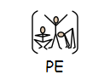 | During your daily exercise - count how many animals you spotted in your garden/ during your walk, etc.  Cosmic Kids Yoga ‘We’re going on a bear hunt’ https://www.youtube.com/watch?v=KAT5NiWHFIU  Animal exercise for kids with real animals  https://www.youtube.com/watch?v=26guG6wr5so  Pupils to draw ‘a map’ of their garden/ home. Obj: Parents/ carers/ siblings to hide objects around the set area for the students to find. Students are required to mark on the map the location of each item.  Minibeast Orienteering worksheet: https://www.twinkl.co.uk/resource/T-T-019-Minibeast-hunt-sheet  Cosmic Kids Yoga: ‘Jungle Safari’ https://www.youtube.com/watch?v=C4CaR0syf1g  Go Noodle I Get Moving: https://www.youtube.com/user/GoNoodleGames  Animal Athletics Team  Can you make an Athletics Team out of animals?  Think about each event individually and show your understanding of the events and animals by picking the right ones!  Think of/ watch films for ideas: Madagascar, Lion King, Jungle book.  Examples  100m - Quick.  Shot Putt – Strong.  Long Jump – Jumps a lot
  Event | Animal | Reason why
  100m
  200m
  1500m
  Marathon
  High Jump
  Javelin
  Shot Putt
  Long Jump
  Diving
  50m Swimming
Cross Curricular  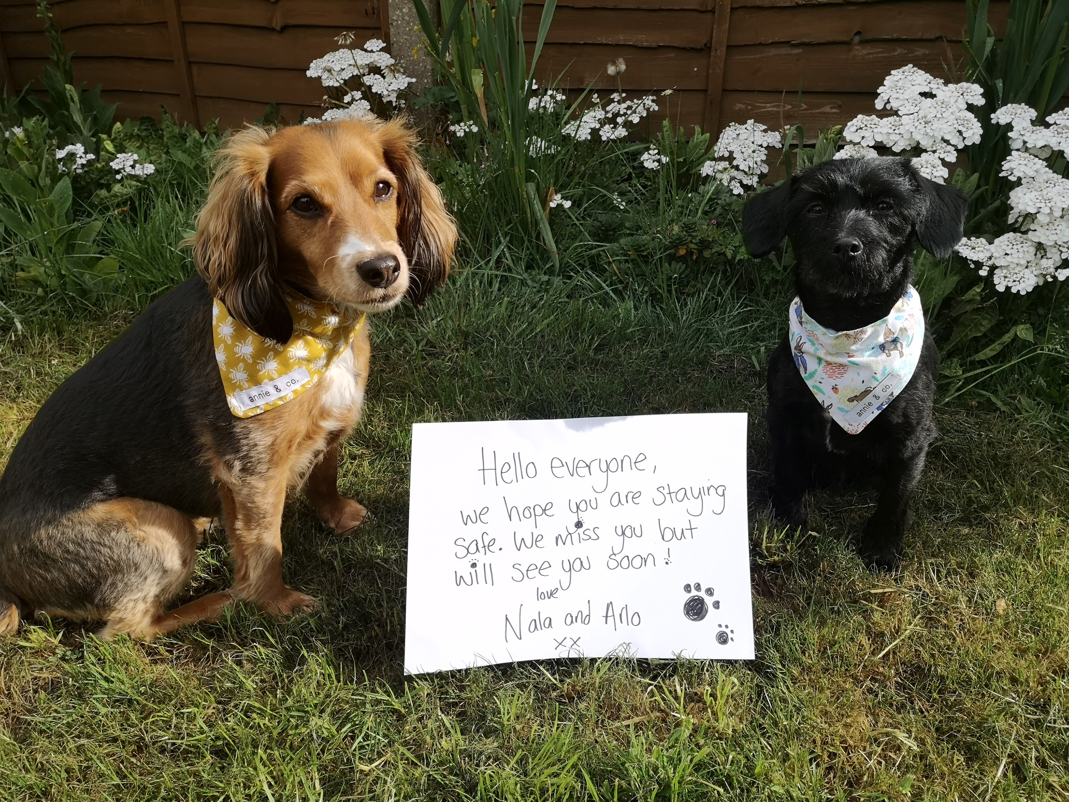  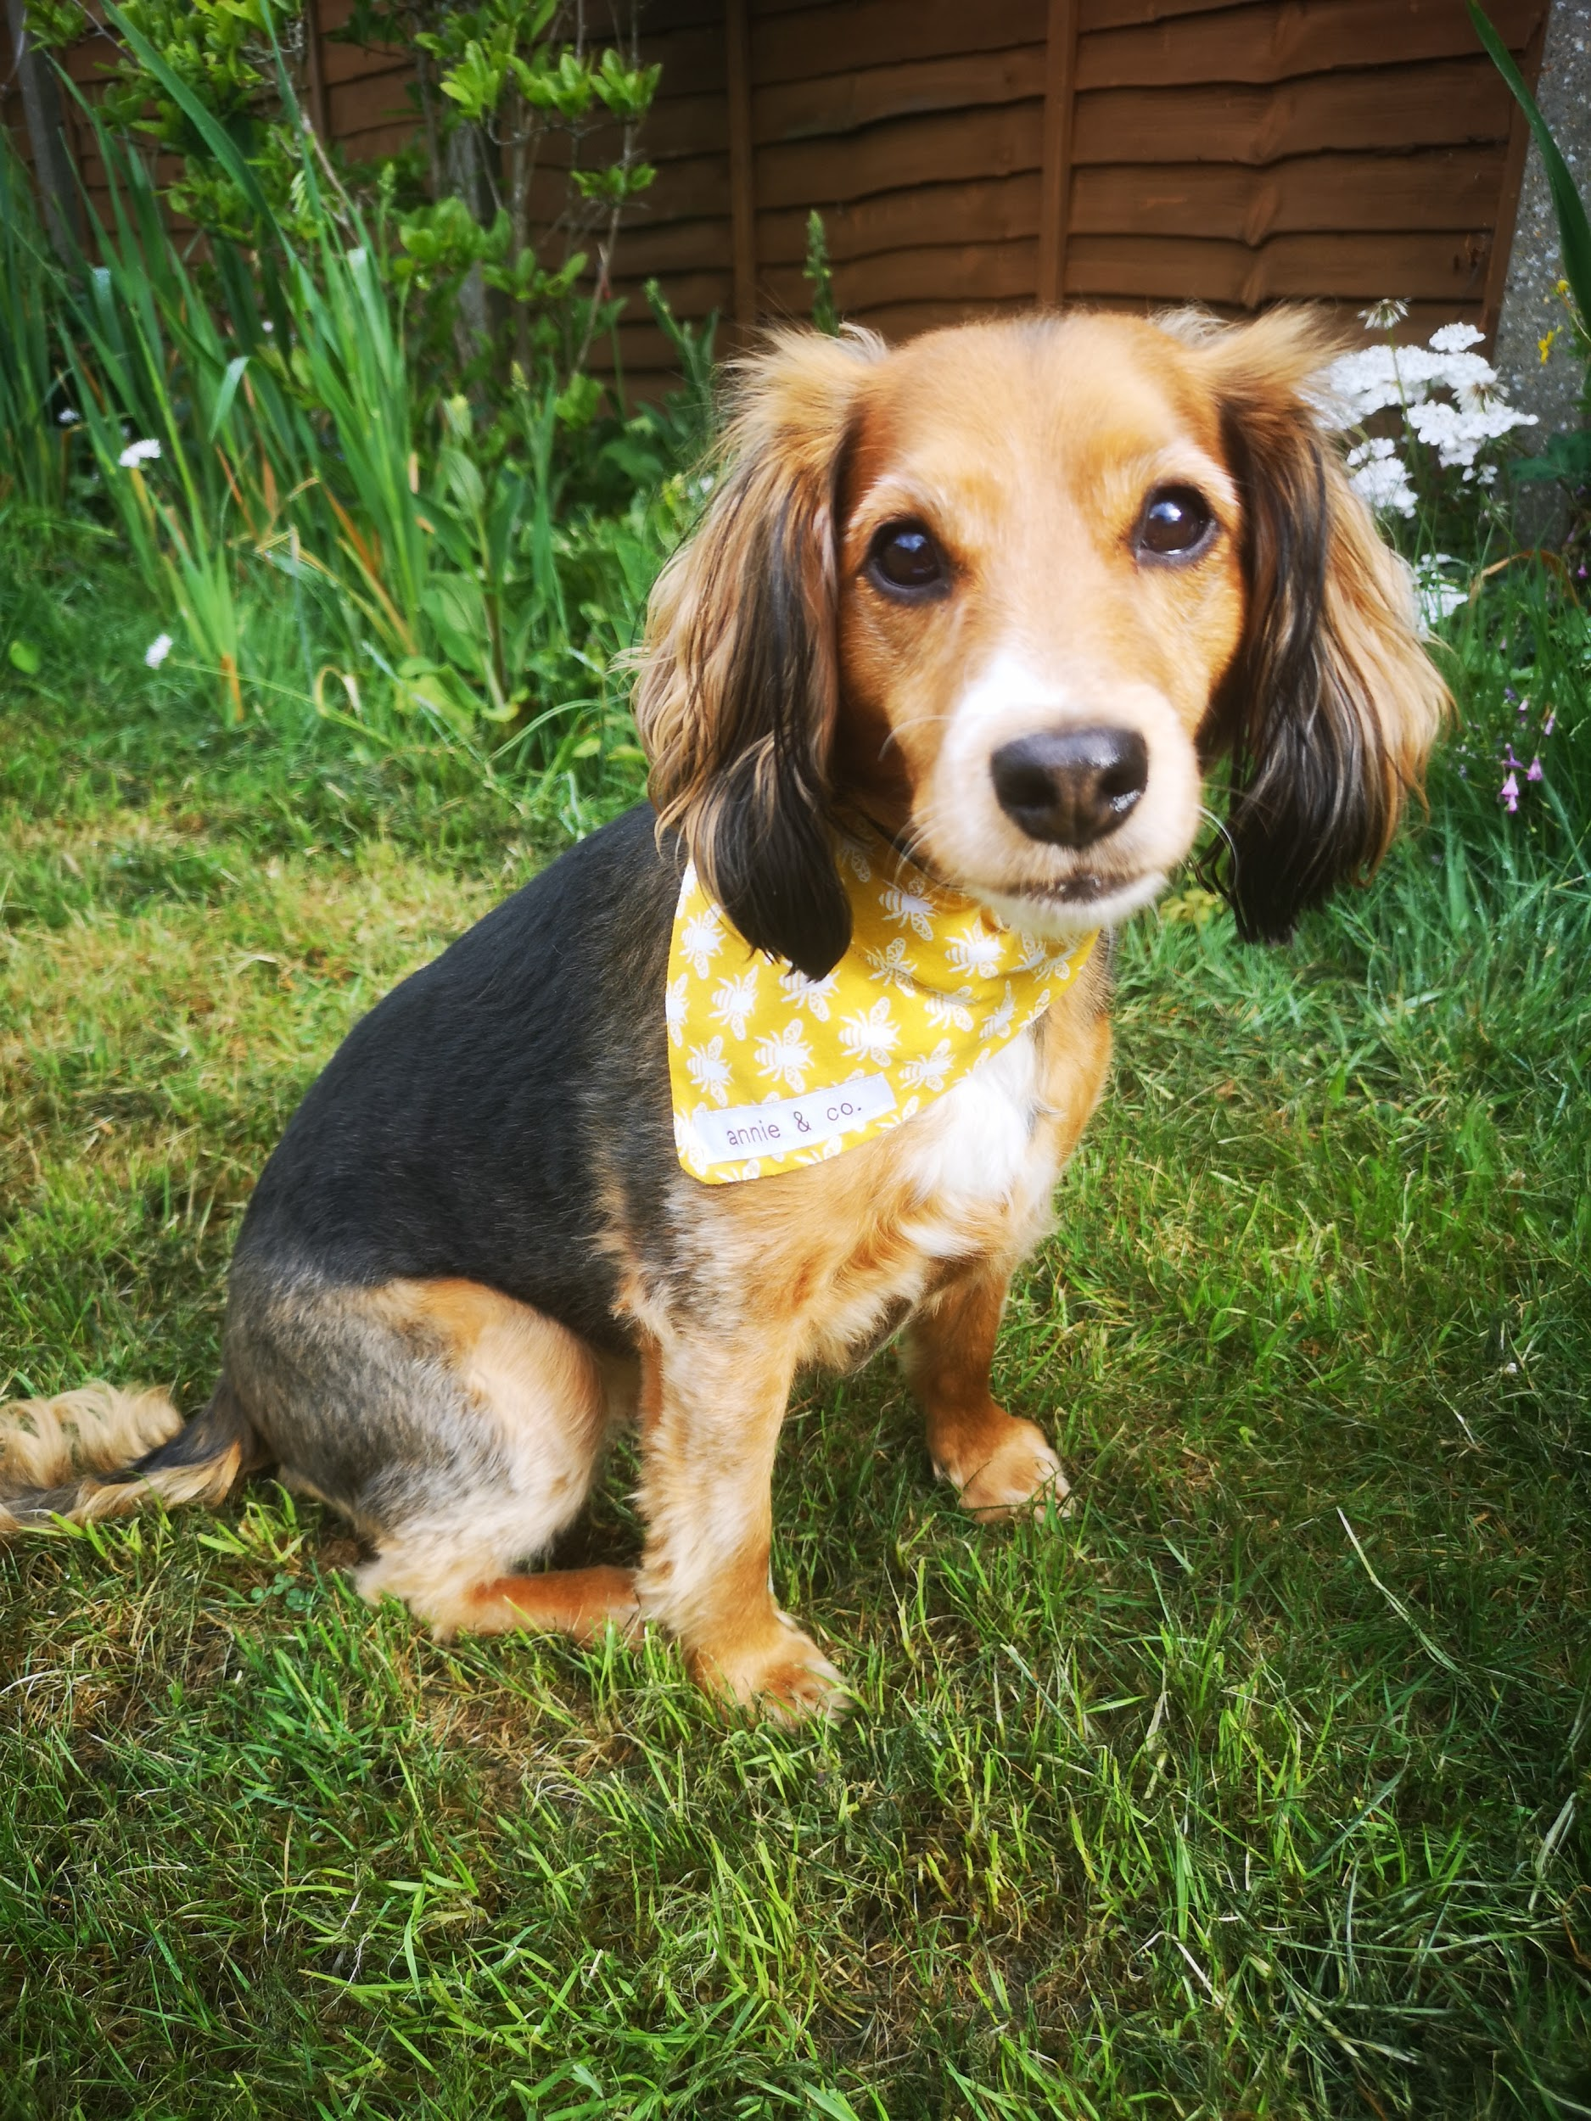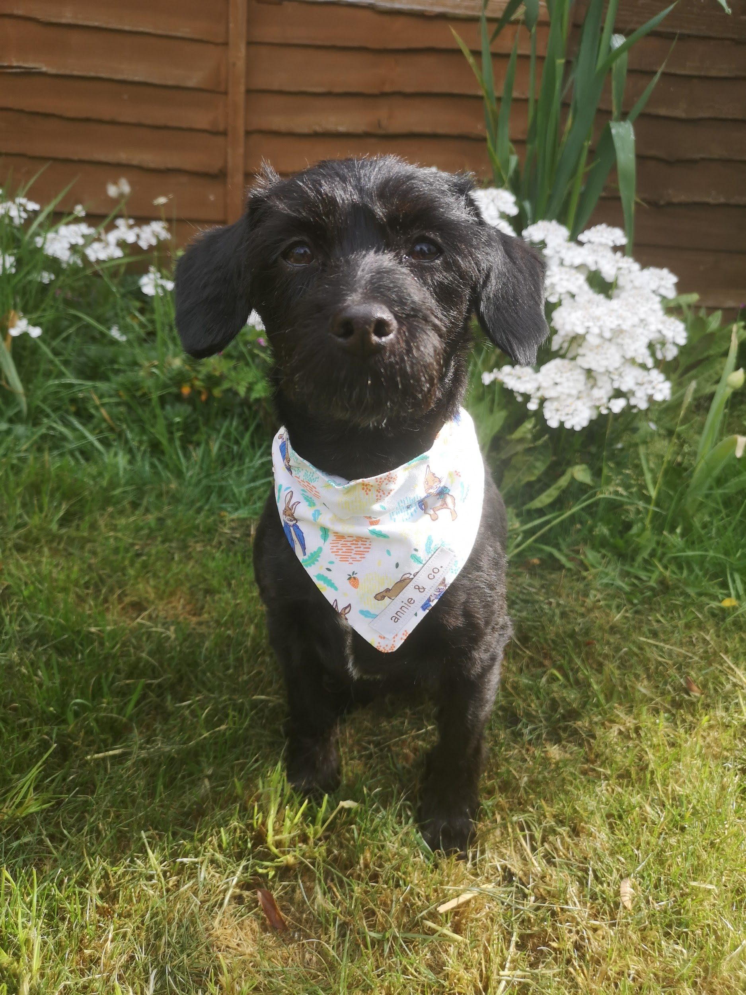 | PSHCE:  1)Create a ‘how to care for …….’ (pet/animal of your choice) profile. (All about a pet worksheet on Twinkl)  https://www.twinkl.co.uk/event/national-pet-month-202ve  If you don’t have a pet or are struggling to pick an animal, why not draw and create an animal profile of Nala or Arlo? They would love to see what you create!  2) Caring for animals is so important! Many of the students have been able to spend time with school bunnies Gunner and Teddy, and dogs Nala, Arlo and Max and would be able to tell you lots about them. If you have seen the films Peter Rabbit, Chicken Run or Shaun the Sheep Movie there are wonderful powerpoints https://www.intofilm.org/resources/1468 with activities all film and animal care related!  Nala and Arlo would love to see any pet profiles and pictures you draw of animals so please email pictures over to petsastherapy@meadowhighschool.org for us to collate and create a collage.

