While standing, hold your right arm straight and use your left arm to pull it across your chest.  Hold for 15 seconds, and switch arms. Repeat 4 times for each arm | 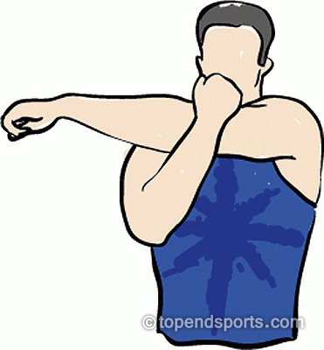
In a standing position, bend your right elbow, using your left hand to pull it gently behind your head.  Hold for 15 seconds, then release and switch sides. Repeat this 4 times for each arm | 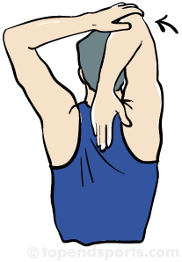
Stand with your feet shoulder width apart, fold both your arms together as shown in the picture and rotate your trunk to the right side.  Hold for 15 seconds, then release and switch sides. Repeat this 4 times on each side. | 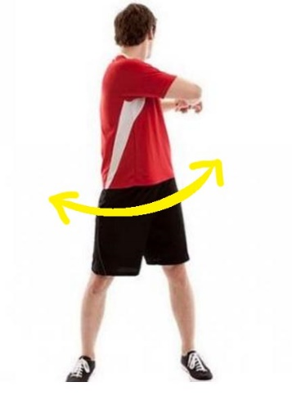
- Kneel on one knee and place your other foot in front of you with your thigh parallel to the floor  - Lean forward, tightening your glutes and stretching your hip toward the floor  - Hold for 15 seconds, then release and switch sides. Repeat this 4 times on each side. | 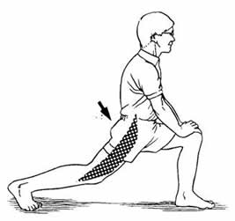

Stand with your feet shoulder-width apart and clasp your hands behind your back. Face your palms down and outward. Slowly raise your arms until you feel a comfortable stretch in your biceps and triceps  Hold the position for 15-30 seconds and repeat the stretch 2-3 times. |  | 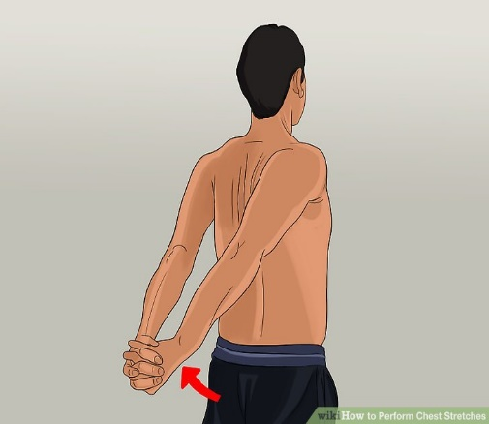
Standing with your both hands over your head until your right arm touches your ear. Lean your upper body to the left, stretching your side.  Hold for about 15 seconds, then switch sides. Repeat 3 times for each side. |  | 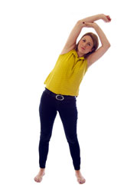
Standing, grab the knee and pull it straight up, towards your chest.  Hold for about 15 seconds, then switch sides. Repeat 3 times for each side. |  | 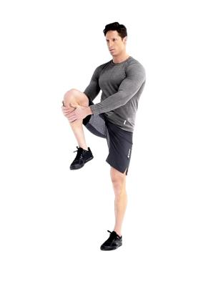
Stand next to a wall you can use for balance, and grab your left foot behind you and pull it towards your hips. Lean your torso forward, keeping your right leg and back straight.  Hold for 15 seconds, then release and switch legs. |  | 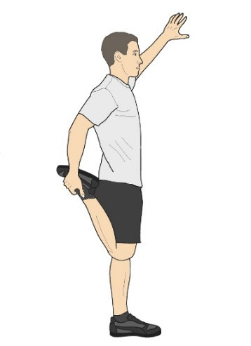
Sit to stand x20 | 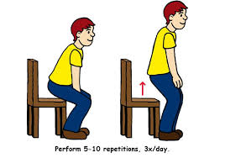
Step ups x 20 | 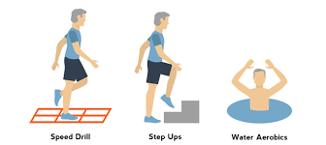
Bridges(15 sec hold)x10 | 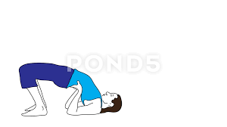
Wall squats (10 sec hold)x10 | 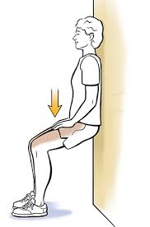
Basketball | 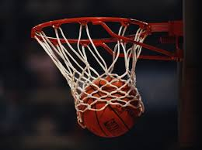
Football | 

