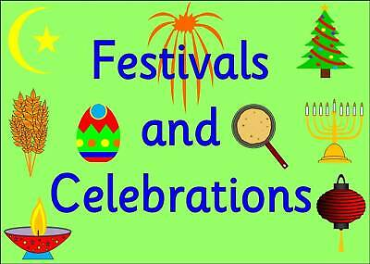
Religious/Cultural festivals and celebrations
Aims: These tasks are designed to be done with your child. Purple coloured tasks are aimed at pupils who would enjoy more of a challenge . These are tasks where pupils should be working with greater independence, however please take time to support pupils in starting the tasks and build communication skills.
Thinking
Literacy Focus  Recommended Audible.com listening this week  Beezer - Disgraced Beezlebub, prince of demons, is banished by his father to Earth. He now lives with a family who are far too nice - he has a heart and feelings, too many feelings!  https://stories.audible.com/pdp/B083MBWSYQ?ref=adbl_ent_anon_ds_pdp_pc_cntr-2-0  Extended Learning:  It is William Shakespeare’s birthday on 23rd April. He would be 456 years old! Research information about him and his plays then, create a birthday card to wish him well!  OR  It is Van Gogh’s birthday on 30th March. He would be 167 years old! Research information about him and his paintings then create a birthday card to wish him well! | Sp. & Comm./Reading & Writing: Plan a party for family or friends [for the end of social distancing or whatever you want to celebrate - what will your theme or colour ideas be?]  Resources: [See Planning A Party powerpoint on MHS website]  Learning Focus: Discussing ideas with others - listening and responding, making clear notes, reading your notes back to confirm ideas and check nothing has been missed.  Research Reading/Writing: Planning a Party - Organising ideas.  Resources: https://www.youtube.com/watch?v=dCM4yK7kWNE  Learning Focus: Researching, planning and organising an event, using bullet point planning pages.  Extended descriptive writing piece:  Write about the best present you ever got OR Write about a party you will never forget.  Resources: [See your folder we sent home - Reading ‘Identifying writer’s techniques’], Bilbo Baggins has an ‘unexpected party’ at his lovely neat hobbit hole https://www.youtube.com/watch?v=DTQjdHhjZj8  Learning Focus: Writing in detail, using descriptive writing techniques to entertain your read  AND/OR  It is the buddhist festival of Vesak on 7th May. It is a time to value all living things. Go vegetarian!  Write a detailed description of a vegetarian meal [This can be a good or bad experience depending on your cooking skills!]  Go on an insect hunt - study one, try and see what is beautiful about it.  Write a detailed description of this insect. [Top Tip: Take a photo]  [I’m going to try this one to get over my fear of spiders! Mrs. Sugden]
Maths Focus | 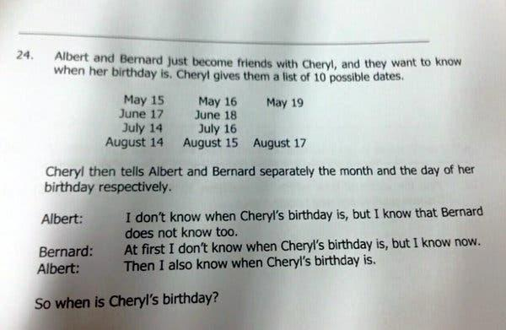  - This is a link to Kahoots-lots of maths games available  https://www.google.com/search?q=kahoot&rlz=1C1GGRV_enGB751GB751&oq=kahoot&aqs=chrome..69i57j46j0l5j5.1750j0j8&sourceid=chrome&ie=UTF-8  - https://www.twinkl.co.uk/resource/t-t2-067-uks2-easter-maths-home-learning-bumper-pack  - Expanding brackets - Chinese New Year https://www.twinkl.co.uk/resource/t3-m-4707-chinese-new-year-maths-expanding-brackets-differentiated-colour-by-number  - Bonfire Night - revision pack https://www.twinkl.co.uk/resource/t3-m-4643-bonfire-night-differentiated-activity-pack
Creativity
Cooking/Technology | Cooking tasks to choose from:  1.Birthday Cake (Cupcakes)  Level of Support:Work as independently as possible (to be able to follow and read the recipe with no/limited support)  Link: https://www.bbcgoodfood.com/recipes/cupcakes  2. 4th May is Star Wars Day! Cook up some Star Wars recipes:  Link: https://www.starwars.com/news/porg-puffs-recipe  3. Here are some Easter recipes that you also may want to choose from which range from different abilities.  Link:ttps://www.goodtoknow.co.uk/food/recipe-collections/easter-recipes-for-kids-46497  Technology tasks to choose from:  1.Make a comic strip or an animation with an Easter theme. Link:https://www.twinkl.co.uk/resource/ks2-easter-comic-strip-differentiated-t2-re-710  2. Use programming software to design a game with an Easter theme.3. Design a card / board game with an Easter theme.  Link:https://www.twinkl.co.uk/resource/t-t-10264-easter-themed-editable-board-game
Drama/Arts  Other optional tasks for wider learning:  https://www.youtube.com/watch?v=7-HasNjXbC0&feature=youtu.be  Myleene Classes Music channel  https://www.youtube.com/channel/UCQh2wgJ5tOrixYBn6jFXsXQ | Task Focus: Discuss celebrations from around the world. Then create a fun poster, powerpoint or presentation  Key Information:  In RE lessons you all have so much to share about what you and your families celebrate, from birthdays, Christmas and Easter to Diwali, Eid and Chinese New Year. Watch the clips then make a Presentation, powerpoint or poster which tells us about a range of celebrations from around the world. Did you spot any similarities or differences?  Task helpful clip to watch:  Reading about celebrations https://www.youtube.com/watch?v=3Sv0ac-W8Vc  Border designs for making posters  https://www.youtube.com/watch?v=GzHrGnPBVgA  Materials Needed:  Poster-Paper pencils, colour pencils or pens  Poster on Powerpoint- Computer or laptop  Presentation: Write it down or video yourself presenting your celebration  Keywords: Celebration, Party, Food, Music, Dancing, Family, Friends, Country, Similarities, differences
Health and Wellbeing
Physical activity | Joe Wicks PE Lessons  https://www.youtube.com/user/thebodycoach1/videos  Yoga  https://www.youtube.com/watch?v=7kgZnJqzNaU&t=939s
Cross Curricular | In RE and PSHCE lessons you all have so much to share about what you and your families celebrate, from birthdays, Christmas and Easter to Diwali, Eid and Chinese New Year. Create a knowledge quiz (can use Powerpoint) about the chosen celebration and play with your family.  Find out how Easter is celebrated in different parts of the world. https://www.rd.com/culture/easter-traditions-around-the-world/ Could you create a news report or an ebook to teach others what you discover? https://www.twinkl.co.uk/resource/t-t-13459-newspaper-template

