RWI – Green Story and activities.
Camping

- Watch the video and follow along, saying the speed sounds set 1: https://www.youtube.com/watch?v=TdpzE9wryzg

- Read these green words using finger spelling:
Went tent lamp lunch match drank Ed grass eggs pond

- Read these red words – Remember, these cannot be sounded out and must be learned on sight.
They the of to supper for

- Read the story:
Introduction:
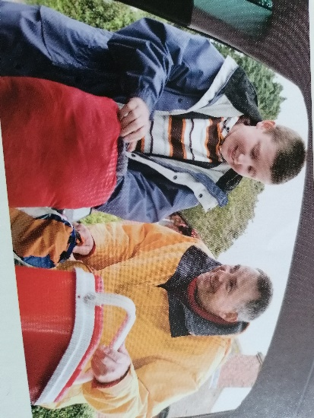
Have you even been on a camping trip? Do you know how to put up a tent? What else would you take to go camping? In this book Ed and his dad go camping and have a lot of fun!

Story:
Ed and dad went camping.

They went in dad’s van.

Things for the camping trip: Can you find them in the pictures?
Tent
Lamp
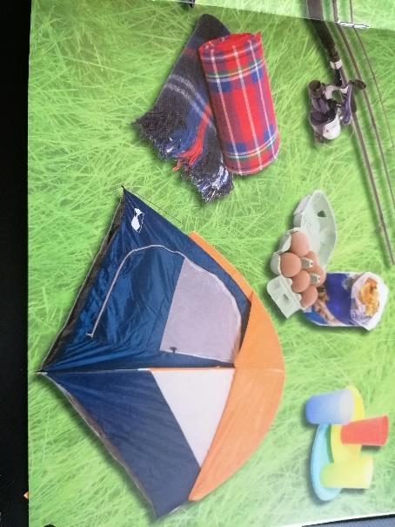
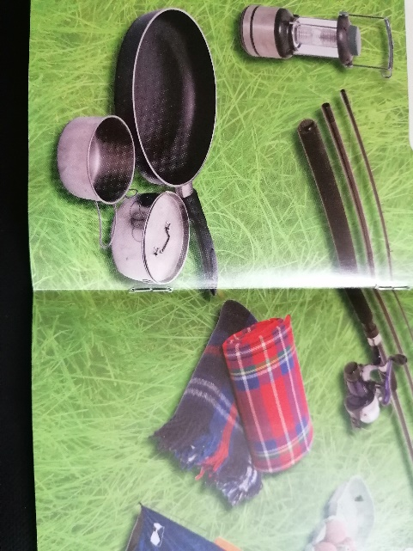
Blankets
Pans
Plastic cups and dishes
Things for lunch
Fishing rods

They put up the tent.

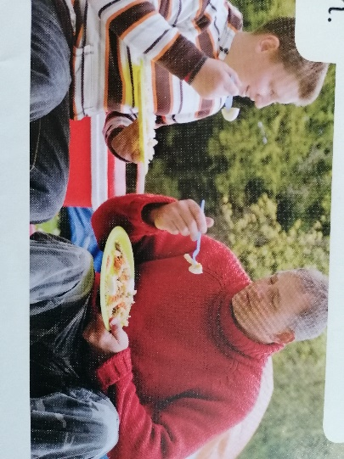
They sat on the grass.

They had eggs and pasta salad for lunch.

They drank cans of pop.

They went fishing in a pond. Ed got a big fish.

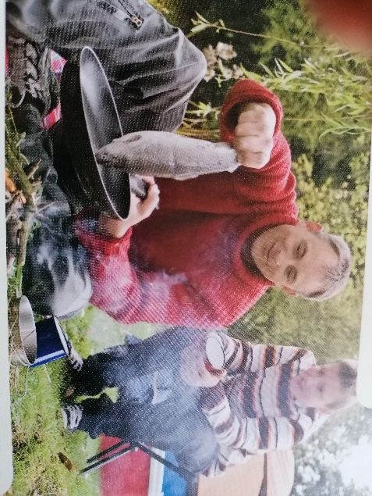
Dad got twigs ad lit them with a match.

They had fish and salad for supper.

At 10 o’clock they went to bed in the tent.

Ed and Dad had fun camping.

- Questions to talk about.
Discuss these questions with a partner. You can write the answers down if you wish.

What did Ed and Dad bring to cook food in?
What did they have for lunch?
What did Dad use to make the fire?
What time did they go to bed?

Extension task:
Make a list of all the things you would take with you on a camping trip. Where would you go camping if you could go anywhere in the UK?

