RWI – Grey Story and activities.
Rex to the rescue.

- Watch the following videos and follow along, saying the speed sounds set 1 in video one, set 2 in video 2 and set 3 in video 3.
https://www.youtube.com/watch?v=TdpzE9wryzg
https://www.youtube.com/watch?v=p7hRbrpq5Bo
https://www.youtube.com/watch?v=n-Y4Ha4e7j4

- Read the green words using finger spelling:
Take while skirt nose lead slide rage came time litt le zoom bloom cute tune rude huge mule truce brute use Luke Bruce Duke June Sue blue

- Read the red words – Remember, these cannot be sounded out and must be learned on sight.
Should were there call want come could one through

- Read the story:
Introduction:
What type of dogs do you like? Do you think people should be able to control their dogs? What would you do if someone else’s dog started fighting with yours?
Luke has a little dog called Bruce. Bruce is a very quiet and gentle dog. One day in the park a big, fierce-looking dog, called Duke, chases Bruce. Luke is upset and tries to get Duke’s owner to control her dog. But she won’t listen. So Luke ha a plan.
What do you think he’ll do?

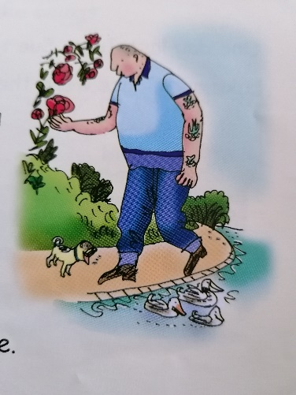
Story
This is Luke. The big man with the shaved head and tattoos.
The little pug with the blue velvet collar is Luke’s dog. His name is Bruce. Cute isn’t he? Not so much little as minute!

Luke likes to take Bruce to the park. Bruce chases sticks (well, twigs) and barks at the ducks, while Luke sniffs the roses or reads ‘Gardening today,’ humming a little tune.

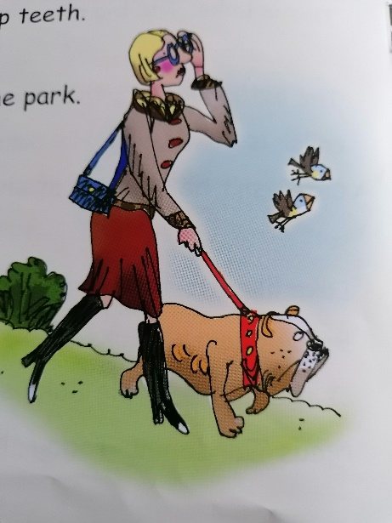
This smart lady in the maroon skirt is Sue, with her dog Duke. Duke’s a bulldog, a big brute with sharp teeth.
One day last June, Sue took Duke to the park. Luke and Bruce were there, too.

Sue let Duke off the lead. Duke sniffed the ground – he could smell a dog!
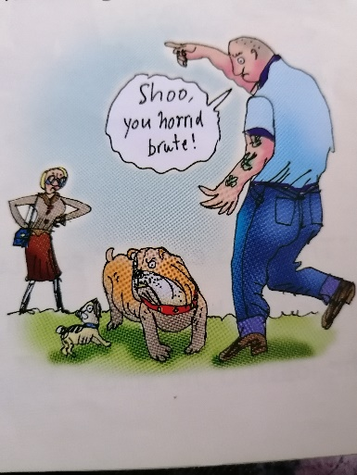
Then he was off, zooming across the grass. Past the slide, past the roundabout, past the swings, until he was nose to nose with Bruce.

“Shoo, you horrible brute!” said Luke, choking with rage.
It was no use, Duke started to growl and snarl. Then he pounced on the poor pug.
Sue came running up.
“Kiss Mummy Dukey darling!” she said.
“He’s in a bad mood today. The postman escaped before Dukey could bite him.”

“That’s no excuse!” said Luke. “Bruce isn’t used to fighting. He’s only had one fight in his life – and that was with a hamster, he lost!

The next day……

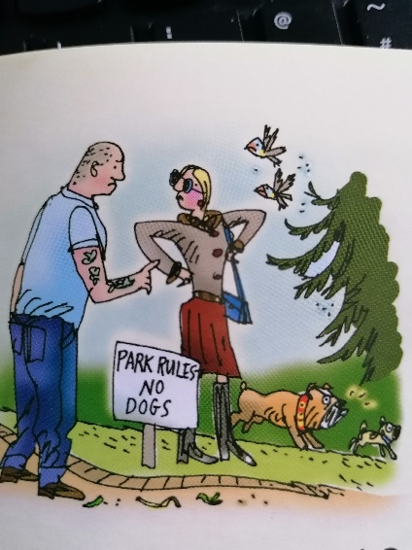
Just as Luke was sniffing a prize bloom and Bruce was having a snooze on his fluffy blanket, Duke came back.
This time, he chased Bruce all round the park.
“I don’t want to be rude,” said Luke to Sue, “but that dog should be kept on a lead.”

Sue refused to listen. “Don’t you accuse darling Dukey!” she snapped. “Come on, Duke!”
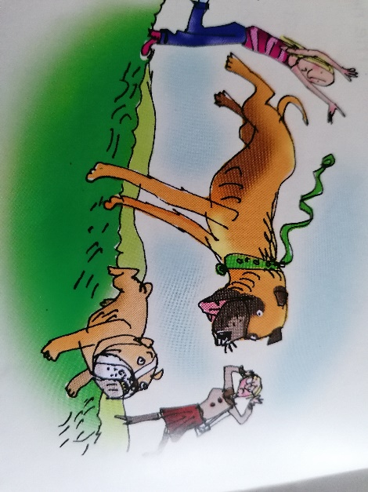
The next day……

This little girl is Luke’s pal, Fran.
This huge brute is her dog, Rex. He’s a bull mastiff!

Rex is as stubborn as a mule. So when he spotted Duke – and chased him across the grass, up the slide, round the roundabout, over the swings and right into the lake – Fran couldn’t stop him.

“Thank you!” said Luke to Fran
He stopped to stroke Rex.
“Good boy!” he said.
“I want all the dogs to call a truce. No more fighting! Okay?”
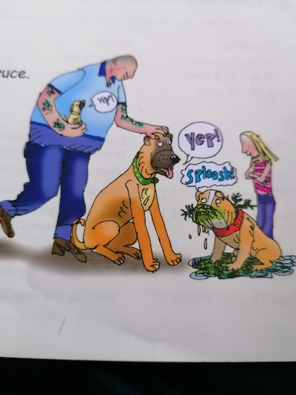
“Yep!” barked Bruce
“Yep!” barked Rex
“Sploosh!” barked Duke through a mouthful of green slime.

Questions to talk about.
Complete these questions. Write the answers using full sentences.
- Dogs are often like their owners. In what way is Luke a surprising character?
- What does Sue’s dog look like??
- Why was Luke cross with Sue’s dog, Duke?
- What is Sue’s excuse for Duke?
- Why is Luke worried about Bruce getting into a fight?
- How do you think Luke felt about Sue as a dog owner?
- What type of dog is Rex?
- What does Rex do to Duke?
- What do you think the dogs think of Luke’s solution?

Extension task:
Look up the meaning of any words from the story that you were unsure of. Can you use 4 words from the story in your own sentence? Try to use some of the trickier words.
1

2

3

4

