RWI – Blue Story and activities.
Barker.

- Watch the following videos and follow along, saying the speed sounds set 1 in video one, set 2 in video 2 and set 3 in video 3.
https://www.youtube.com/watch?v=TdpzE9wryzg
https://www.youtube.com/watch?v=p7hRbrpq5Bo
https://www.youtube.com/watch?v=n-Y4Ha4e7j4

- Read the green words using finger spelling:
Ch ee se too soon night match food hold cold arm jar sh arp smart star start part scar car Mark mar ge lar ge
ch ar ge gu ard

- Read the red words – Remember, these cannot be sounded out and must be learned on sight.
Does were all one said

- Read the story:
Introduction:
Do you have a dog?
Imagine owning a really naughty dog. Barker is a big, dark grey dog that is always barking. He gets into lots of trouble for doing bad things and he is always being told off. Then one night he barks at the right time.
What do you think he does?

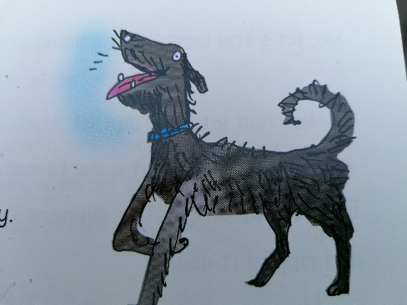
Story
Barker’s my dog.
He’s the best!
He’s big, dark grey and a bit smelly. (He rolls in mud a lot)
He barks a lot, too. In fact, he does lots of bad things. Mum, dad, grandad and the postman were all fed up with Barker.
Until the day that….

No, let’s start at the beginning with Grandad’s slippers.
Barker had lots of fun with them. One night, when Grandad was at a darts match, Barker got hold of one of the slippers and ripped it apart!
Grandad said “No Barker.” And Barker just barked.

Then he started to pinch food from the kitchen. Jam tarts, cheese sandwiches and jelly. Barker wasn’t fussy.
Mum left a dish of cold beef on a shelf, and Barker jumped up to get it. A carton of milk, a jar of plum jam – Barker knocked them off the shelf to get to the beef.
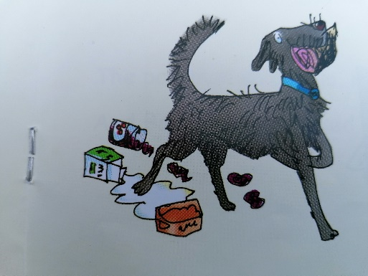
He looked like a cartoon dog running away from mum with a big chunk of beef between his teeth!
Mum said, “No Barker.” And Barker just barked.

The best part was when Barker bit the postman. He was bringing us a postcard from Dad’s pal Mark (on holiday in Cardiff.)
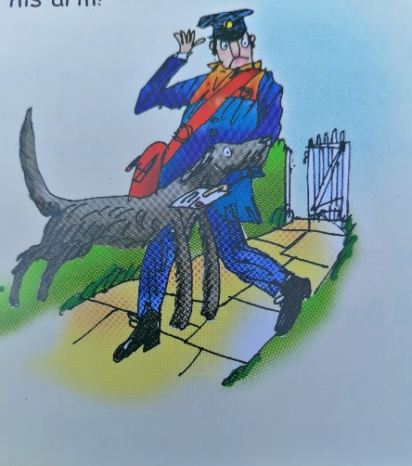
Barker charged up to him and bit his arm! (He’s got sharp teeth, my dog. The postman’s still got the scar!)
The postman said, “No, Barker.” And Barker just barked.

Barker’s best trick was being sick in the car. One day, we went shopping in Farnham. Barker grabbed an old hotdog from a bin, and when we got back to the car he looked a bit ill. We all got in and as soon as Dad started the car, Barker was sick….
Very sick indeed.
And we were still in the car park!
Dad said, “No Barker.” And Barker just barked.

Then, one night, he started barking when we were al fast asleep in bed!
Dad went to see what was up. The kitchen window was smashed, and Dad spotted some men running away from the flat!

“Meet Barker the guard dog!” I said.
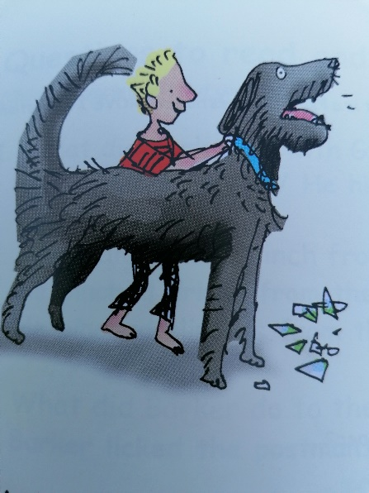
“Smart dog Barker! You’re a star!”

That night, they all agreed with me.

Questions to talk about.
Complete these questions. Write the answers using full sentences.

- How would you describe Barker?
- What did Brkr do to Grandad’s slippers?
- Why was Mum cross with Barker?
- Why do you think Barker bit the postman?
- What made Barker sick?
- Why did everyone think Barker was a star at the end?

Extension task:
Look up the meaning of any words from the story that you were unsure of. Can you use 4 words from the story in your own sentence? Try to use some of the trickier words.
1

2

3

4

