RWI – Pink Story and activities.
Scruffy Ted.

- Watch the following videos and follow along, saying the speed sounds set 1 in video one and set 2 in video 2.
https://www.youtube.com/watch?v=TdpzE9wryzg
https://www.youtube.com/watch?v=p7hRbrpq5Bo

- Read the green words using finger spelling:
This gran ring cudd le
Read in Syllables:
Jim ‘ jams Jimjams pupp ‘ y puppy
Sall ‘ y Sally spag ‘ hett ‘ i spaghetti
Hett ‘ y Hetty Hiss ‘ y Hissy
Pand ‘ a Panda tink ‘ ly tinkly
Fluff ‘ y Fluffy

- Read the red words – Remember, these cannot be sounded out and must be learned on sight.
the my all like I’ve

- Read the story:
Introduction:
Do you have a favourite toy? Why is this toy your favourite? Does it have any special memories?

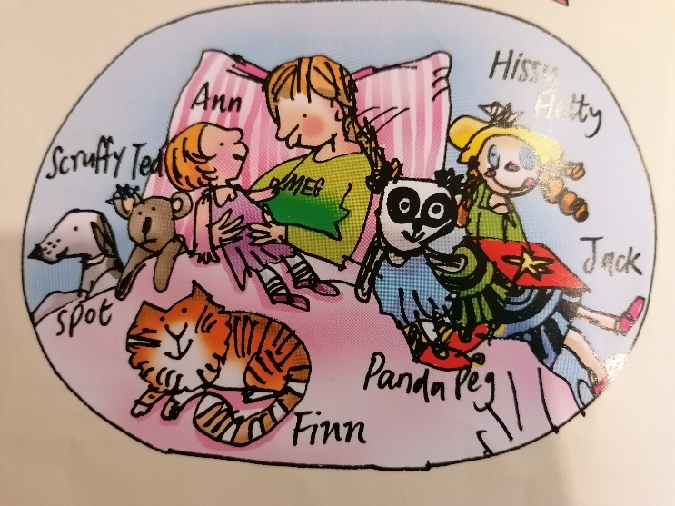
Story:
This doll is Ann. I got Ann from my Gran.
The fluffy cat is Finn, I can put my jimjams in.

I’ve got Panda Peg as well. I can ring her tinkly bell.
The rag doll is Hissy Hetty. She has long legs like spaghetti.

The puppy dog is Spot. I cuddle him such a lot.
I have a jumping Jack-in-the-box in his red and black check socks.
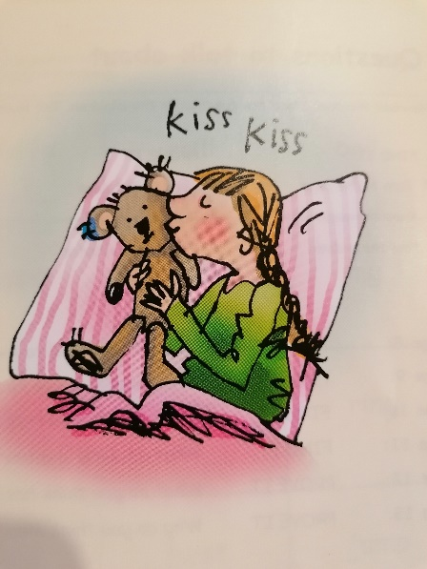
And this is Scruffy Ted. He is tucked up in bed.
I cuddle all the rest, but Scruffy Ted’s the best!

- Questions to talk about.
Discuss these questions with a partner. You can write the answers down if you wish.
Who gave the doll to Meg?
What does Meg use Finn for?
What do Hissy Hetty’s legs look like?
What do Jack-in-a-box’s socks look like?
Hy do you think Meg likes Scruffy Ted the best?
What do you think has made him so scruffy?

Extension task:
Find and correct the 5 errors in this sentence. Hint – 2 capital letters, 1 spelling and 2 full stops.
i have got a doll i got it from my Grin

