
Aims: These tasks are designed to be done with your child. Purple coloured tasks are aimed at pupils who would enjoy more of a challenge . These are tasks where pupils should be working with greater independence, however please take time to support pupils in starting the tasks and build communication skills.
Thinking
Literacy Focus: Maintaining and building key skills including communication skills and confidence ready for September. Focus on reading, writing and following a sequence of instructions.  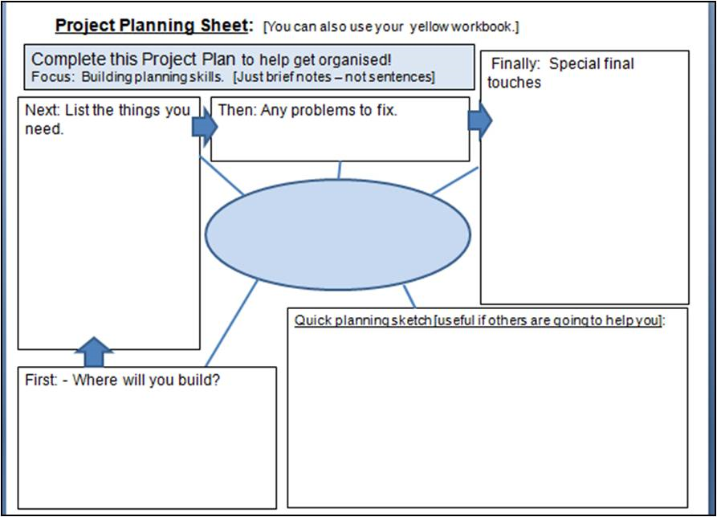  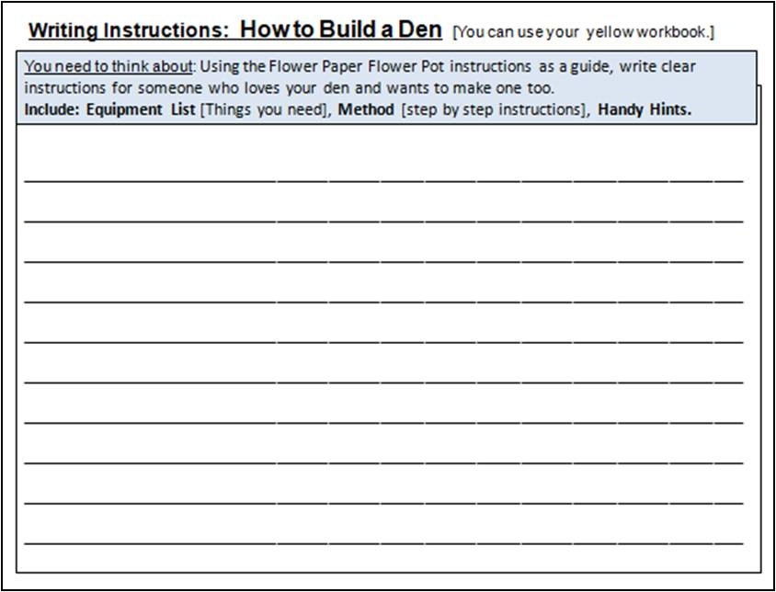  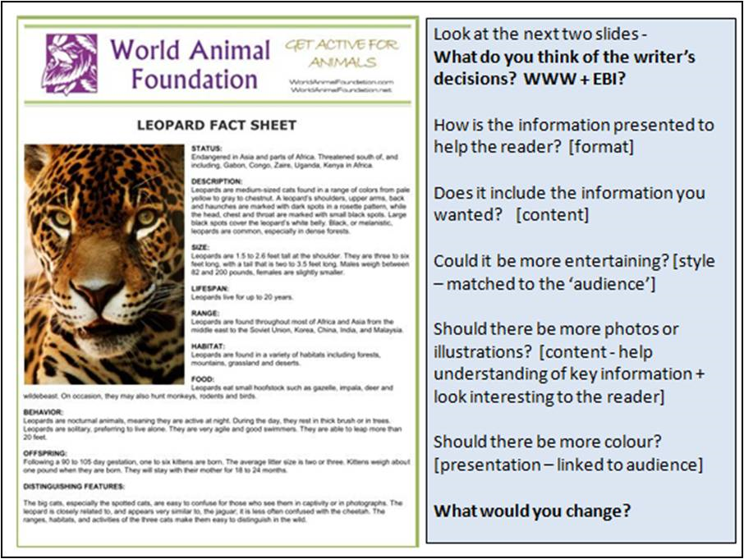 | Speaking, Listening & Communication, Reading and Fun Holiday Activities  Resources: Come and collect FREE bag of soil and seeds from school.  Powerpoints - W10 Leisure Holiday Activities PURPLE as  W10 Leisure Research Project PURPLE as  Videos - Instructional - Miss Lennon teaches how to plant a seed  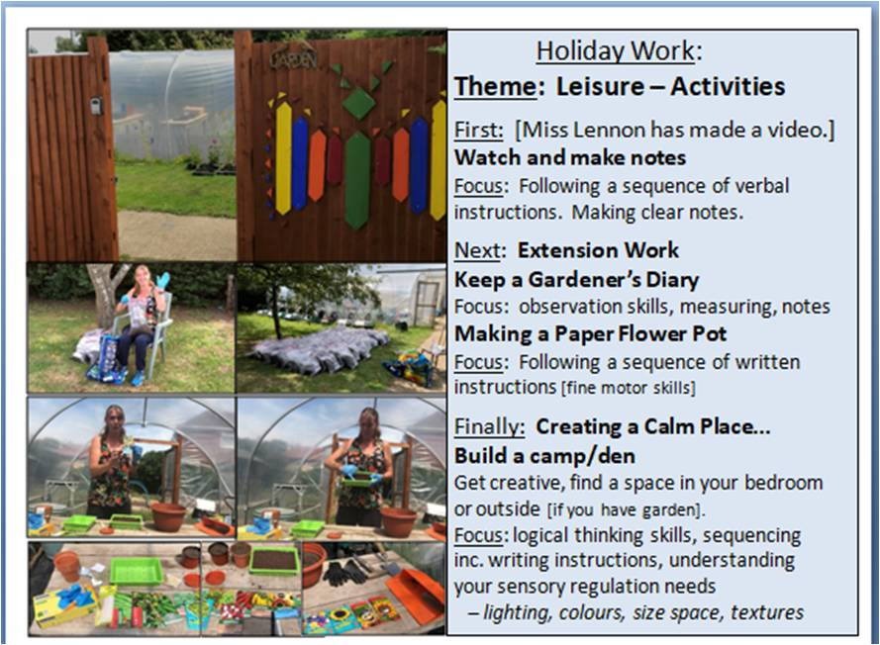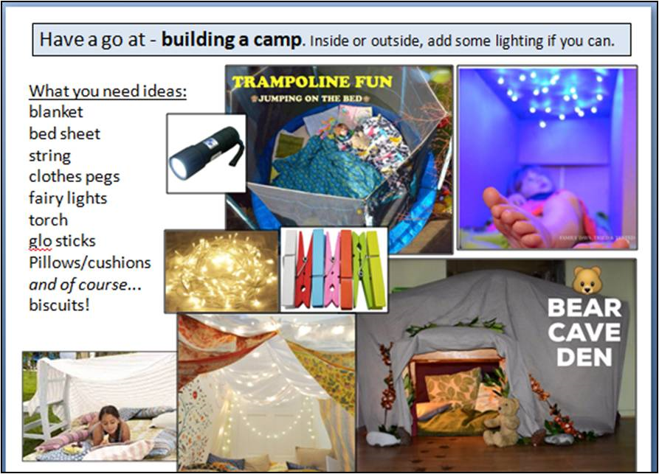  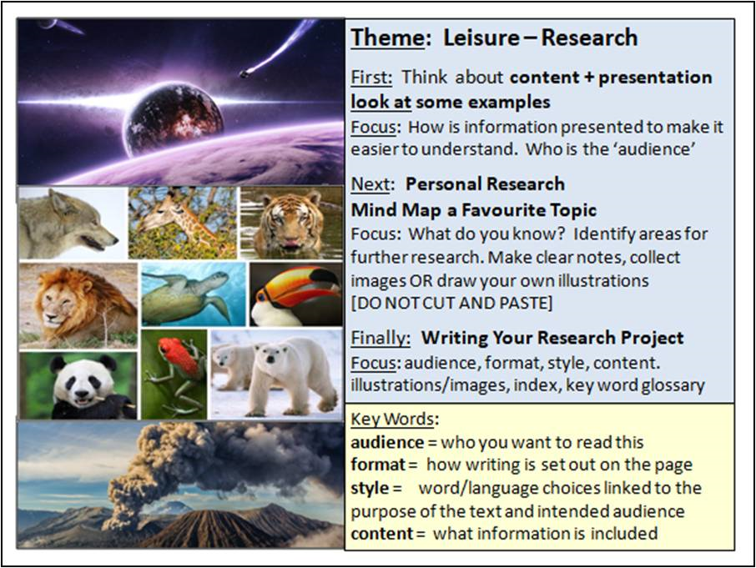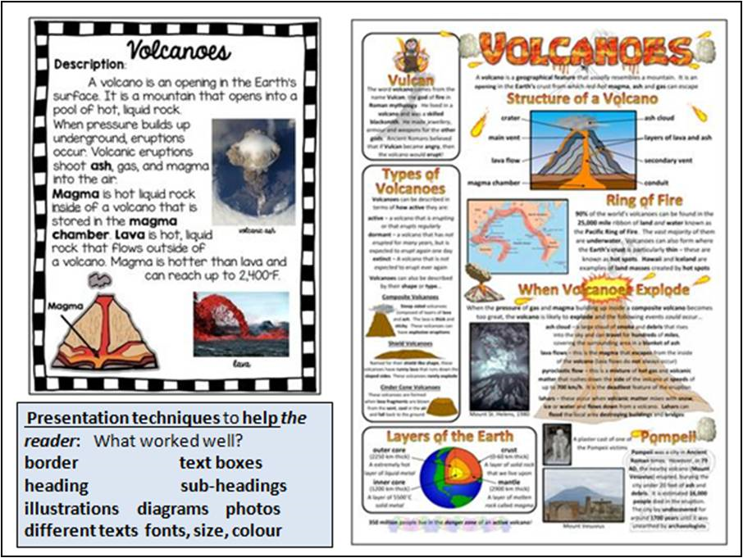  Remember: Take photos / draw the camp or den you made.  Take photos / draw your seeds as they grow.  Send us your research project  Email meadow@meadowhighschool.org and we will put them on the website.
Maths Focus | - Think like a mathematician videos https://www.bbc.co.uk/bitesize/topics/zfxhfg8/resources/1  - Maths quizzes on Kahoots!  https://kahoot.com/  - Maths games  https://www.mathsisfun.com/  https://www.themathsfactor.com/games/  - Countdown maths  https://nrich.maths.org/6499
Science Focus | 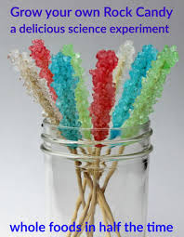  Crystal Candy Rock  Task: Create candy rock crystals and watch them grow!  -Observe what happens over time  - Can you think of why this happens? (evaporation? precipitation, saturation?)  Equipment:  - Sugar, water, skewers, jar, clothespins  Website  https://www.growingajeweledrose.com/2015/02/rock-candy-experiment.html  https://sciencebob.com/make-your-own-rock-candy  What's happening: What makes the crystals grow?  You have a supersaturated solution that is unstable (in this case, sugar) more than can stay in a liquid form—so the sugar will come out of solution, forming what's called a precipitate.  Water evaporates over time and the solution becomes more saturated and sugar molecules will collect on the seed crystals on the string. The rock candy crystals grow molecule by molecule. Your finished rock candy will be made up of about a quadrillion (1,000,000,000,000,000) molecules attached to the string.
Cooking/Technology | Poster Activity  ICT has impacted our leisurely activities as it has developed through time.  From being able to communicate better and introducing new technology for fun, such as, gaming consoles, exercise machines etc.  - Have a read about how ICT (pages 1 to 6) has changed and impacted lifestyles with the link provided https://www.bbc.co.uk/bitesize/guides/z4s39j6/revision/1  - Create a poster and illustrate 5 ways that ICT has changed our lives.  - Do you think it is positive or negative and why?  Mobile devices - have impacted our leisure and lifestyle from the way we connect via social media or text, to how we can easily take pictures to capture a moment.  Read the information in the link below and answer the questions on the worksheet on how mobile devices have developed over time.  https://www.bbc.co.uk/bitesize/guides/z4p4jxs/revision/7  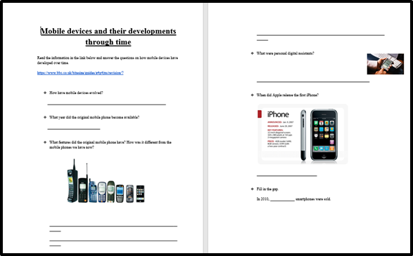  Attachment: PDF - MOBILE DEVICES research and questions worksheet  Jelly and Custard Trifle Tart - Create this retro jelly and custard trifle using cheat’s ingredients. It’s a completely make-ahead dessert, so ideal for a stress-free get together.  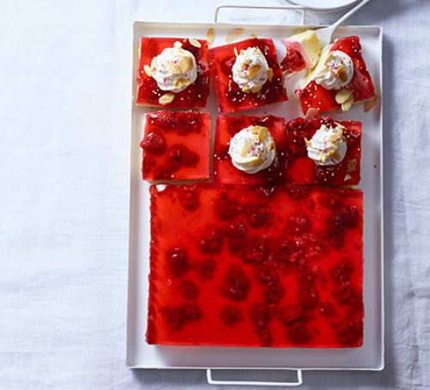  Link:https://www.bbcgoodfood.com/recipes/jelly-custard-trifle-squares  Here are some brilliant website for you to look at different recipes that you may choose to make:  https://www.bbcgoodfood.com/recipes/collection/school-holiday  https://www.bbcgoodfood.com/recipes/collection/summer-family  https://www.tasteofhome.com/collection/fun-recipes-for-summer-vacation/
Drama/Arts/Music | Task Focus Learning to make predictions when reading an image and colour with a limited colour range  Information:  Reading what might be going on in an image requires some observation and imagination. It is good to practice. Degas was famous for his pictures of ballet dancers, look at his soft use of colour.  Art: Edgar Degas  Look at the image below:  What type of dance do you think the girl is going to do?  Task 1: Draw a light outline of the figure  Task 2: Add detail using a pencil. Add colour using only blue, brown and black pencil.  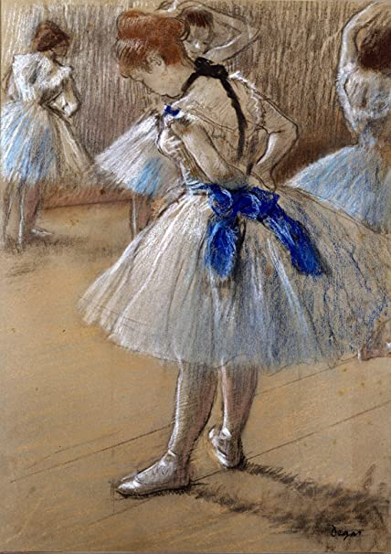  Materials you will needs:Pencil, blue, black and brown colour pencil  Task Helpful link to follow:  Watch the clip and discuss where Degas was from, how did Degas start his drawings of his Ballet class?  Degas for kids:  https://www.youtube.com/watch?v=kzL1nOXZI-I  Keywords:Degas, predict, limited colour range, Blue, Black,Brown  Other wider Learning  - How to make a Paper hot air balloon mobile  https://www.youtube.com/watch?v=-lOdTb5A6aw  You could bend a coat hanger or adapt plastic lid if you don’t have a fabric hoop  - Listen to the relaxing music and try designing summer themed letters or developing the beach seen with pattern and people  Staying out for the summer  https://www.youtube.com/watch?v=umD_GwXnArA  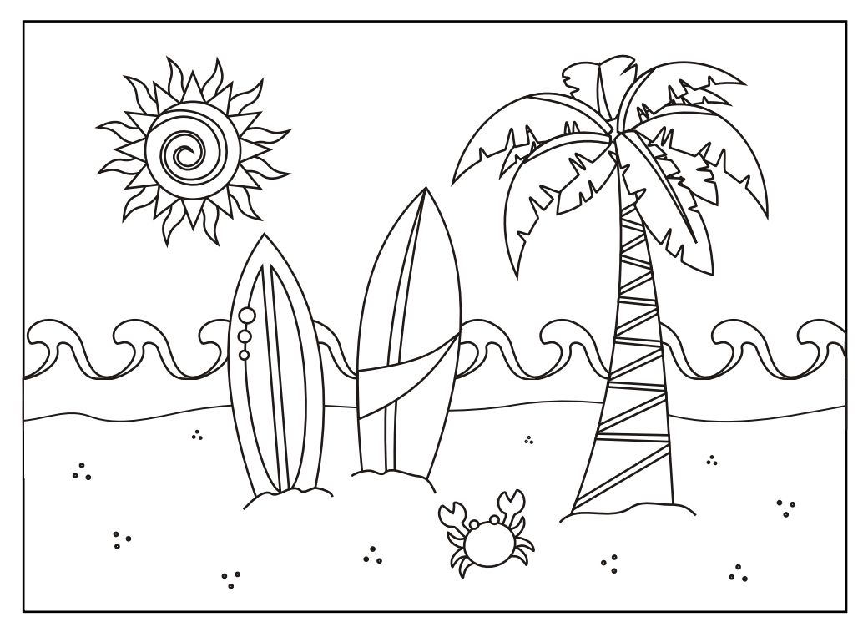  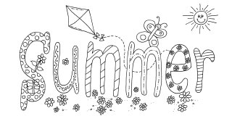  - How to make corner bookmarks  https://www.youtube.com/watch?v=ajPnqLqvqqM  - How to make a magic card  https://www.youtube.com/watch?v=uQRorab922I  We hope you enjoyed the Arts Activities looking forward to seeing you in school again in September
Health and Wellbeing
Physical activity | The PE staff have uploaded lots of videos of circuits training or challenges to the youtube channel. Have a look and have a go. Keep active!  https://www.youtube.com/channel/UCQVlu1D0XnL-bwjaXIzbZxQ/videos  ThisIsPE: Updated 3 times a week. Fun and easy activities to be done at home. https://www.youtube.com/results?search_query=thisisPE  Using ideas from the “This is PE” link, try and create your own game using things you can find at home. Write down the rules and play with your family. If you can, upload to Twitter and tag “@MeadowPE” so we can see it.  Nike Move Crew: Fun games and dance activities led by Nike athletes. https://www.youtube.com/results?search_query=nike+move+crew  Go Noodle I Get Moving: Lots of videos to get children moving, dancing and exercising with lots of music and singing. https://www.youtube.com/user/GoNoodleGames  Fitness Blender: Build your own circuit training session  https://www.fitnessblender.com/videos  Lawn Bowling: Find 10 empty bottles and arrange them into a triangle. With a ball or rolled up socks roll/throw the object to knock down as many “skittles” you can in 2 rolls/throws. 1 game is made up of 10 turns (2 rolls/throws each turn). Count up your total score and see who wins.  Target Throw: Find 5 containers (they can be the same size or different sizes) and roll 5 pairs of socks up. Place the containers in different spaces and give them points based on how difficult they will be. Take a turn to throw the rolled up socks into the containers and count up your points.  Just Dance: If you like dancing or just want to keep moving. Use Just Dance’s youtube page and enjoy their videos.  https://www.youtube.com/channel/UC0Vlhde7N5uGDIFXXWWEbFQ  Using your leisure time to keep active is a way of creating and maintaining a healthy and active lifestyle. Find ways to enjoy keeping active!  Can you participate in some kind of activity that raises your heart rate for 30 minutes per day?
Wellbeing  Useful links offering support and discussion:  https://youngminds.org.uk/    https://www.time-to-change.org.uk/   | MAKE TIME TO STAND UP TO STIGMA  Objectives:  • To help students feel a part of wider movement tackling mental health stigma and discrimination  • To inspire students to take the campaign message out into their community  Resources:  ‘Week 4 make time to stand up to stigma’  ‘Week 4 Powerpoint Final’  Task:  Work your way through this very reflective activity and think about how you can change the stigma! These activities can be done individually or as a family.

