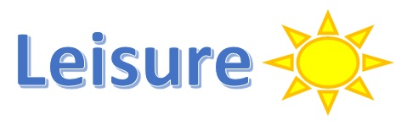
Aims: These tasks are designed to be done with your child. Blue coloured tasks are aimed at Pathway 1 pupils as well as pupils who prefer more interactive activities and require a higher level of support. These are tasks we hope you will enjoy, please select the ones you feel are most appropriate for your child.
Thinking
Literacy Focus: Building confidence and communication skills ready for September.  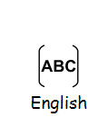  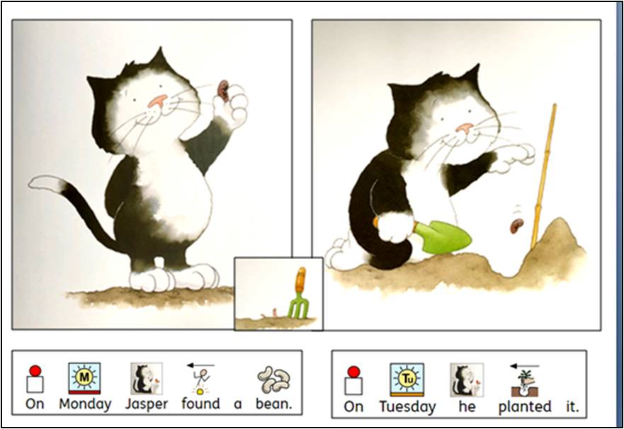  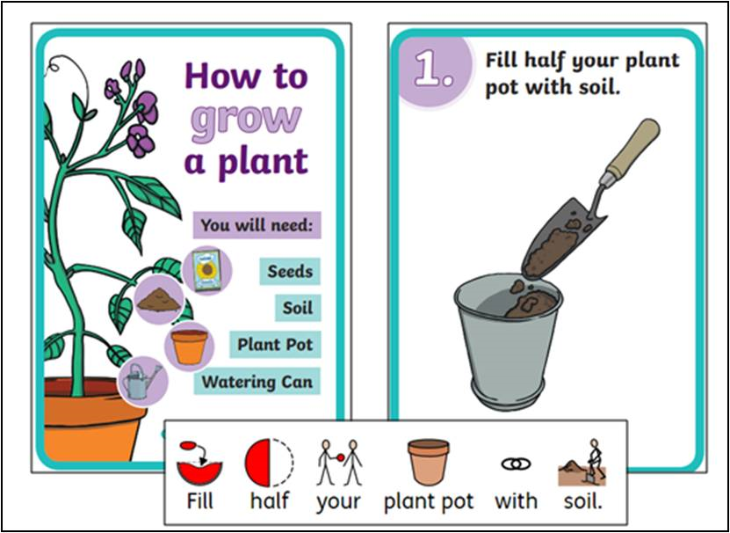  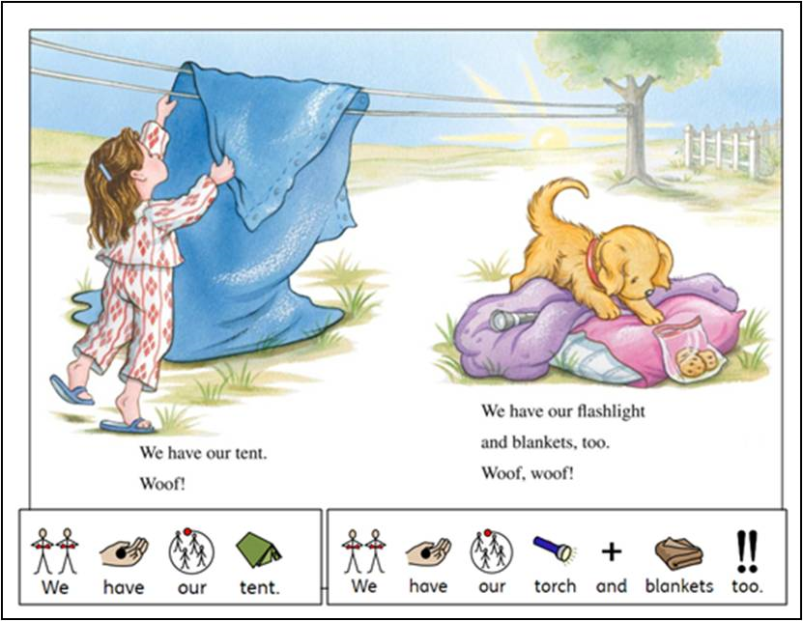 | Speaking, Listening & Communication, Reading and Fun Holiday Activities  Resources: Come and collect FREE bag of soil and seeds from school.  Powerpoints - W10 Leisure Jasper’s Beanstalk BLUE as  W10 Leisure Biscuit Goes Camping BLUE as  Videos -  2 x signed stories - Jasper’s Beanstalk, Biscuit Goes Camping [Mrs. Sugden]  Instructional - Miss Lennon teaches how to plant a seed  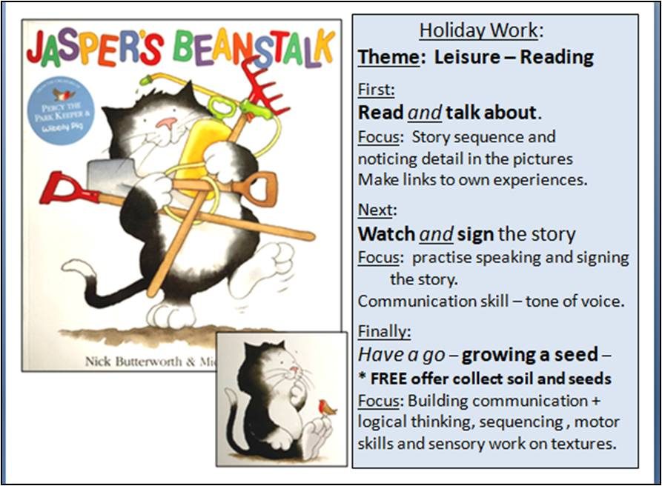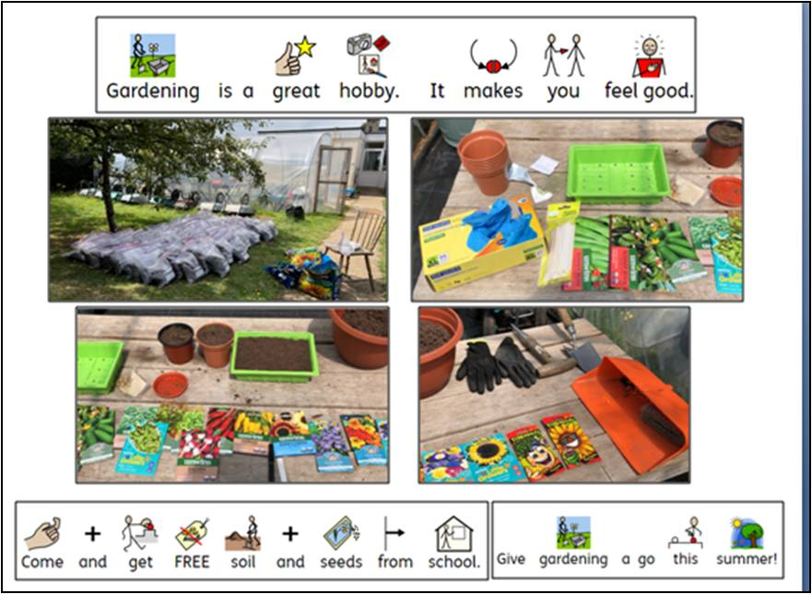  Focus: Observational skills- take photos / draw your plants as they grow - email to meadow@meadowhighschool.org and we will put them on the website.  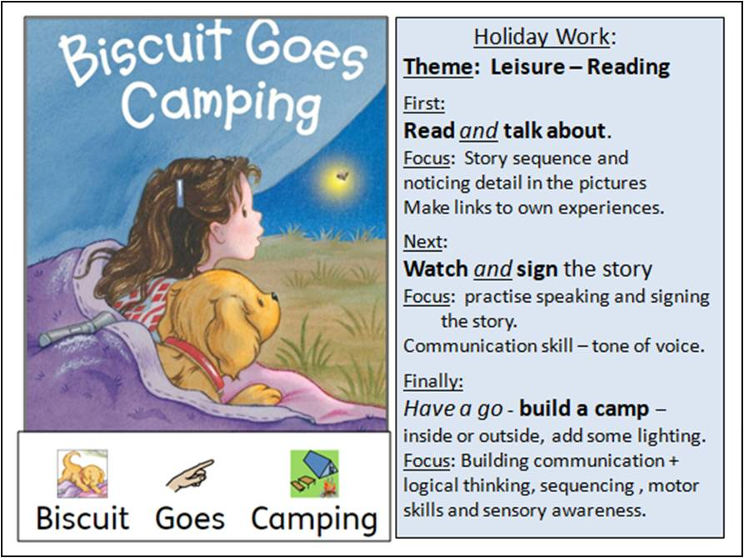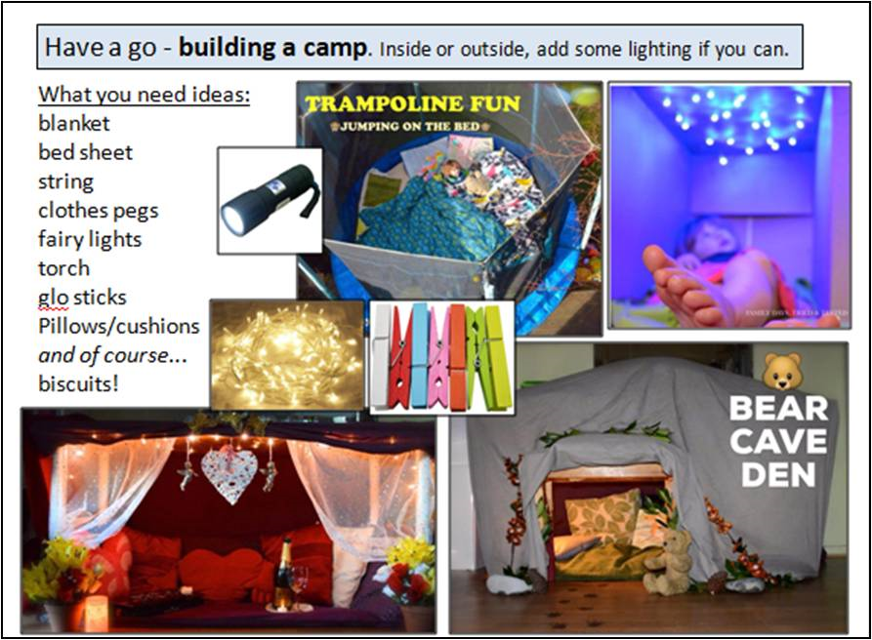  Focus: Teamwork - take photos / draw the camp or den you made. If you want to you can list the things you used so that others can have a go too! email to meadow@meadowhighschool.org and we will put them on the website.
Maths Focus  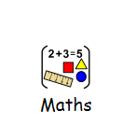 | - Do you like listening to maths stories? Listen below:  https://www.youtube.com/watch?v=cbi_mhNEwdU&t=197s  - Look at the images below: Draw your own house, boat and person by drawing shapes only.  - Now: Can you draw a robot by drawing shapes?  - If you like, paint or colour your shapes in the end. Count how many different colours you have used. Count how many yellow triangles you have. Count how many red squares you have. Compare the size of your shapes.  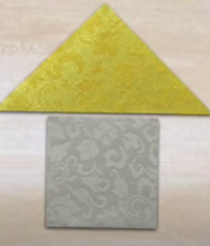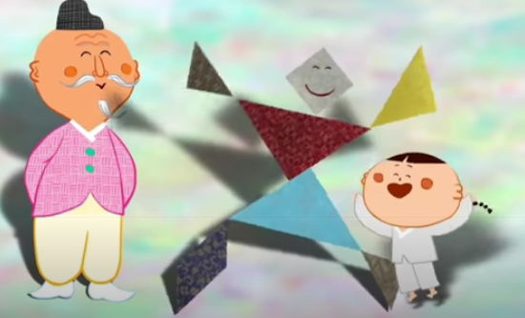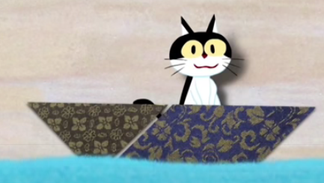  - Play shape hunt at home or school. Look at the 3d shapes below.  - Can you remember their names?  - Look around in the classroom and try to find objects that have these shapes.  - Record your answers on the sheet using tally marks (III)  - Compare the answers with your classmates. Who found most of the cubes?  - Who found most of the cuboids? Who found most of the spheres?  - Who found most of the cylinders?  - Who found most of the shapes altogether?  If you are at home, move around in different rooms and find objects with these shapes. You could play with a parent, sibling or carer and compare your answers with them.  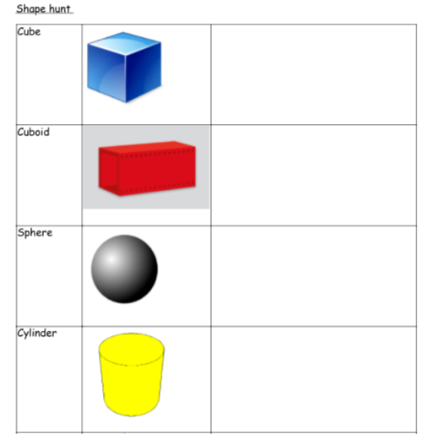  - Design an ice cream cone using line and colour patterns.  - Watch the video and listen to instructions https://www.youtube.com/watch?v=InLkKxyxdrU  - Now: Can you design the ice cream cone using the same line and colour patterns?  - When you finish, try to design another ice cream cone using your own line and colour patterns.  - Make your own emoji face!  - Also downloadable on Twinkl  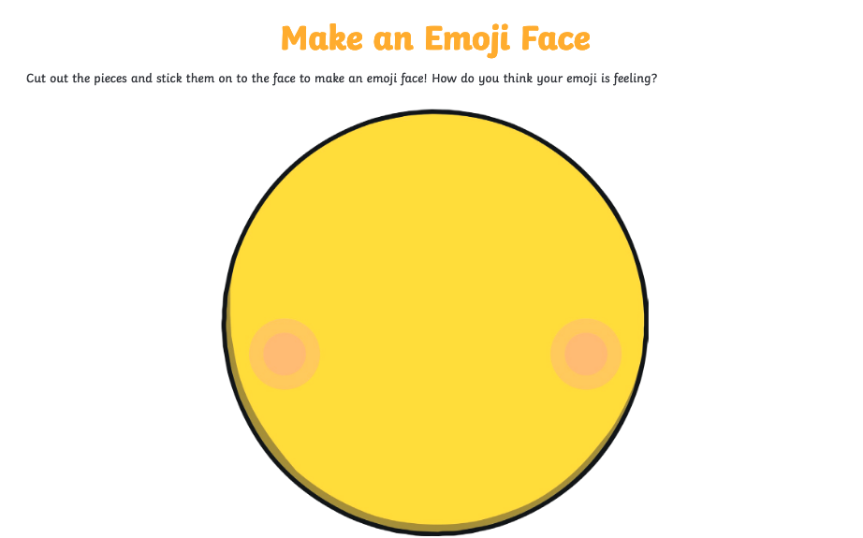  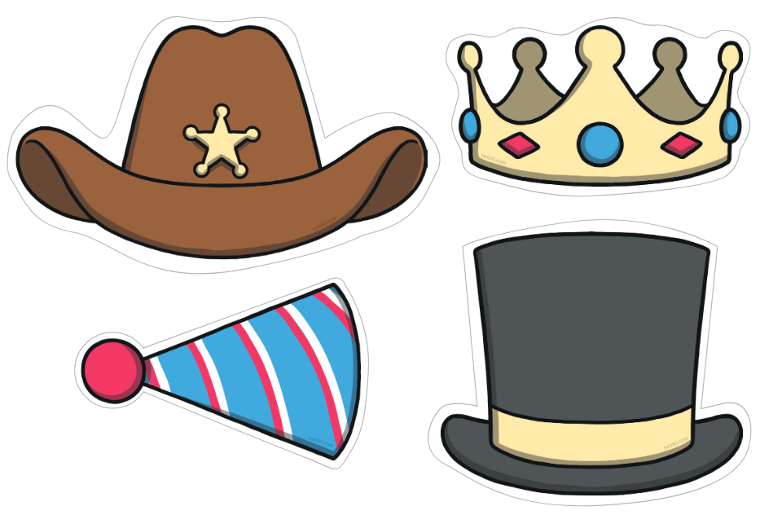  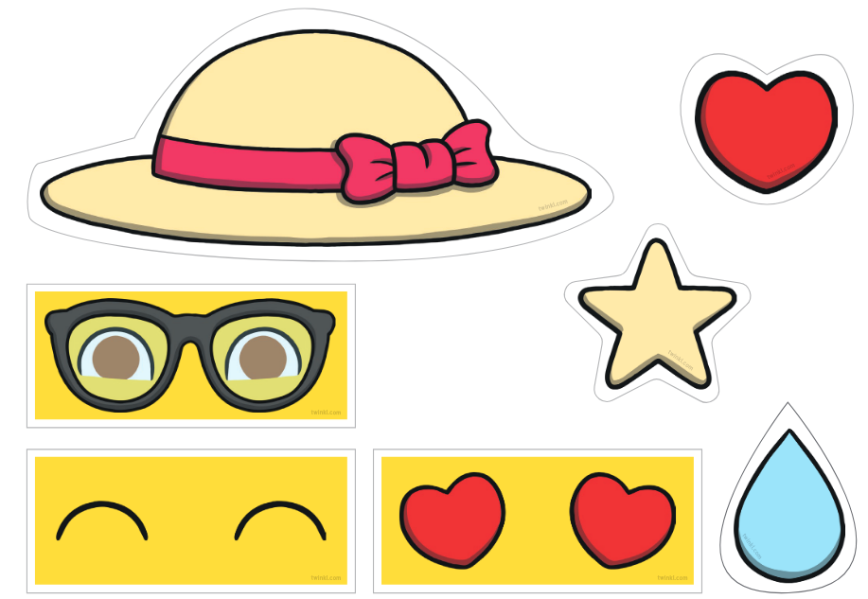  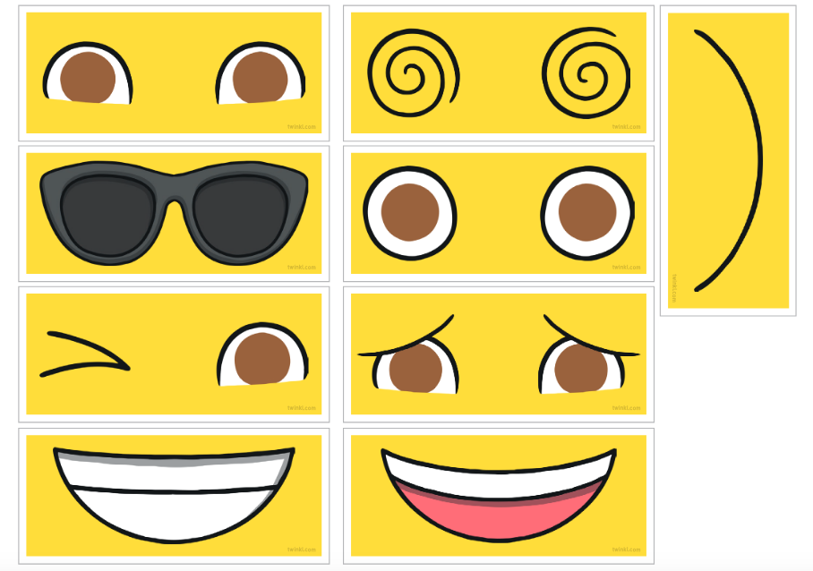  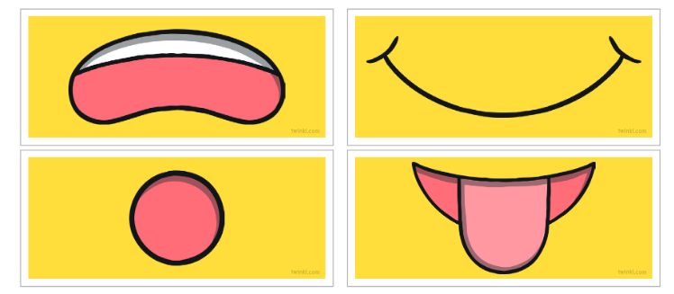
Science Focus  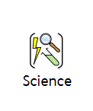 | 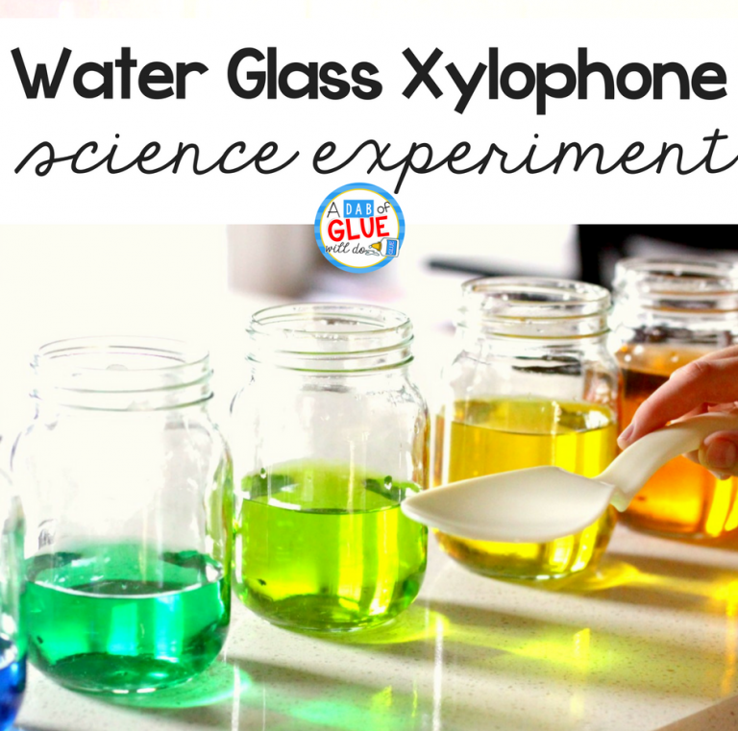  Musical bottles  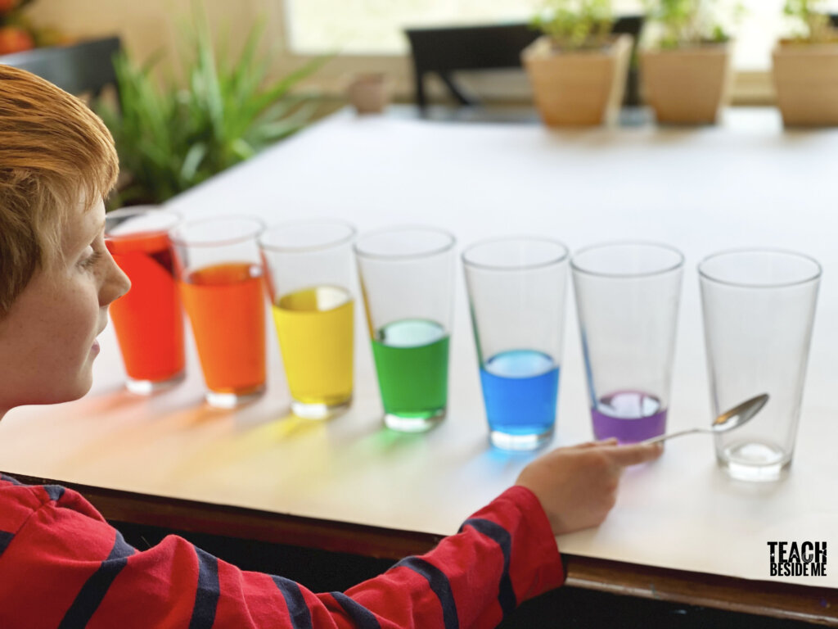  Task: Create a water xylophone and explore the science of sound.  - Explore the sounds- Do they sound different?  - Can you hear a high and low pitch?  - Does the amount of water change the sound ?  What you will need:  - 5 identical bottles (or jars or glass cups)  - Water  - Spoon  - Food colouring (optional)  Website: https://kids.nationalgeographic.com/explore/science/sounds-great--bottled-music/  https://www.adabofgluewilldo.com/water-glass-xylophone/  What's happening:  Changing the amounts of air and water in the bottles lets you change the pitch—how high or low the sound is. When you blow across the tops of the bottles, you're making the air inside vibrate. In bottles with more air, vibrations are slower, so the pitch is lower.
Creativity
Cooking/Technology 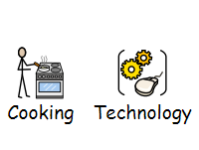 | Create a video game character  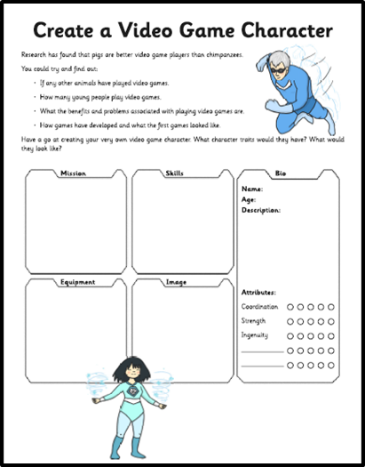  Attached: PDF - Create-A-Video-Game-Character-Activity-Sheet  Tropical Granola Lollies - Simple fruity lollies that count as one of your five-a-day, topped with rich dark chocolate and crunchy cereal for a moreish frozen treat.  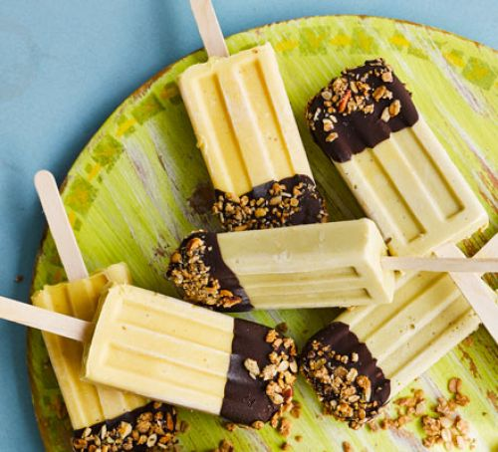  Link:https://www.bbcgoodfood.com/recipes/tropical-granola-lollies  Here are some brilliant website for you to look at different recipes that you may choose to make:  https://www.bbcgoodfood.com/recipes/collection/school-holiday  https://www.bbcgoodfood.com/recipes/collection/summer-family  https://www.tasteofhome.com/collection/fun-recipes-for-summer-vacation/
Drama/Arts/Music   | Art:  Task 1: Watch video - Just Dance  https://www.youtube.com/watch?v=G74_o_43_RQ  Task 2: How did the video make you feel? Select and draw the emoji    Task 3:Listen to the song again and this time see if you can dance in time to the music. Who can you ask to dance with you?  Task 3: Draw the things make you happy  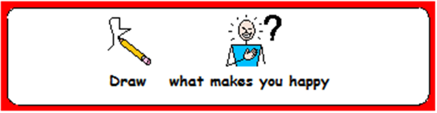  Other ideas for wider learning:  - Try the different holiday colouring activities  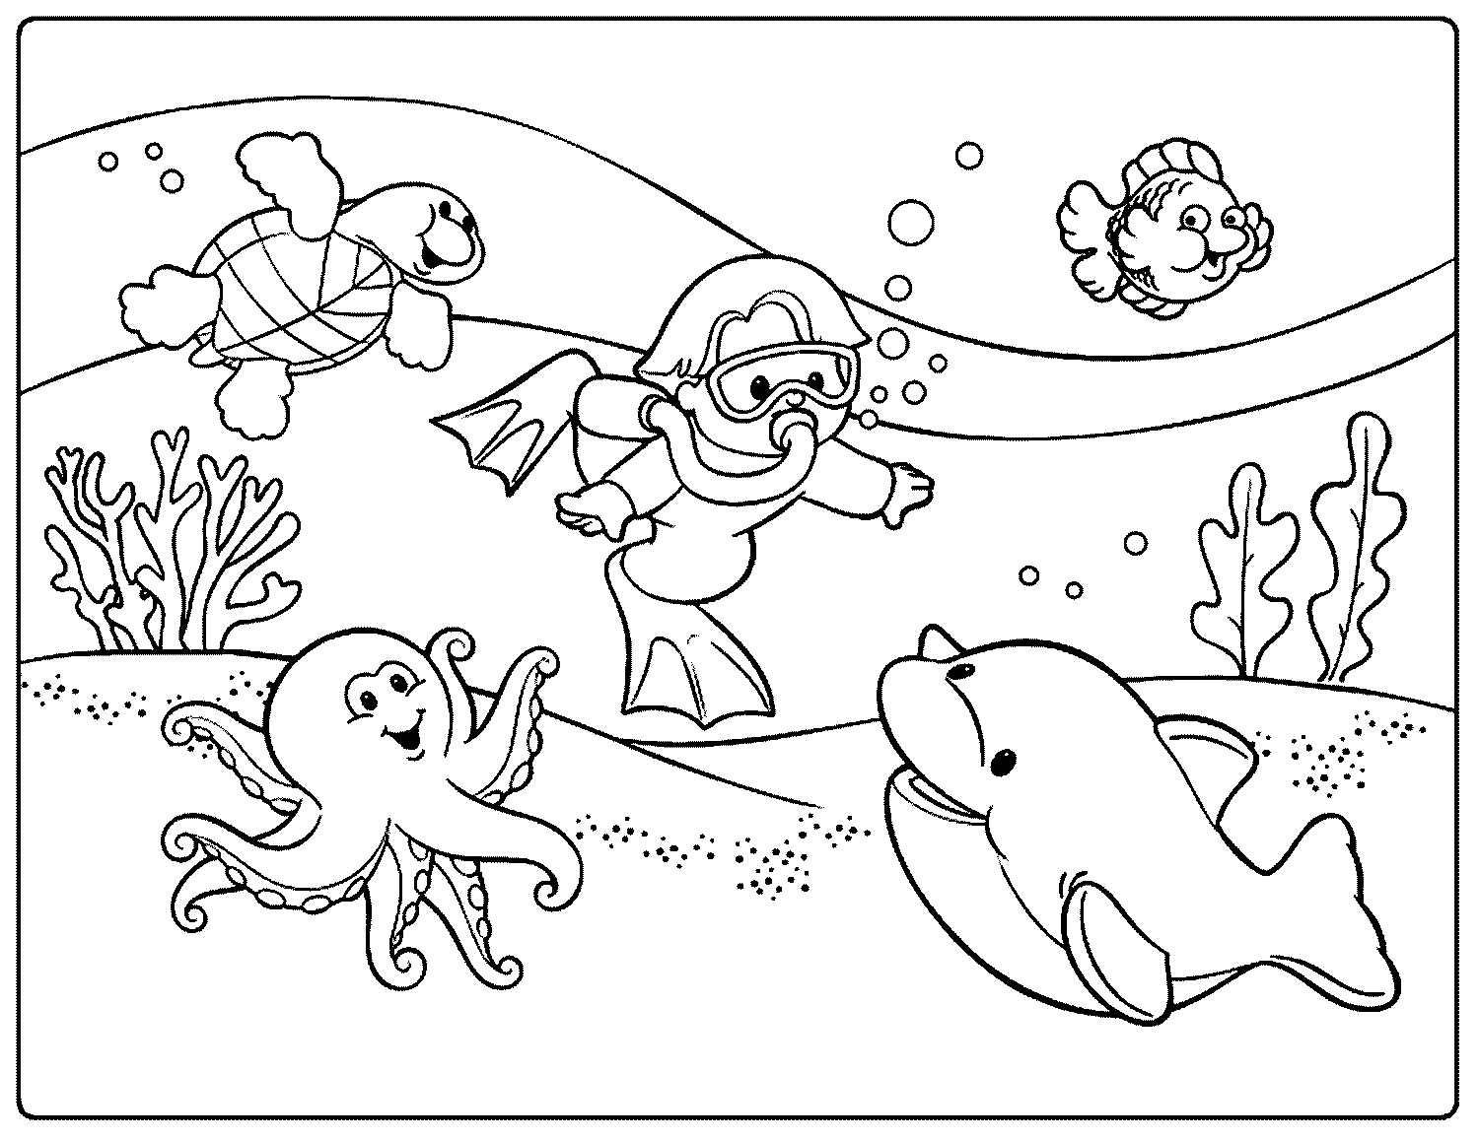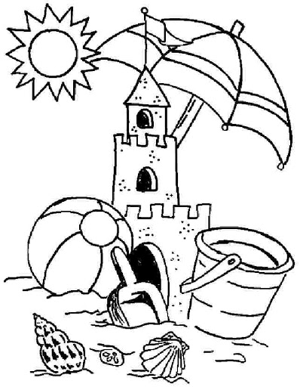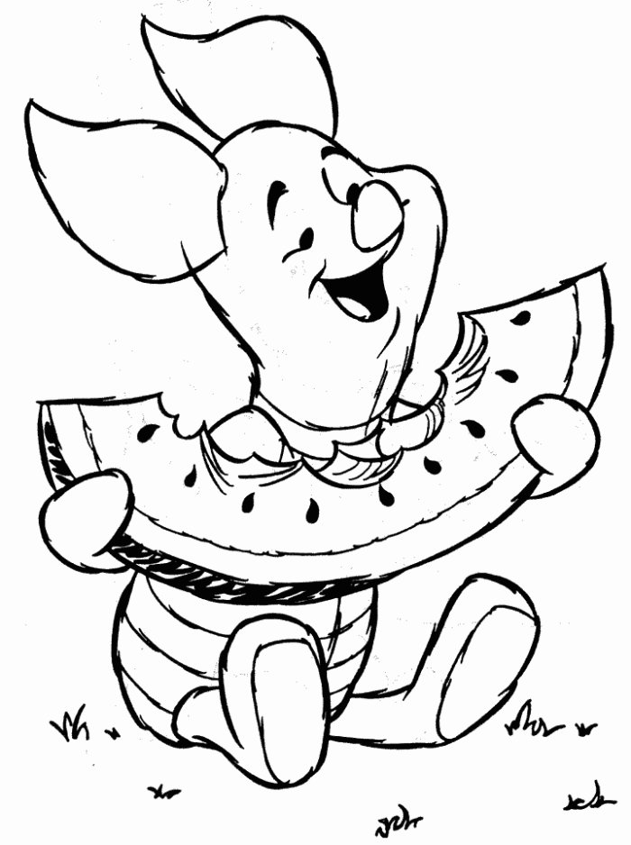  - Listen to the summer songs, sing along and sing about what you like to do in the summer  https://www.youtube.com/watch?v=mVhh0oATqBI  https://www.youtube.com/watch?v=wyzJtGRZWwM  - Hand print Art https://www.youtube.com/watch?v=oNhfGyi0Hwo  Play musical status and sleeping lions to your favourite song  We hope you enjoyed the Arts Activities looking forward to seeing you in school again in September
Health and Wellbeing
Physical activity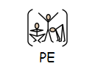 | The PE staff have uploaded lots of videos of circuits training or challenges to the youtube channel. Have a look and have a go. Keep active!  https://www.youtube.com/channel/UCQVlu1D0XnL-bwjaXIzbZxQ/videos  ThisIsPE: Updated 3 times a week. Fun and easy activities to be done at home. https://www.youtube.com/results?search_query=thisisPE  Using ideas from the “This is PE” link, try and create your own game using things you can find at home. Write down the rules and play with your family. If you can, upload to Twitter and tag “@MeadowPE” so we can see it.  Nike Move Crew: Fun games and dance activities led by Nike athletes. https://www.youtube.com/results?search_query=nike+move+crew  Go Noodle I Get Moving: Lots of videos to get children moving, dancing and exercising with lots of music and singing. https://www.youtube.com/user/GoNoodleGames  Fitness Blender: Build your own circuit training session  https://www.fitnessblender.com/videos  Lawn Bowling: Find 10 empty bottles and arrange them into a triangle. With a ball or rolled up socks roll/throw the object to knock down as many “skittles” you can in 2 rolls/throws. 1 game is made up of 10 turns (2 rolls/throws each turn). Count up your total score and see who wins.  Target Throw: Find 5 containers (they can be the same size or different sizes) and roll 5 pairs of socks up. Place the containers in different spaces and give them points based on how difficult they will be. Take a turn to throw the rolled up socks into the containers and count up your points.  Just Dance: If you like dancing or just want to keep moving. Use Just Dance’s youtube page and enjoy their videos.  https://www.youtube.com/channel/UC0Vlhde7N5uGDIFXXWWEbFQ  Using your leisure time to keep active is a way of creating and maintaining a healthy and active lifestyle. Find ways to enjoy keeping active!  Can you participate in some kind of activity that raises your heart rate for 30 minutes per day?

