
World of Work
Aims: These tasks are designed to be done with your child. Purple coloured tasks are aimed at pupils who would enjoy more of a challenge . These are tasks where pupils should be working with greater independence, however please take time to support pupils in starting the tasks and build communication skills.
Thinking
Literacy Focus: Developing skills identifying key information in a range of non-fiction texts and making clear notes to be used in a range of contexts. Building understanding of writing a summary and completing a piece of extended persuasive writing [sales ‘pitch’]  Examination Writing Terms: [See powerpoint]  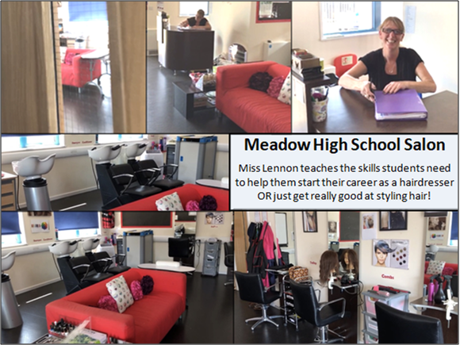  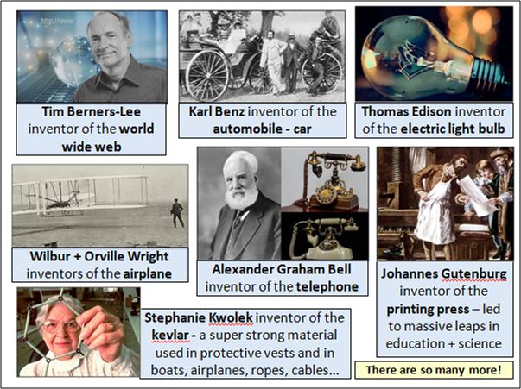 | Speaking, Listening, Reading and Writing:  Resources: video links in powerpoints  Powerpoints: W9 WoW Hairdressers+Lockdown Hair PURPLE as  and W9 WoW Inventors PURPLE as  Videos: Miss Barratt reading an extract from Whoosh!  An Interview with a Hairdresser [Miss Lennon]  Extension Work: Additional research on world changing inventions  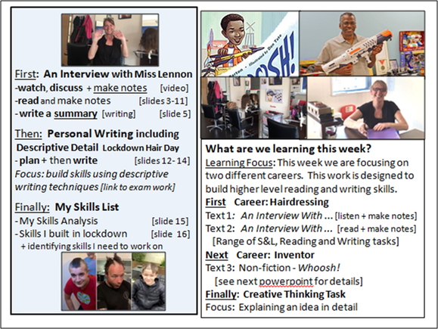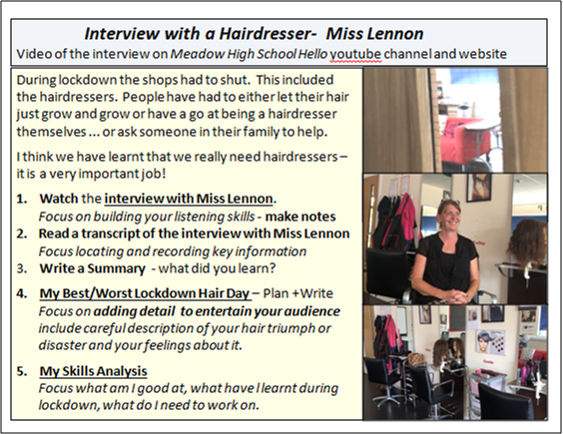  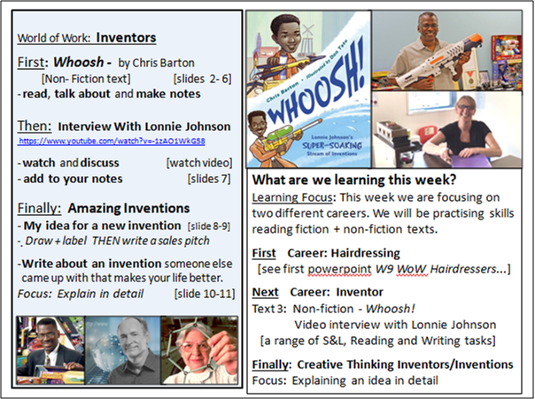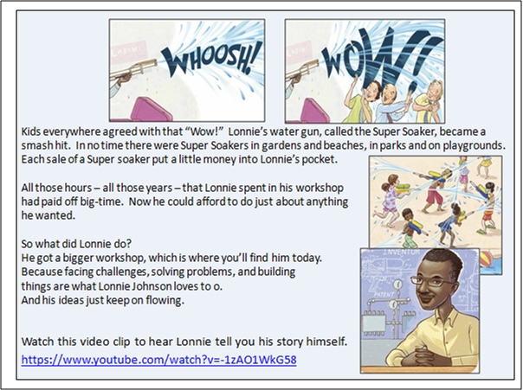  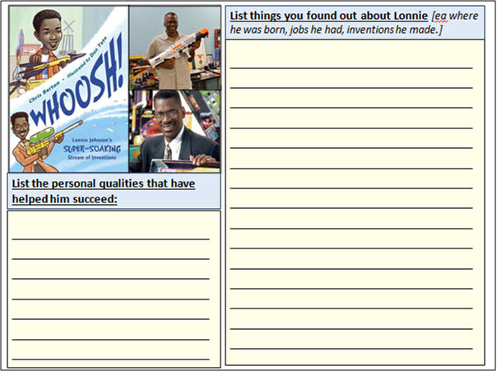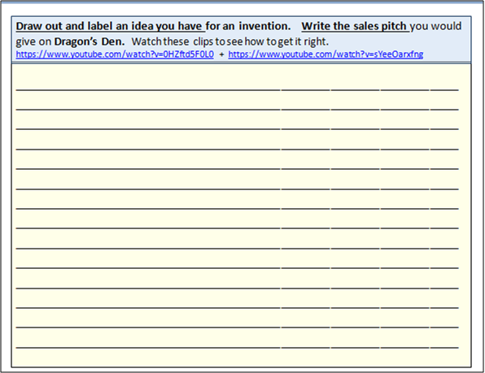
Maths Focus | - You are a scientist! Start with the letter D and see if you can solve all the letters. Good luck!  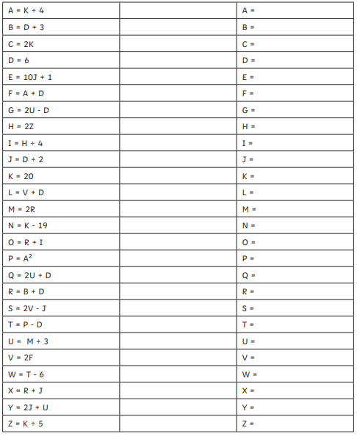  - Complete the fractions maze  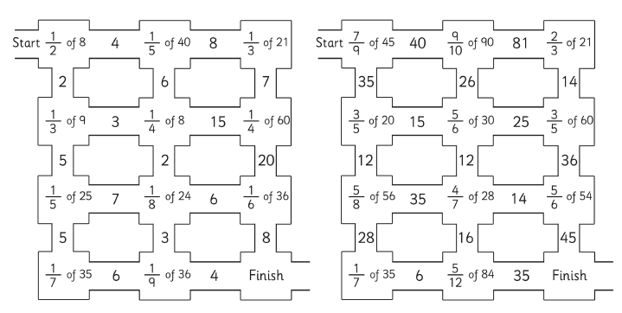  - You are a mathematician! Complete the ultimate times table challenge  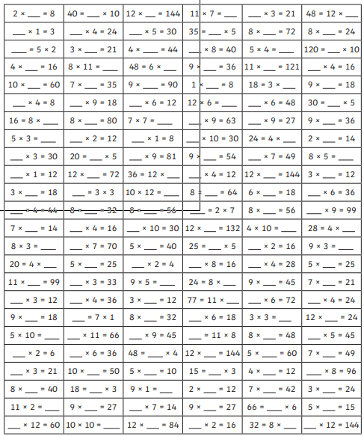  - Functional Skills Money Problem questions  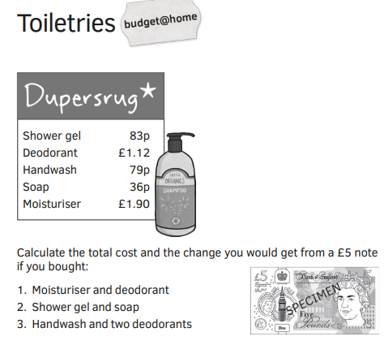  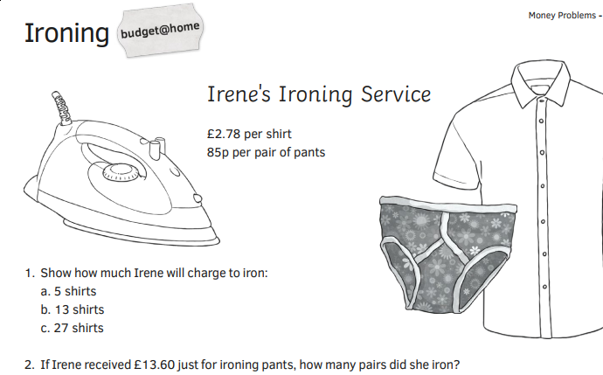  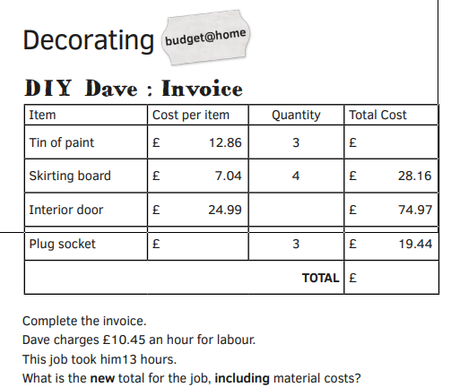  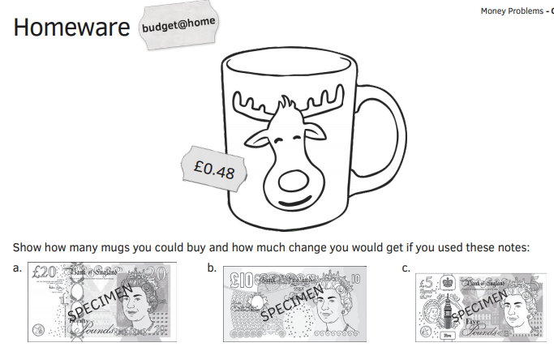
Science Focus |   Chef - A chef is a trained professional cook. In this activity you will explore the different ways food can be heated up.  Aim: To understand the 3 methods of heat transfer- convection, conduction and radiation.  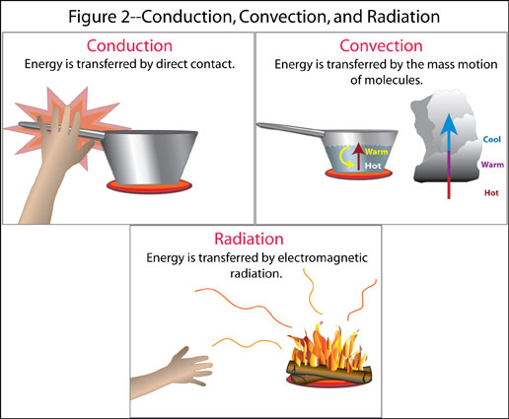  Task: Read the example for Conduction and fill in the sections for Convection and Radiation.  Remember: The transfer of heat is always from warmer objects to cooler objects!  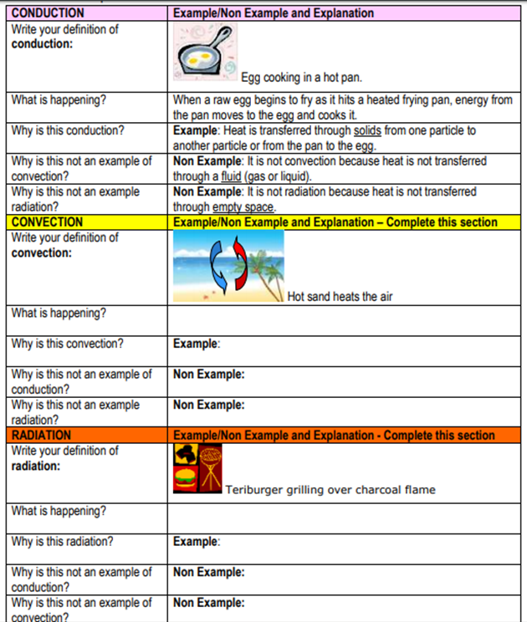  Video:  https://www.youtube.com/watch?v=EnI_d3GPypc  Worksheet link:  https://studyres.com/doc/10159947/conduction--convection--and-radiation-worksheet  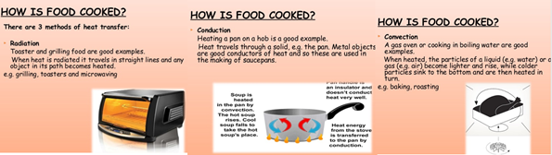
Cooking/Technology | Task: Choose a job that uses ICT - Identify how it is used in the work environment.  The link below shows Jobs that use Computing and ICT:  https://www.bbc.co.uk/bitesize/tags/zhj692p/jobs-that-use-computing-and-ict/1  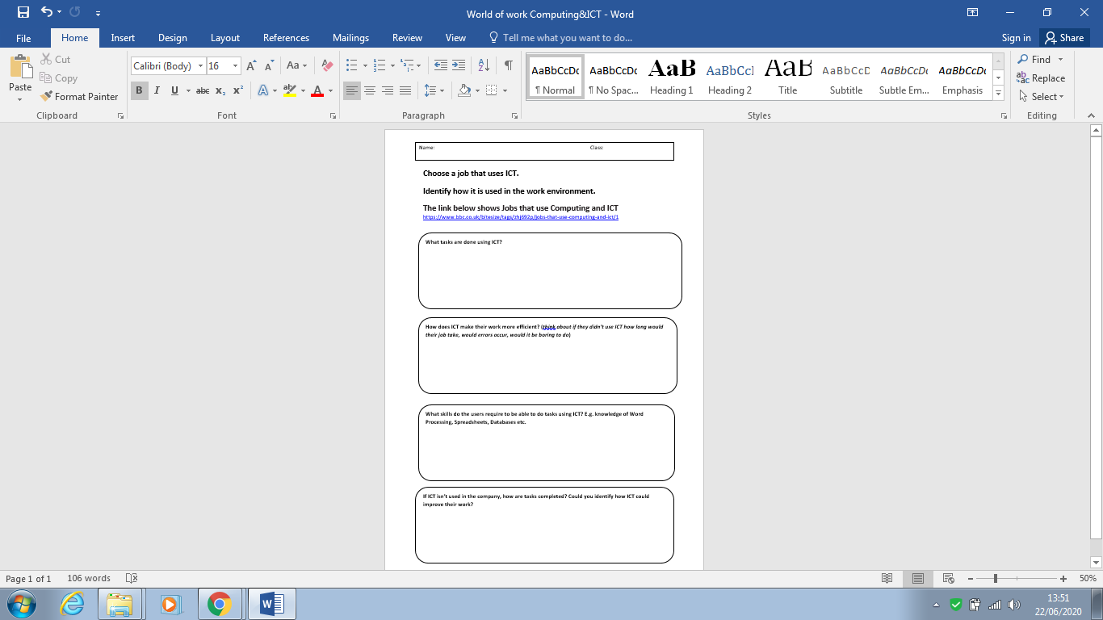  Attached: Worksheet - World of work Computing & ICT - Purple  Task: Balanced Lunch - Whatever job you may work, from a builder to an office worker to a dentist or a waiter, it is important to take a break and have a balanced lunch. Remembering what we have learnt from the EatWell Plate, can you create a balanced lunch using the different food groups.  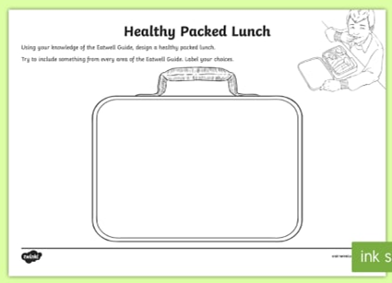  Attached: PDF - Packed Lunch Ideas - Purple  Helpful Links on the EatWell Plate:  https://www.twinkl.co.uk/resource/t-t-5470-eatwell-plate-poster  https://www.twinkl.co.uk/resource/t2-s-1204-food-pyramid-powerpoint  Task: Healthier Flapjacks Recipe - A healthier version of traditional fruit and nut bars that are packed with seeds, oats and syrup - perfect for snacking and lunchboxes.  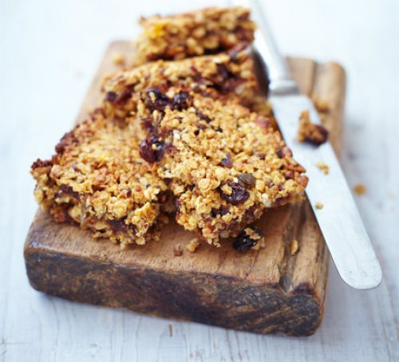  Link: https://www.bbcgoodfood.com/recipes/healthier-flapjacks
Drama/Arts/Music | Task Focus: Design-to develop a gaming character  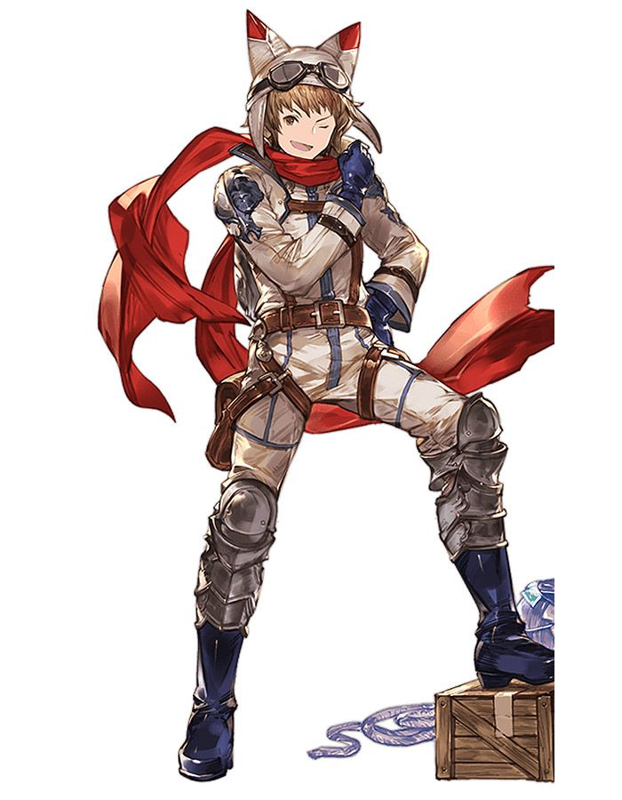  Information : A designer is someone who is paid for their designs ideas. They can design clothes, characters, storybook pictures and even computer game characters- People who design 2d ideas are usually called illustrators.  Step:1  Watch the clip on how to design your own character.  Many designers use photoshop to help them design a character  Task Helpful link to follow:  https://www.youtube.com/watch?v=oD8pfviW6G8  Discuss how the different layers are used to add costume and actions.  Step2: Design your own character on paper  Decide your character specifics  Write them at the top of your A3 paper page  Name:  Age:  How does it move? Fast Slow, Jump, Crawl, Fall etc..  Colour:  On a piece of paper design your character.  Here are some ideas to help you  Step 3: Try to draw your character from different angles  1 x from the front, 1 x from the side.  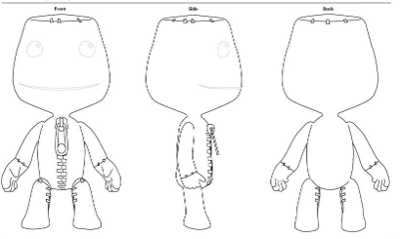  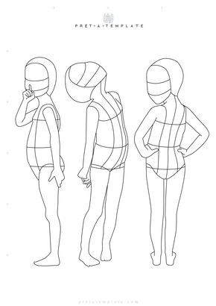  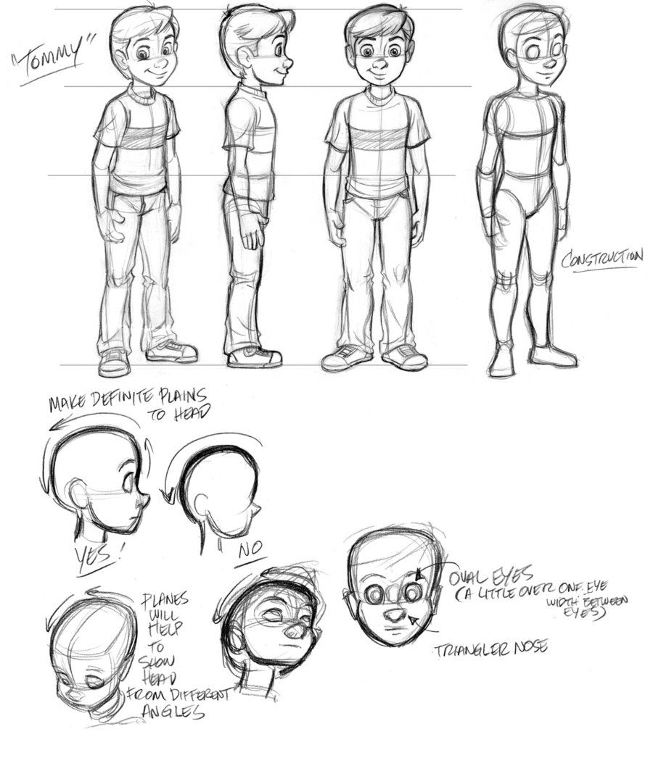  You will need:  -A3 or A4 Paper  -Pencils  -Colouring Pens  Keywords: Art Job, Career, Designer, Illustrator, Gaming Designer, Character, Front, Side  Other optional ideas for wider learning:  1.Watch the Lego story how it all happened?  Discuss how the name design was important in the sales in the story?  https://www.youtube.com/watch?v=qr_dTySMl7s  2.Try tying a tie so you can be ready for a job interview.  Practice acting out interviews for a job you would like-with someone at home.  https://www.youtube.com/watch?v=-55he7NGmDA  3. Develop Fashion Design Ideas-Colour the sheets or design your own  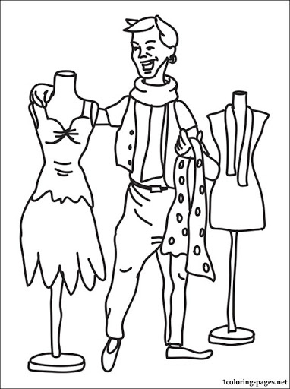  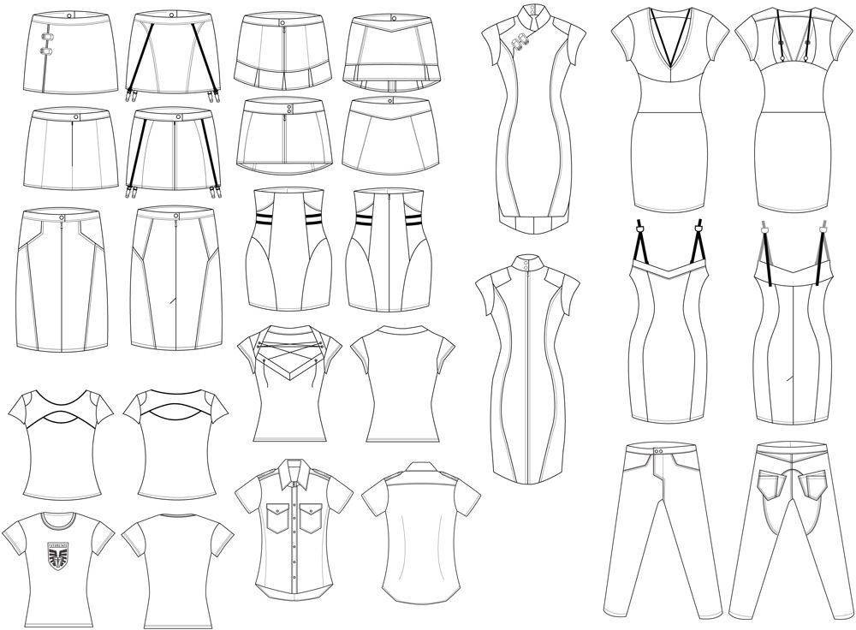
Health and Wellbeing
Physical activity | The PE staff are uploading videos of circuits training or challenges every week. Have a look at this week’s videos and have a go.  https://www.youtube.com/channel/UCQVlu1D0XnL-bwjaXIzbZxQ/videos  ThisIsPE: Updated 3 times a week. Fun and easy activities to be done at home. https://www.youtube.com/results?search_query=thisisPE  Using ideas from the “This is PE” link, try and create your own game using things you can find at home. Write down the rules and play with your family. If you can, upload to Twitter and tag “@MeadowPE” so we can see it.  Nike Move Crew: Fun games and dance activities led by Nike athletes. https://www.youtube.com/results?search_query=nike+move+crew  Go Noodle I Get Moving: Lots of videos to get children moving, dancing and exercising with lots of music and singing. https://www.youtube.com/user/GoNoodleGames  Fitness Blender: Build your own circuit training session  https://www.fitnessblender.com/videos  Careers within the sports industry:  Photographer: Try and take a photo of someone performing a sporting activity. See if you can get the perfect “action shot”. If you can upload it to Twitter, tag @MeadowPE so we can see it.  Sports Journalist: Now that sport is back on the TV, watch some sport and write a review of what you have watched. Try to include players names and key moments within the games.  Personal Trainer: Start by watching the circuit training videos on the Meadow youtube then have a go at designing your own circuit. Challenge yourself more by trying to focus on specific areas of the body for different sport stars. You can use the Fitness Blender link above to help you.  Sports Nutritionist: Research and make a typical meal for sports people in these sports:  - Weight lifter  - Marathon Runner  - Swimmer  - Footballer  Which diet would you most like to have? What are the main differences between the diets? Why do you think that is?  Create a poster for the following components of food, giving their role and what sports they are useful for:  - Carbohydrate  - Protein  - Fat  - Fibre  - Vitamins & minerals  Dancer: After watching some “Nike Move Crew” or “Go Noodle” videos, can you plan your own set of moves into a dance sequence?  If you want to make it easier:  You could do a sequence of different animal positions. E.g. Tall giraffe, then small mouse etc.
Wellbeing  Useful links offering support and discussion:  https://youngminds.org.uk/    https://www.time-to-change.org.uk/   | This week's focus is: Make Time for Me  Resources:  ‘Wellbeing Make Time for Me activity’  ‘Wellbeing Resilience Exercise’  ‘Wellbeing Powerpoint’  Objectives:  • To encourage students to talk about mental health openly  • To make pupils aware there are ways we can look after our mental health  Work your way through this very reflective activity and think about taking some time out for you! These activities can be done individually or as a family.
Cross Curricular | PSHCE:  Task: Future focus activity pack  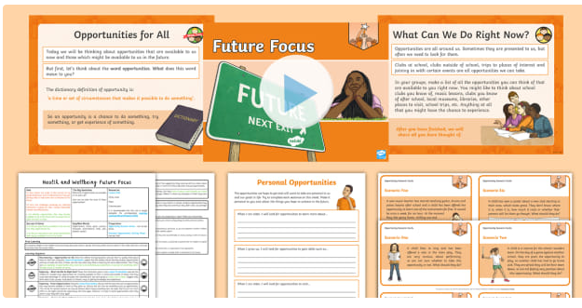  Link:  https://www.twinkl.co.uk/resource/t2-lf-519-pshe-and-citizenship-y5-aiming-high-lesson-3-future-focus-lesson-pack  Task: Innovation and Enterprise activity pack  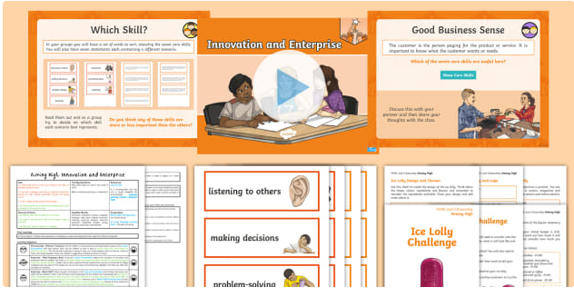  Link:  https://www.twinkl.co.uk/resource/t2-lf-517-pshe-and-citizenship-y5-aiming-high-lesson-5-innovation-and-enterprise-lesson-pack

