
World of Work
Aims: These tasks are designed to be done with your child. Blue coloured tasks are aimed at Pathway 1 pupils as well as pupils who prefer more interactive activities and require a higher level of support. These are tasks we hope you will enjoy, please select the ones you feel are most appropriate for your child.
Thinking
Literacy Focus: Building comprehension and language skills talking about, noticing same and different and stating yes or no. Reading practise [widget supported], initial letter sounds work and fine motor skills.  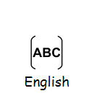  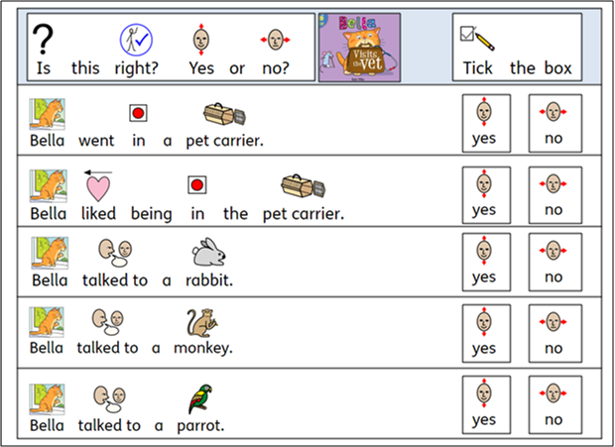  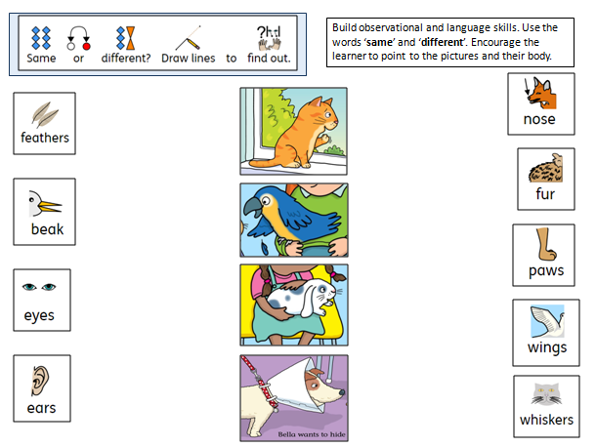  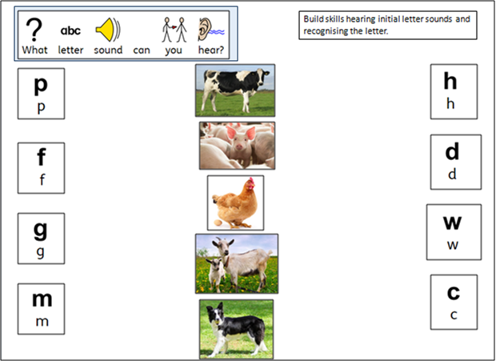 | Speaking, Listening & Communication, Reading and Writing:  Resources: powerpoints W9 WoW Vet Story + Tasks BLUE as; W9 WoW Farmers Life + Tasks BLUE as - youtube links in the powerpoints, 2 x signed stories on video Bella Visits the Vets and A Farmer’s Life For Me.  No internet, no problem - stories and tasks all on the powerpoints.  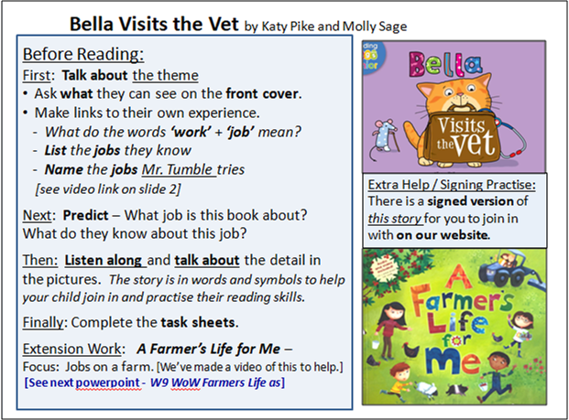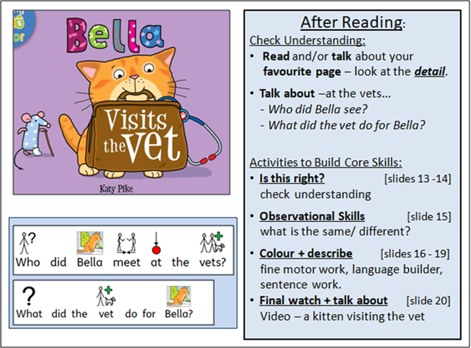  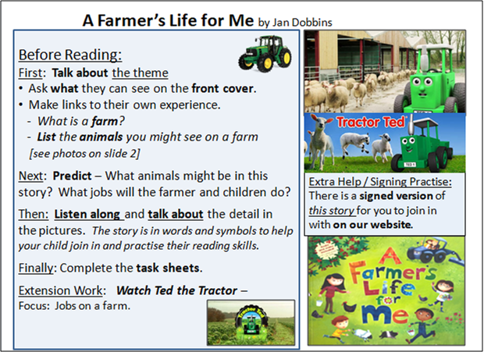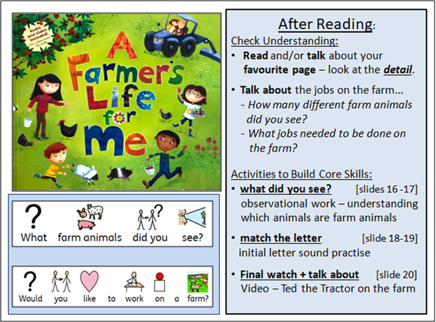  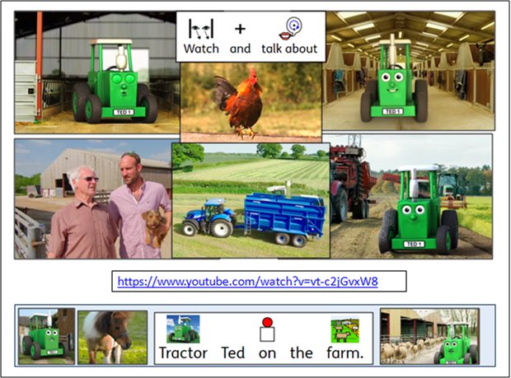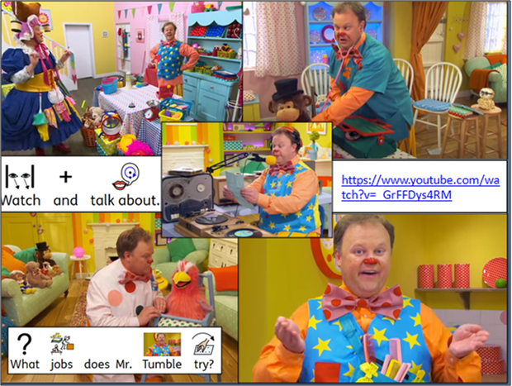
Maths Focus  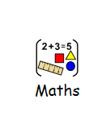 | - Look at the image below and answer the questions  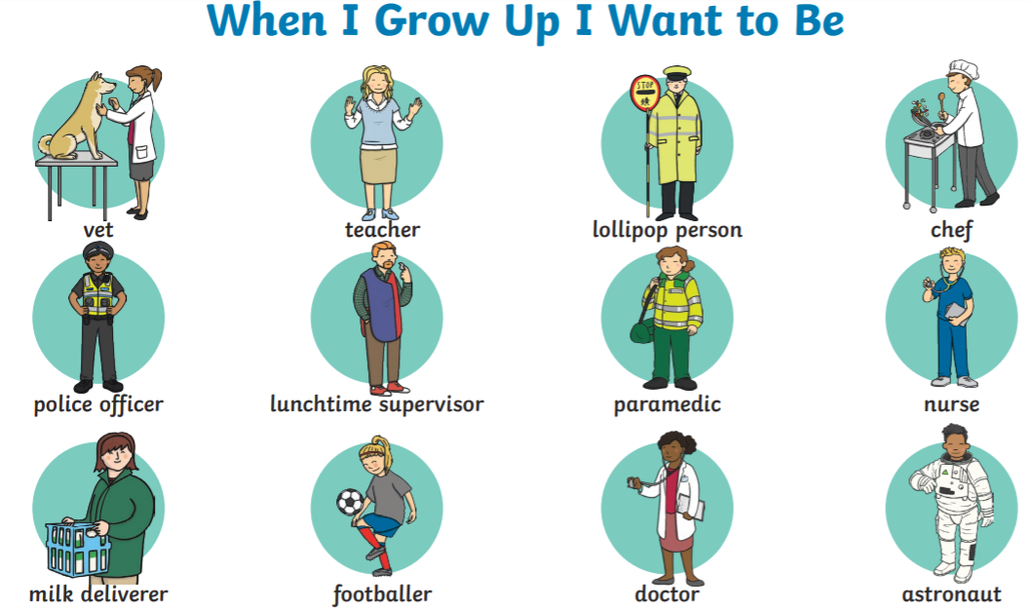  - How many workers wear white uniforms?  - How many workers use a stethoscope?  - How many workers wear hi-vis jackets?  - How many workers work in a hospital?  - How many workers work in a school?  - Do you know any more jobs that people do?  - What job would you like to do when you grow up?  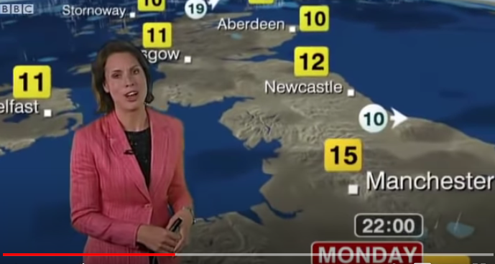  - Watch the video with the meteorologist explaining the weather on Monday https://www.youtube.com/watch?v=HSHNkT-V7LY  - What was the temperature in Newcastle?  - What was the temperature in Manchester?  - What was the temperature in London?  - Compare your answers above. What city was the coldest? (lower temperature=colder)  - Compare your answers above. What city was the hottest? (higher temperature=hotter)  - Search online for the weather forecast in the next few days https://www.bbc.co.uk/weather/2643743  - What’s the temperature today? How does it feel?  - Can you spot the days with the highest temperatures?  - Can you sport the days with the lowest temperatures?  - Compare the temperatures in the morning, afternoon and evening. When does the temperature drop? When does the temperature rise?  - Imagine yourself being a cashier in a supermarket. Look at the prices of the vegetables and answer the questions  - How much does the cucumber cost?  - How much do the peppers cost?  - Which vegetables have the same price?  - Can you calculate the total cost of all items? (if you need help, use a calculator)  - How much change would you get from a £5 note?  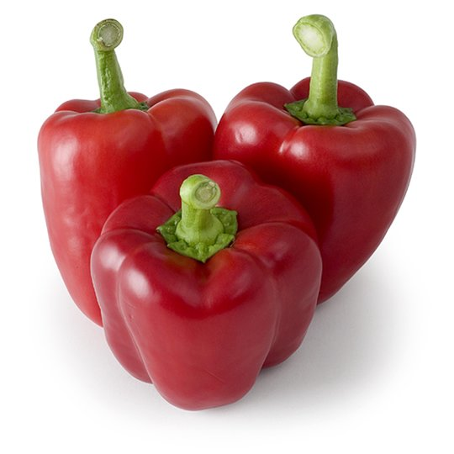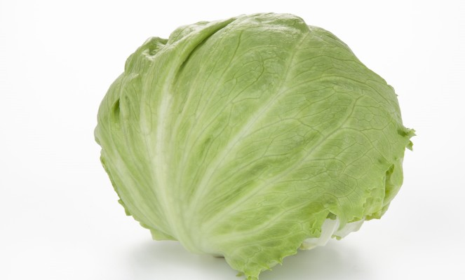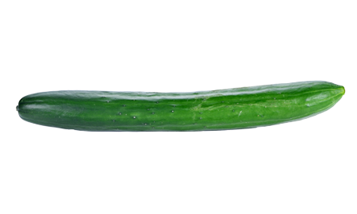  - £1.50 peppers  - 50p lettuce  - 50p cucumber  - Look at the foods below and answer the questions  - What food is the cheapest?  - Which food is the most expensive?  - How much do the crisps and the chocolate bar cost altogether?  - How much does everything cost? (if you need help, use a calculator)  - A customer pays with £10, how much change would you get?  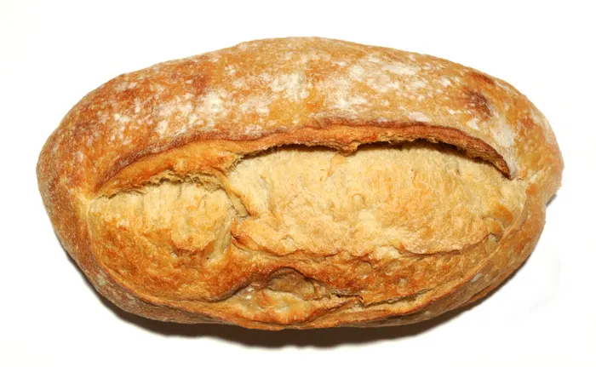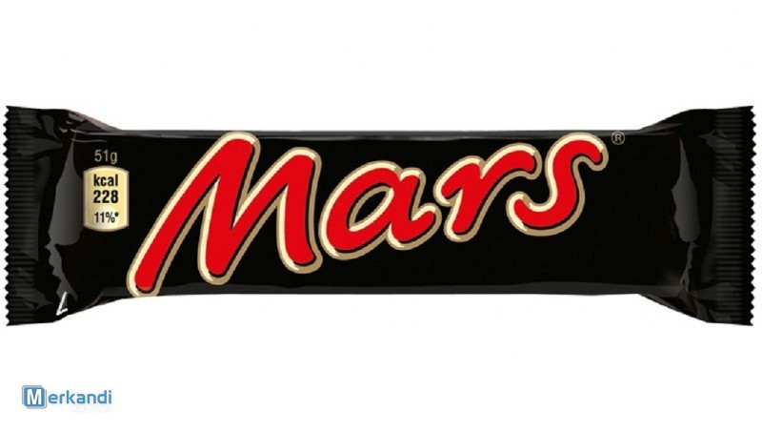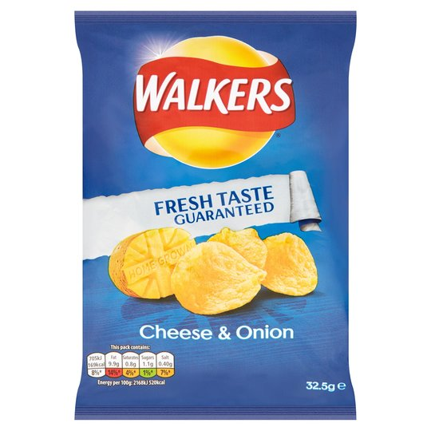  - Bread £1.10  - Chocolate bar 60p  - Crisps 25p
Science Focus  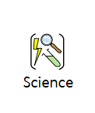 |   ASTRONOMER - Astronomers are scientists who study the universe, its objects and how it works.  Task:Solar System Hat Activity - Create a solar system hat with planets in the correct order  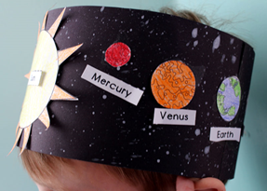  Key Words: Mercury, Venus, Earth, Mars, Jupiter, Saturn, Uranus, Neptune  Equipment: Card, Paper, Colours, Glue, Scissors  Method:  Cut out the planets in the template and stick on your card. Tape the ends together and wear your hat!  Use the planet template provided in the links or draw your own!  Remember to use the correct colours for the planets and make you stick them in the correct order.  Links:  https://www.bestcoloringpagesforkids.com/wp-content/uploads/2013/07/Name-the-Planets-Worksheet.jpg  http://www.primarythemepark.com/2014/04/solar-system-activity-for-kindergarten/  Questions: Using your hat answer the following questions:  •What planet is closest to the sun?  •What planet do we live on?  •What is the name of the biggest planet?  •Which planet has rings around it?  •How many planets are there in our solar system?  •What colours did you use to colour Earth?  •What do these colours represent?  (Answers: Mercury, Earth, Jupiter, Saturn, 8, Blue and Green, Land and Sea).
Creativity
Cooking/Technology 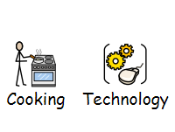 | Task: Healthy Lunch - In the world of work it is essential to keep your energy up through breaks and lunch. Therefore it is important that children know what a healthy lunch is and this resource is ideal for teaching them about making healthy choices. The children will cut out the foods and stick them in the lunch box to show what they think a healthy lunch is.  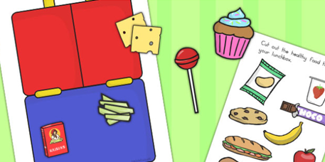  Attached: PDF - Healthy Eating Lunch Activity - Blue  Task: Fruity Sundae Recipe - A sweet and fruity treat for a boost at lunchtime - yogurt swirled with mashed strawberries, topped with berries.  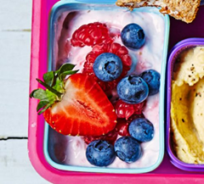  Link: https://www.bbcgoodfood.com/recipes/fruity-sundae
Drama/Arts/Music   | Task Focus: Drama Can you act out a job?  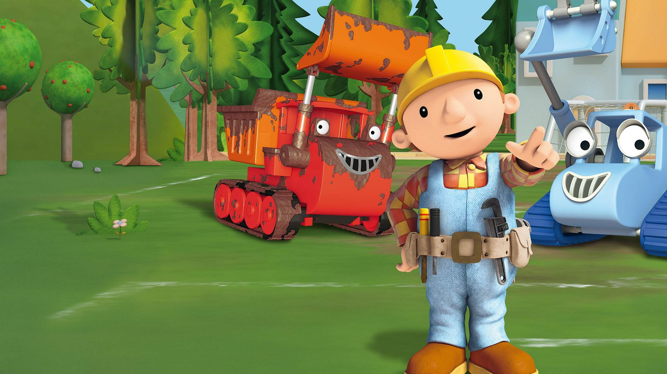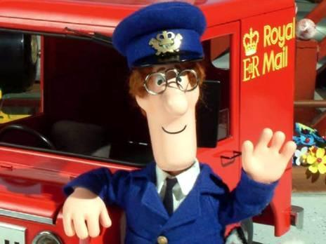  Information: Many people like to do active jobs, Postman and Builders are very active. Can you think of actions that they do? What other jobs can you think of?  Step 1 watch Bob the builder and Postman Pat.  Try acting out some jobs  Step 2. Look in your clothes for the costume, what can you use?  Step 3. Make a hat/headband using the link and resource pack  Step4 play the drama game-  https://www.youtube.com/watch?v=_q9mePfdnj8  Take turns to act out your job, then try and act different jobs, see if the others can guess the job.  Task Helpful link to follow:  Bob the builder clip: https://www.youtube.com/watch?v=a0fbIqwFs9E  Postman pat clip:  https://www.youtube.com/watch?v=SrjEJp4dS1I  You will need:  -Print outs  -Scissors  -Tape  -Stapler  -Colouring pencils  To make a work hat/headband you will need to watch the clip:  https://www.youtube.com/watch?v=TRXpBcJpLzY  You can print the PDF from the attached headband PDF resources or draw your own.  Instructions:  - Print  - Colour all the images on the page.  - Cut along dashed lines. You will have 2 pieces.  - Attach the 2 pieces together on both sides with tape or staples to make a crown-style hat.  Keywords: Doctor, Nurse, Fire fighter, Police, Pilot, Chef, Construction, Detective, Postman, Farmer.  Other optional ideas for wider learning:  https://www.youtube.com/watch?v=MLmPsvlw4no  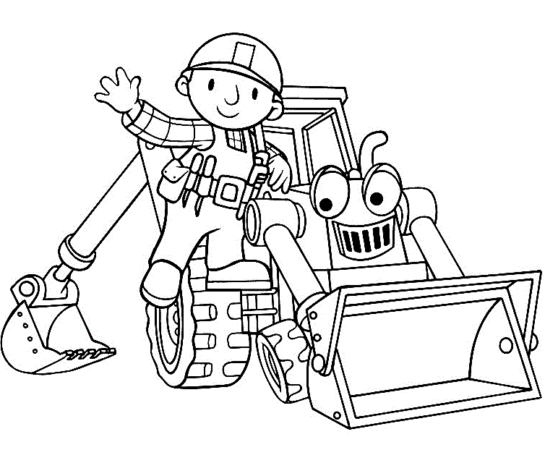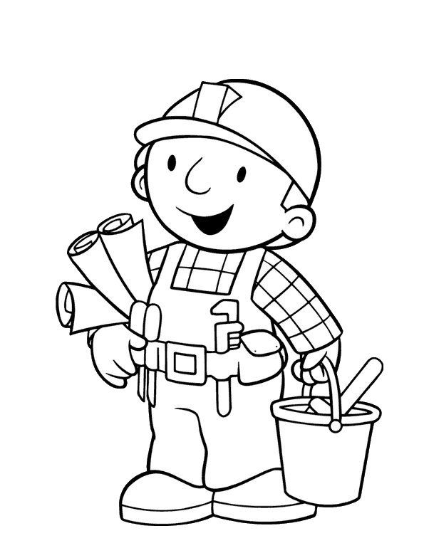  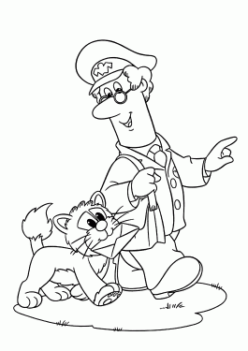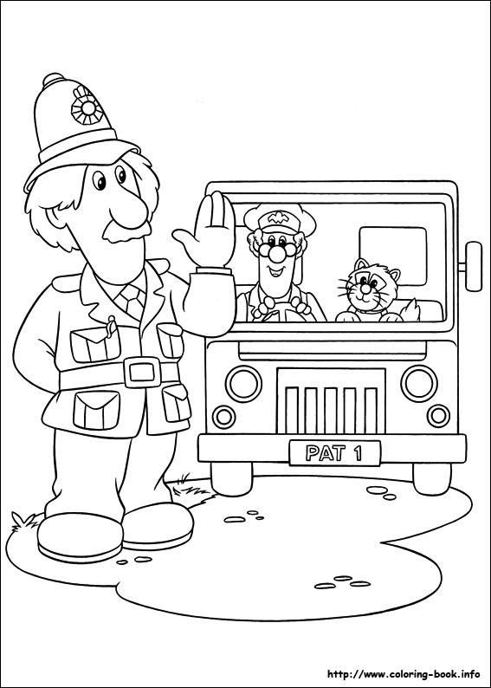
Health and Wellbeing
Physical activity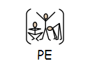 | The PE staff are uploading videos of circuits training or challenges every week. Have a look at this week’s videos and have a go.  https://www.youtube.com/channel/UCQVlu1D0XnL-bwjaXIzbZxQ/videos  ThisIsPE: Updated 3 times a week. Fun and easy activities to be done at home. https://www.youtube.com/results?search_query=thisisPE  Using ideas from the “This is PE” link, try and create your own game using things you can find at home. Write down the rules and play with your family. If you can, upload to Twitter and tag “@MeadowPE” so we can see it.  Nike Move Crew: Fun games and dance activities led by Nike athletes. https://www.youtube.com/results?search_query=nike+move+crew  Go Noodle I Get Moving: Lots of videos to get children moving, dancing and exercising with lots of music and singing. https://www.youtube.com/user/GoNoodleGames  Fitness Blender: Build your own circuit training session  https://www.fitnessblender.com/videos  Careers within the sports industry:  Photographer: Try and take some photos of things to do with sport. It could be equipment, clothes or places where you can play sports.  Sports Journalist: Now that sport is back on the TV, watch some sport and write down as many things as you can about it.  - Who was playing?  - What colour were the kits?  - What sport were they playing?  - What were their names?  - What was the score?  - What sport are they playing?  Personal Trainer: Watch the circuit training videos on the Meadow youtube and try them out. Then try and add your own exercises to make them even better! You can take out exercises you don’t like and add your favourite.  Sports Nutritionist: Research and make a typical meal for sports people in these sports:  - Weight lifter  - Marathon Runner  - Swimmer  - Footballer  Which diet would you most like to have?  Dancer: After watching some “Nike Move Crew” or “Go Noodle” videos, can you plan your own set of moves into a dance sequence?  If you want to make it easier:  You could do a sequence of different animal positions. E.g. Tall giraffe, then small mouse etc.
Cross Curricular | PSHCE:  Task: Jobs and skills activities pack  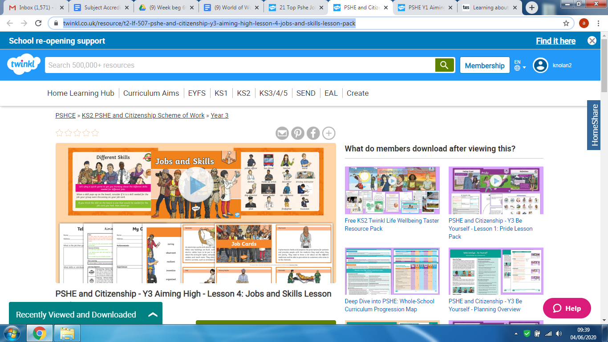  Link: https://www.twinkl.co.uk/resource/t2-lf-507-pshe-and-citizenship-y3-aiming-high-lesson-4-jobs-and-skills-lesson-pack  Task: When I grow up activity pack  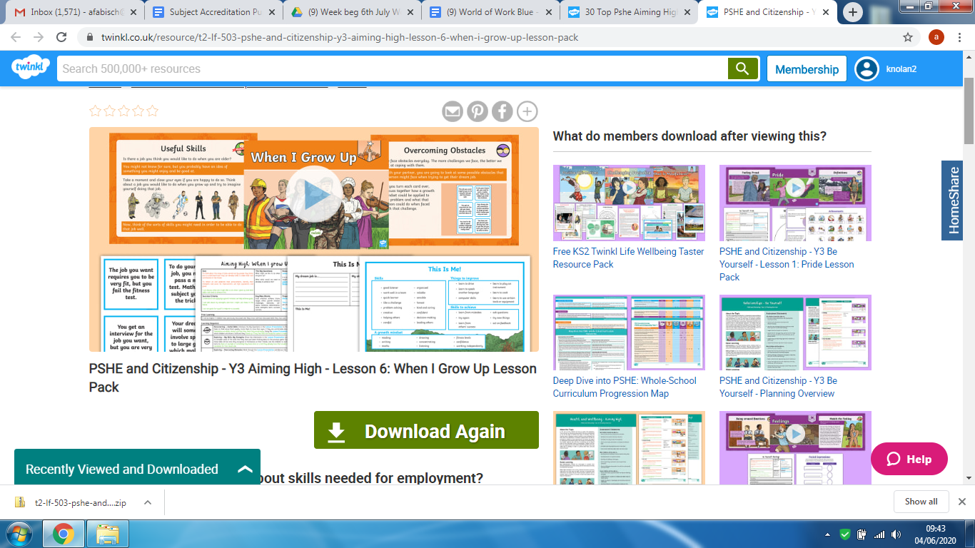  Link: https://www.twinkl.co.uk/resource/t2-lf-503-pshe-and-citizenship-y3-aiming-high-lesson-6-when-i-grow-up-lesson-pack

