Aims: These tasks are designed to be done with your child. Purple coloured tasks are aimed at pupils who would enjoy more of a challenge . These are tasks where pupils should be working with greater independence, however please take time to support pupils in starting the tasks and build communication skills.
Thinking
Literacy Focus: Build skills identifying key moments in a text, making links between events and the character’s feelings. Embed close reading skills, using evidence from the text. Build auditory memory through listening and taking notes leading to writing a summary. Developing imagination and language skills through narrative and descriptive writing tasks.  Signing & Communication Link: Zones of Regulation linked to feelings and language to talk about change and transition.  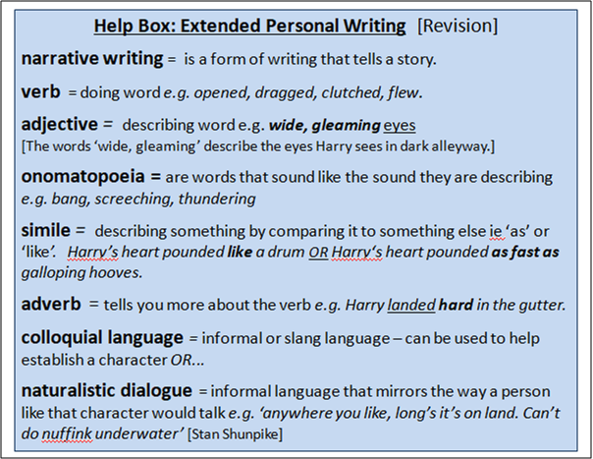  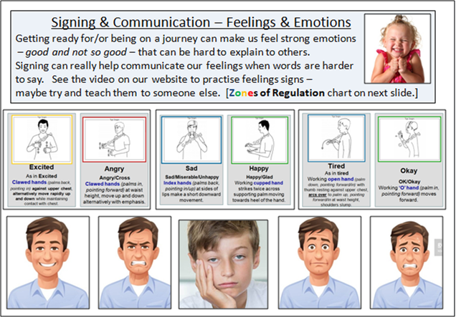 | Speaking & Listening, Reading + Writing:  Resources: video links the powerpoint .  Powerpoints: W8 Transport Read, Discuss + Write PURPLE as  W8 Transport Descriptive Writing PURPLE as  Videos: Miss Barratt reading Horrid Henry’s Car Journey [3 x videos]  Mr. Brady reading Harry Potter the Knight Bus  Extension Work: Mrs. Sugden - Zones of Regulation + emotion signs  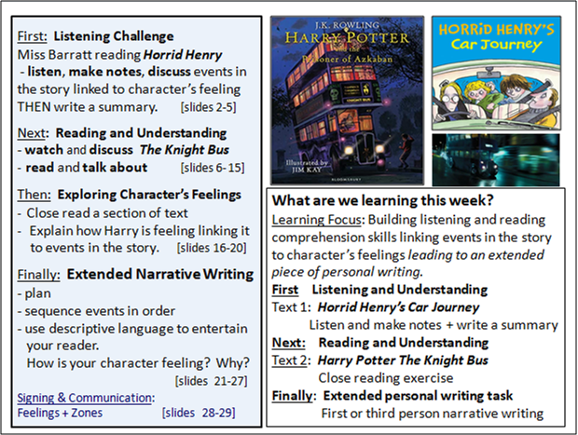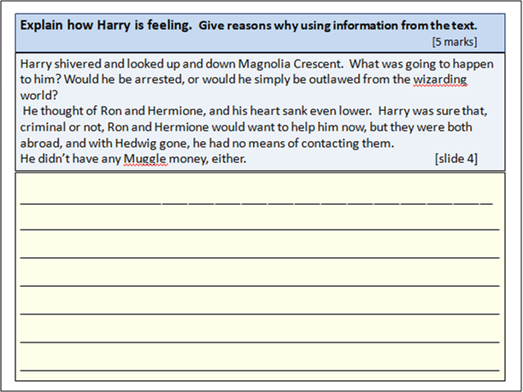  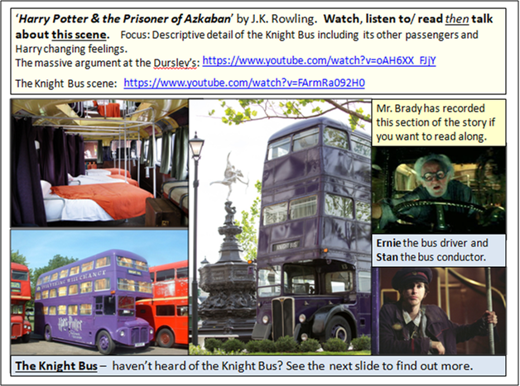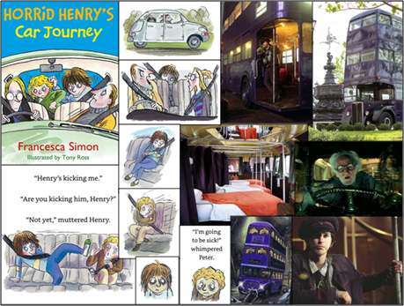  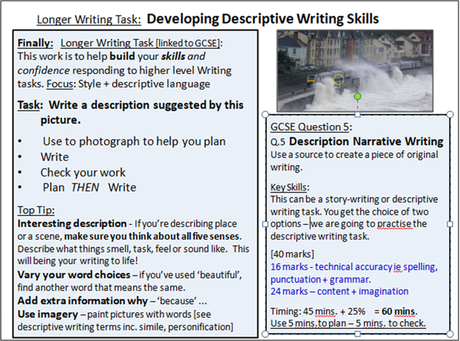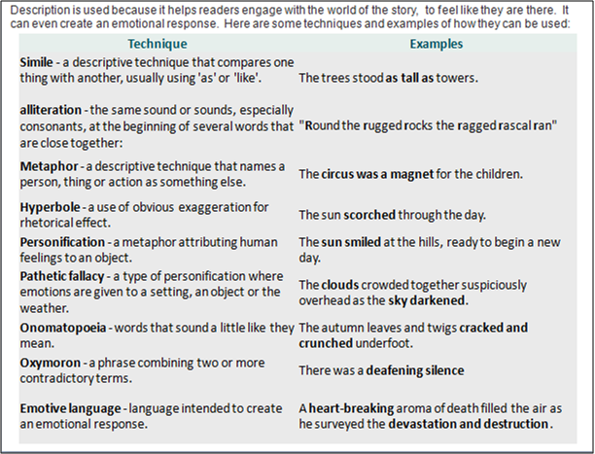
Maths Focus | - This is the London Underground map, can you research the distance between these stations in km? Can you convert them to miles?  - Euston Square to Oxford Circus  - Angel to Bank  - Royal Oak to Wood Lane  - Putney Bridge to South Kensington  - Borough to Monument  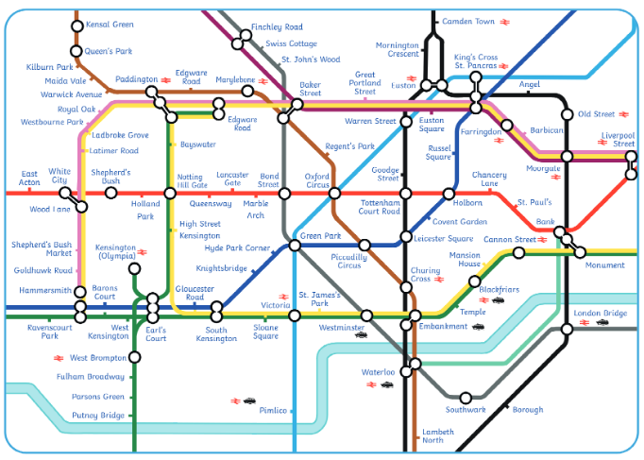  - Can you solve this puzzle?  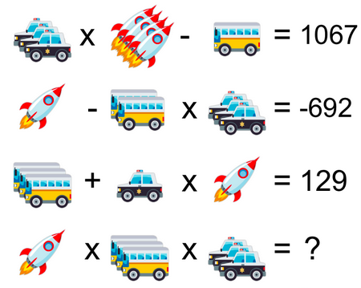  - BBC Bitesize Revision - decimals, fractions, percentages  https://www.bbc.co.uk/bitesize/topics/zh7xpv4  https://www.bbc.co.uk/bitesize/topics/zsxhfg8  https://www.bbc.co.uk/bitesize/topics/zf6pyrd
Science Focus | Task 1: Make COKE AND MENTOS ROCKET CAR! - This demonstration unleashes the power of candy and soda to propel a rocket car.  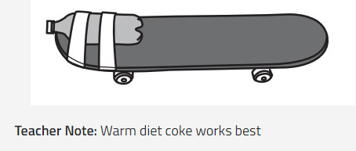  Link:https://www.scienceworld.ca/resource/coke-and-mentos-rocket-car/  Task 2: Fastest Animal - Put the following animals in order of their speed-highest to lowest.  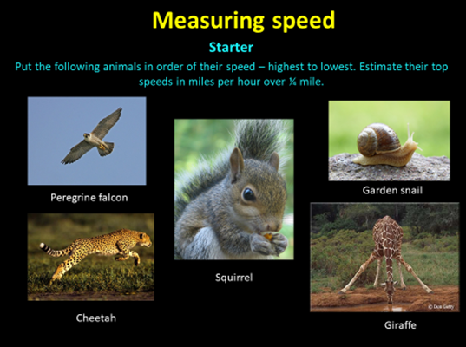  Answers:  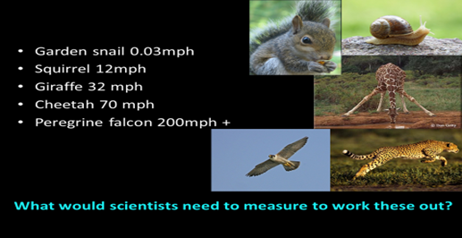  Task 3: Speed - Measure the speed of a trolley down a ramp and use the formula to calculate speed  Video clip: https://www.youtube.com/watch?v=U6K-F9Bjl8s  Which variables affect the speed of a toy car?  What you will need:  • metre ruler or tape measure  • toy car  • ramp/or some cardboards  • blocks  • stop clock  Method  A) Set up the ramp as shown. Put a cushion at the end of the  ramp to catch the car.  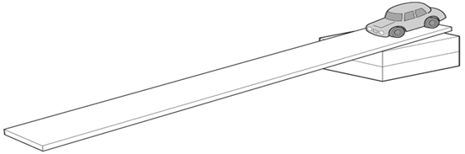  B) Measure the height and length of the ramp. Write the numbers here:  Height ________________ cm Length _________________________ cm  C) Measure the time taken for the car to roll down the ramp and write it in the results table under Time 1.  D) Repeat the measurement twice more.  E) Repeat steps B to D with different ramp heights  1a. Calculate the mean time for each height by adding all three results together and dividing the answer by 3.  1b. Now calculate the speed for each ramp height.(distance /time)  2. How does the height of the ramp affect the speed of the car?  Evaluation  3. How reliable were your results? (Hint: how close were your repeated results to each other?)  4. Suggest one way to improve your investigation.
  Ramp height (cm) | Time 1 (s) | Time 2 (s) | Time 3 (s) | Mean (average) time (s) | Mean (average) speed (m/s)
Cooking/Technology | Task: Make “no bake” train cake! - A no-bake cake that magically transforms into a train when all of the pieces are put together. It’s a shop-stopper of a treat.  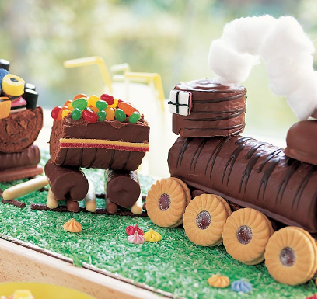  Link: https://www.annabelkarmel.com/recipes/no-bake-train-cake/  Task: Transport challenge - Computing and technology has transformed the globe, including transport. Create a timeline using one of the available templates to show how transport has developed through time as technology has developed. Below is an example of one of the templates  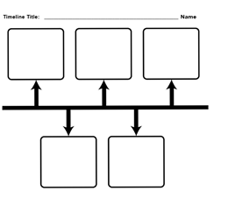.  You can choose one type of transport to focus on for the timeline.  Below are two useful websites to help you complete the task.  Link: https://www.youtube.com/watch?v=FaLCQo8NJFA  Link: https://www.scienceforkidsclub.com/cars.html  Attached: PDF - Blank Timeline Template
Drama/Arts/Music | Task Focus: Design a warning sign or poster helping people keep safe on public transport. 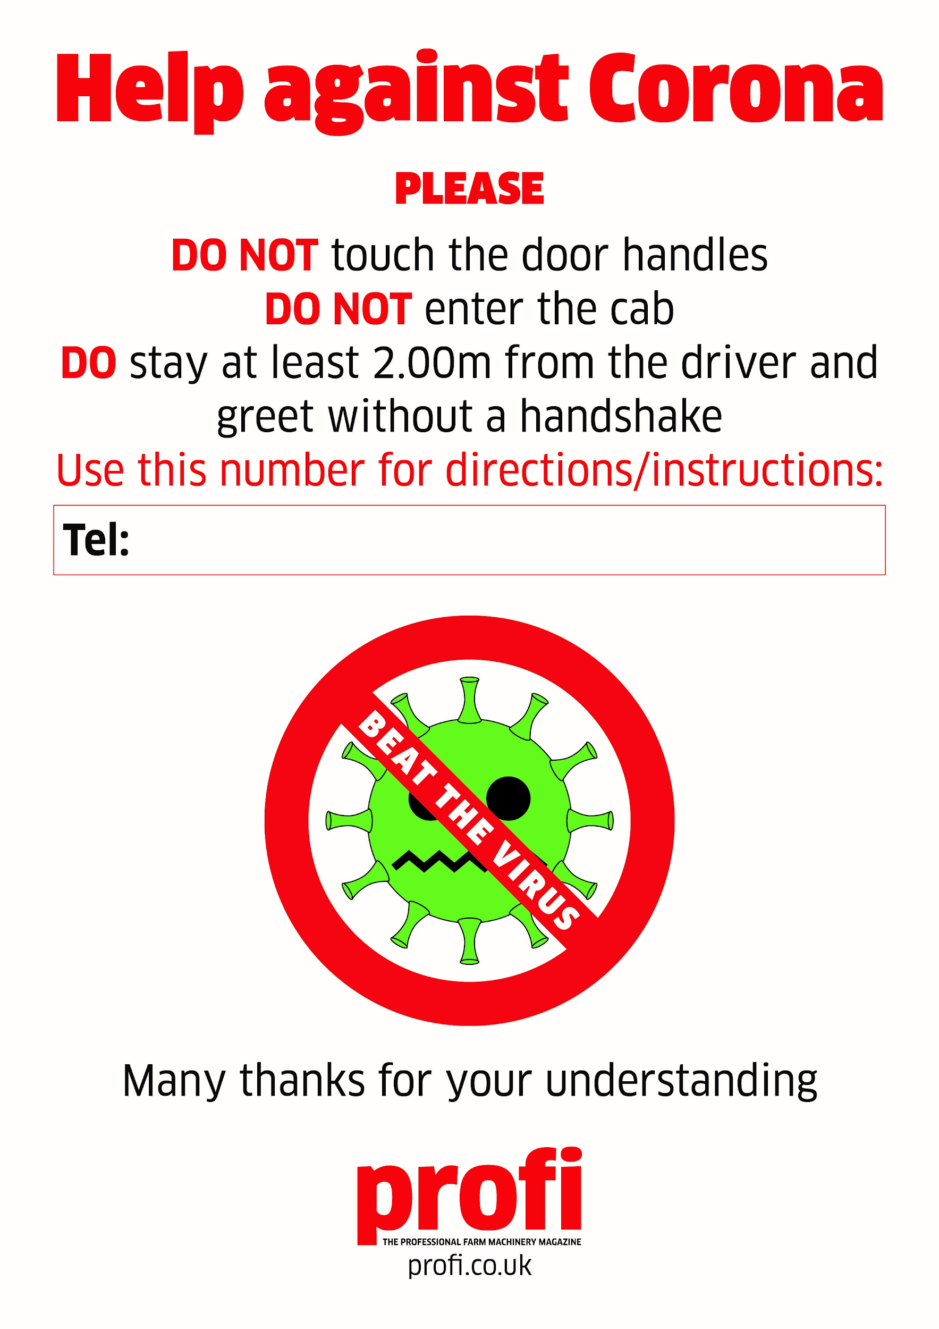  Task Helpful link to follow:  https://www.gov.uk/guidance/coronavirus-covid-19-safer-travel-guidance-for-passengers  You Will need:  Pencil, Paper and Colouring Pens. You can paint it if you like  Key Information: Designers create art by working to a design brief.  You are going to pretend you are a designer and you have been asked to create a fun poster encouraging young children to stay safe when using transport.  Remember you need a title- e.g. Help Stay Safe!  You need instructions- e.g. Do stay at least 2M away from other. Remember wear a mask.  You need a logo/picture to help people see what it is about and look at your poster..  Keywords:Transport, Train Bus Plane Taxi Safe Mask  2 Metres  Instructions:  1 Look at the example poster and link on government guidelines  2. Pick the type of transport your design is for  3. Plan your Title, logo-drawing and key information  4. Colour your design in bold colours which will attract attention.  If you use opposite colours on the colour-wheel together they stand out better. These are cold Complementary Colours  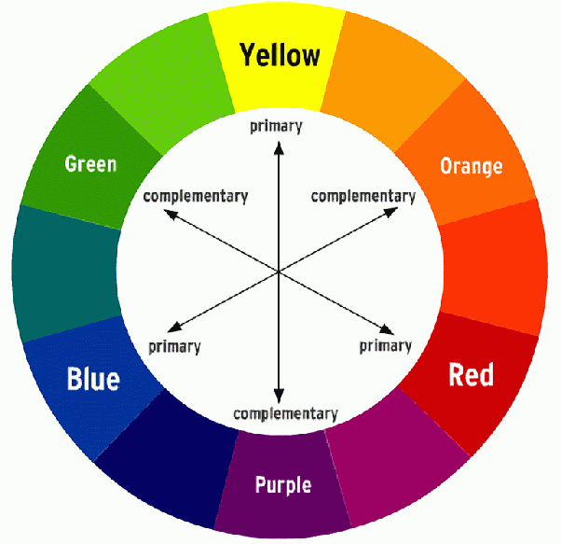  Other Wider Learning  Task: Transportation crafts -  Painting a plane contrasting colours  https://www.youtube.com/watch?v=-eYITrhQPpE  Fun Fluid Art- try this with knotted string and paint to create movement in your painting  https://www.youtube.com/watch?v=lMBJRAfAvmI  Fun Fluid art with String  https://www.youtube.com/watch?v=dMLPw6DGHAc  One point perspective high ability  https://www.youtube.com/watch?v=R3fRwrZhiMg  Two Point Perspective- High Ability  https://www.youtube.com/watch?v=mgfeehj48a4
Health and Wellbeing
Physical activity | The PE staff are uploading videos of circuit training or challenges every week. Have a look at this week’s videos and have a go.  https://www.youtube.com/channel/UCQVlu1D0XnL-bwjaXIzbZxQ/videos  ThisIsPE: Updated 3 times a week. Fun and easy activities to be done at home. https://www.youtube.com/results?search_query=thisisPE  Using ideas from the “This is PE” link, try and create your own game using things you can find at home. Write down the rules and play with your family. If you can, upload to Twitter and tag “@MeadowPE” so we can see it.  Nike Move Crew: Fun games and dance activities led by Nike athletes. https://www.youtube.com/results?search_query=nike+move+crew  Go Noodle I Get Moving: Lots of videos to get children moving, dancing and exercising with lots of music and singing. https://www.youtube.com/user/GoNoodleGames  Fitness Blender: Build your own circuit training session  https://www.fitnessblender.com/videos  Measuring speed:  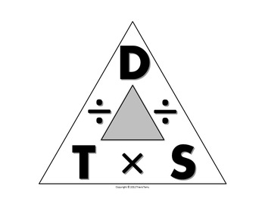  Distance, Speed, Time  - Measure a distance you want to run in metres. E.g. 10m, 5m or 200m. This could be in a room, garden or park.  - Get someone to time how long it takes you to run/walk that distance.  - Divide your distance by your time. E.g. 100m ➗ 9.58 seconds = 10.4m per second (Usain Bolt’s 100m world record!). This is your speed.  - Investigate what your speed is at different distances.  Pacing:  Using what you have just used in the measuring speed task have a go at setting yourself a speed target and try to achieve it.  E.g. 10m course 2m per second speed target  Using the speed triangle:  10 ➗ 2 = 5 seconds  So, your target is to run the 10m course in exactly 5 seconds.  This will be trial and error and you will not get this straight away.  Explore with different distances and different speed targets or even harder, can you repeat the same speed multiple times.  This is a helpful skill to adjust your pace when racing in athletics or cross country.
Wellbeing  Useful links offering support and discussion:  https://youngminds.org.uk/    https://www.time-to-change.org.uk/   | Make Time For Me  Task: To discuss the importance of speaking about mental health openly and think about how we can take care of our mental health and wellbeing.  Using the PDF and powerpoint discuss how we can make time for ourselves to do something that makes us feel good. Read through the Make Time for Me list. Explain that these are all ways that people can help themselves feel better when they’re feeling low or having a tough time. Some of them can help contribute to feeling more healthy physically and mentally (though, just as with physical health, sometimes people will get mental health problems even if they do all these things). Make a poster to include all the things you like to do that makes you feel good.  Links: https://www.time-to-change.org.uk/  How Many Positives  Individual/family task: In this task we want to think about all the positives we have to be grateful for. Use the PDF ‘How many positives’ to guide students and family through the activity.  Links: https://youngminds.org.uk/
Cross Curricular | PSHCE: Planning a journey  Task1: Using a bus map worksheet  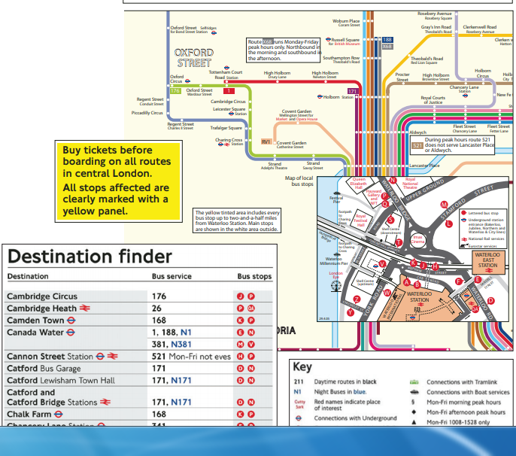  Link: http://content.tfl.gov.uk/plan-journey-teacher-resource-bus-map-safety-citizenship.pdf  Task2: Know your area  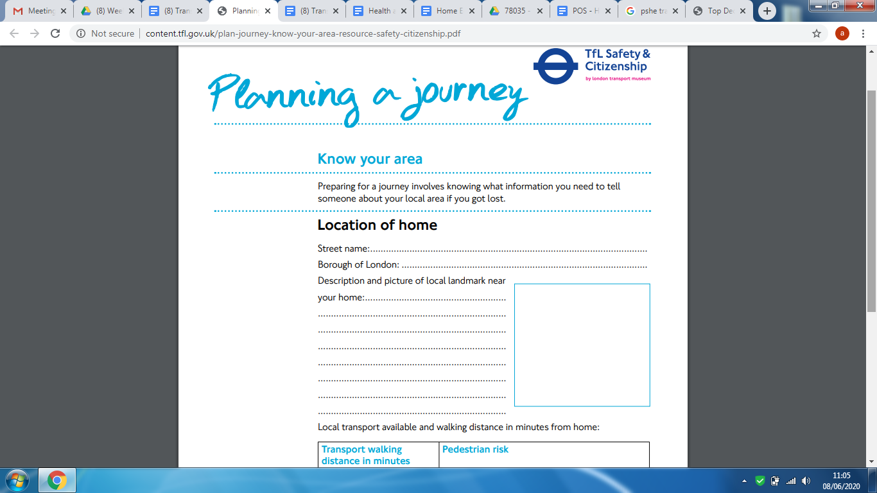  Link: http://content.tfl.gov.uk/plan-journey-know-your-area-resource-safety-citizenship.pdf  Task 3: What to take with me on a journey  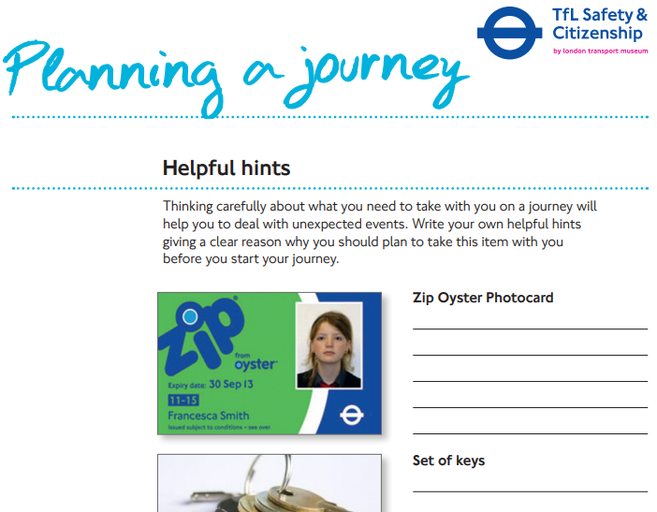  Link: http://content.tfl.gov.uk/plan-journey-helpful-hints-resource-safety-citizenship.pdf

