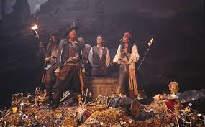
Pirates and Treasure
Aims: These tasks are designed to be done with your child. Purple coloured tasks are aimed at pupils who would enjoy more of a challenge . These are tasks where pupils should be working with greater independence, however please take time to support pupils in starting the tasks and build communication skills.
Thinking
Literacy Focus: Completing extended research over a range of texts.  Identifying and recording key information in texts and making notes.  Using research in fiction and non-fiction writing [contrasting formats].  Key Terms to try and learn:  non-fiction = facts and information  fact = a true piece of information  fiction = made up/story  key information = the most important information  brief notes = are to help you remember key information. Notes should be just words/short phrases - not full sentences. NB. You should be able to quickly scan and re-read.  paragraph = a short section of writing.  heading = what the text is about.  sub-heading = what that section of text is about.  leaflet = a piece of paper giving information on a particular subject.  format = to organise or arrange a particular way for a particular type of text eg letter, newspaper article  structure = the way that the text is organised to help the reader.  style = the writer’s choice of words, sentence structure.  images =photos or illustrations  audience = is a person or group of people listening to or reading a text. | Speaking & Communication, Research Reading:  Resources: Powerpoint W5 Research Pirates PURPLE as  T.V. documentaries, internet, books [if you have these at home]  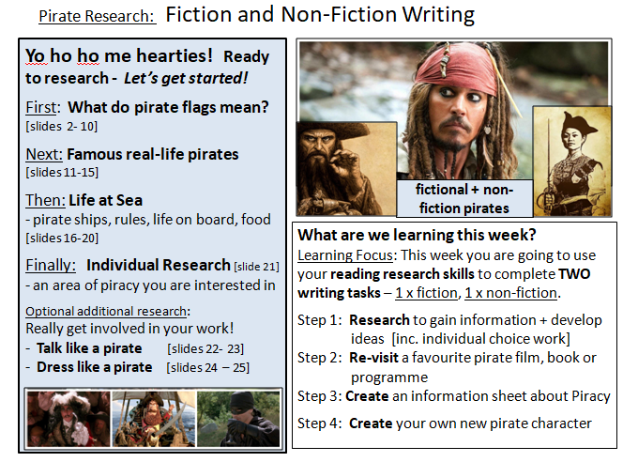  Planning and Writing a Narrative:  Resources: Powerpoint W5 Fiction + Non-Fiction Writing PURPLE as  Own choice films, T.V. programmes or books  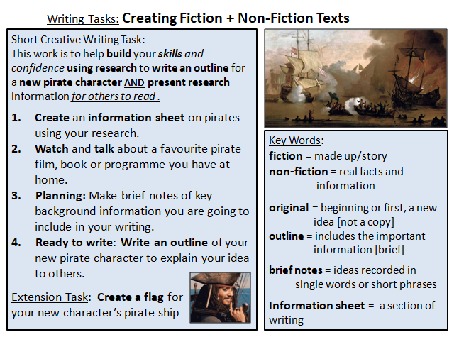
Maths Focus | - Can you solve the pirate riddle?  https://www.youtube.com/watch?v=Mc6VA7Q1vXQ  - The Mystery of the Missing Golden Goblet  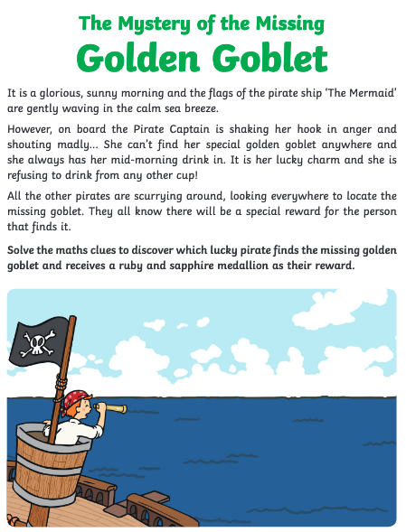  - Practise your mental maths... No calculators or working out allowed!  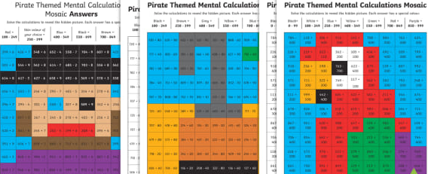  - Can you solve this pirate riddle?  Five pirates board a commercial vessel, do what pirates do best, and flee with 100 gold coins. Back on their own ship, the scalawags must decide how to divide up the booty.  The pirates have a system that they are sworn to follow, else they are killed. It works like this: The oldest among them proposes a way to divide the coins. Then all the pirates, including the one that made the proposal, vote on whether or not to accept the terms. If 50 percent or more accept, then they divide the loot as proposed. If less than 50 percent of the pirates agree to the plan, then the pirate who made the suggestion is thrown overboard and killed. The next oldest pirate then makes a suggestion, and they vote again.  There are a few important things to know about these pirates. First, they will make their decisions according to whatever will net them the most money without getting them killed. Second, they are bloodthirsty pirates, and all other things being equal, they would rather throw someone overboard. Third, they do not trust each other in the slightest and will make no agreements amongst themselves to determine how they vote. Finally, these are highly logical pirates, capable of considering all possible outcomes.  Let's consider the pirates A, B, C, D and E, with A being the oldest and E the youngest. How should Pirate A suggest they divvy up the coins?  ANSWER: https://www.popularmechanics.com/science/math/a25369/solution-to-riddle-of-the-week-17/
Science Focus | Task1: Living Organisms - Follow the pirate at sea and explore the different organisms he encounters. Complete the quizzes after each section on the characteristics of the living organism and their cells.  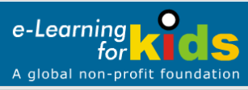  Link:https://en.e-learningforkids.org/science/lesson/plants-and-animals/  Task2: Crack the code game! - Code cracking is brilliant for helping to develop logical thinking and you can make it as easy or as hard as you want!  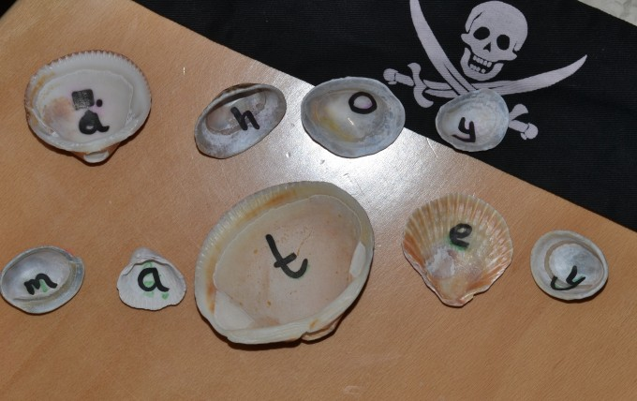  Link: https://www.science-sparks.com/crack-code-pirate-theme/
Creativity
Cooking/Technology | Cooking:  Task1: Fruity Pirate Ship - This is a healthy fun recipe where you can create a delicious fruity pirate ship snack.  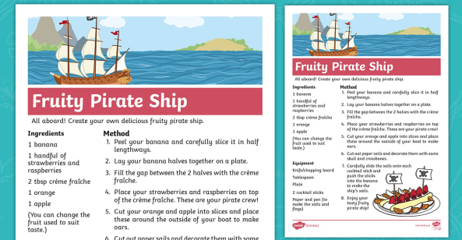  Key Skills: Cutting, Arranging and Presentation  Attached: PDF- Fruity pirate ship recipe - Purple  Task2: Piece of Eight Cookies -This is a step by step recipe to create 'pieces of eight' cookies! This is where you have the opportunity to be creative with the decorating of your cookies.This is a more challenging recipe so support will be required.  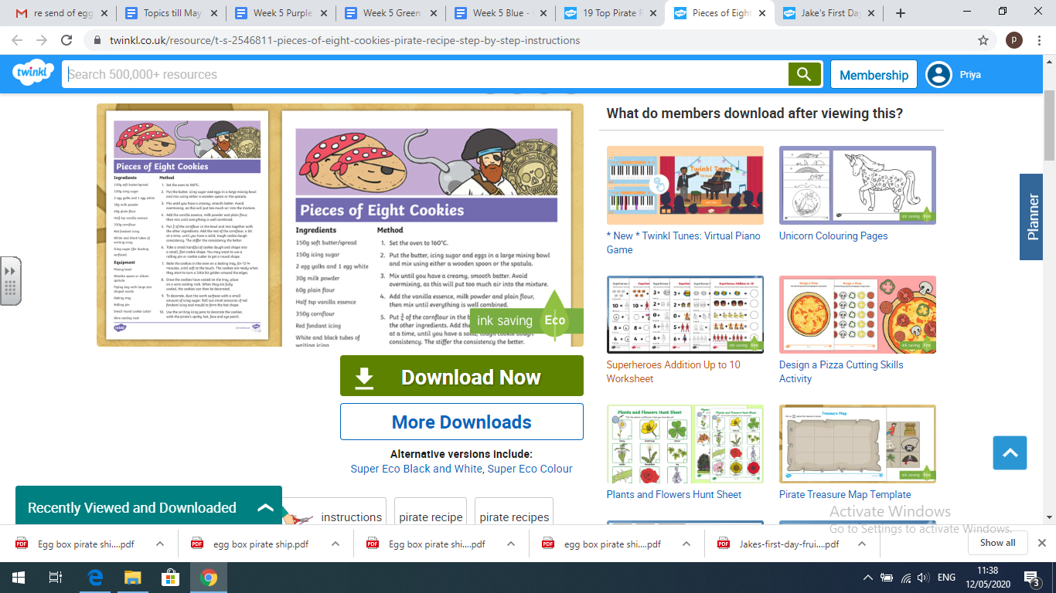  Key Skills: Weighing, Mixing, Baking and Decorating  Attached: PDF - Piece of eight cookie pirate recipe - Purple  Technology:  Task1: Pirate Island - Why not make your own pirate Island. All the templates are provided, so all you need to do is get some cards, decorate, cut out and assemble  .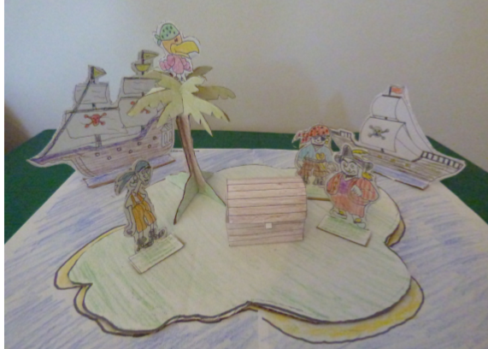  Attached: PDF - Pirate Island instructructions - Purple  PDF - Pirate Island resource - Purple  Task2: Pirate Chest - You can make your own pirates chest out of paper. You can keep hidden your precious treasure in your very own chest.  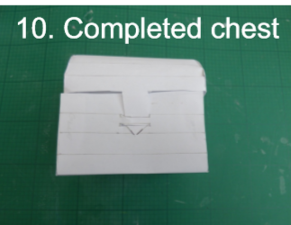  Attached (Instructions with template): PDF - Pirates Chest - Purple
Drama/Arts/Music | Task Focus: Sharing thoughts  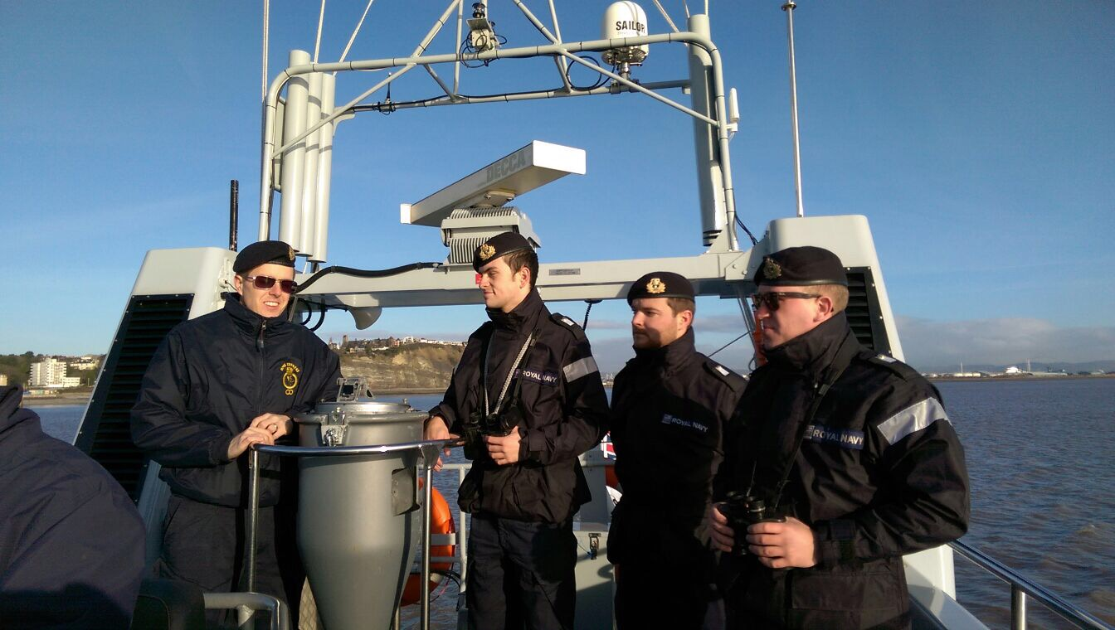  Key Information:  It’s important to share feelings. Even big strong sailors need to share what they are feeling.  It’s what makes them so good at their job!  Start by making 2 paper sailor hats each,  On one hat draw a skull, wear this when you want to be a pirate and the other one when you want to be a sailor, you are now ready to play the game, remember to keep it fun and don’t judge other people!  Task helpful clip to watch:  How to make a sailor hat/boat  https://www.youtube.com/watch?v=T8hPKuqZsEc  Drawing a skull: How to draw a skull, step by step challenge:  https://www.youtube.com/watch?v=XBW1veqluvg  Materials Needed: News Paper, Paper, Pencils, Colour pencils scissors  Keywords: Pirate Sailor Stop Start Plank Treasure Listen Speak Share Decide Describe Clothes Hair Size.  Game: Walking the Plank  You might want to make sailor hats before you play, following the online tutorial.  You have all been captured by a pirate ship! One of you is the captain of the pirate ship and the rest of you are sailors. The captain is going to make you walk the plank unless you can save yourself.  Make an imaginary plank using sheets of paper or newspaper on the floor. Everyone should stand on their own plank. Decide who the Captain of the pirate ship is.  The Pirate-Captain takes turns asking the sailors what they have done well this week. They need to say something good to keep them from walking the plank into the ‘Sea of Sharks’!  If the captain is happy with what the sailor says, then the sailor is saved, otherwise they have to walk the plank!  They can save themselves if they promise to help the captain with something this week!  Remember to make sure the rules are clear at the start and everyone knows they have 2 chances to save themselves! You can take turns on who is the Captain.  Other Activities:  Did you manage the other skull? This one is a little harder!  Drawing a skull: How to draw a skull, step by step challenge:  https://www.youtube.com/watch?v=Rye-uIIa2Xk  Try some of these Pirate drama games, how many characters can you be?  https://www.youtube.com/watch?v=YHs_tN85-gs
Health and Wellbeing
Physical activity | Battle Pirate Ships: 2 people needed to play.  On three pieces of paper write (not thick marker that can be seen from the other side) “Pirate ship 1”, “Pirate ship 2”, “Pirate ship 3” and place face down with a number of other blank pieces of paper. The more blank pieces, the harder it will be. Scatter them in a grid shape in front you. Players take it in turns to throw a softball or scrunched up piece of paper at the other players grid. Whichever piece of paper gets hit, gets turned over and if it is a Pirate ship then the ship is sunk. First player to sink all ships wins. You can change it around by adding more or less ships, increasing the distance between grids, or even if you have lots of plastic cups and having to land the ball in the cup to be able to see if it is a ship.  Land or Sea: Play with members of your family.  One person in charge with those playing standing side by side on some form of “line”. Where they are standing is “land” and in front of the line is “sea”. The person in charge calls out “land” or “sea” and players must jump into the right section. Calls get faster and in different orders to try and trick the players. If you get it wrong you lose a life or are out.  Steal the Treasure: Play with at least 2 teams (you only need one per team if you like). Each team finds 10 (maybe more) items of “treasure”, these can be anything you like. Treasure is placed in a pile on your “island” and islands are as far apart as you like. There further apart the more fun it will be! The rules of the game are that 1 person from each team needs to run to another island and steal ONE piece of treasure and return it to their island before the next person on their team must go. The game continues for a period of time 2, 3, 5 minutes it is up to you. Whichever team can steal the most treasure the fastest is the winner. You can make it harder by trying to hide where your islands are in the house or garden or awarding different pieces of treasure more points if stolen.  ThisIsPE: Updated 3 times a week. Fun and easy activities to be done at home. https://www.youtube.com/results?search_query=thisisPE  Nike Move Crew: Fun games and dance activities led by Nike athletes. https://www.youtube.com/results?search_query=nike+move+crew  Fitness Blender: Build your own circuit training session  https://www.fitnessblender.com/videos
Cross Curricular | Task 1: Make your own Treasure Chest  Using a cardboard box (or any box you have lying around), make your very own treasure chest. Inside place objects that are special to you. Your own little treasures.  Examples:  - A shell or pebble from a beach you visited  - A picture of your family  - Trophies/ medals  - A sticker/ certificate you got in school  - Postcards/ birthday cards from friends and family  Decorate your treasure box with paint, paper, any materials you have.  Helpful videos: https://youtu.be/vL5EgeKtZ2I  Task 2 : Message in a bottle- ‘How do I feel today?’  Key information:  Make a message in a bottle and add rolled up pieces of paper of how you’re feeling everyday.  What you need:  - An empty bottle  - Paper  - Pen  - Emotion word map (as prompt) https://www.twinkl.co.uk/resource/t-s-1056-how-do-you-feel-today-emotions-chart  Instructions:  Everyday write down how you’re feeling on a piece of paper using the word map to help, if you want add why you feel like this eg. “I am happy because I made a pirate ship”.  Roll up your piece of paper and put it in the bottle.  You can decorate your bottle too!  

