Animals and Nature
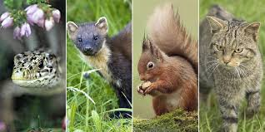
Aims: These tasks are designed to be done with your child. Green coloured tasks are aimed at pupils in the main body of the school. Tasks are a mixture of interactive tasks and tasks which build core skills. These are tasks we hope you will enjoy, please select the ones you feel are most appropriate.
Thinking
Literacy Focus: Identifying and recording key information in texts.  Writing a detailed paragraph explaining why.  Key Terms to try and learn:  non-fiction = facts and information  fact = a true piece of information  fiction = made up/story  key information = the most important information  brief notes = are to help you remember key information. Notes should be just words/short phrases - not full sentences. Notes can be quick drawings too if that works best for you.  You should be able to quickly scan and re-read to help you remember..  paragraph = a short section of writing  leaflet = a piece of paper giving information on a particular subject.  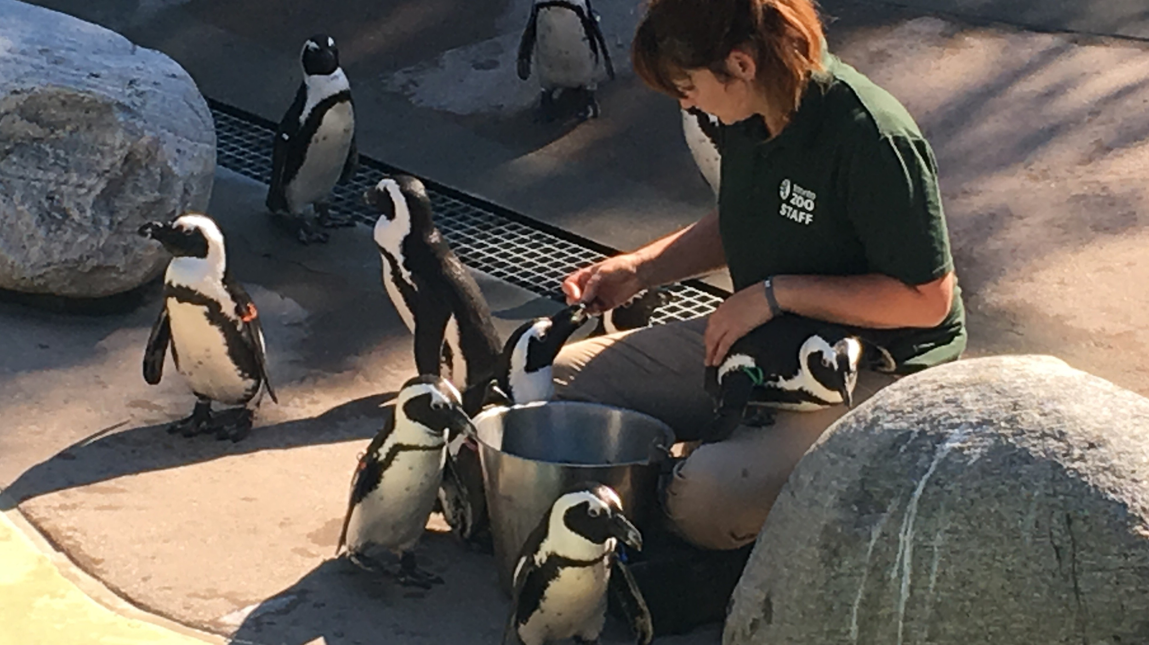 | First: Speaking, Listening & Communication AND Writing:  Wildlife Documentaries [non-fiction texts]  Watch, discuss and make brief notes on TWO different animals.  Key skills to develop - listening carefully, identifying and recording key information in note form.  Resources: Yellow workbook. For this task you will need to watch a section of a nature documentary. This might be on the internet or a T.V. programme OR it could be information from a book or leaflet..  Here are some suggestions [but use any animal programme you like]  The Really Wild Show - Mountain Gorillas (4 min. clip)  Presenter Steve Backshall  https://www.bbc.co.uk/programmes/p00mk75w  The Animal’s Guide to Britain - Seal’s Secret Weapons [3 mins. clip]  Presenter Chris Packham  https://www.bbc.co.uk/programmes/p00gvfpp  No internet, no problem! There are TWO in leaflets about mountain gorillas for you to print out. Choose the right one for you.  Next Step: Make and then use your notes in a short writing task -  Life in the Zoo - If I was a zookeeper...  - Watch one of the clips below..  - Pick ONE animal - re-watch making notes.  - Write a paragraph. If you were a zoo keeper at this zoo, what animal would you like to look after. Use your notes to help you explain which animal and why.  If you don’t want to be a zoo keeper write about which animal you would least like to look after and why!  Resources: Your yellow workbook, either Learn Zoo Animals with Blippi https://www.youtube.com/watch?v=DBr5-fceV3k  OR A Day in the Life of Zoo Keeper at Paradise Wildlife Park [one of the zoos we visit from school sometimes - two video clips to watch!]  https://www.youtube.com/watch?v=bIjQ4tAi49M  https://www.youtube.com/watch?v=KMmErFORdJ
Maths Focus | - Tangram activity booklet (can you try and draw your own animal?)  https://www.twinkl.co.uk/resource/t-t-13166-tangram-animals-activity-booklet  - Beetle game  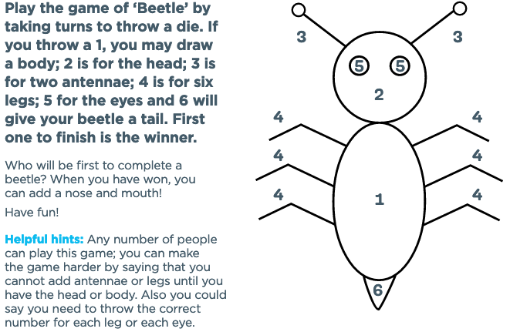  - Hen laying eggs riddle  If a hen and a half lay an egg and a half in a day and a half, how many eggs will half a dozen hens lay in half a dozen days?  - Create your own animal using different cut out shapes  - Farmer riddle  In reply to an inquiry about the animals on his farm, the farmer says: "I only ever keep sheep, goats, and horses. In fact, at the moment they are all sheep bar three, all goats bar four, and all horses bar five." How many does he have of each animal?
Science Focus | Task: Carry out the Invisible Ink with Lemon Juice experiment.  Making invisible ink is a lot of fun, you can pretend you are a secret agent as you keep all your secret codes and messages hidden from others. https://www.sciencekids.co.nz/experiments/invisibleink.html  Task: Create art from natural objects: https://curiodyssey.org/activities/science-experiments-for-kids/how-to-create-art-from-natural-objects/  Animals and their habitats:  Task: Choose one habitat and create a fact file on it- include information about the climate, nature and animals within that habitat  Task: Find out as much information about one of the animals (ie. what sort of animal it is, where it lives, what it looks like, some interesting facts about it, and whether it eats animals, plants, or both).  Task: Habitat fact file ideas: https://www.twinkl.co.uk/resource/t-t-2547618-ks1-animal-habitat-differentiated-fact-file-activity-sheets  Task:Habitat interactive work: http://www.crickweb.co.uk/ks2science.html  Task: Habitat interactive quiz- https://www.cserc.org/sierra-fun/games/match-habitat/  Task: Build your own habitat- https://switchzoo.com/games/habitatgame.htm
Creativity
Cooking/Technology | 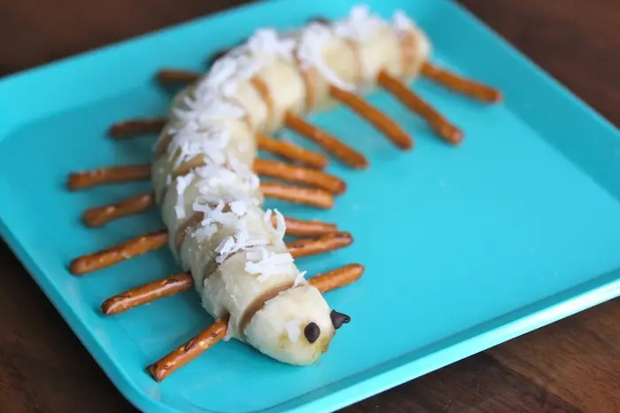  Recommended Recipe: Caterpillar Bananas  If you have spare bananas, why not turn a snack into a fun caterpillar. All you need is a banana, some pretzels and 2 chocolate chips.  Key Skills: Chop (use a table knife) place the pretzels on either side of the chopped banana slice and add 2 eyes.  Cooking Task: Animal Themed recipes ( differentiated)  https://www.twinkl.co.uk/blog/cooking-with-kids-fun-and-easy-animal-themed-recipes  Cooking Task: Why not make an animal inspired snack.  https://www.mommynearest.com/article/10-easy-animal-themed-snacks-for-your-preschooler  Technology Tasks: 4 Animal Cutout Activities  You can print off the images and stick on cardboard. You can cut around the image and colour in.  PDF document attached - 4 Animal Cutout Activities
Drama/Arts/Music | 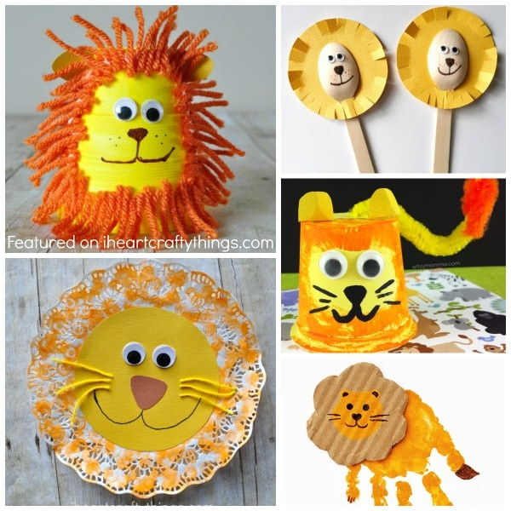  Task Focus: Making Animals props using recycled materials  Key Information:  In art and we like to make props to inspire imagination and interacting with each other. Have a go making an animal from recycled materials.  Then try to act out what your animal is like, try to make sounds and voices like the animal or discuss what it might eat or where it might live?  Task helpful clip to watch:  Art: Zoo animal crafts for kids  https://iheartcraftythings.com/50-zoo-animal-crafts-kids.html  Materials Needed:  Scissors, a range of the following (not all needed) :recycled packaging, glue, stapler or cellotape, string or wool, Cardboard, any old wrapping paper , doyles, kitchen roll or tissue paper.  Ready Mix paint if possible but not necessary water pot, Paint brush apron etc..)  Keywords:  Sounds, Animals, Puppet, Prop  Other Options:  Work sheet-Art Make an animal out of shapes can be down to help give ideas for how to break down the shapes in an animals face.  Use a seperate piece of paper to try drawing the monkey using the step by step diagrams provided in the Arts booklet.
Health and Wellbeing
Physical activity | During your “once a day” walk, why not gather some leaves and make some patterns/collages  https://www.google.com/search?q=collage+making+with+dry+leaves&rlz=1C1GGRV_enGB751GB751&oq=making+dry+leav&aqs=chrome.5.69i57j0l7.13364j0j8&sourceid=chrome&ie=UTF-8  Lots of gardening ideas for all the family, with or without a garden! https://kidsgardening.org/garden-activities/  Pupils to draw ‘a map’ of their garden/ home. Obj: Parents/ carers/ siblings to hide objects around the set area for the students to find. Students are required to mark on the map the location of each item.  Minibeast Orienteering worksheet: https://www.twinkl.co.uk/resource/T-T-019-Minibeast-hunt-sheet  ThisIsPE: Lots of easy games to be played at home.  https://www.youtube.com/results?search_query=thisisPE  Nike Move Crew: Fun dance and exercise ideas.  https://www.youtube.com/results?search_query=nike+move+crew  Animal Athletics Team  Can you make an Athletics Team out of animals?  Think about each event individually and show your understanding of the events and animals by picking the right ones!  Think of/ watch films for ideas: Madagascar, Lion King, Jungle book.  Examples  100m - Quick.  Shot Putt – Strong.  Long Jump – Jumps a lot
  Event | Animal | Reason why
  100m
  200m
  1500m
  Marathon
  High Jump
  Javelin
  Shot Putt
  Long Jump
  Diving
  50m Swimming
Cross Curricular  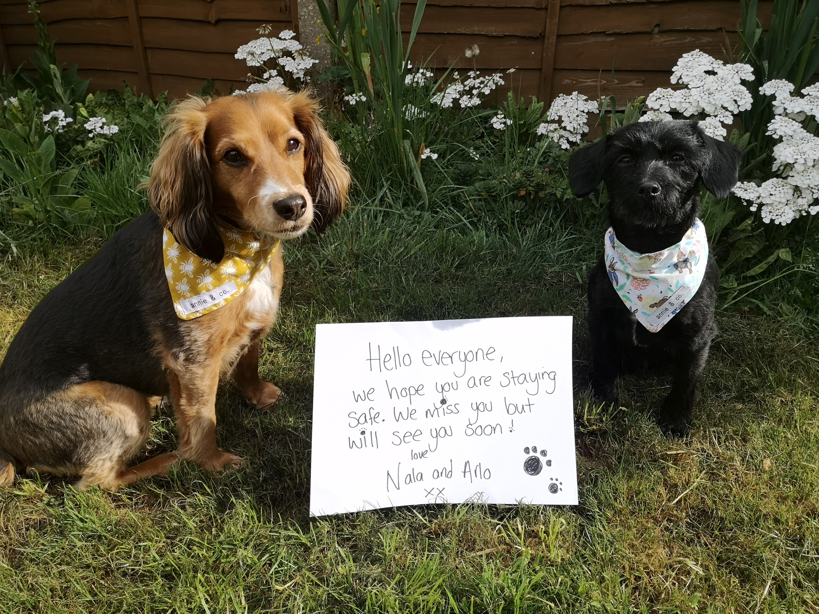  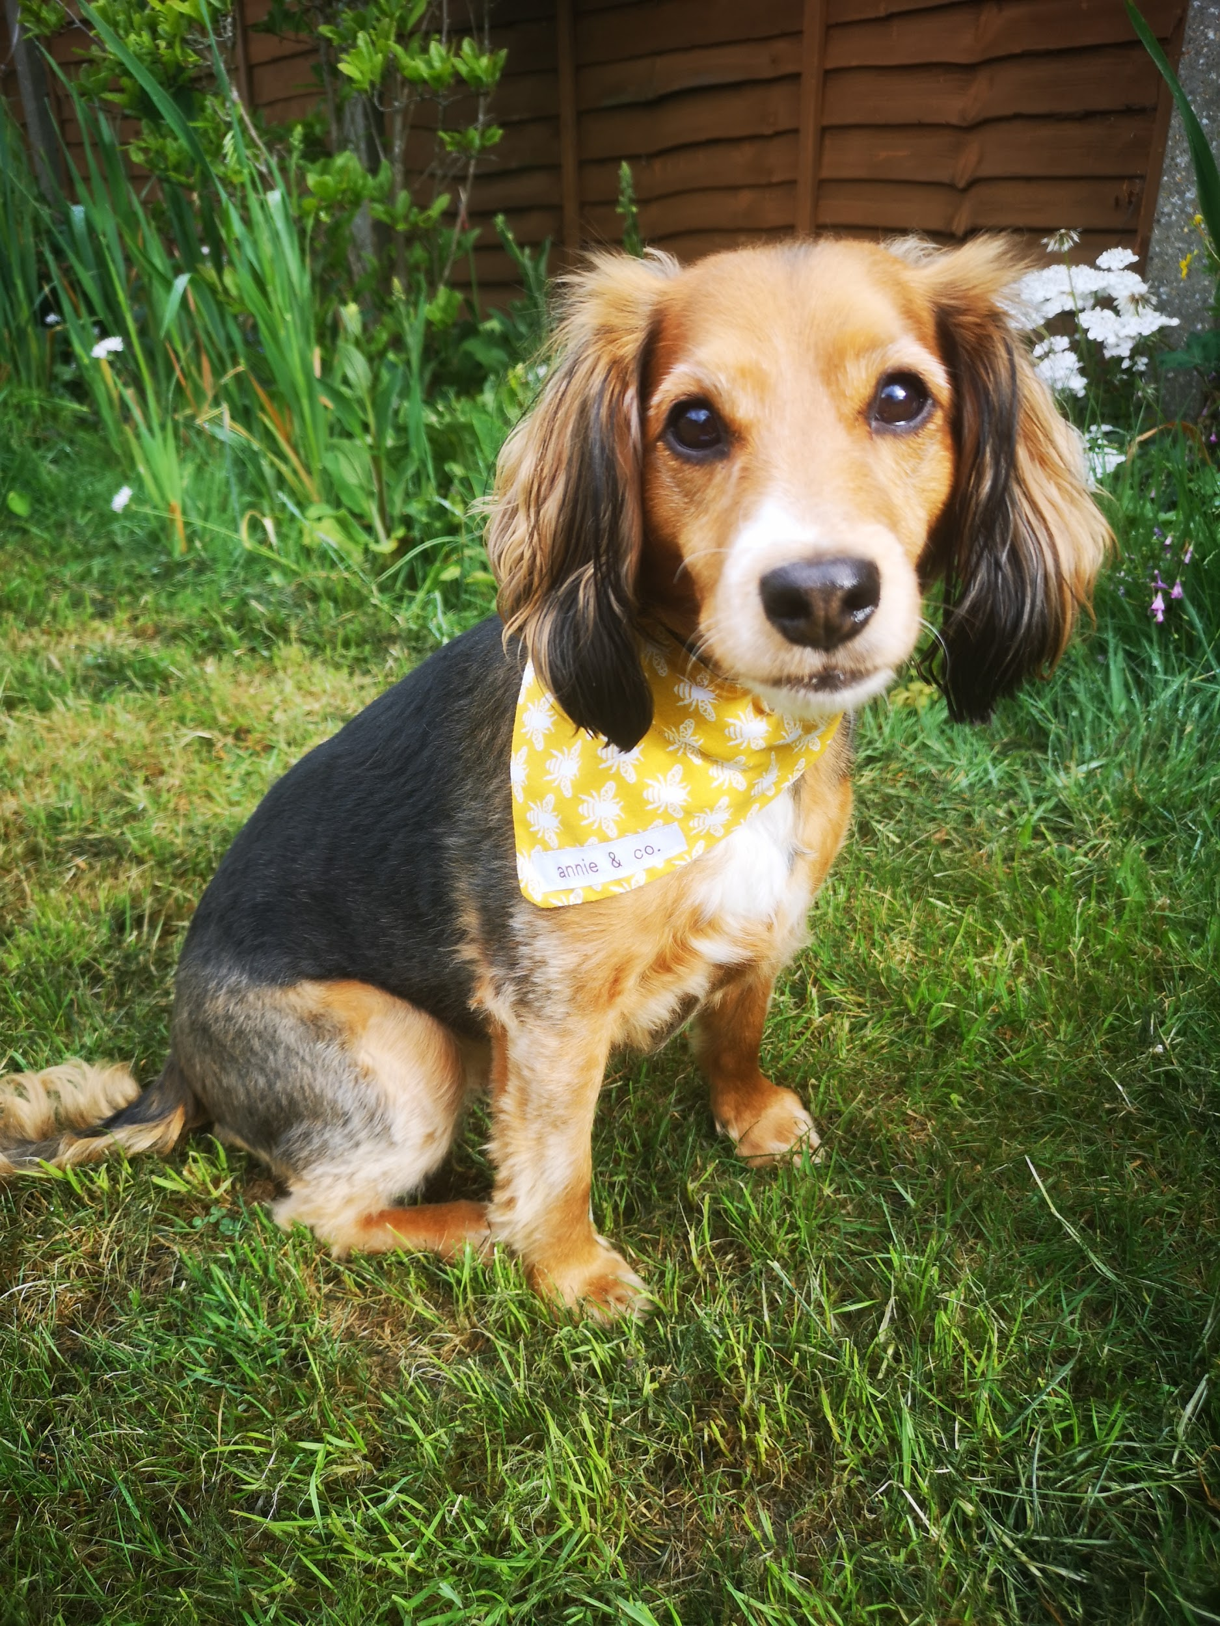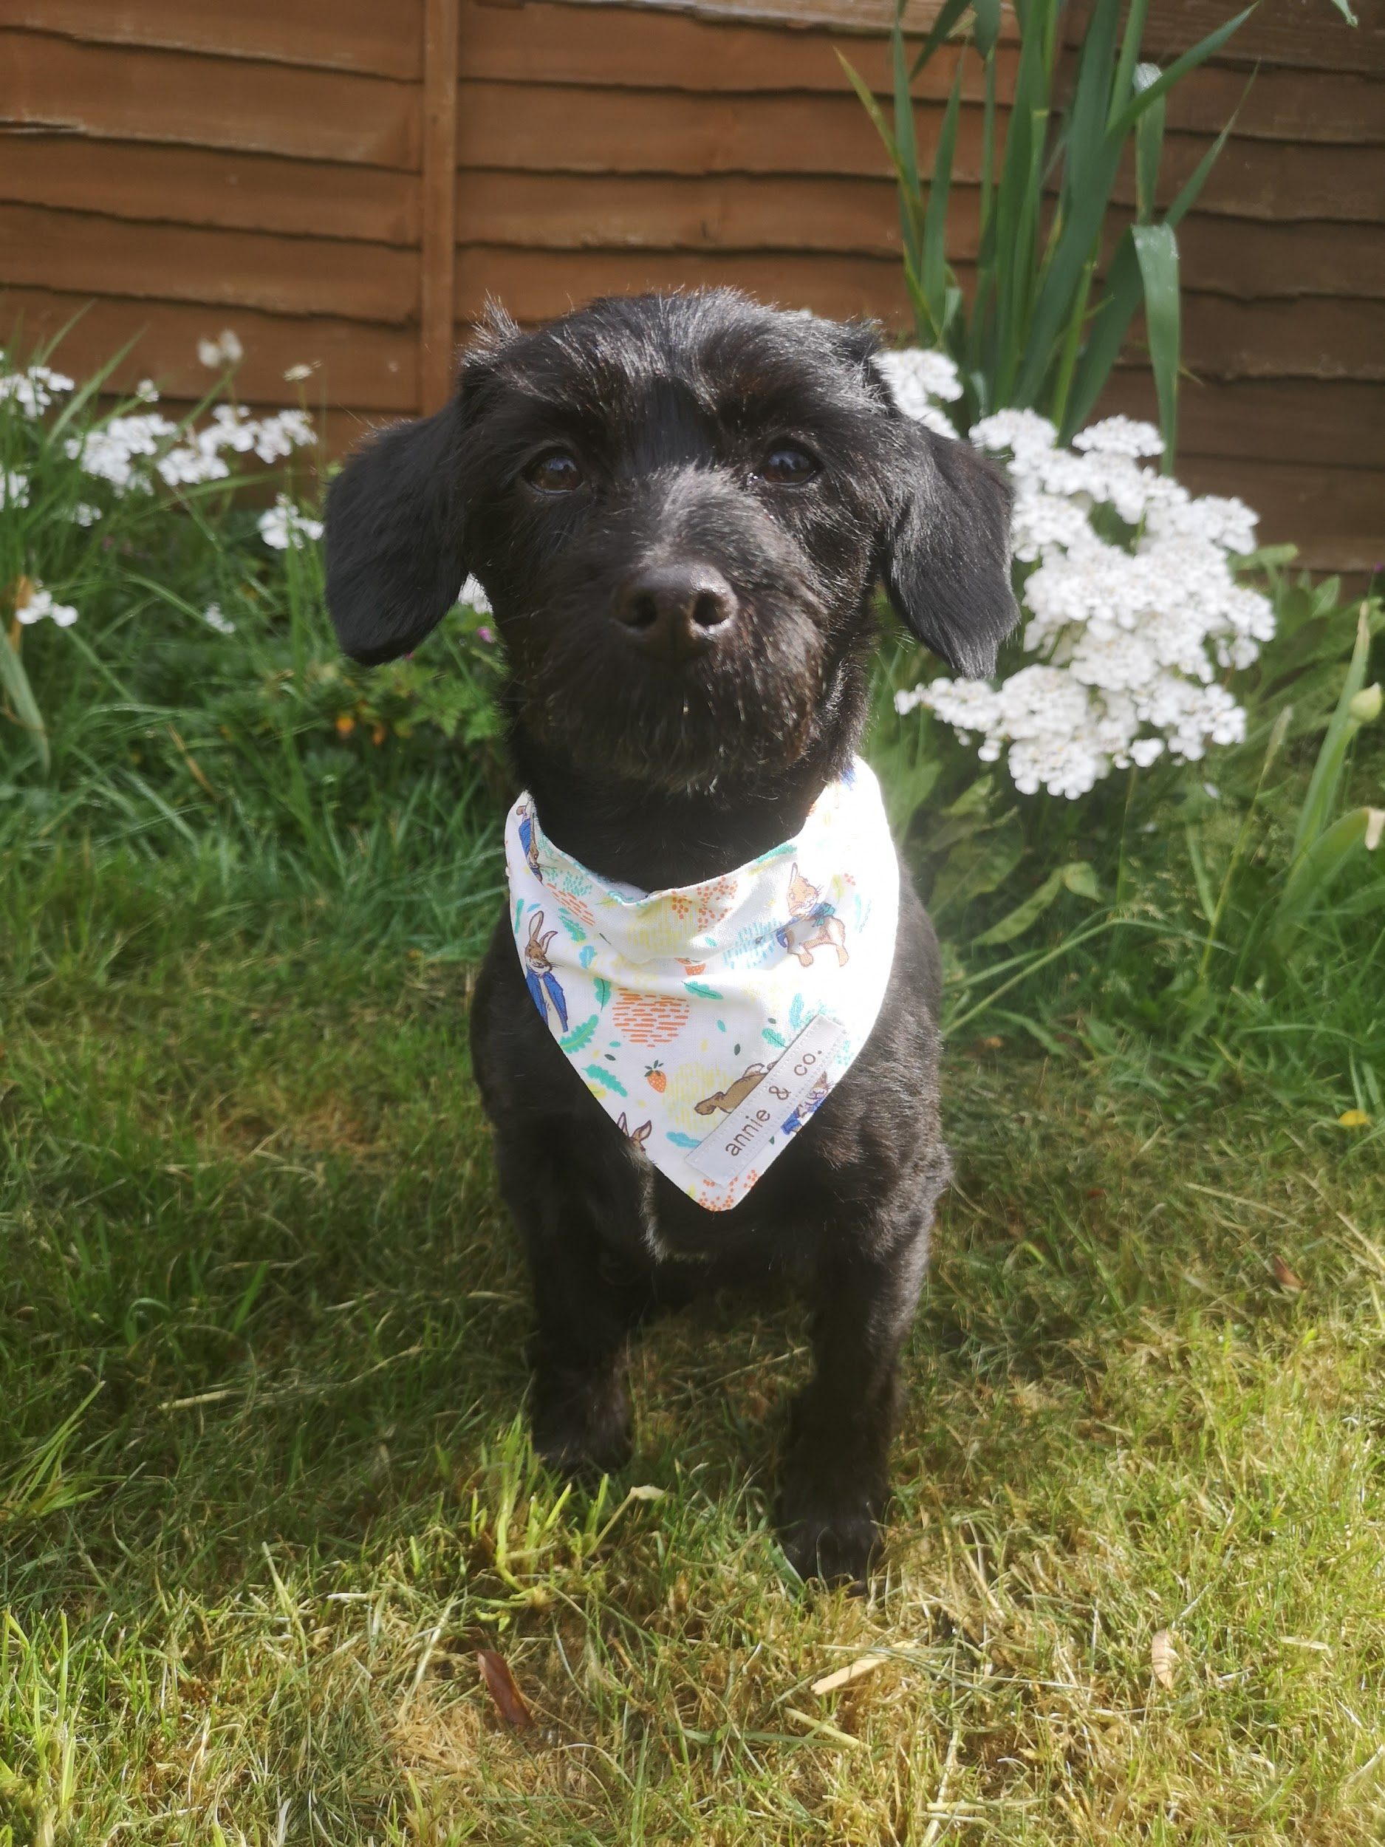 | PSHCE:  1)Create a how to care for ……. (pet/animal of your choice) profile. (All about a pet worksheet on Twinkl)  https://www.twinkl.co.uk/event/national-pet-month-202ve  If you don’t have a pet or are struggling to pick an animal, why not draw and create an animal profile of Nala or Arlo? They would love to see what you create!  2)Caring for animals is so important which we all know. Many of the students were able to spend time with school bunnies Gunner and Teddy and would be able to tell you lots about them. If you have seen the films Peter Rabbit, Chicken Run or Shaun the Sheep Movie there are wonderful powerpoints https://www.intofilm.org/resources/1468 with activities all film and animal care related!  Nala and Arlo would love to see any pet profiles and pictures you draw of animals so please email pictures over to petsastherapy@meadowhighschool.org for us to collate and create a collage.

