Whittington Health NHS Trust

Oral Health Improvement Team



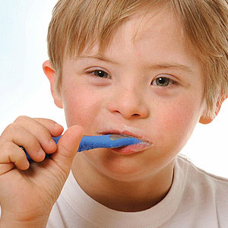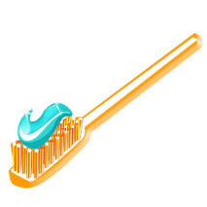



**Summer activity pack**

**KS2 Year 3&4**

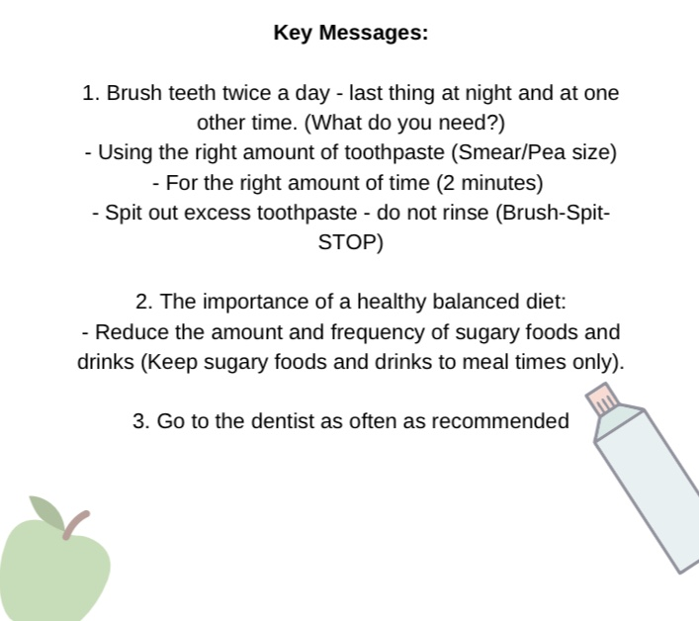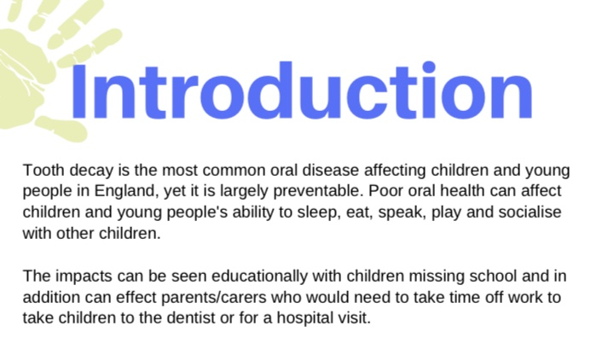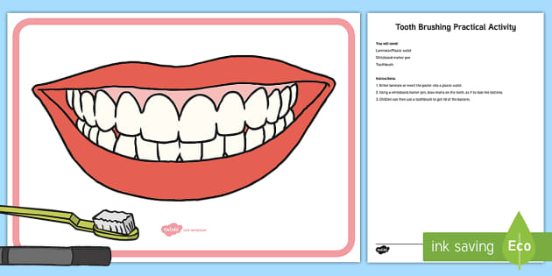

**How many teeth do we have teeth?**

Teeth are very important in our everyday life. We use teeth for cutting and chewing our food. They start the digestion progress.

**How many Teeth do we have?**

* Children have 20 teeth in their mouth.
* There are 10 teeth on both the top and bottom jaw.
* Children’s teeth are also known as **primary teeth**.
* Due to the smaller jaw size of a child, there are only 20 teeth in total.
* Adults have 32 teeth.

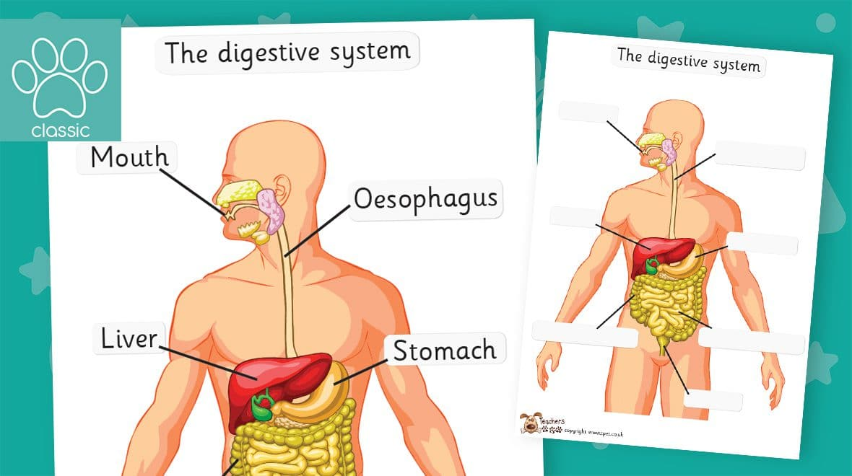

**The mouth**

Food enters the **digestive system** through the **mouth**.

Food is broken down into smaller pieces by **chewing**.

The teeth **cut** and **crush** the food, while it’s mixed with **saliva**.

This process helps to make it **soft** and easier to **swallow**.

After being **swallowed**, the food passes down the **oesophagus** and into the **stomach**.



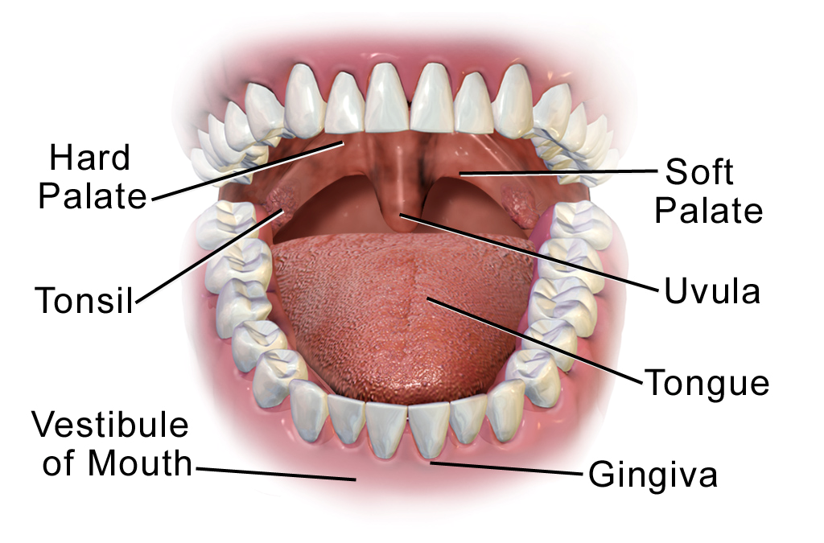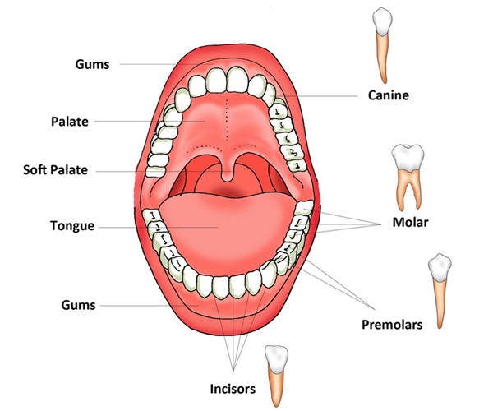

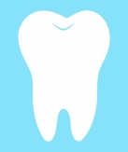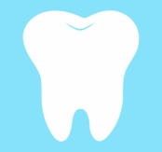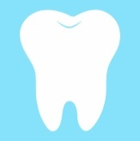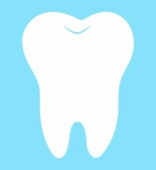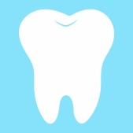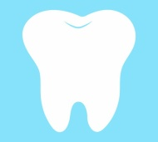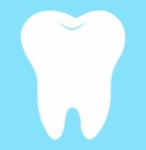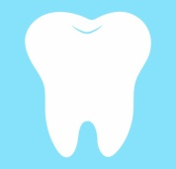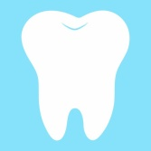

10 + 10 = 20

10

9

8

7

6

5

4

4

3

2

1

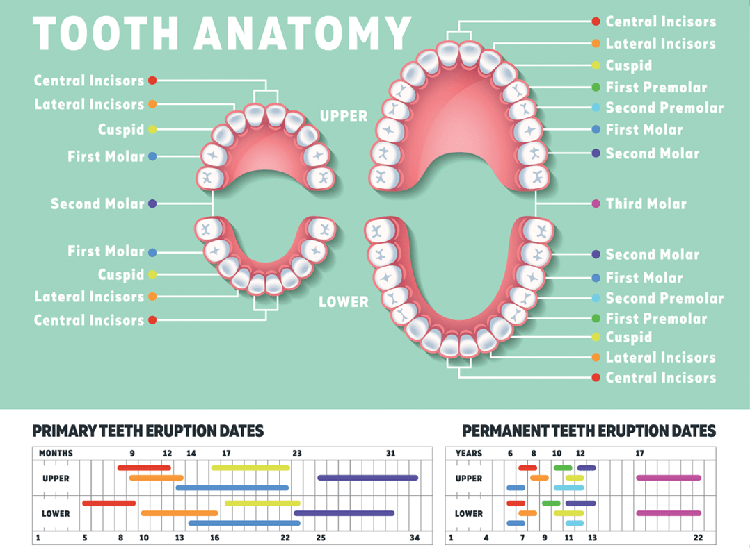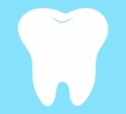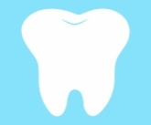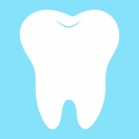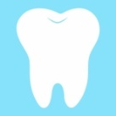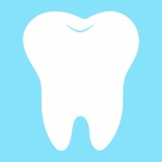

10

9

8

7

6

5

4

3

2

1

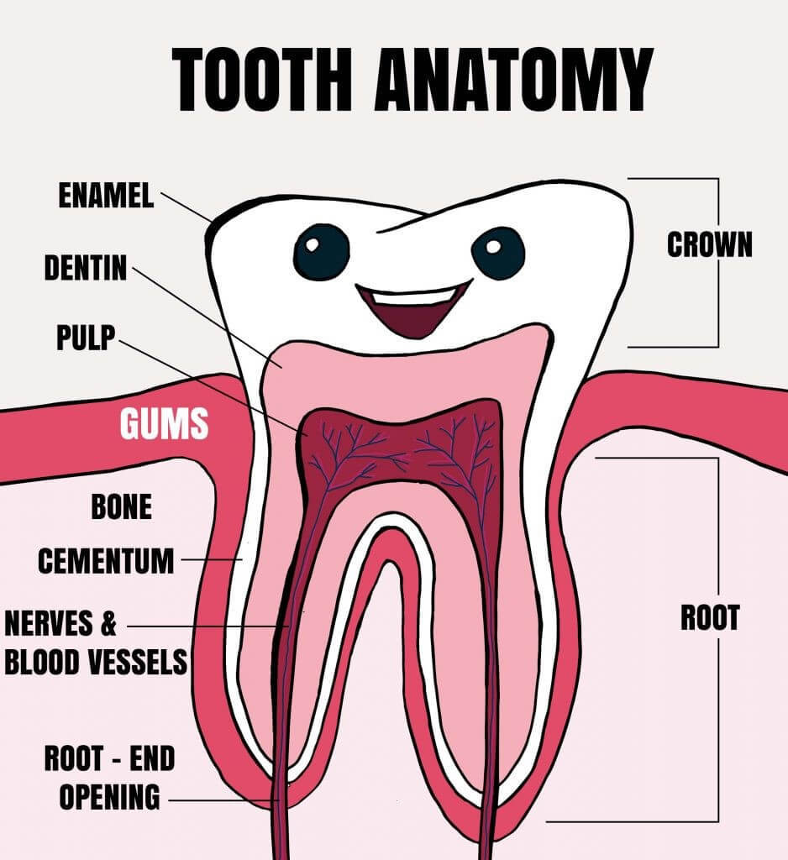

* **Crown:** The top area of the tooth that is covered with enamel.
* **Enamel:**It’s the white outer part and is the hardest part of the tooth.
* **Dentin:**The dentin, which is between the enamel and the cementum, is less mineralized than the enamel and less brittle. It acts as another level of protection for the pulp, and support for the crown.
* **Pulp:**The soft inner part of the tooth. It contains blood vessels, connective tissue, and nerves. One of the pulp’s most important functions is to provide moisture and nutrients to the surrounding mineralized parts of the tooth.
* **Gums:**This is the soft tissue that covers the jaw and protects the roots of the tooth. The gums also cover and protect teeth that are forming and have not yet erupted.
* **Root:**The area of the tooth that lies beneath the gums, and should not be visible.
* **Cementum:**The cementum is the layer of hard connective tissue that covers the root. This layer is softer than the dentin and the enamel but still acts as a bone like a protective layer.
* **Nerves and Blood Vessels:**Located in the pulp and run through the tooth in the root canal.
* **Root-End Opening:**Blood vessels and nerves enter the tooth through this opening at the apex of the root.

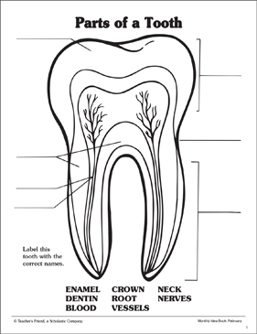

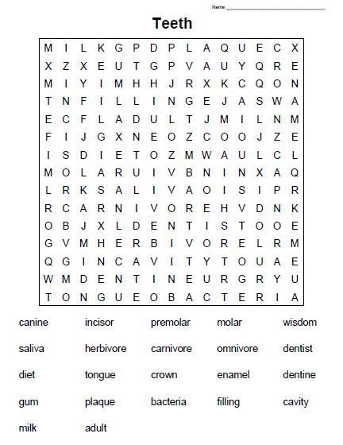

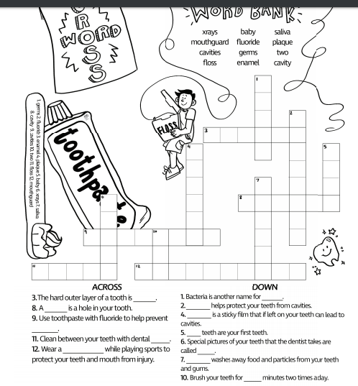

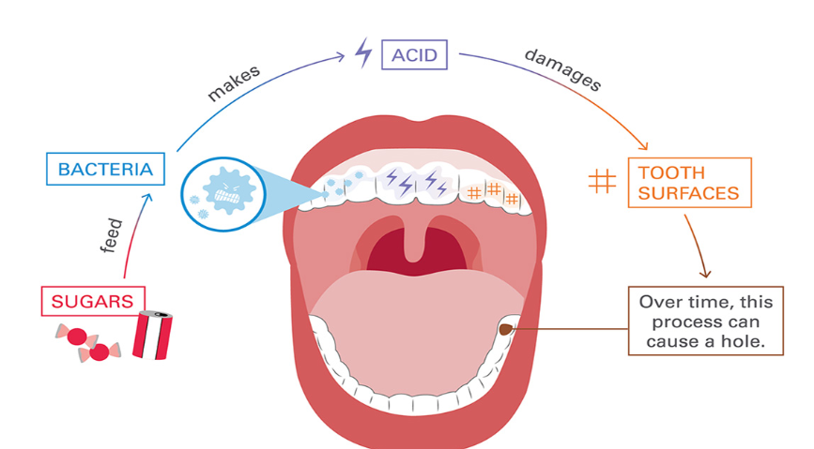

**Causes of tooth decay in young children**

Bacteria in the mouth feed on sugars from foods and drinks. These bacteria produce acid, which damages the outer surface of the tooth (the enamel). Saliva helps to repair this damage, but if over time there is more damage than repair, it leaves a cavity or ‘hole’ in the tooth.

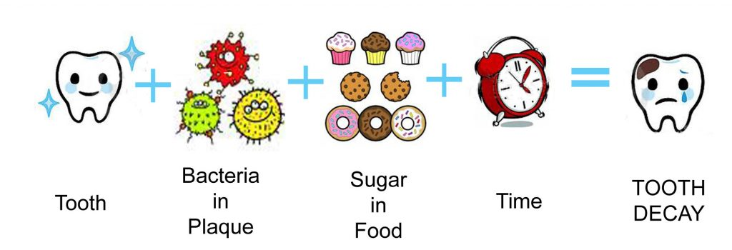

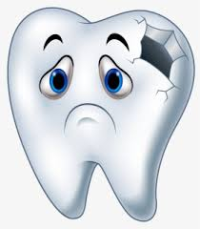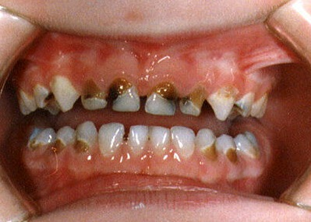

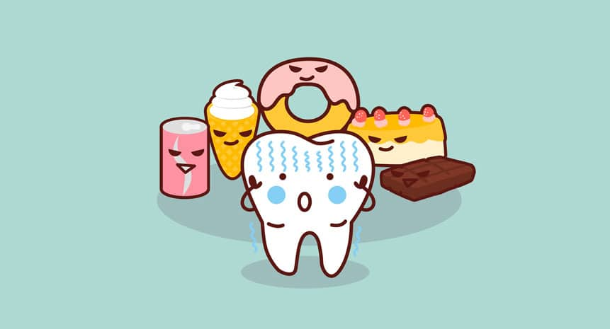

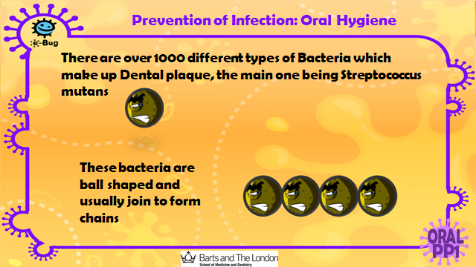

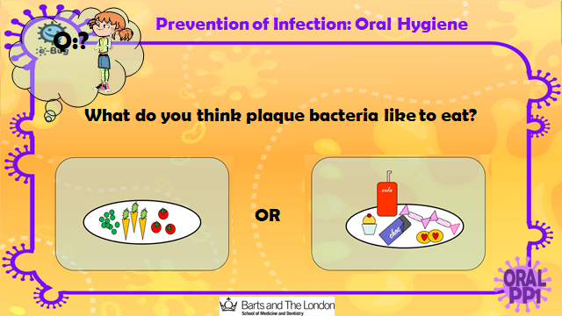

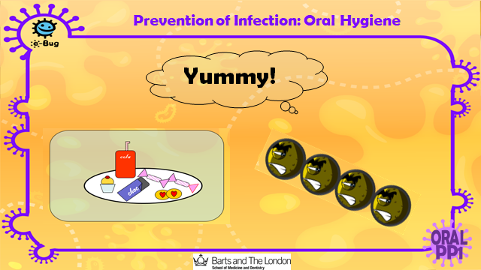

**Where Would We Be Without Them?**

Your mouth and teeth form your smile, which is often the first thing people notice when they look at you. The mouth is also essential for speech

The tongue (which also allows us to taste) enables us to form words with the tip of our lips and teeth. The tongue hits the teeth to make certain sounds

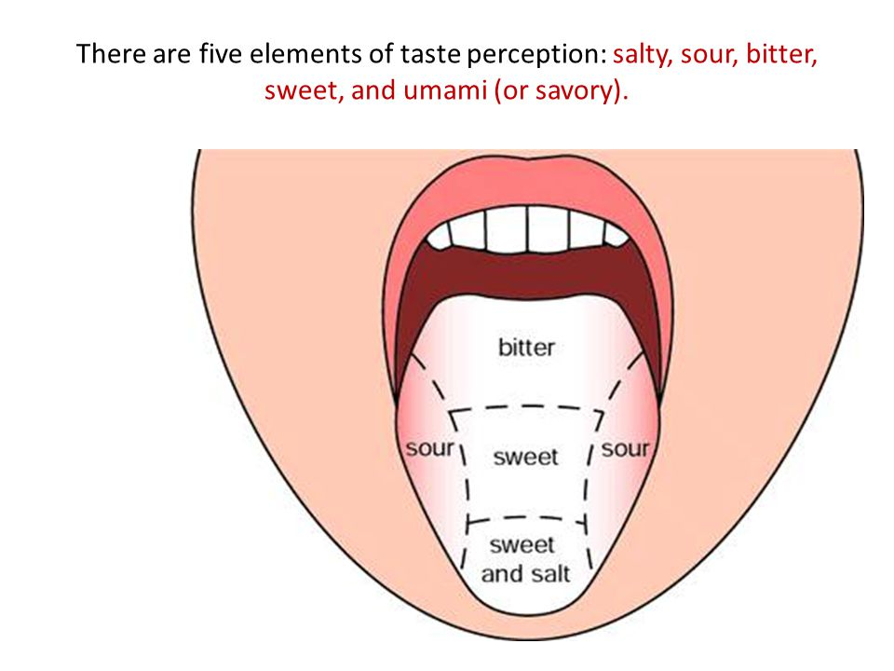

**Fun Facts about Your Tongue and Taste Buds**

* **Tongue-tastic!**
* **..**
* **The average tongue is about 3 inches long.**
* **Your tongue has between 2,000 and 4,000 taste buds.**
* **You can't see your taste buds.**
* **You have taste buds other places besides your tongue.**
* **You don't sense different tastes in different areas of the tongue**
* **The tongue is not the strongest muscle in your body.**
* **Your tongue print is as unique as a fingerprint.**
* **Every person's tongue is unique, and similar to fingerprints some see the potential for the tongue to act as an identity verification tool. The tongue is protected in the mouth and would be difficult to forge, and a person can stick it out for examination. Researchers are working on ways to use the tongue as a biometric authenticator – a reliable way to positively identify a person**.

Teeth Poem

When we’re little we have 20 milk teeth

But these drop out one by one.

We then grow our proper adult teeth

If we lose these, that’s it, they’re gone.

8 incisors, 4 canines for biting we clean them to keep them white8 premolars, 12 molars for chewing

We clean them day and night.

Our incisors are sharp for biting

We then brush all the food away;

Canines for gripping and tearing

We don’t want any decay.

Our molars are flat for grinding

There are 32 teeth in a set

Be sure to keep your teeth healthy

They’re the only ones you will get!

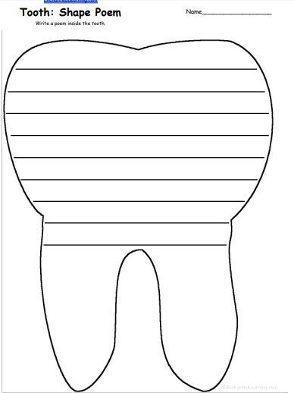

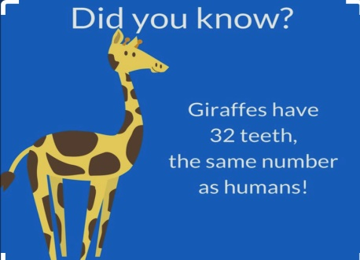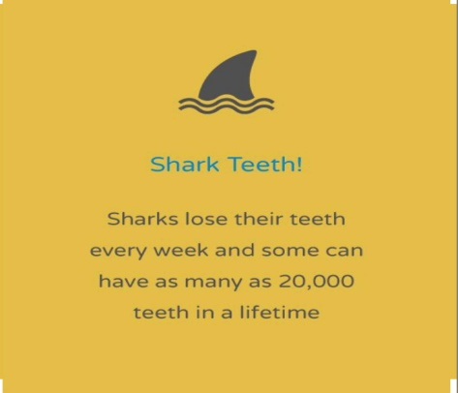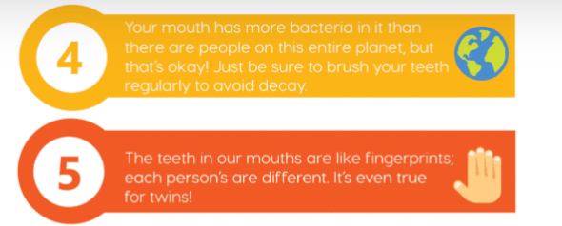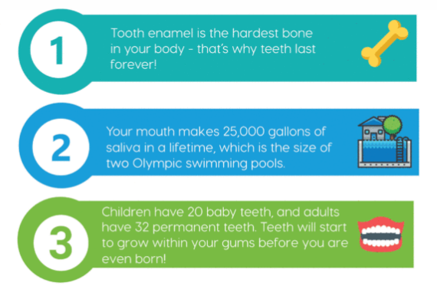

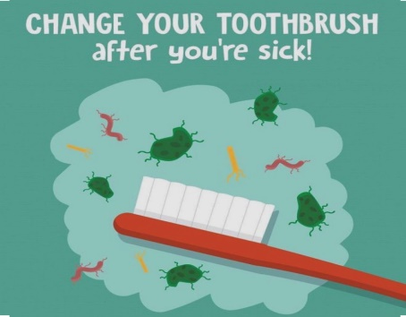

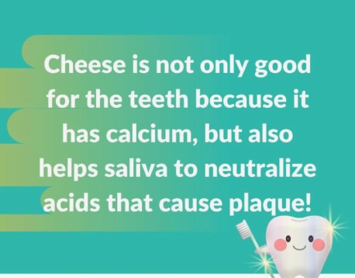

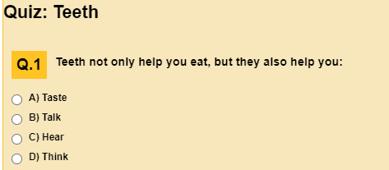

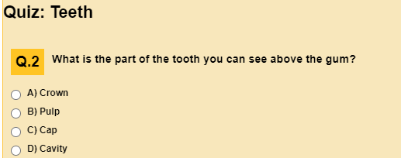

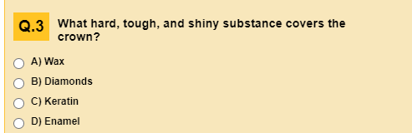

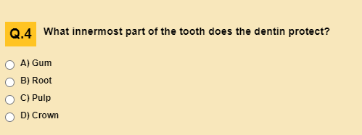

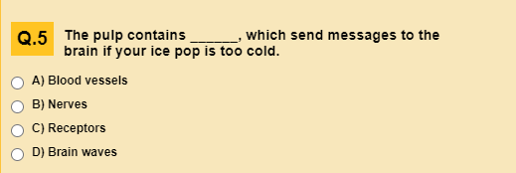

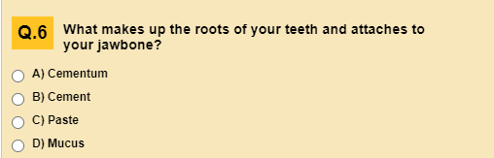

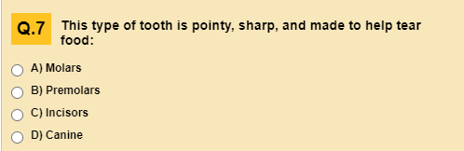

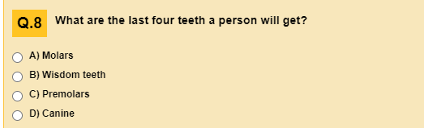

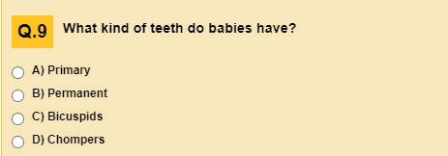

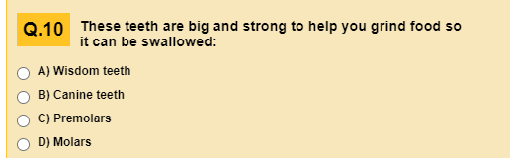



<https://widgit-health.com/easy-read-sheets/index.htm>

**Links to Oral education**

<https://www.bbc.co.uk/bitesize/topics/z27kng8/articles/zsp76yc>

<https://www.youtube.com/watch?v=GHS27DHyIi0>

Answers to Quiz below

<https://kidshealth.org/en/kids/teethquiz.html>

