Who Am I?
Can you identify who the members of staff are, using these clues?
Guess | Clues
1. | - Support in KS5  - Chelsea fan  - Love dancing & sports
2. | - I once ate a grasshopper at a school cultural food festival.  - I speak English, French, Portuguese and some Spanish and Kiswahili.  - I have travelled to over 30 countries in the world but have never been to Asia.
3. | - I am a female.  - I am a form tutor.  - I wear glasses.  - I can speak another language too.  - You cannot see my hair.
4. | - I took part in the London Marathon.  - My best friend used to work at Meadow High School
5. | - I can arrange a beautiful bunch of flowers!  - I had blonde hair before Christmas and now it's brown!  - I drive a little red car!
6. | 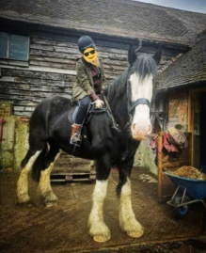 | 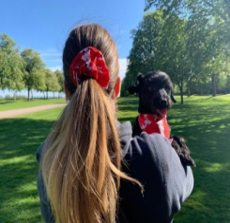
7. | I support this football club… | I can be seen doing this ….. | and I may tell you about these ……
8. | - She likes walking and riding her bike.  - She was out with her two daughters for their daily exercise this day.  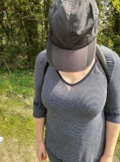  - She LOVES singing and acting.
9. | - “Hi guys”. I am a Form Tutor but started at Meadow as a teaching assistant.  - My room was in the main building however, this year you will find me near the field.  - I support Chelsea Football Club.
10. | - I teach more than one subject at Meadow.  - I used to be a Sixth Form Tutor  - I was recently a best man at a wedding in Hong Kong!
11 | - You use to find me in my classroom but that’s history.  - My fun assemblies make staff nervous.  - I love eating doughnuts
12 | - I started as a teaching assistant at Meadow  - I play lots of sports  - I have twins.

Staff’s Name | Guess Number
Miss Bhopal
Miss Leigh
Mrs Rigby
Mr Anstee
Mrs Bullen
Mr M
Miss Bergin
Miss Kepinska
Miss Carter
Mr Caines
Mrs Mansoor
Mr Vincent

