How to make soap (visual)
Put the pictures in the correct order

.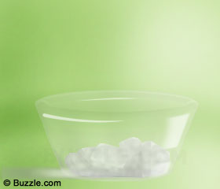 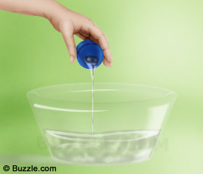
Now, transfer these pieces into a bowl Add required quantity of fragrance to the melt

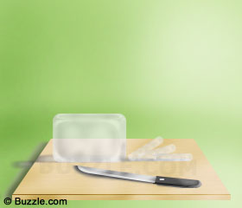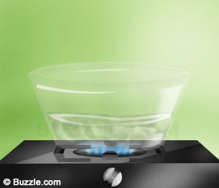
Take a transparent/ soap and cut it into small pieces. Melt the soap pieces either in a microwave oven

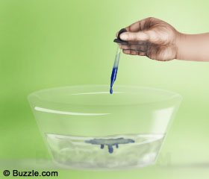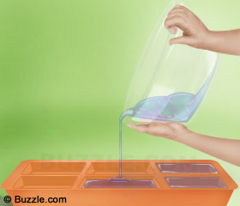
You can add a few drops of desired liquid food colour to the melt. Pour the mixture into soap moulds.

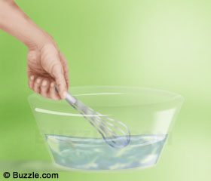
Take a hand blender and mix the ingredients to get a clear liquid.

Ingredients needed
- Melt and pour soap base
- Food colouring
- Scented oils
- Mould (I have some enough for the Science Dept.)
- Bowls
- Wooden spoons
- Microwave
- Alcohol in a spray bottle
- Paper to wrap the soap
- strings

