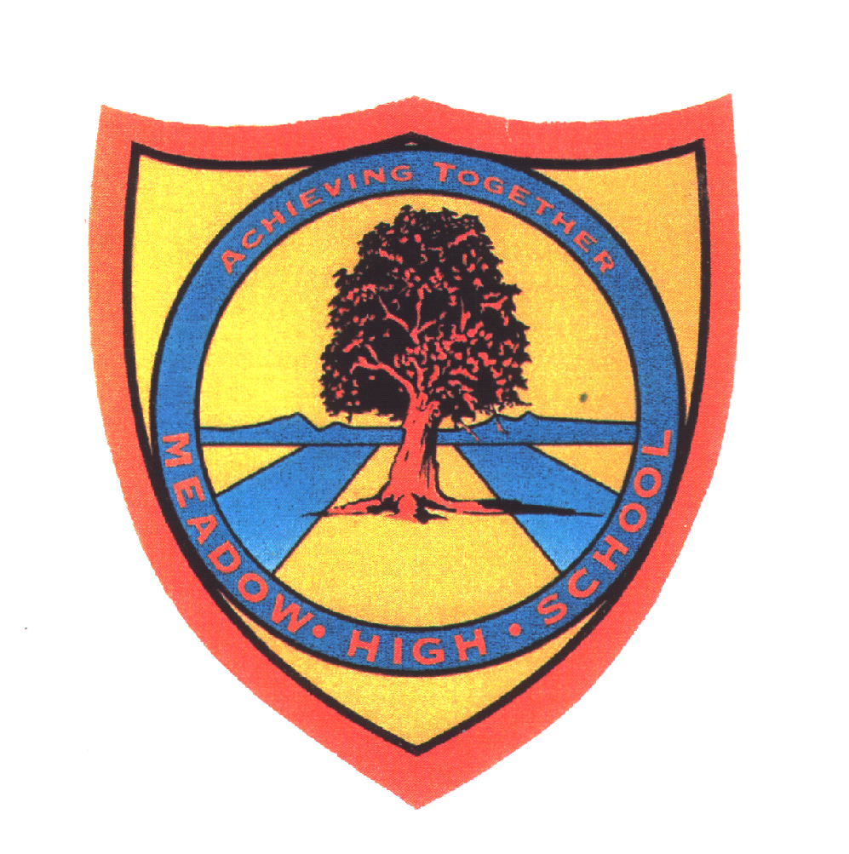 | Pathway  ‘2-3’ | Year 7 Music | Autumn Term 1 up to Spring half Term of Term 2
Learning Intention: Music ‘Getting to Know Music’
The purpose is for pupils to get to know each other, learn about each other’s music tastes and have an introduction to music. That includes a variety of instruments, instrument families and music styles. They learn to spot music styles by listening to them and learn key words and instruments. The start to develop their interest in music and learn signing when completing some singing tasks.
Key knowledge that should be learned during this SoW |  | All (Pathway 2) | Most (Pathway 3) | Some (Pathway 4)
Concept: |  | To encourage and support pupils to:  - Develop understanding of basic musical instruments and styles  - Develop an interest in music | To encourage greater independence and decisions making through guidance in:  - Develop the ability to talk about favourite genres and styles  -Develop pupils interest in a range of of music genres inspiring passion in music | To develop independent thinking, decision making, basic leadership skills and problem solving in group work by:  - Develop the ability to talk about favourite genres and styles giving examples  -Encourage pupils to begin to pursue their own passion for Music with the correct technique and style.
Knowledge: |  | Develop a basic understanding of the following Core Knowledge:  - Be aware of different instruments and what they look like. | Develop a competent understanding of the following Core Knowledge:  -To recognise instruments and say their names. | Develop a confident understanding of the following Core Knowledge:  -To recognise instruments, say their names and talk about their favourite instruments.
Key Skills: |  | what will they actually be able to do as a result of this learning  -To develop correct posture using the keyboard and recognise some of the keys  -To follow a simple song | what will they actually be able to do as a result of this learning  -To improve posture and use a range of keys  To follow a simple song | what will they actually be able to do as a result of this learning  -To improve posture and use a range of keys accurately.
Language and/or communication skills: |  | To develop confidence in subject related language and begin to use a range from the following keywords independently and mostly accurately sharing ideas verbally when prompted.  •Pop Music  - Loud  - Quiet | To improve use of subject related language and appropriate application of the below keywords and to share a range of new descriptions and their own keywords with the class:  • Jazz  - High  - Low | To explore use of subject related language using broad and appropriate application for the most of the below keywords and regularly sharing own additional language  Opera  - Style  - Fast  - Slowly
Curricular Links |  | Spiral Learning  SMSC/PSHCE- personal and social development linked to getting to know each other’s music taste and interests.  A practical based project with a cross curricular Music focus on Musical theatre and Jazz music,Literacy- Keyword exercises, word games, word frames, vocabulary quiz  Numeracy is encouraged through counts of beats, Timings  Dance- linking with the Dance Curriculum in year 7 Jazz and Musical Theatre

Talking points

Students can discuss what they know about music; their favourite instruments, artists, bands etc..
Use the internet to share their favourite music style with others

Implementation
Core Focus of teaching:
- Developing Rhythm
- Recognising Pitch
- Learn about Dynamics
- Introduction to Tempo
- History of Music: Pupils are introduced to a range of Musicians and music styles and are expected to develop a greater understanding of instrument families within an orchestra.

- Composition & Notation: Pupils look at the percussion family and the keyboard in greater detail and experiment with their own compositions working as a class and in smaller groups.

- Voice: Pupils Develop High, Low, loud and quiet voice skills establishing the basic skills needed to participate with others in singing

There are opportunities for students to build up their body coordination during this unit. There are musical starters that require students to move around following the pace of the music. Also, this unit includes singing a sign song, where students need to multitask - singing and signing at the same time. Students with dyspraxia will get extra support from the teacher and TA’s, including 1-1 tutorial and extra rehearsal time.

Assessment: Pupils are continuously assessed by the teacher as they Llearn to sing and explore instruments. Pupils also complete a Baseline Assessment which covers a wide variety of skills.
Impact
Core Outcomes
Outcomes: 4 main outcomes
1.Showing understanding of a variety of musical instruments and styles
2. Group performance
3. Base Line Assessment
4. Singing and signing songs

Wider Outcomes
Students can use what they have learnt to create music of their own. Develop a passion for music and different music Genres.
Career Links-Develop new interests pupils are encouraged share with others. Inspiring passion for music and instruments, inspiring interest and intrigue into the instruments that professional musicians might use.

