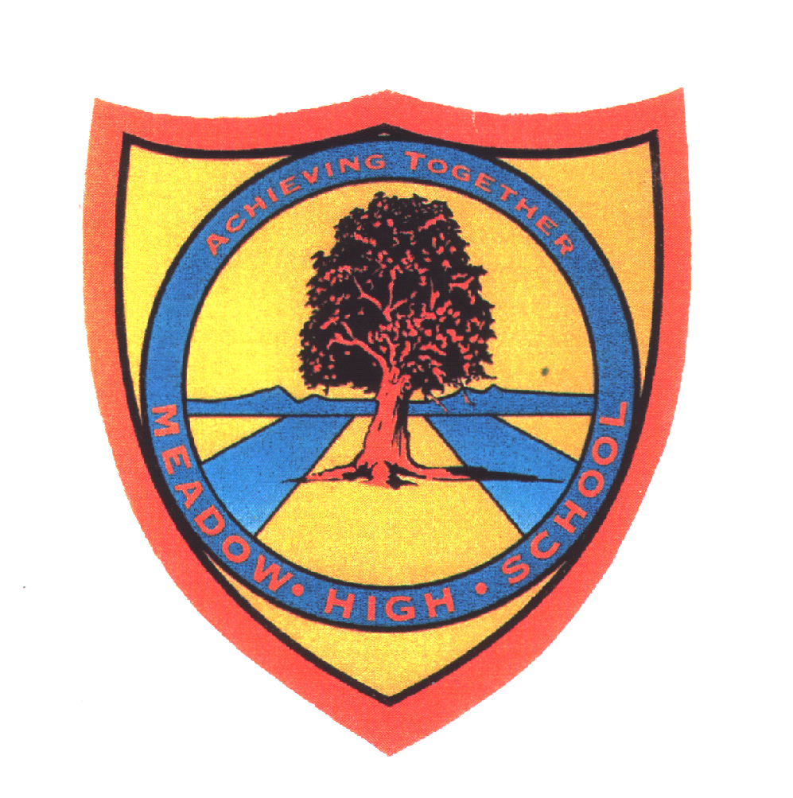 | Pathway 1 | Key Stage 3 Cycle 1 |  |  | Autumn 1  Topic: The Senses
Learning Intention: Pupils will explore the five senses (touch, taste, sight, smell and hearing). Pupils will start to learn about how our senses work and conduct experiments with restrictions and evidence.
Key knowledge that should be learned during this SoW |  |  | All | Most |  | Some
Concept: |  |  | Pupils will explore the senses and be able to label body parts accordingly. Pupils will learn how those body parts allow us to experience each sense. Pupils will learn how people manage when they lose a sense and how out body works for help us understand the world.
Knowledge: |  |  | To explore the 5 senses. | To know the body part connected to which sense.  To label body parts to senses. |  | To have basic understanding of how our body works in relation to senses.
Key Skills: |  |  | Explore and discover | Investigate and test. |  | Experiment  Hypothesise
Language and/or communication skills: |  |  | Senses | Taste  Sight  Sound/hear  Touch  Smell  Label |  | Label
Curricular Links |  |  | Geography, history, PSHCE

