Meadow High School
Royal Lane, Hillingdon, Middlesex UB8 3QU

Telephone: (01895) 443310
Email: meadow@meadowhighschool.org
Website: www.meadowhighschool.org

Headteacher: Mrs Jenny Rigby
Deputy Headteacher: Ms Claire Caddell

20th May 2022

Queens Jubilee Celebration Non-Uniform Day
Friday 27th May 2022
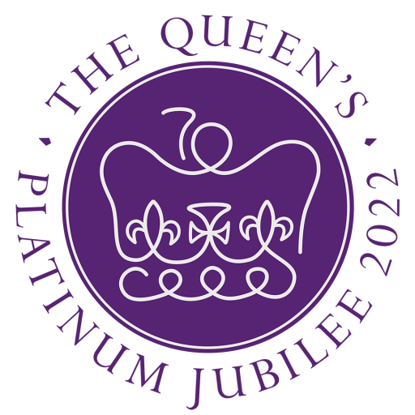

Dear Parent/Carer,

To celebrate the Queens Platinum Jubilee, we will be holding a street party at school on the afternoon of Friday 27th May 2022.

We will be having a traditional afternoon tea, in the playground, followed by activities and games on the field. There is no cost for this event.

We would like to encourage pupils to come dressed up as a Royal
or in the colours of the British flag (Red/White/Blue)!

If you have any further questions, please feel free to contact the school via your childs Link Book.

Kind Regards,

Miss S Bhopal Mrs A Mistry
Assistant Headteacher Maths Faculty leader

