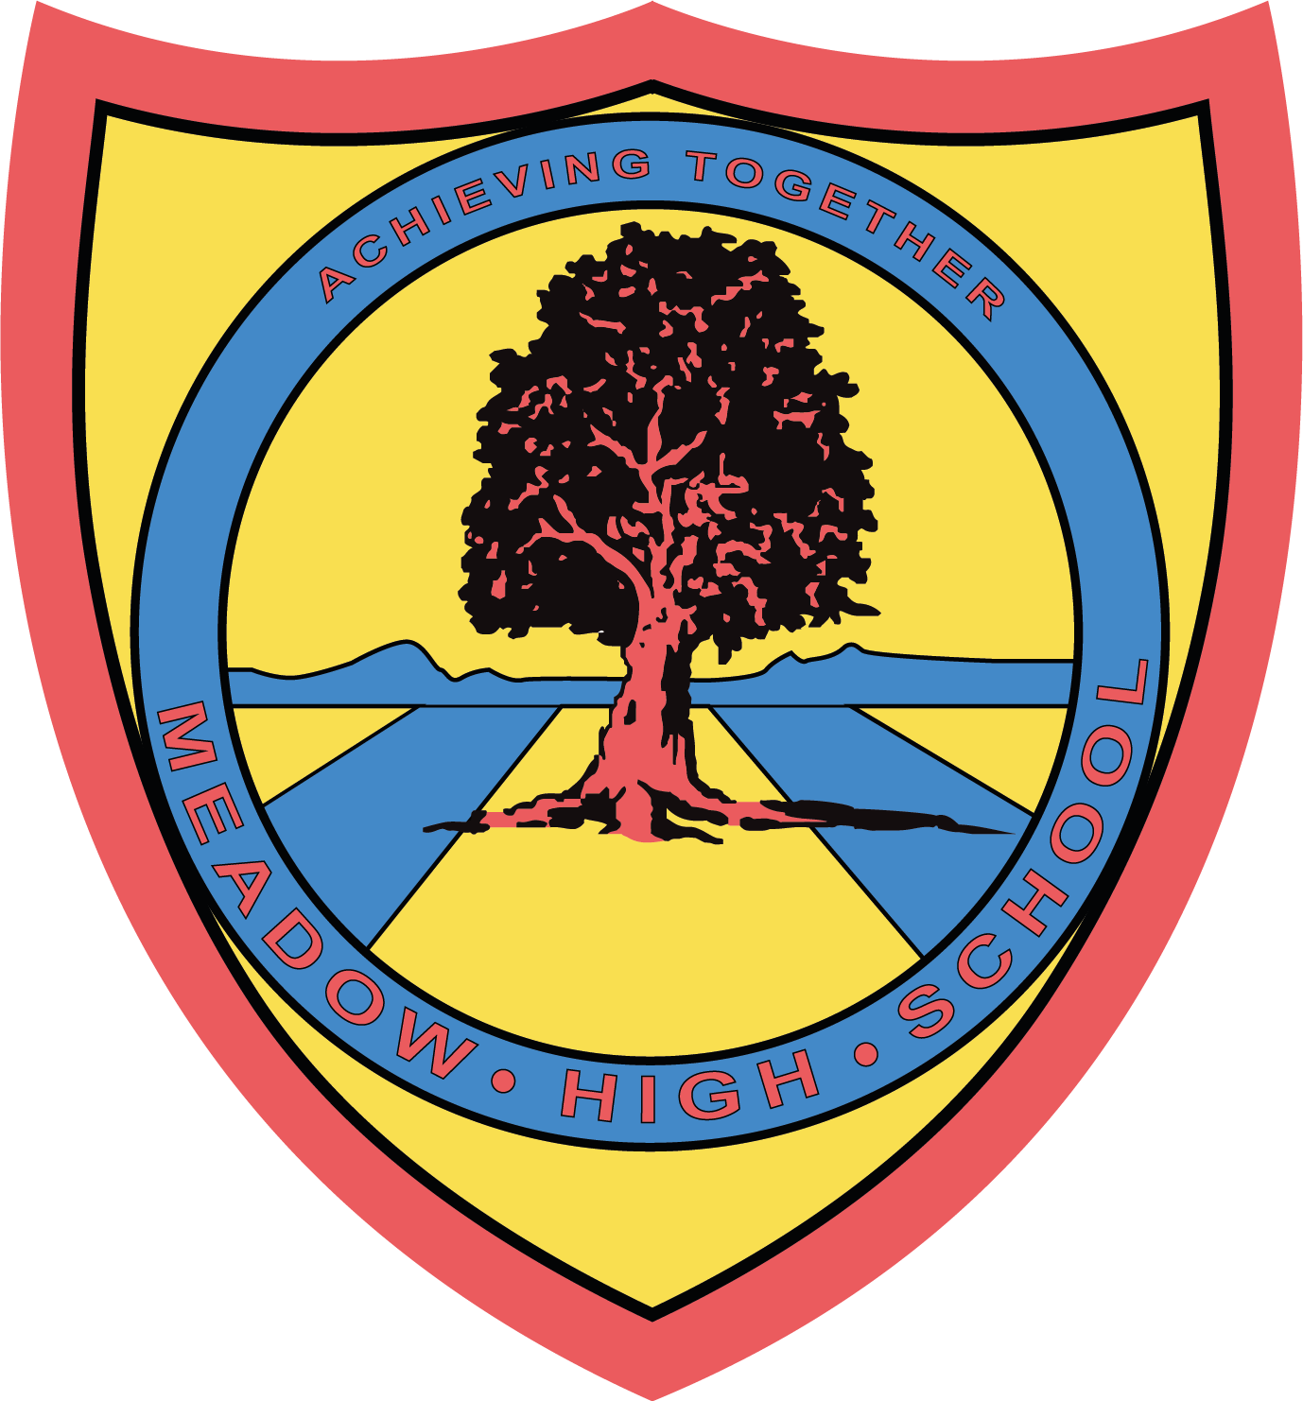
Meadow High School
Royal Lane, Hillingdon, Middlesex UB8 3QU

Telephone: (01895) 443310
Email: meadow@meadowhighschool.org
Website: www.meadowhighschool.org

Headteacher: Mr Graham Cunningham
Deputy Headteacher (Royal Lane): Miss Michelle Taylor
Deputy Headteacher (Northwood Road): Miss Amy Willis

Wednesday 15th April 2026

Dear Parent/Carer,

As part of our celebrations for the National Year of Reading 2026, we are very excited to announce that from Monday 27th April to Friday 8th May we will be running a Scholastic Book Fair in our Library!


The Scholastic Book Fair is a pop-up celebration of reading that puts the very best books directly into your child’s hands, all while raising rewards to spend on free books and essential resources for our school. For every sale made, Meadow High School will receive FREE rewards that we can use for even more resources for our students.

To provide an opportunity for you to visit the Book Fair with your child, we will be hosting two parent coffee afternoons on

Tuesday 28th April 1.40pm - 2.40pm

Thursday 30th April 1.40pm - 2.40pm

You will be able to meet with other parents and also choose from the fantastic books on offer. We have made sure that there will be a wider selection of picture books this time. As previously, payment can be made via card, using a QR code we will provide at the fair.

If you would like to join us for one of the sessions, please complete the slip below and return as soon as possible. If you would like to collect your child at the end of the session please ensure you tick the relevant box. Please note that there is no on-site parking - if there is a particular need, please contact your child’s form tutor.

If you have any questions, please contact our Librarian, Miss S Gaafar, on sgaafar@meadowhighschool.org.

Kind Regards,

Miss S Gaafar & Miss S Kennedy Anne Sugden
Librarians (Supporting and Delivering Learning) English & Communication Faculty Leader

Article 23:- 'A child with a disability has the right to live a full and decent life with dignity and independence, and to play an active part in the community.'


___________________________________________________________________________________
Re: Scholastic Book Fair Parents Coffee Afternoon Sessions 28.04.26 or 30.04.26

( ) I would like to attend the Tuesday 28th April 1.45pm - 2.45pm session with my child.
( ) I would like to attend the Thursday 30th April 1.45pm - 2.45pm session with my child.
( ) I will be taking my child home with me at the end of the session.

Child’s Name: __________________________________________ Class: ____________________

Signed: _________________________________________________________________

PARENT/CARER NAME: ___________________________________________________________

