Meadow High School
Royal Lane, Hillingdon, Middlesex UB8 3QU

Telephone: (01895) 443310
Email: meadow@meadowhighschool.org
Website: www.meadowhighschool.org

Headteacher: Mrs Jenny Rigby
Deputy Headteacher (Royal Lane): Miss Michelle Taylor
Deputy Headteacher (Northwood Road): Miss Amy Willis
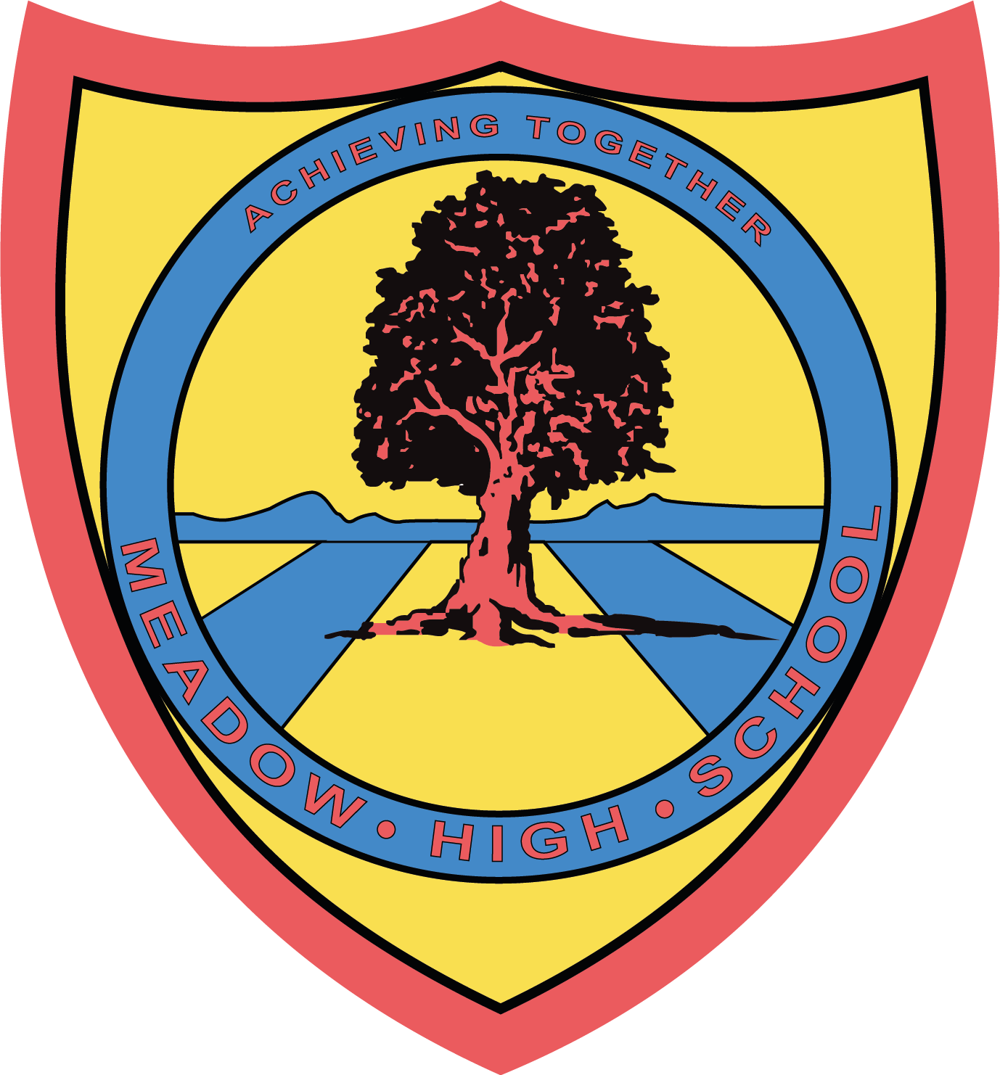

13 June 2025

Dear Parent / Carer,

On Friday 20th June, the Sixth Form Committee will be holding a fund raising event to support our school Prom and Young Minds. Young Minds is a remarkable organisation fighting for a world where no young person feels alone with their mental health.

The Sixth Form Committee will be raising money to support our Prom and Young Minds by holding a cake sale throughout the day on 20th June. We need your support by donating cakes that the committee can sell to the school community. Not only will we raising money for an excellent charity, but it will also be a good opportunity for the committee to further develop key skills and gain experience in organizing an event.

Thank you in advance,

Kind Regards

Sixth Form Committee

Article 23:- 'A child with a disability has the right to live a full and decent life with dignity and independence, and to play an active part in the community.'



