Meadow High School
Royal Lane, Hillingdon, Middlesex UB8 3QU

Telephone: (01895) 443310
Email: meadow@meadowhighschool.org
Website: www.meadowhighschool.org

Headteacher: Mrs Jenny Rigby
Deputy Headteacher PW2/3: Ms Claire Caddell
Deputy Headteacher PW1: Miss Amy Willis
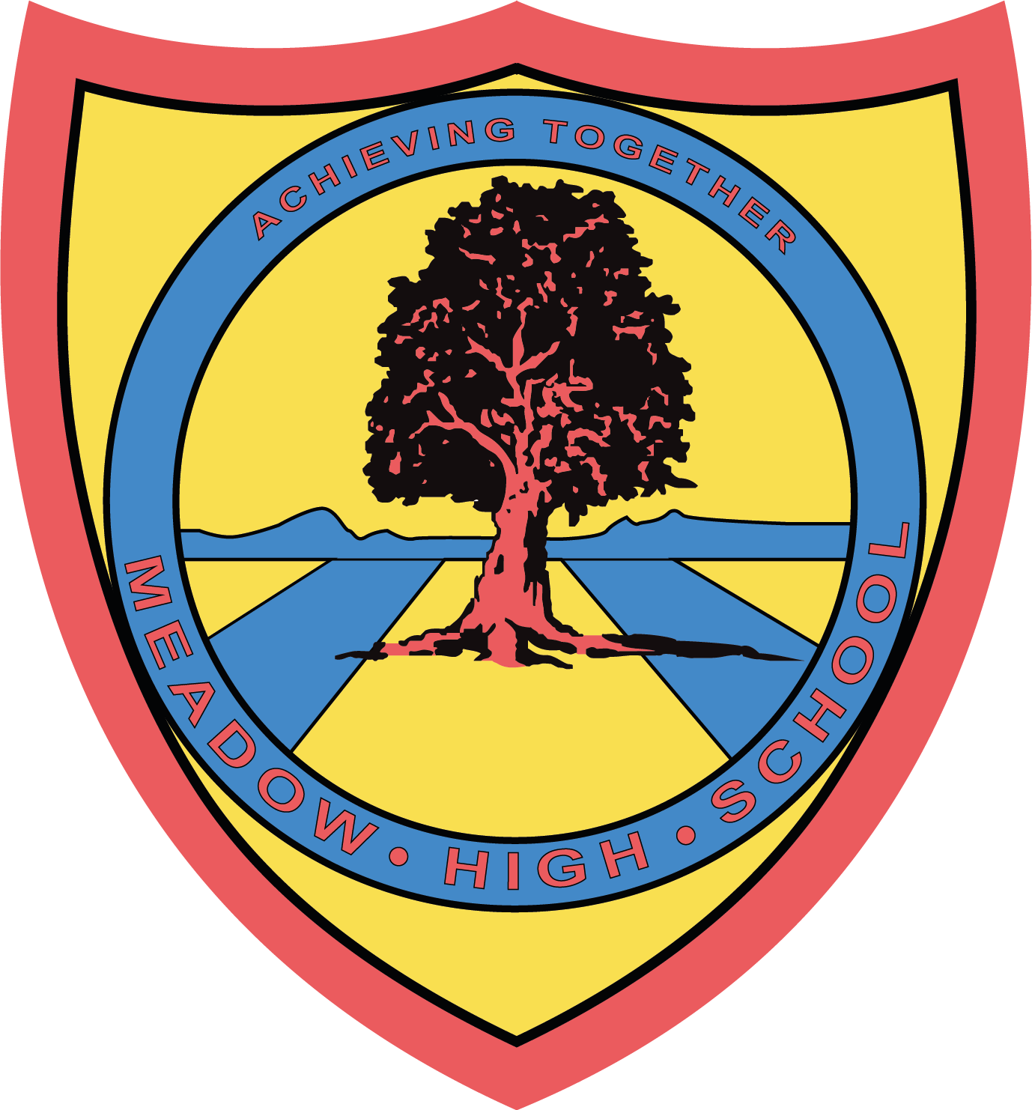

Friday 1st March 2024

Comic Relief / Red Nose Day Non-Uniform Day
Friday 15th March 2024



Dear Parent/Carer,
On Friday 15th March we will be having a non-uniform day and are asking students to wear something red.

We will also be organising a cake sale. Students who would like to buy cakes should bring in a small amount of money on the day. If you would like to donate some cakes, please bring to reception.

We have a small amount of Comic Relief red noses that we will be selling to pupils throughout the week. Students who would like to purchase one should send in £2.00. These are also available to purchase from the Comic Relief website and Amazon.

We will be accepting voluntary charity donations via your child’s parent pay account.

Many thanks for your continued support.

Mrs Mistry
AHT Workforce Development

