Meadow High School
Royal Lane, Hillingdon, Middlesex UB8 3QU

Telephone: (01895) 443310
Email: meadow@meadowhighschool.org
Website: www.meadowhighschool.org

Headteacher: Mrs Jenny Rigby
Deputy Headteacher PW2/3: Ms Claire Caddell
Deputy Headteacher PW1: Miss Amy Willis
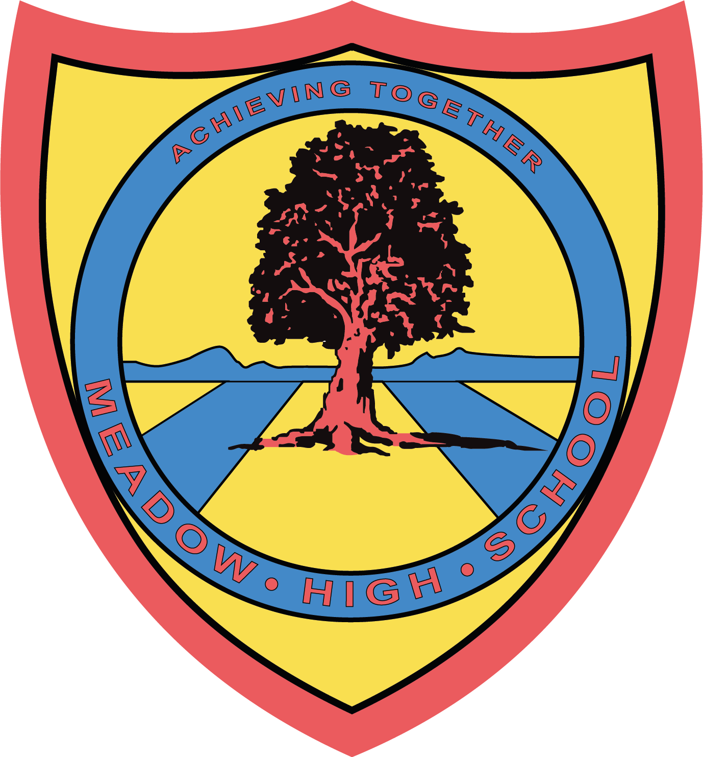

Tuesday 6th Feb 2024

Dear Parents / Carers,
Re: Swimming Lessons for Year 7 students
After February half term your child will be having their swimming lessons on a Tuesday period 3 and 4, instead of PE so will not need their PE kit but will need their swimming kit. These lessons are conducted off site and students will be taken there via school mini bus. Swimming lessons will run from Tuesday 19th Feb until Tuesday 7th May 2024.
They will need to bring:
- Swimming trunks / costume (no bikinis)
- A towel
- Goggles if required
If you have any queries please do not hesitate to contact me at school.
Yours Sincerely,

Ms C Sojka
(Swim Teacher)

Article 23:- 'A child with a disability has the right to live a full and decent life with dignity and independence, and to play an active part in the community.'


