***Meadow High School***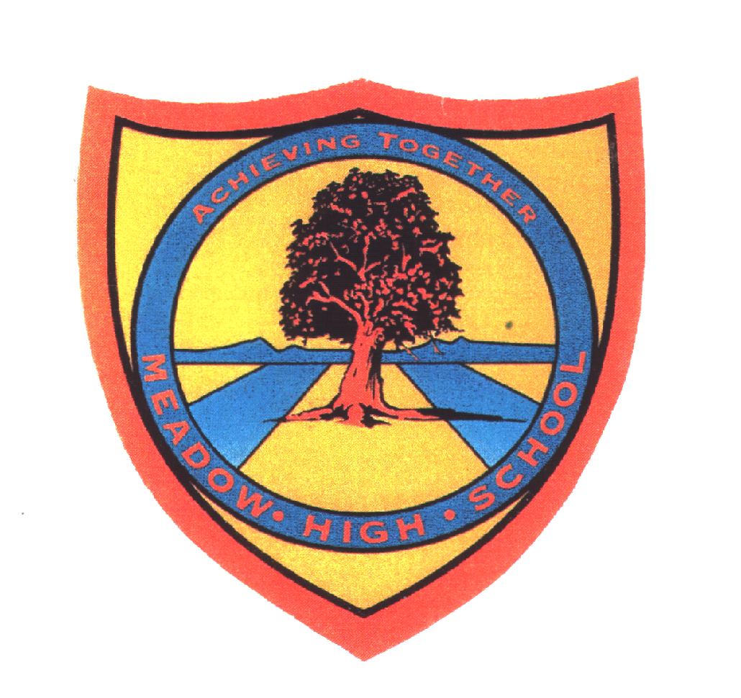

*Royal Lane, Hillingdon, Middlesex UB8 3QU*

*Telephone: (01895) 443310*

*Email: meadow@meadowhighschool.org*

*Website: www.meadowhighschool.org*

***Headteacher: Mrs Jenny Rigby***

***Deputy Headteacher: Ms Claire Caddell***

4th May 2022

Dear Parents/ Carers,

**Girls Only Middlesex FA Tournament**

Your child has been selected to attend the Girls Only Football Event on **Wednesday 11th May**. The event will be taking place between 09:50 – 12:40, so no extra travel arrangements need to be made. Pupils will also be back for normal lunch arrangements. On the day, your child should come into school in their PE kit with **shin pads**.

If you have any questions just let me know.

Kind regards,

Mr. Anstee

PE Teacher

@MeadowPE