Meadow High School
Royal Lane, Hillingdon, Middlesex UB8 3QU

Telephone: (01895) 443310
Email: meadow@meadowhighschool.org
Website: www.meadowhighschool.org

Headteacher: Mrs Jenny Rigby
Deputy Headteacher: Ms Claire Caddell
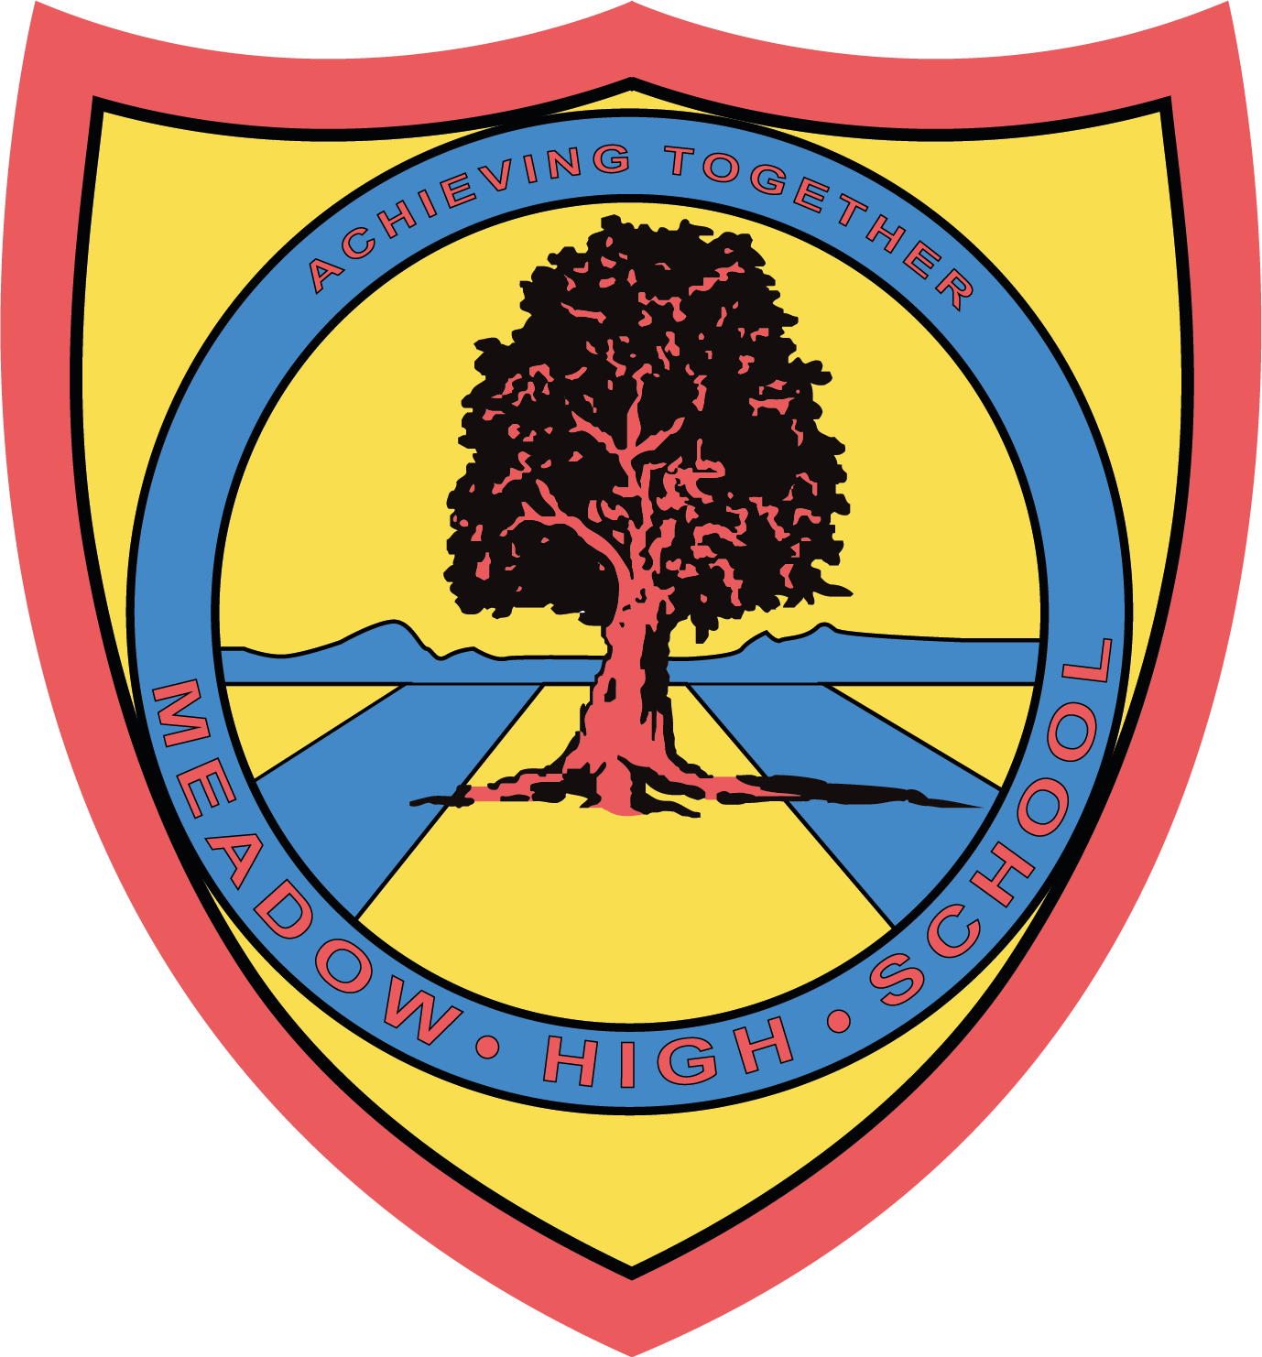

Thursday 2nd February 2023

Dear Parent / Carer,

Visit to Runneymede and Ankerwycke Grounds

To support pupils learning into the Magna Carta, as part of our History unit, we will be visiting the Runneymede and Ankerwycke grounds on the morning of Wednesday 22nd March 2023.

We will be travelling by school Minibus, leaving soon after registration and we will be back at school in time for normal lunch arrangements. All pupils are required to wear school uniform.

If you require any further information about this event, please contact me at school.

Yours sincerely,

Miss Cryan
Year 7 tutor

Article 23:- 'A child with a disability has the right to live a full and decent life with dignity and independence, and to play an active part in the community.'



