Pathway 1 KS4/5 cover page Entry Levels

 | Pathway:  1 | Key Stage:  4/5 | Term:  Autumn/ Spring/ Summer
Learning Intention: Entry Levels provide opportunity for pupils to learn and consolidate basic and relevant numeracy skills. Pupils must submit assessments from eight components: 1) properties of number, 2) the four operations, 3) ratio, 4) money, 5) the calendar and time, 6) measures, 7) geometry, 8) statistics.
Key knowledge that should be learned during this SoW |  | (Entry Level 1) | Some (Entry Level 2)
Concept/ Knowledge and Key Skills: |  | - Component 1 - properties of number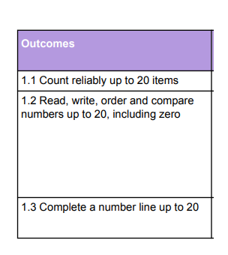  - Component 2 - the four operations  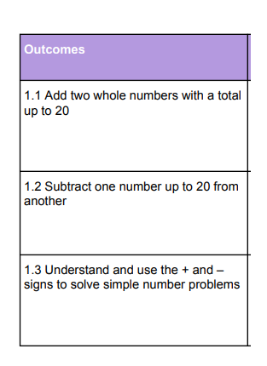  - Component 3 - ratio  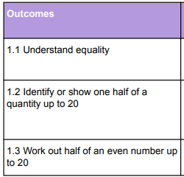  - Component 4 - money  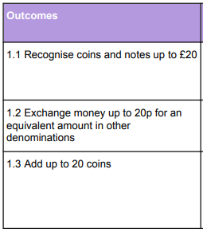  - Component 5 - Calendar and time  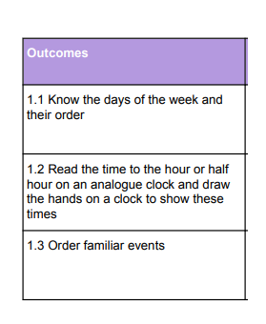  - Component 6 - Measure  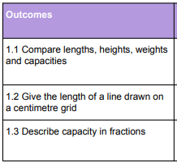  - Component 7 - Geometry  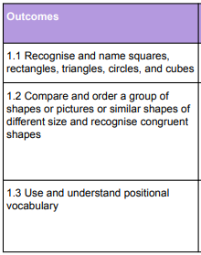  - Component 8 - Statistics  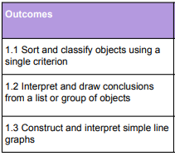 | - Component 1 - properties of number  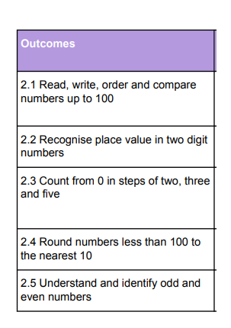  - Component 2 - the four operations  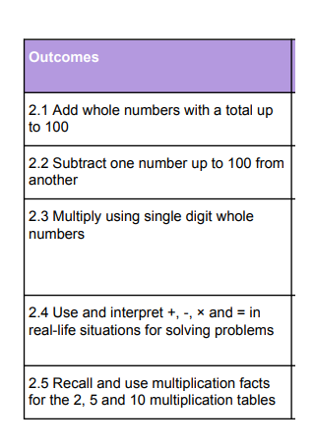  - Component 3 - ratio  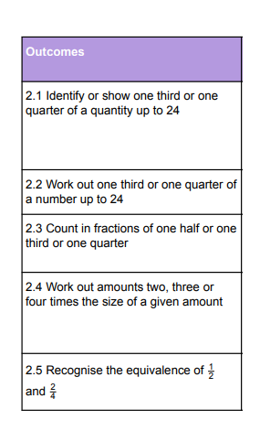  - Component 4 - money  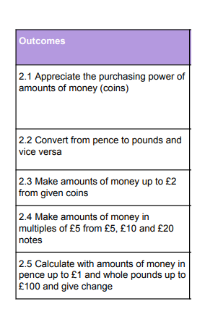  - Component 5 - Calendar and time  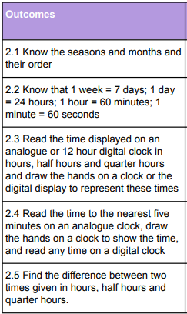  - Component 6 - Measure  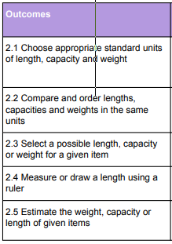  - Component 7 - Geometry  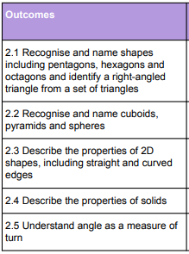  - Component 8 - Statistics  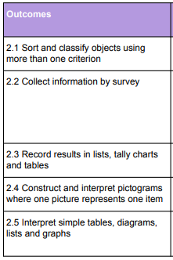
Language and/or communication skills: |  | - Number - place value, 10, 100, 1000’s  - Four operations - add, subtract, times, divide, equals (other vocabulary to be used - see calculation guidance document)  - Money - pounds, pence, coins, notes, convert, change  - Calendar and time - seconds, minutes, hours, days, weeks, months, weeks, years, seasons  - Geometry - two dimensional, three dimensional, tessellation, symmetry, angles, turns  - Ratio and fractions - whole, half, quarter, three quarters, third...  - Measurement - length, weight, height, mass, volume, capacity  - Statistics - bar chart, line graph, tally chart, pictogram, carroll diagram
Curricular Links |  | PSHCE - interacting with the public when making appointments, travelling on public transport, placing orders at restaurants etc.  Food technology - finding and cooking recipes, costing and budgeting for them, shopping for ingredients etc.

