KS4 Art Autumn 1 - Kung Fu Panda

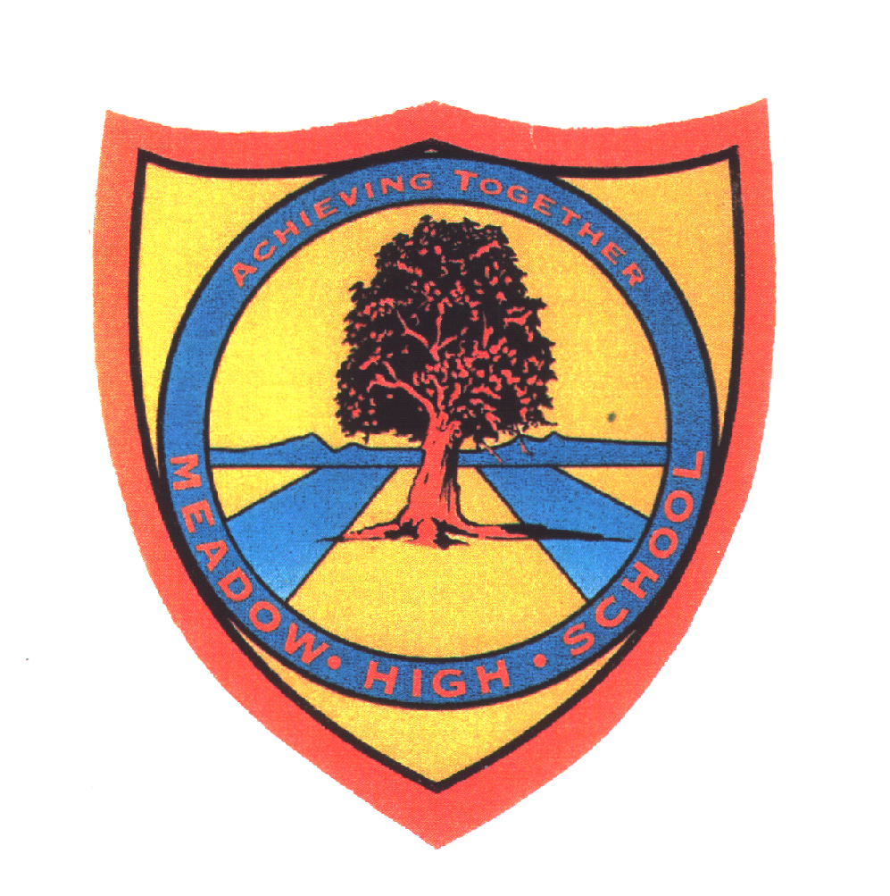 | Pathway 1 | KS4  ART | Autumn 1  Title: Kung Fu Panda
Learning Intention: A focus on the theme of Kung Fu Panda providing students with skills for expressing their artistic creativity using resources in an artistic way. Students will learn that they can explore their creativity and expressive nature through colour and materials. They will develop their fine motor skills through using and manipulating materials whilst creating images, colour and texture. They will be able to explore the mindfulness and comfort that art can provide. Students will develop and explore art as a means through which to communicate emotion, feeling and their innermost selves through creative expression.
Key knowledge that should be learned during this SoW |  | All | Most | Some
Concept: |  | All students will have had some experiences in expressing their artistic skills using some variety of materials and mediums for recreating pictures and artworks. | Most students will be able to experience using a range of materials and mediums for expressing their creativity for the recreating pictures and artworks. | Some students will be flexible and explore all materials and mediums and be able to successfully use them to express their creativity for the concept of recreating pictures and artworks.
Knowledge: |  | All students will know that artistic resources are used to make art work. | Most students will know that there is a choice of resources that can be used to make art work. | Some students will be able to know that they can use different materials for creating images. They will be able to use this knowledge in a cross curricular way in other lessons where they can be creative.
Key Skills: |  | All students will use and apply materials and mediums in a way that is most suited to their needs - developing their fine motor skills and recognition for creative mediums. They will use paint brushes, fabrics, and tissue paper. | Most students will be able to use their fine motor skills to apply creative mediums for creating a desired effect. | Some students will be able to effectively use and apply creative mediums in a range of activities within and outside of art lessons. This will support those students who then may be able to continue to develop their fine motor skills outside of the school environment.
Language and/or communication skills: |  | All students will have experience signing, saying and using keywords within the context of art lessons:  Hand-prints  Panda  Ears  Claws  Finger-painting  Press  Detail  Stamp  Tile  Press  Tile  Press  Stamp  Marble painting  Scene  Blob  Swirl  Bamboo  Leaves  Pattern  nature | Most students will be able to use the key words in the context of the art lessons and remember them for the following lessons. | Some students will be able to use and apply the key words in alternative lessons. Moving forward, some students will be able to use keywords effectively outside of school and lessons.
Curricular Links |  | English - vocabulary development  Signalong - key words through sign

