Cycle 2 PSHCE Cycle 2 Spring 2 Current affairs

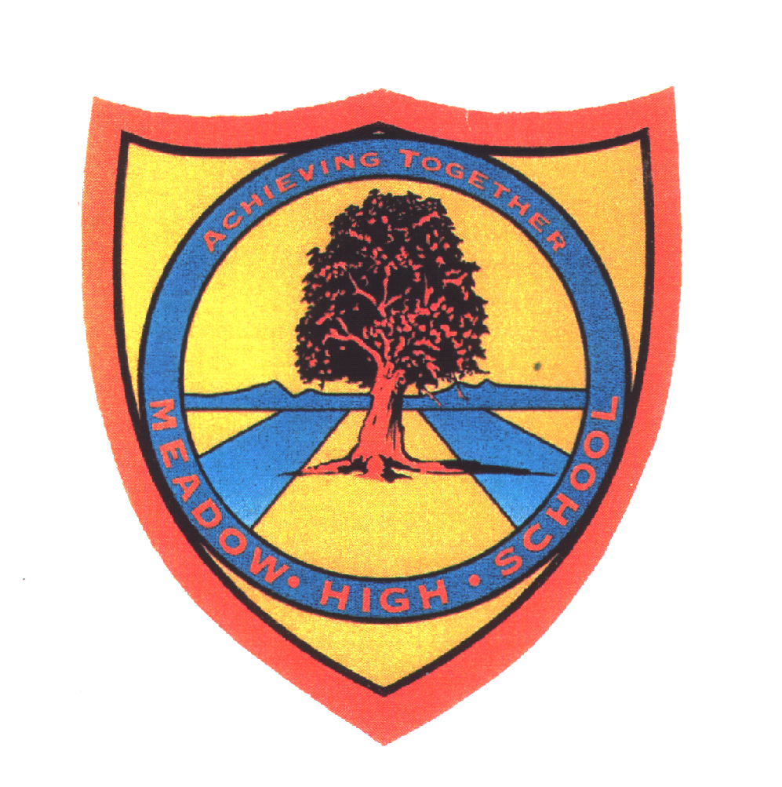 | Pathway 1 | KS5  PSHCE  Cycle 2 | Spring Term 2  Current affairs
Learning Intention: Pupils will learn about current affairs in the UK, including the monarchy, prime minister and other recognisable/important people in the UK and wider world. Pupils will explore current news and explore how we access it, as well as considering how reliable sources of information are.
Key knowledge that should be learned during this SoW |  | All | Most | Some
Concept: |  | For pupils to be aware of wider issues in the world. | Pupils to be aware of current affairs. | Pupils to be explore current affairs and own thoughts regarding these.
Knowledge: |  | To recognise national figures of impoartnce.  SMSC  Exploring wider issues . Links between elf and others.  British values - mutual respect for and tolerance of those with different faiths and beliefs and for those without faith. | Will be aware of wider news and events  SMSC  Forming own opinions and thoughts of current affairs and issues.  British values - Understanding the rule of law | To be aware of national and international figures who they see on the news. Pupils to be aware of regional and national news.  SMSC  British values- democracy
Key Skills: |  | Communication  Awareness of others and impact we have on others. | Listening skills  Research skills | Discussion
Language and/or communication skills: |  | News  Respect  Tolerance | Reason | Voting  Democracy  Fair  Unfair
Curricular Links |  | Theme KS3-4. Science

