Meadow High School
Royal Lane, Hillingdon, Middlesex UB8 3QU

Telephone: (01895) 443310
Email: meadow@meadowhighschool.org
Website: www.meadowhighschool.org

Headteacher: Mrs Jenny Rigby
Deputy Headteacher: Ms Claire Caddell
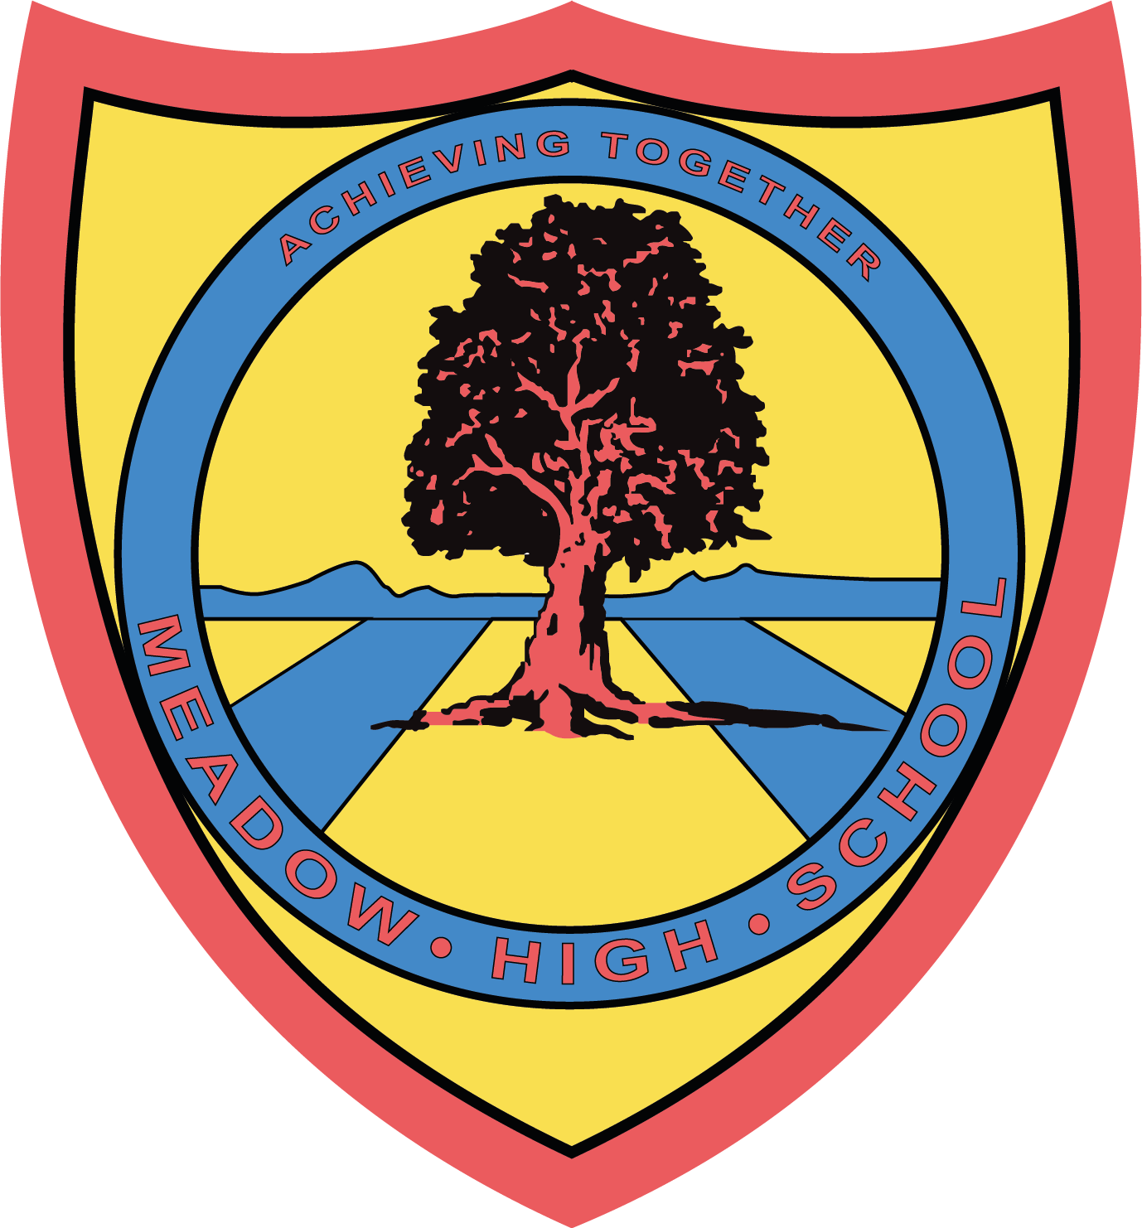

Dear Parents / Carers,

Re: South London Special League

Your child has been selected to represent Meadow High School at the above event. The event will be taking place on Wednesday 1st March. For this event, please note that no studs / blade boots are allowed, only astros or moulded boots can be worn and they must have shin pads (FA rules).

They will need to be at school for 7.30am for a 7.45am leave. They will require a healthy packed lunch, if your child is eligible for free school meals then one will be provided, but please indicate which sandwich they would like. We aim to be back to school in time for transport. If there are any delays, we will contact you on the number you leave below. Please indicate if your child is an independent traveler on the slip below.

Please complete and return the below reply slip as soon as possible.

Kind Regards,

Mr. G. Millard

Article 23:- 'A child with a disability has the right to live a full and decent life with dignity and independence, and to play an active part in the community.'



REPLY SLIP: South London Special League – please return to Mr. Millard

I give permission for my child __________________________ to take part in the South London Special League. I acknowledge that my child must be at school for 7.30am.

My child is entitled to free school meals and would like a:
Tuna / Cheese / Egg sandwich (Please circle)

My child is an independent traveler and will make their own way home after the event.

My emergency contact details are ______________________________________

Signed: ______________________________________

