Meadow High School
Royal Lane, Hillingdon, Middlesex UB8 3QU

Telephone: (01895) 443310
Email: meadow@meadowhighschool.org
Website: www.meadowhighschool.org

Headteacher: Mrs Jenny Rigby
Deputy Headteacher PW2/3: Ms Claire Caddell
Deputy Headteacher PW1: Miss Amy Willis
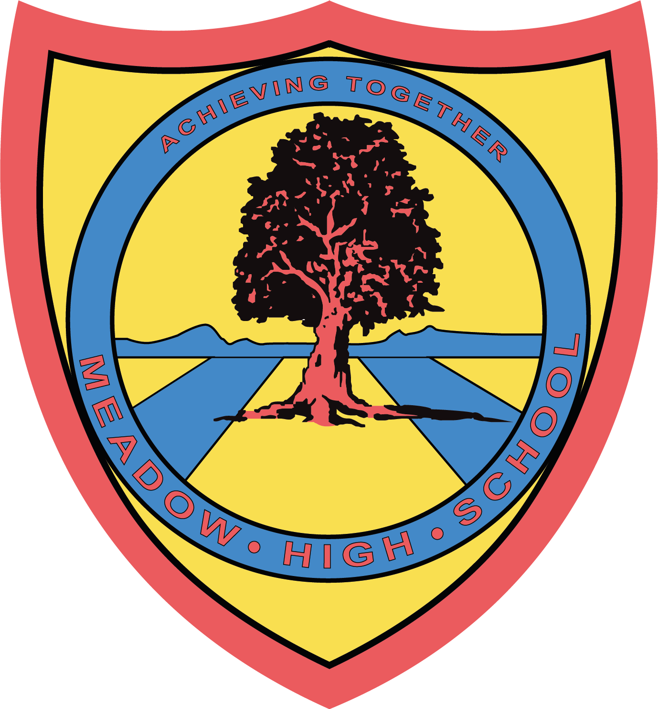

May 2024

Dear Parent/Carer,

Glee Club Confirmation letter

Your child has received a place in our new after school Glee club!

If your child is an independent traveller and you have signed the permission form, they can make their own way home. Pupils who are not currently independent travellers must be picked up by an agreed person at 4.15pm promptly.

The first session will be on Wednesday 15th May 2024. This session will cover the structure and rules expected of our students, the club will be run by Miss Kalia and Mr Ellis.

Glee Club has established rules that students and parents must uphold to allow the safety of students.
Students will have three warnings for any unacceptable behaviour within the club. Each warning will be sent home with your child explaining the nature of the behaviour. On the third and final warning your child, we will sadly have to ask that your child is withdrawn from the club.
If you are running late, please ring the school office to inform us. Parents will also have a warning system for picking their child up late without phoning to tell the school in advance. Should this happen then we will have to withdraw the pupils place at the club. Where pupils are picked up late regularly even with notice the child’s place may have to be withdrawn.

To support the running and resourcing of this club we would like to ask parents and carers to make a voluntary donation of £1 a week to cover our costs. This can be done weekly or paid in a block. If you choose to make the donation in a block and your child is absent the money would be carried over to the next week. Please pay via ParentPay.

Below are this terms Glee club dates:

Wednesday 15th May
Wednesday 22nd May
Wednesday 5th June
Wednesday 12th June
Wednesday 19th June
Wednesday 26th June

Yours sincerely,
Mr Ellis and Miss Kalia

Article 23:- 'A child with a disability has the right to live a full and decent life with dignity and independence, and to play an active part in the community.'


